An Update from June…
Safer Neighbourhoods

July 2026
Matlock & Tansley.

What has the team been up to?

-Joint School visit alongside Fire & Rescue
This month, Police Community Support Officers from your local Safer Neighbourhoods Team and joined forces with the Derbyshire Fire and Rescue Service! This joint partnership response is to help raise awareness in Schools around the dangers of derelict building sites, and how to be safe in open water.
This has had an overwhelmingly positive response from School, with the kids and teachers engaging well with the presentation. The kids even had a chance to have a bit of fun with a team building game showing the kids how to correctly use the life saving throw lines that are often around open bodies of water.
We would like to thank both the School for allowing us to visit, and the Derbyshire Fire and Rescue Service for joining us.

Anti-Social Awareness week
Running from the 29th of June to 2nd July we will be putting a hard focus on anti-social behaviour throughout the Matlock area. The hot spot areas will be a primary target zones, which include Spider Par, Hall Leys Park, Knowleston Gardens (cave) and many more through the Matlock area. During these patrols, Officers will be engaging with those on the parks, conducting late night patrols and keeping an eye out for underaged drinking and Drug use.
The team will also be present outside Schools during kickout to have the usual presence to encourage both kids and parents to behave!

Street meet dates

1st- Matlock Market Day: 12:30-1:30pm.

2nd- Soul Food Café, St Giles Church: 1-1:30pm

2nd Spider Park, Hurst Rise: 3:30pm-4pm

7th M&S Matlock: 11-12pm

22nd- Matlock Market Day: 10-12pm

23rd- Sould Food Café, St Giles Church: 10-11am

29th Matlock Market Day: 12:30-14:30pm

Safer Neighbourhoods
Matlock & Tansley.

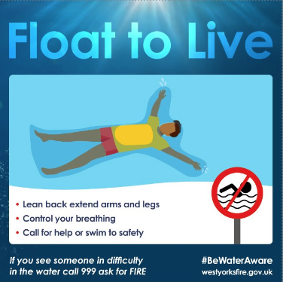

-Plain clothes patrols
This month, the team has been coming together to take part in plain clothed areas throughout the Dales area. Together, the team were focussing on hotspot areas for drug dealing and shop theft.

What has the team got planned?

-School visits
The team will be focussing on Summer safety at the schools on the run up to the holidays. Matlock, being the stunning historic area that it is, has several danger spots that kids have recently being exploring and vandalising. We will continue to join forces with the Fire and Rescue Service to help educate kids about the dangers of these areas, and how to have fun safely.
-New Quarterly Priorities
-Anti-Social Behaviour on Hall Leys Park and the surrounding area will be a target over the next quarter. As summer approaches, so will the level of ASB on the local park areas, which will likely see an increase in underaged drinking, drugs use and general ASB. The team will be coming up with a problem management plan to help combat this issue! During this period, you can expect to see more cops out on foot patrol alongside their PCSO colleagues to help tackle the issue.
-Noisy and Nuisance bikes is the other priority set by the Inspector for the team to focus on. During the busy periods, the team will be not only helping raise awareness of the issue at the usual street meets, but will be monitoring the manner that some bikers drive their bikes through these residential areas.



