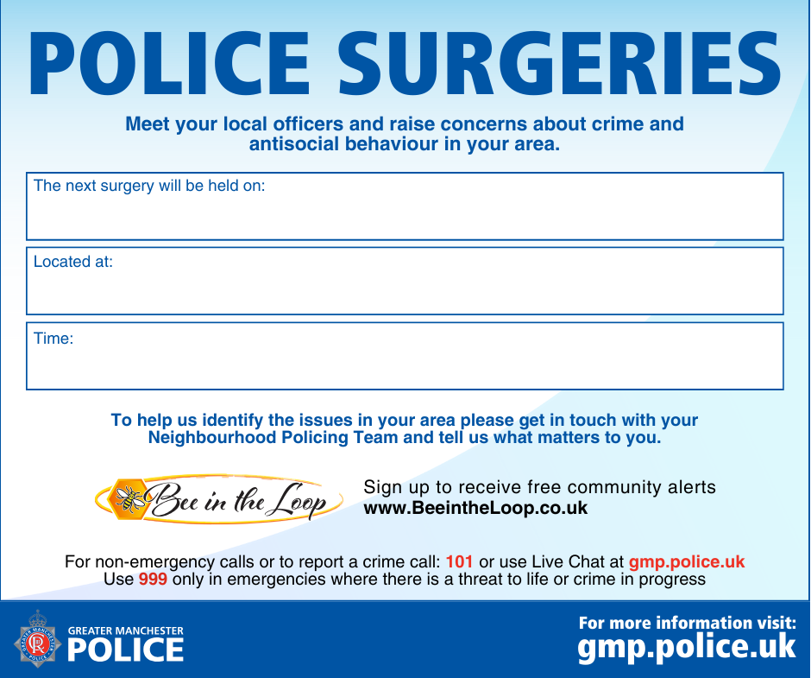
17th of September 2026
Honeywell centre, Hadfield street
1630-1830

