An Update from April…
Safer Neighbourhoods

April 2026
Matlock & Tansley.

What has the team been up to?

-School Visits
Your local PCSO’s have visited a several Schools throughout the month to raise awareness around their safety in summertime. This is to help them be aware of water safety, outdoor safety and the green cross code near roads. Our team have also completed talks about anti-social behaviour which is making them aware of being respectful in public, what peer pressure is and who it might effect.
Your SNT officers have also been present outside of schools during the morning and afternoon to build relationships in the community and address any issues or concerns you may have.

-Patrols/community engagements
Our Safer Neighbourhood team has recently been bolstered by the addition of New PCSO’s which means there will be an increase in patrols in the local area.

As summer is coming our PCSO’s have been setting up engagements in Hall Leys Park. We have leaflets about crime prevention and some goodies! We also bring a police vehicle to give you the opportunity to see inside, take photos and even put the sirens on!

-Dangerous Drivers off the Road

SNT PC have stopped two Road users who are suspected of driving under the influence of Alcohol, one of whom was also doing so with a License! Our team will continue working to keep the Roads safe for our community.

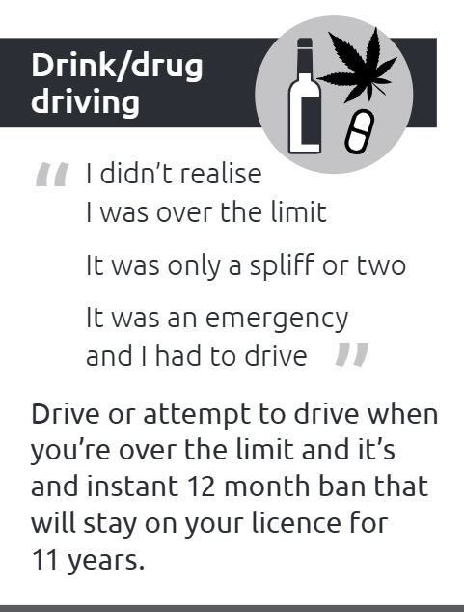
Street meet dates

Street Meet
3:30PM - 4:00PM, Wed 06 May
Tansley town hall. Church Street, Matlock

Street Meet
1:00PM - 2:00PM, Thu 07 May
BOYES Matlock (purse bells), Bakewell Road, Matlock

Street Meet
10:00AM - 10:30AM, Mon 11 May Hurst Community Centre. Hazel Grove, Matlock

Street Meet
3:00PM - 4:00PM, Tue 12 May
All Saints Infant School. Smedley Street

Matlock Market Day
10:00AM - 11:00AM, Sat 23 May
Hall Leys Park

Matlock Market Day
11:00AM - 12:00PM, Wed 27 May
Hall Leys Park

Safer Neighbourhoods
Matlock & Tansley.



Knife Bin, Hall Leys park- 18th May

Knife Bin Stall, Sainsburys- 22nd May 10:00AM-11:00AM

Knife Bin Stall, M&S- 22nd May 10:00AM-11:00AM

Knife Bin stall, Hall leys Park- 23rd May 11:00AM-13:00AM

Knife sweeps, Hall Leys Park- 23rd May 11:00AM-13:00AM

Knife Bin stall, Sainsburys- 24th May 11:00AM-13:00AM

Knife Bin Stall, Hall Leys Park- 24th May 13:00AM-15:00AM

-OP Sceptre
Coming up this month is OP Sceptre, which is a national operation that runs for a week, aiming to tackle knife crime.
We will be doing knife sweeps in parks around Matlock, which even includes getting the metal detectors out! We will also be running an Knife amnesty initiative, which will give members of the community the opportunity to dispose of any unwanted knives and bladed articles in a safe manner by attending our Knife bin stalls.



