
An Update from September…
Safer Neighbourhoods

October 2026
Matlock & Tansley. 

News from the team!

Mini Police back up and running:
Previously, your SNT had a mini police program that would engage with a chosen local school over the year, engaging with yr5’s or yr6’s weekly. This program would educate the year group about selected issues ranging from classroom sessions, to practical displays from the dog unit! We are happy to say that we are now starting the program with a new local school! Plenty of news around this to follow!

Driving through School zones:
The team has noticed several issues with morning and afternoon drivers going through school zones dangerously. Since the start of the new school year, the team have recorded drivers texting whilst driving, speeding, and failing to stop for crossing guards. All this puts the drivers and the children around them at a high risk. Mobile phone use whilst driving is unacceptable, and will see you issued 6 points on your license. You MUST stop for crossing guards, no ifs or buts, they have right of way and failure to stop is an offense.

Digital Help Centre
The Digital Help Centre run sessions every Friday at The Imperial Rooms, and is hosting a special one off event within the session on Friday 16th October. They will be hosting a ‘Digital Confidence Roadshow’ led by the Digital4Everyone Team at Platform Housing. The purpose of these Roadshows are to give people access and guidance on simple IT equipment to enhance and ease their digital experience. Many people who require support are still using 2G/3G-only mobile phones, which will soon stop working as older networks are decommissioned

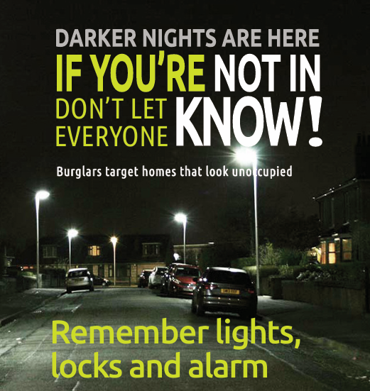
Street meet dates

October Street Meets

Street Meets October
9th October- Imperial Rooms, Matlock-1100-1200

15th October- Soul Food Café, Matlock- 1100-1200

14th October- Market Day, Hall Leys Park, Matlock- 1100-1200

16th October- Imperial Rooms, Matlock- 1100-1200

20th October- Market Day, Hall Leys Park, Matlock- 1300-1400

20th October- Farmers Larder, Hurst Farm, Matlock- 1700-1730

22nd October- Highfields School lower site, Matlock- 1500-1530

27th October- Farmers Larder, Hurst Farm, Matlock-1700-1730

Safer Neighbourhoods
Matlock & Tansley.



In recent digital sessions, as many as 30–40% of attendees rely on devices that will soon lose connectivity. At the same time, some people have purchased new phones that are too expensive, too complex, or not suitable for their needs and as I’m sure you will have seen, often leaves people feeling frustrated, embarrassed, and digitally excluded.
The Digital Confidence Roadshow brings simple, accessible technology directly into communities so customers can try devices, learn at their own pace, and build confidence in a calm, no pressure environment. And it's FREE to attend with cups of tea provided. There are no bookings required, just turn up if this is something you require help with. You local SNT will also try to be present during these events to help people who have concerns around scams and fraud.
If you, or someone you know could benefit from this free input, please pop on round.

Inspectors Update

As the officer in charge of policing for Derbyshire Dales, I want to provide you with some brief updates on just a few of the things that officers from your Safer Neighbourhoods Teams have been doing over the summer months.
Muti agency meetings have been held with parters to discuss how we can work together to manage and reduce the impact on residents and businesses caused by an increase in visitors to Stanton Moor which is a scheduled ancient monument. Leading up to and throughout the Autmn Equinox Police Officers and PCSOs patrolled these areas to remind people that fires are prohibited under a Public Spaces Protection order and that Camping is not allowed under The Countrysides and Rights of Way Act 2000. They were supported by colleagues from Derbyshire Dales District Council, Fire Service, Peak District National Park, and the Landowner. Whilst one small fire was dealt with by fire service, the occasion passed without significant disruption. You can find out about PSPO’s here Public Space Protection Orders - Derbyshire Dales District Council

Matlock SNT attended a meeting regarding the problems caused by high visitor numbers and the increased reporting of anti-social driving and parking at Matlock Bath. Suggestions for traffic calming measures and protecting pedestrian areas were discussed and have been sent to the relevant agencies for their consideration. We have continued to work with Civil Parking Enforcement to support their work and our colleagues from the Road Policing Unit (RPU), Casualty Reduction and Enforcement Team (Crest) have been out across Derbyshire Dales to help tackle the ‘Fatal Five’, which are Speeding, Drink/Drug driving, mobile phones, seatbelts and careless driving. You can see Sgt Scott Riley discussing these in the constabulary’s podcast Off Duty: The Fatal Five - Roads Policing Unit | Derbyshire Constabulary

SNT officers worked alongside officers from our Criminal exploitation team to successfully execute several warrants across Matlock resulting in four men and 2 women being arrested. You can read more about this here Four charged with drug offences following series of warrants in Matlock | Derbyshire Constabulary. The work done to disrupt crime and drugs in our communities continues, if you have any information regarding drugs or other criminality then you can report this through the Derbyshire Constabulary website, by calling 101 or anonymously via Crimestoppers on 0800555111.

Over the Autumn months officers will be concentrating on the priorities that have been set by you for your areas, you can contribute to these by contacting your local officers Your area | Derbyshire Constabulary, through social media or by signing up to Derbyshire Alert.

The SNT officers will be patrolling in your area and publish their engagements on the meetings and events page of our website. As the nights now begin to draw in then we would encourage residents across the Derbyshire Dales to think about securing their properties and outbuildings and making sure valuable items are safe. Lawnmowers and bikes put in sheds can be a target for thieves so consider locking things together to make them difficult to move and try not to leave things on show. If you are out of the house when it is becoming dark, then consider putting a light or television on or setting a timer switch so that potential thieves cannot see that there is nobody at home. Please come along to one of our engagement events if you would like to ask about the security of your home or discuss anything else with us. To see more about what is happening in your local area then please visit our website or follow us on social media.

