Community Policing Update  Your local officers remain committed to keeping our community safe and reassured. We continue to carry out high-visibility patrols across the area, focusing on building positive relationships and deterring criminal activity.  Fraud  Report of suspected fraud and criminal damage to a property roof. The builders initially requested a substantial sum of money and have subsequently caused damage to the roof. They have continued to demand further payment despite concerns regarding the quality and legitimacy of the work carried out. This incident may be linked to rogue traders, and residents should remain vigilant.  Be Aware  Reports have been received of an individual shining a laser light at motorists by directing it into vehicle mirrors while they are driving. This behaviour has the potential to distract or temporarily impair a driver's vision, creating a significant risk of a road traffic collision and placing other road users at risk.  Anyone who witnesses this behaviour or has any information, including dashcam footage, is encouraged to report it to police.  Road Traffic Safety  Local officers conducted speed enforcement checks in the area using a speed detection device. As a result, Traffic Offence Reports (TORs) were issued to drivers for speeding offences and for using a mobile phone whilst driving. Officers will continue to carry out regular patrols and enforcement activity to improve road safety and deter dangerous driving behaviour.  - Community Engagement: We are committed to engaging with the Greenhill and Westbay Wards community. This includes holding regular community meetings, which are advertised via My Community Voice. We want to hear your concerns and work together to find solutions.  We are committed to keeping you informed. We publish this monthly newsletter and provide updates on local crime trends and the work we are doing to address these issues on My Community Voice. | 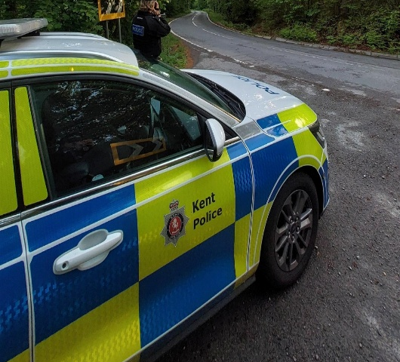  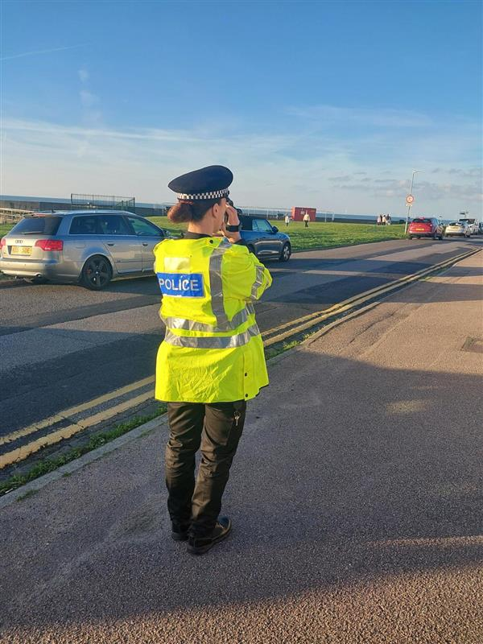
Next month’s engagements:  - Hampton Car Park 03/11/026 13:00-14:00hours  - Greenhill Church 03/11/26 10:00-11:00hours | Your local officers are;  PC 15918 TOTTEN

