
Wigston Newsletter
Issue: September 2026

Introduction
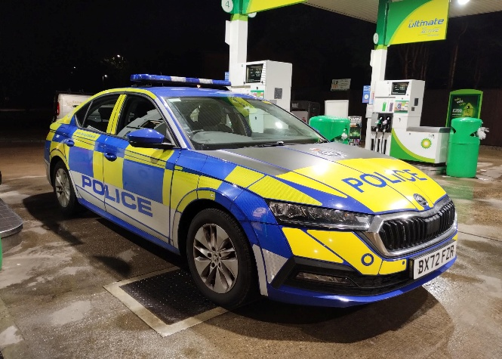
PS 2179 Mark Body
PC 186 Tommy Wright
PCSO 6158 Cara Hayter PCSO 6115 Adam Ghrairi

Keeping Wigston Safe
Local officers and PCSOs have continued proactive work across Wigston, with high-visibility reassurance patrols taking place in key areas, including Wigston center (Bell Street and surrounding), Aylestone Lane, Little Hill and The Meadows.
These patrols aim to deter crime, engage with residents, and respond to concerns around anti-social behavior (ASB).

Officers are encouraging residents to continue reporting issues, as community intelligence plays a vital role in shaping local policing priorities and ensuring timely action is taken. We are aware of antisocial behaviour from youths and vulnerable residents has become an issue in Wigston town center, but with appropriate action and patrols this has significantly reduced.
#YouSaidWeDid - What matters to you

Tackling Anti-Social Behavior (ASB)
ASB remains a focus for neighborhood teams. Patrols have been specifically targeted at areas where residents have raised concerns about:
- Youth disruption- Bell Street, Central Avenue and Station Road.
- Rowdy or nuisance behavior using vehicles in hotspot areas. Leicester Road
- Drug use in public spaces. This includes vehicles. The council and Police have been working collaboratively to tackle drug use in the area. This has led to warning letters being given to residents.

• Road Safety & Traffic Enforcement
Road safety continues to be a priority across Wigston. Residents have reported issues such as speeding, dangerous driving, and obstructive parking.
In response, officers have:

- Carried out vehicle stop checks based on intelligence. This has also included stopping people that we can see on their mobile phones. This has resulted in multiple people being issued tickets.
- Conducted speed checks to ensure road users adhere to speed limits in areas that you have raised to us as having high rates of speeding in the area.

These operations are part of an ongoing effort to reduce dangerous driving and improve safety for all road users. We look to complete a day dedicated to road safety during the month of October, where we look to take the speed gun out to targeted areas and manage those who are speeding within the areas raised to us. We have received concerns around Leicester Road, Kelmarsh Avenue, Newton Lane.

Tackling Drug-Related Activity
Local police teams continue to address concerns around drug use and dealing in Wigston. Work has included:

  - Intelligence-led operations and warrants.
  - Increased patrols in known hotspot areas. People stop checked that we have intelligence to believe that they are possessing drugs.
  - Partnerships with other agencies to prevent ongoing issues and develop intelligence in areas known to us. Partner visits with the council in relation to drug use and antisocial behaviour activity at an address, an Antiscoial behavour Order was delivered.
Recent activity has resulted in disruption of local drug activity, showing the importance of public information and reporting.

Burglary & Vehicle Crime Prevention
Neighborhood officers continue working to reduce burglary and vehicle crime by:
  - Conducting targeted patrols in hotspot areas
  - Providing crime prevention advice to residents. Particularly as we approach the warmer weather, we have been ensuring that people have closed windows and doors before leaving their homes unoccupied.
  - Developing intelligence in relation to subject vehicles and individuals

There have been reductions in certain vehicle-related offences, thanks in part to targeted operations and intelligence-led policing.
Residents are reminded to:
  - Lock doors and windows, even if you are just going out for a short period of time.
  - Avoid leaving valuables in vehicles
  - Report suspicious behavior promptly. This allows us more time to get to them, and increases are likeliness to catch those and challenge their behavior early doors.

Working with the Community
Wigston’s neighbourhood team works closely with:

  - We have put out messages via our Neighbourhood Link page to seek information that you wish to share with us. This has led to a lot of intelligence logs from residents, actions taken by officers for antisocial events reported.
  - Local Police Drop in sessions have been conducted by officers to talk with members of the community and discuss crime prevention advice and actions that police can take and have taken.
  - We have seen Andrew JACKSON arrested this month with the help of our Safer Streets Team and the stores compliance in statement taking, CCTV obtained and their observations on the shop floor.

This partnership approach helps deliver long-term solutions to local issues and improves safety across the borough. Recent engagement activities have included community patrols, youth engagement, and ongoing communication via social media and local messaging systems.

How You Can Help
You can support your local police team by:
    - Reporting crimes or suspicious activity via 101 or online
    - Call 999 in an emergency
    - Sharing information that could assist investigations
    - Joining local alerts such as Neighbourhood Link for updates

Final Message
Your neighbourhood team remains committed to visible policing, tackling priorities, and keeping Wigston safe. Continued community support is essential in helping police respond effectively and build a safer environment for everyone.

To let us know what your local concerns are for the months ahead then please contact us via Neighbourhood Link, Complete our surveys as we work off of these to see what your local concerns are in the area.
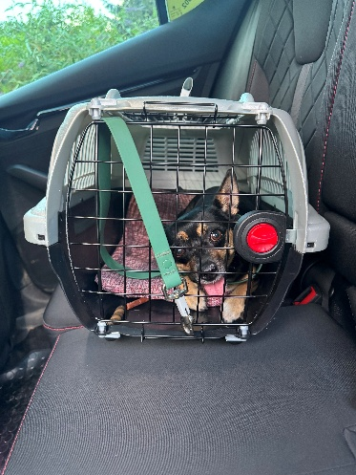
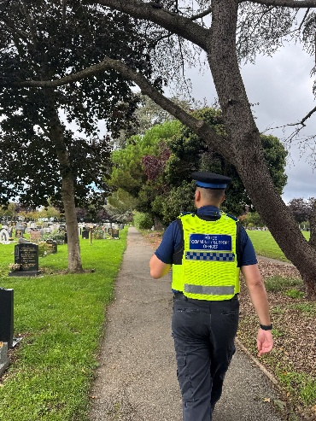
UPCOMING Local Police Drop In Session:
- 19th October - 6pm-7pm-Tythorn Community Centre 6115 and 6158

Other ways to keep up with our beat surgeries and what we get up to is to go to our Facebook page: “Oadby and Wigston Police”

Our website has information on several different types of crime, resources and local services. Calling 999 in non-emergency situations can delay access for those in urgent need.
#HelpUsHelpYou by visiting our website to get more information or access the service you need https://orlo.uk/RKenf

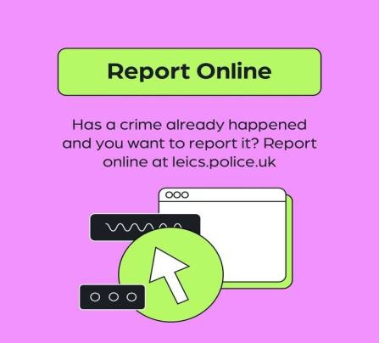
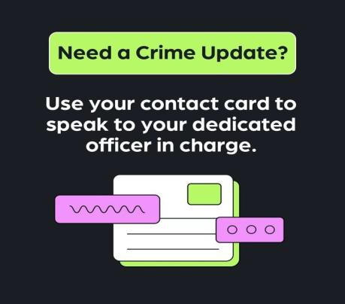




Follow our channels for the latest updates
WhatsApp Channel
Your local NPA Facebook page
Receive more updates
Instagram

Confidence Survey Your Views Survey



