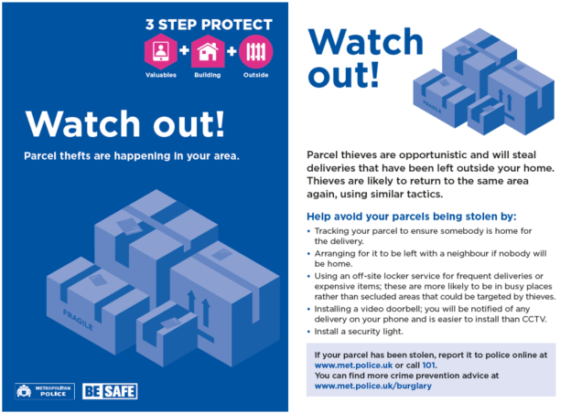
Preventing stolen doorstep deliveries
Practical advice to reduce the risk of being affected by the growing trend of theft of items left unattended by delivery drivers.
Preventing theft from your doorstep
Here are some things you could do to reduce the risk of doorstep theft:
- track your parcel to ensure you or someone else is at home for the delivery
- install a video doorbell; this can be connected to your mobile, so you are notified immediately of any delivery, and is easier to install than a full CCTV system
- install a security light
- arrange for your parcel to be delivered to a trusted neighbour, or other family members who will be at home; if you live in a flat, is there a concierge who could accept the parcel for you ?
- use an off-site locker service for frequent deliveries, or for expensive items; these parcel boxes are more likely to be in busy, safer locations - such as supermarkets - rather than secluded areas which could be targeted by thieves

