

We have listened to you.

Issue:
Sept 26

Western Ward

Newsletter

Introduction

#YouSaid
-

What matters to you

PS Simon WALTERS

PC Dave MARTIN

PC Callum JOHNSTON

PC Georgia POWELL

PC Lee FLAVILL

PC Alex ALDRICH

PCSO Pete SMITH

PCSO Sally
-
Ann MORGAN

PCSO Sabra BABAI

PCSO Andy BROWN
PCSO Grant JARVIS
Priority 1
Dangerous and illegal use of vehicles around the Western Ward continue to be reported and raised as concerns by local residents. Speeding, E-bikes and E-Scooters and dangerous parking outside Primary Schools have all been highlighted.
Action
The whole team have been working hard with high visual patrols by the PCSOs & PC, also some plain clothes work by officer in which the followed. Numerous cars ticketed and seized vehicles, other vehicle recovered for being used for anti-social behaviour. We will continue this action with more schools being visted in the following month.
Priority 2
Retail crime continues to be a problem for our shops across the Western ward which is causing staff to feel unsafe whilst at work.
Actions
Officer have been doing regular plain clothes patrols outside local stores and targeting those people who cause the shops and shoppers most harm, all stores on the beat and some close by are in a what-app group. Some great results with prolific Shoplifters caught, 2 x shoplifters arrested and charged.
Priority 3
The community in the area of Styon Road, Keightley Road and Lamen Road tell us that youths are regularly causing Anti-Social Behaviour in and around the grassed Play area. Motorcycle gatherings causing excessive noise, Vandalism/damage to Property are regularly being reported.
Actions
Since Luke Westell council ASB officer has issued issuing warning letters to address on Styon Road & Holmwood Drive things have calmed down a little but will be still patrols and challenging any anti-social behaviour.
Bike Rider Putting Child at risk



Officers are looking for the identification of the above male who has been seen on Rowanberry Avenue, liberty Road, Dominion Road and the surrounding area. The rider is driving at speed, as well as driving an unregistered bike, with no Tax no Mot and no insurance with no safety equipment. He is putting a young child live at risk.
Male is described as a White male large build wearing a balaclava glasses black t-shirt and short with white trainers
Local residences have complained and experience officer are concerned with the manor of driving. This situation is too dangerous for officers to follow, if you know who this person is and were the vehicle is being kept, please contact Andy Brown (6083) andrew.brown@leics.police.uk

Or contact Crimestoppers on

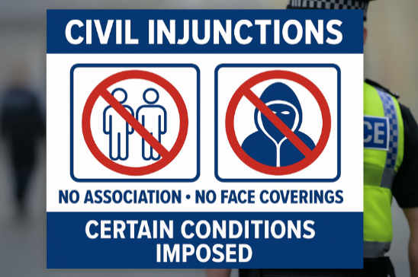
Crime & ASB You could lose your property
Full closure order obtained for 9 Chainama Close, PC's Dave and Georgia have assisted the housing officer with the eviction and taken full possession.
Hopefully local residence can have a better quality of life

Upcoming beat event Activities eat

Beat Surgery at New Parks Salvation Army Center.
11:00AM - 12:00PM, Thu 01 October 2026
New Parks Salvation Army Centre, 330 Aikman Ave, New Parks, Leicester LE3 9PW

NP Steering Group
12:00PM - 3:00PM, Wed 07 October 2026
Team HUB St Oswalds Road New Parks

Beat Surgery New Parks Library
11:00AM - 12:00PM, Tue 13 October 2026
321 Aikman Avenue

Beat Surgery at One Stop Shop on Stephenson Drive
11:00AM - 12:00PM, Mon 19 October 2026
One Stop Shop, 155 Stephenson Drive, Leicester

Beat Surgery at New Parks Salvation Army Center.
11:00AM - 12:00PM, Wed 04 November 2026
New Parks Salvation Army Centre, 330 Aikman Ave, New Parks, Leicester LE3 9PW

#NeighbourhoodPolicing #SaferStreets #WesternWard
Follow us @LPWestLeicester

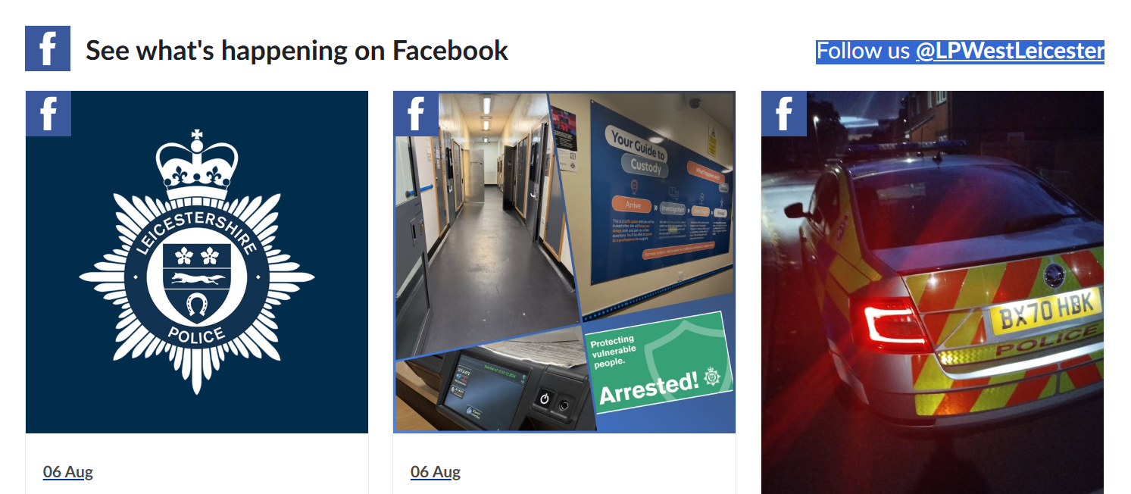
nts November 25

Your Beat Team in action

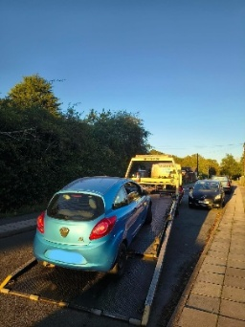
Pool Car Taken of the road
concerned resident called in an abandoned vehicle on the street, vehicle was insecure and full of nitrous oxide cannisters, Vehicle had no Tax , No insurance and no MOT and had been see being driven in and around the New Parks Area, the vehicle was in very poor condition and was recovered by Police so the user could commit any more offences’
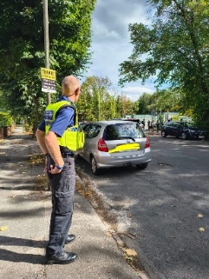
PCSOs Andy & Sabra School Parking Patrol
Both officers attended Brookmead School Garland crescent Leicester to educate drivers and challenge any dangerous parking outside the schools this has been highlighted. As one of our beat priorities
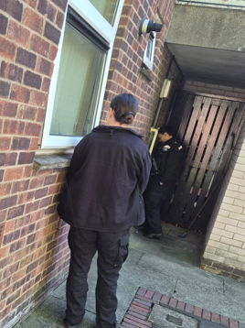
Vulnerable person Check
PC Georgia and PC Paige from the Braunstone beat team carry out visits to vulnerable people that might be being exploited or taken advantage of. This is important so we can protect vulnerable people from harm. If you are worried about someone you know that might be being exploited, please contact Leicestershire police and we can investigate safeguarding matters.
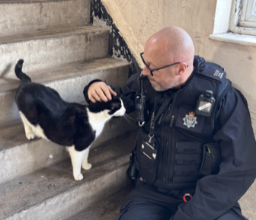
Patch walk with housing officer
2nd & 3rd - PC Dave and PC Georgia carry out a patch walk with housing officer Kelly around Dupont gardens area.

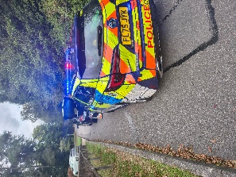
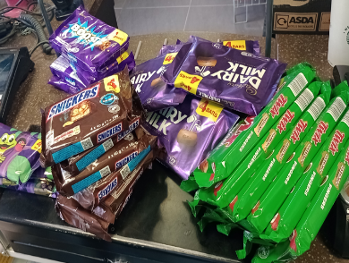
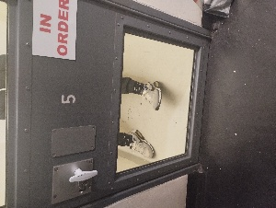
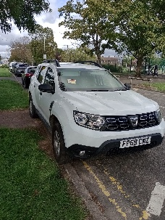
PC 1544 & team have had a productive month, stolen motorcycle recovered, Fost Lodge school request from residents and the school re parking issues outside the primary school, numerous cars ticketed and seizures, vehicle recovered in relation to causing ASB for local residence. Sweet Tooth prolific Shoplifters caught, 2 x shoplifters arrested and charged
PCSO Sabra Babai (6121) quick response to stolen motorbike recovered with few hours of theft reported
Beat Surgery at One Stop Shop on Stephenson Drive

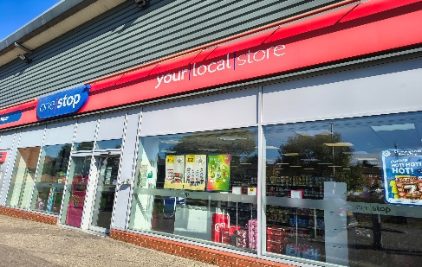
11:00AM - 12:00PM, Mon 19 October 2026
One Stop Shop, 155 Stephenson Drive, Leicester

