Public Protection Partnership Press Release – 10 February 2026

Trader Warned for Selling Unsafe Toys

The Public Protection Partnership is reminding businesses of their legal obligations under The Toys (Safety) Regulations 2011, following the discovery of toys placed on the market without the required safety information.

The Regulations, which apply to all toys made available to consumers on or after 19 August 2011, require clear identification of both the toy and its manufacturer. This information must be affixed directly to the toy unless its size or nature makes this impossible. Where this is the case, the information must appear on the packaging or in an accompanying document.

Trading Standards Officers visited a premises in Bracknell Forest to follow up on a complaint regarding vapes being sold. While the vapes inspected were found to be compliant, officers noted that the store was also selling a range of toys that appeared potentially unsafe. As a result, several items were seized and sent for testing. Four of the products failed safety requirements, presenting risks including choking hazards, lack of warnings, and missing manufacturer information.

Products seized and test findings
Slime
The product was classified as a toy and should therefore have carried full safety labelling. It failed due to:

- No labelling of any kind  - No UKCA/CE mark  - No manufacturer details  - No importer details  - No information about the contents  - No age warning or suitability guidance | 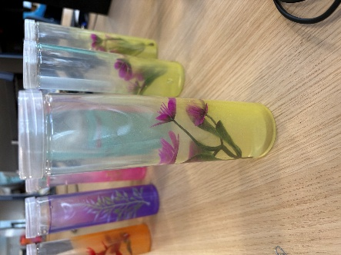

Bubble Fan
This toy posed several safety risks and failed on the following grounds:

- No labelling  - Failed tension test  - Detachable fan/fin components creating a potential choking hazard for children under 36 months  - No warning such as “Not suitable for children under 3 years”  - Presence of small parts | 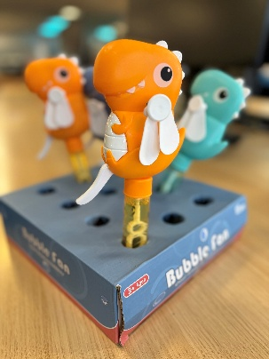
Cat Squashy
As a squashy toy, this item is considered suitable for young children and must meet strict standards. It failed due to:

- No labelling  - Failed tension test – detachable parts (tops of ears), creating small parts  - Choking hazard to children under 36 months  - No UKCA/CE mark  - No product identification  - No manufacturer name and address  - No importer name and address  - No age warning | 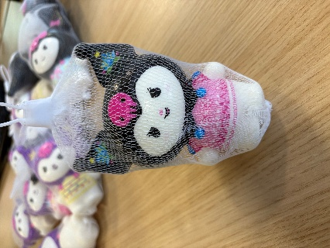
Prime Squashy & Packaging
Both the toy and its packaging presented compliance and safety concerns:

- No UKCA/CE mark  - No age warning (“Not suitable for children under 3 years”)  - Product defined as a toy but sold without required labelling  - Plastic packaging posed a potential asphyxiation hazard due to thickness and size  - Tension test failure on straw – part detached  - Choking hazards due to small parts  - No product identification  - No manufacturer name and address  - No importer name and address | 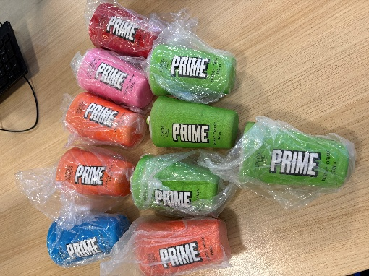

The trader received business advice and a warning not to sell products without the correct labelling. Trading Standards is continuing to work with the retailer to ensure unsafe items are removed from sale and to prevent further non-compliant products from reaching consumers. Parents and carers are encouraged to remain vigilant when purchasing low-cost toys, particularly those lacking labelling, warnings, or manufacturer details.

Councillor Tom McCann the Chairman of the Joint Public Protection Committee said, ‘“Ensuring the safety of children is one of our highest priorities, and these findings highlight exactly why robust checks and enforcement are so important. Parents and carers should be able to trust that the toys they buy meet the legal standards designed to keep young people safe. I’m grateful to our Trading Standards Officers for their vigilance in identifying these unsafe products before they could cause harm. We will continue to work closely with retailers to ensure they understand their responsibilities, and we will not hesitate to take action where those responsibilities are not met.”

If you have concerns about potentially unsafe toys being sold please contact the service on 01635 519930 or e-mail tsadvice@westberks.gov.uk.

Notes:

The Public Protection Partnership (PPP) is a shared service delivering Environmental Health, Licensing and Trading Standards to people and businesses on behalf of Bracknell Forest Council, and West Berkshire Council.

PPP work jointly with Wokingham Borough Council to provide a Trading Standards, Financial Investigation and Case Management Service across the three authority areas.

These services encompass a wide range of areas of responsibility from environmental protection to fair trading, food safety to animal health, housing standards to taxi licensing, and more.

Website: www.publicprotectionpartnership.org.uk
Facebook: @PublicProtectionPartnershipUK

About National Trading Standards

National Trading Standards delivers national and regional consumer protection enforcement. Its Board is made up of senior and experienced heads of local government trading standards from around England and Wales with an independent Chair.

