An Update from May…
Safer Neighbourhoods

June 2026
Matlock & Tansley.

What has the team been up to?

-Op Sceptre
As usual, Op Sceptre had a huge positive reception from Matlock and other local areas! The team were hard at work engaging with local store fronts, giving School inputs and setting up information stands in hotspot areas to help raise awareness around knife crime. As a whole, the team had a large quantity of utility knives handed over that people were unsure of how to dispose of safely . We would like to thank all those who engaged with us during this period.

-Patrols/community engagements
With the increase in staff, we are happy to say that there has been a huge uplift in the quantity of street engagements the past month. This also has allowed the team to cover much more ground more regularly to help provide reassurance to those seldom heard communities and to tackle those hot spot areas for effectively.

More notably, this month the team responded to an emergency call in Wirksworth regarding suspicious behaviour at a vacant property. The team arrived with a dog unit and a male soon tried to flee , however the male was soon found hiding in a garden by our 4 legged friend and he was swiftly arrested.

-Dangerous Drivers off the Road
This month our colleagues have had a couple positive stops and seizures for those driving with no insurance or under the influence of illegal substances. One of such is PC HUSSAIN stopping a vehicle that appeared to be unsuitable to be driven due to a crack on the windshield, this stop later turned into one of the passengers of said vehicle being in possession of cannabis.

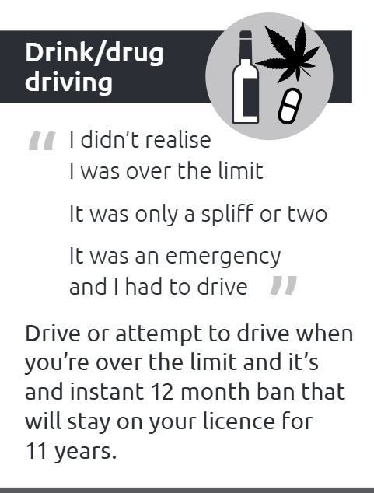
Street meet dates

Wed 3rd- 1330-1400- Market Day,
Hall Leys Park.

Thurs 4th-1300-1330, Sainsburys, Matlock.

Mon 8th- 1000-1030, Hall Leys Park.

Fri 12th- 1500-1600, Tansley Primary School

Sat 13th- 1330-1430, Matlock Market Day
, Hall Leys Park.

Sat 20th- 1100-1200, Matlock Market,
Hall Leys Park.

Sun 21st- 1000-1030, Church in the Peak.
Lime tree road.

Safer Neighbourhoods
Matlock & Tansley.


What has the team got planned?

-Joint School visit alongside Fire & Rescue
As the summer holidays are coming rolling round and (hopefully) some nice weather, you SNT and the local Derbyshire Fire and Rescue community Officer will be visiting your local schools. The aim of this joint work is to promote safety and highlight the dangers of several issues in the area, namely Derelict Buildings, Fire safety and water safety. We hope that through this joint work it will keep kids safe, but also keep them having fun outside during the coming holidays.

On top of this, the team are also visiting several schools in the area to touch on other important subjects, including what a Digital Footprint is, and how to look out for County Lines.

Anti-Social Awareness week
This month, starting Monday 29th your local Safer Neighbourhood Team will be raising awareness around Anti-Social behaviour. This will cover all the aspects of ASB, including the negative effects it can have on people, the long term impacts it can have on victims and the community, and what counts as ASB.
Keep an eye out for our Officers, who will be present with leaflets and other resources throughout Matlock to help raise awareness around the issue.



