Mid Holderness Ward Newsletter – July 2026
Detailed crime and ASB data for your area can be obtained by visiting www.police.uk and following the ‘Find your Neighbourhood’ link.
Meet Your Community Police Team

Inspector Ian Foster Sergeant Mick McLaughlin PC Maria Adlington PCSO Darren Bainton
What’s happening in Your Area & Community Priorities?

QR – please scan to visit our Community Team page.
40 crimes reported during June
Humbertalking has set our priorities, this month we are to:
- Tackling Anti-Social Behaviour
- Improve Road Safety around our schools.

Here’s a summary of crimes that have been reported across Mid Holderness last month:
- Domestic Related incidents: (eighteen investigations)
Domestic Assault x4, Rape x1, Harassment x9, Controlling & Coercive behaviour x 2, Damage x1 other x1
- Residential Burglary reports: (One investigation)
13/06/2026 Burglary Catwick Lane, LONG RISTON entered via open front window of unoccupied property, used cooker to heat food/seek shelter.
- Business Burglary reports: (no reports)
- Thefts: (two investigations)
07/06/2026 Theft A165, BURTON PIDSEA – theft of a cat.. 04/06/2024
07/06/2026 Theft Drove Lane, WAWNE – two garden milk churn ornaments
- Vehicle Crime: (one investigation)
17/06/2026 Theft of vehicle Main Road, BILTON
- Damage: (five investigation)
01/06/2026 Damage to door Dorest Avenue, SKIRLAUGH
10/06/2026 Damage to fencing Sproatley Road, FLINTON
14/06/2026 Damage Humbleton Road, FITLING – spray paint graffiti to building
14/06/2026 Damage Humbleton Road, FITLING – spray paint on tractor/shed
24/06/2026 Damage to crops, GREAT HATFIELD (nighttime poaching)
13 incidents - public order x1, assault x2, harassment x2, harassment by neighbour(s) x4, dangerous dog x1, Fraud x2, Malicious Communications x1 reported in June across the Mid Holderness ward area.

Humber-talking has set our priorities, this month we are to:
- Tackling Anti-Social Behaviour
We regularly deploy high visibility patrols to our communities in response to reports of criminal damage, drug dealing and anti-social behaviour.

The local policing team have also had productive meetings with partners from East Riding Council, Parish Councils and Neighbourhood Watch groups to listen to community concerns.
Our officers are also committed to eradicating the harm that the illegal and anti-social use of off-road bikes cause to the communities through our Operation Yellowfin.
Action – aims to:
- Protect vulnerable residents
- Restore community confidence and create a safer environment
- Demonstrate the effectiveness of a partnership approach between with local partners.
Intended outcome:
- Reduce the number of ASB reports
- Increase residents’ confidence and feeling of safety
Anyone who wishes to report anti-social or criminal behaviour can contact The Police on 101 or East Riding of Yorkshire Council on 01482 393939

- Improve Road Safety – around our schools.
As with most other areas, road safety is something in which we can improve upon in our rural communities.

Action –
- As we enter the summer months, members of the Holderness Policing Team will continue to be out and about policing our roads to promote safe behaviour and enforcement of traffic laws.
- Officers will continue to support Bilton & Aldbrough Primary Schools to reduce traffic in the villages and encourage families to walk or cycle to school.
Intended outcome:
The intended outcomes are to:
- Education & awareness campaigns to reduce the number of casualties on our roads.
- Create a culture of road safety where individuals understand and practices safe behaviours.
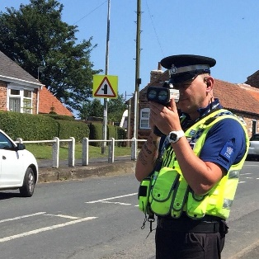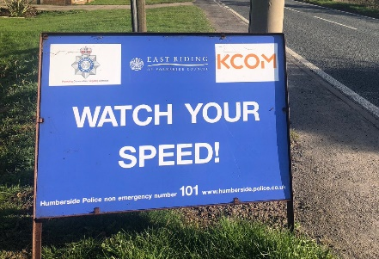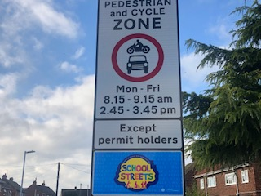
With the last few weeks of all children at our primary schools before the Summer Holidays, the Community Team will be conducting patrols around the schools making sure that the roads are safe for everyone especial for our young members outside the schools’ gates.

How you can help
Your local Neighbourhood Policing Team appreciates the importance of being in the right place, at the right time, for the right reasons to reassure the public, improve public confidence and reduce crime and anti-social behaviour in the area in which we all live and work.
We encourage all residents to call and report any issues where they live so that we can deal with any issues and step up our patrols in that area.
If you feel that there are other issues affecting you or your local community that should be given priority, please inform your local councillors or your Neighbourhood Policing Team.
News and Appeals
Please visit our website www.humberside.police.uk for the latest news & appeals
FACEBOOK users did you know? You can find out more about the work of your local officers and teams by liking their Facebook accounts: Please visit Humberside Police – East Riding of Yorkshire South www.facebook.com/HumberbeatERYS
Twitter (X) users can keep up to date with events, alerts and traffic news within Mid Holderness by following the community team @HumberbeatERYS and @PCSODarrenB.

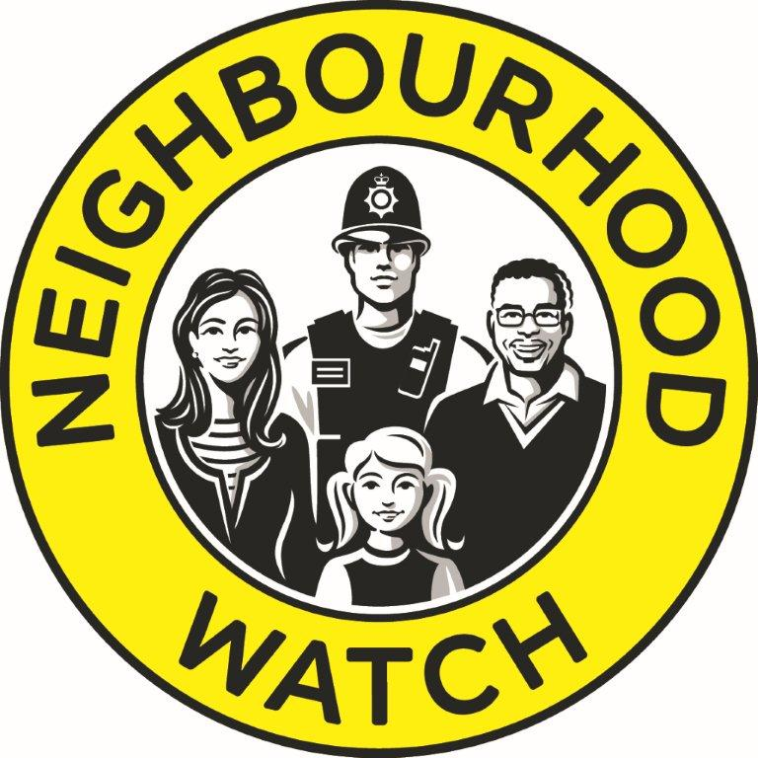
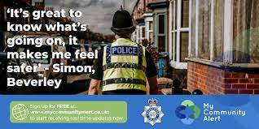
My Community Alert - free sign up
“My Community Alert” is a free messaging system operated by Humberside Police and Humberside Fire & Rescue Service, giving you information about incidents happening in your area. Choose how you often you want to hear from us and about the issues that matter to you.

Engagements: In July 2026, the dates and locations are as follows:
2nd- Thursday 7pm - WAWNE Parish Council, Village Hall, Main Road, WAWNE
7th - Tuesday 7pm EAST GARTON Parish Council, Village Hall, Garton Road, ALDBROUGH
8th- Wednesday 7pm – WITHERNWICK Parish Council, St.Albans Church
11th- Saturday 11:30am -Village Hall, Swine Lane, CONISTON
23rd- Thursday 7:30pm – HATFIELD Parish Council, St.Albans Church, WITHERNWICK
28th- Tuesday 7:30pm BURSTWICK Parish Council, Village Hall, Church Lane, BURSTWICK
Schools will be visited during the morning and afternoon commute.

Domestic Abuse evolves overtime – could you or a loved one be a victim?

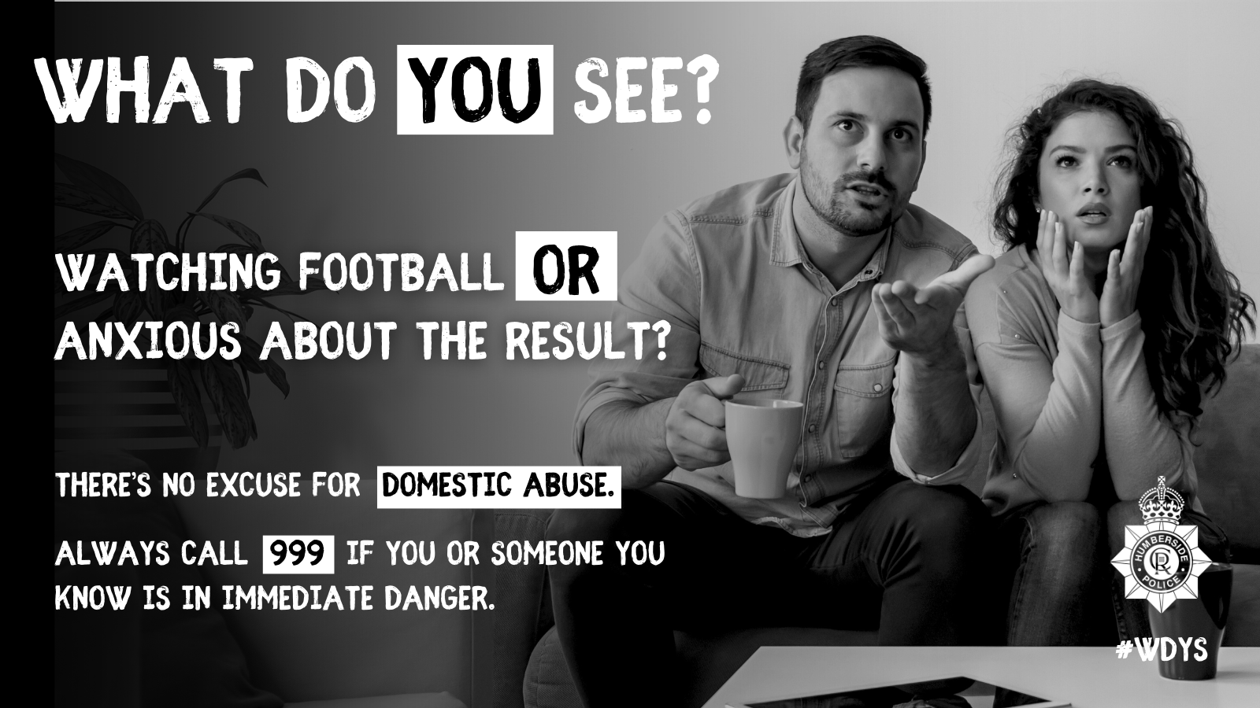

Domestic abuse takes shape in many forms and without realising, you, your friend, your family member, or your colleague could be a victim of domestic abuse, whether that be at the hands of a partner or even a relative.

We take all incidents extremely seriously and we would encourage anyone who believes they have been a victim or witnessed domestic abuse, in any form, to contact us as soon as possible. To report domestic abuse call us on 101 or if you’re in immediate danger, always call us on 999.

You can find out more about the different types of domestic abuse and the support networks available by visiting our campaign page. https://www.humberside.police.uk/police-forces/humberside-police/areas/campaigns/campaigns/what-do-you-see/


Humberside Police's longest-running youth event, and it's all about you! Since 1989, we've been supporting young people in making a positive impact in their communities each summer.
Making a Difference Every year, young participants take on cool and inspiring projects, from awareness campaigns and public space clean-ups to charity fundraising and community support. Your dedication and teamwork help make your neighbourhoods better places to live.
Lifestyle is ready to be launched in your area.

Action: All Neighbourhood Policing Teams have received their Lifestyle packs with promotional materials, and their PowerPoint (and video) has been delivered in schools.
Lifestyle is our longest-running youth engagement event, inspiring young people since 1989 to make a positive impact in their communities through innovative, fun-filled, and inspiring projects during their summer holidays. Each year, we witness incredible dedication from young individuals who strive to improve their neighbourhoods, showcasing exceptional organization and teamwork to achieve their Lifestyle goals.

Lifestyle is open to 10-16 year olds, either in small teams of 2-5 members or as larger youth teams representing youth clubs. This programme offers Humberside’s young people the chance to fill their summer with enjoyable activities that benefit their communities. You can find out more about Lifestyle on our new dedicated website: Humberside Police Lifestyle – Making a Difference, where registration is NOW OPEN.
Op Coastline is back once again!
Whether you're planning a seaside stroll, enjoying a picnic by the shore, or visiting local attractions, our coastal towns and villages are filled with springtime activities. However, this busy season can also present opportunities for crime and antisocial behaviour.
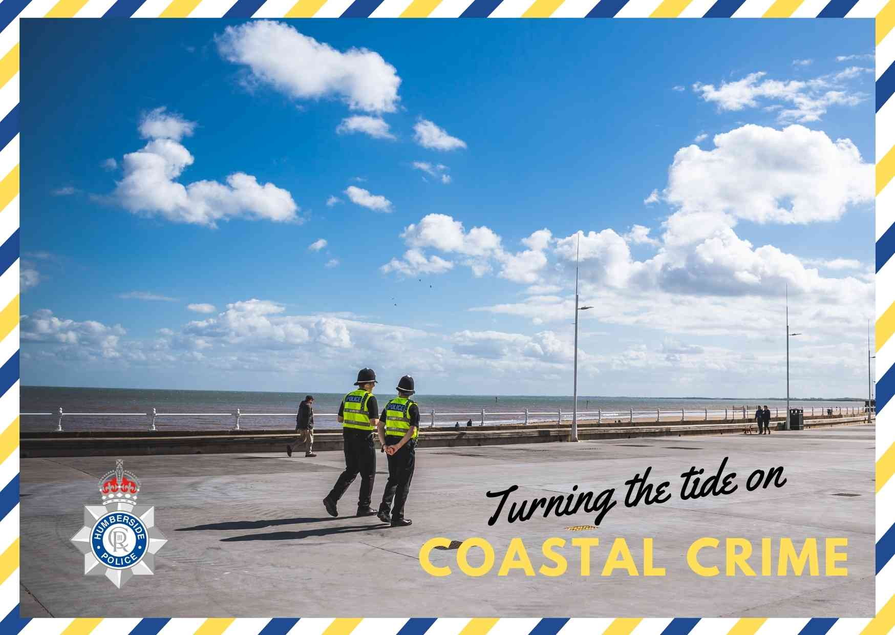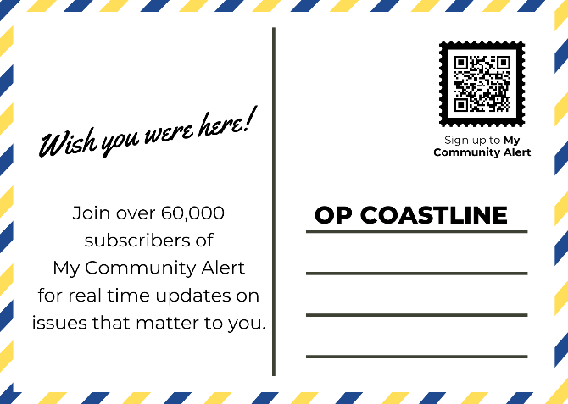
To help keep communities safe, local neighbourhood policing teams, the Rural Task Force, and the Community Safety Unit will be out on high visibility patrols and engaging with those across the area. Our Roads Policing unit will be actively patrolling key routes, using both marked and unmarked vehicles, to tackle and deter crime and antisocial behaviour.
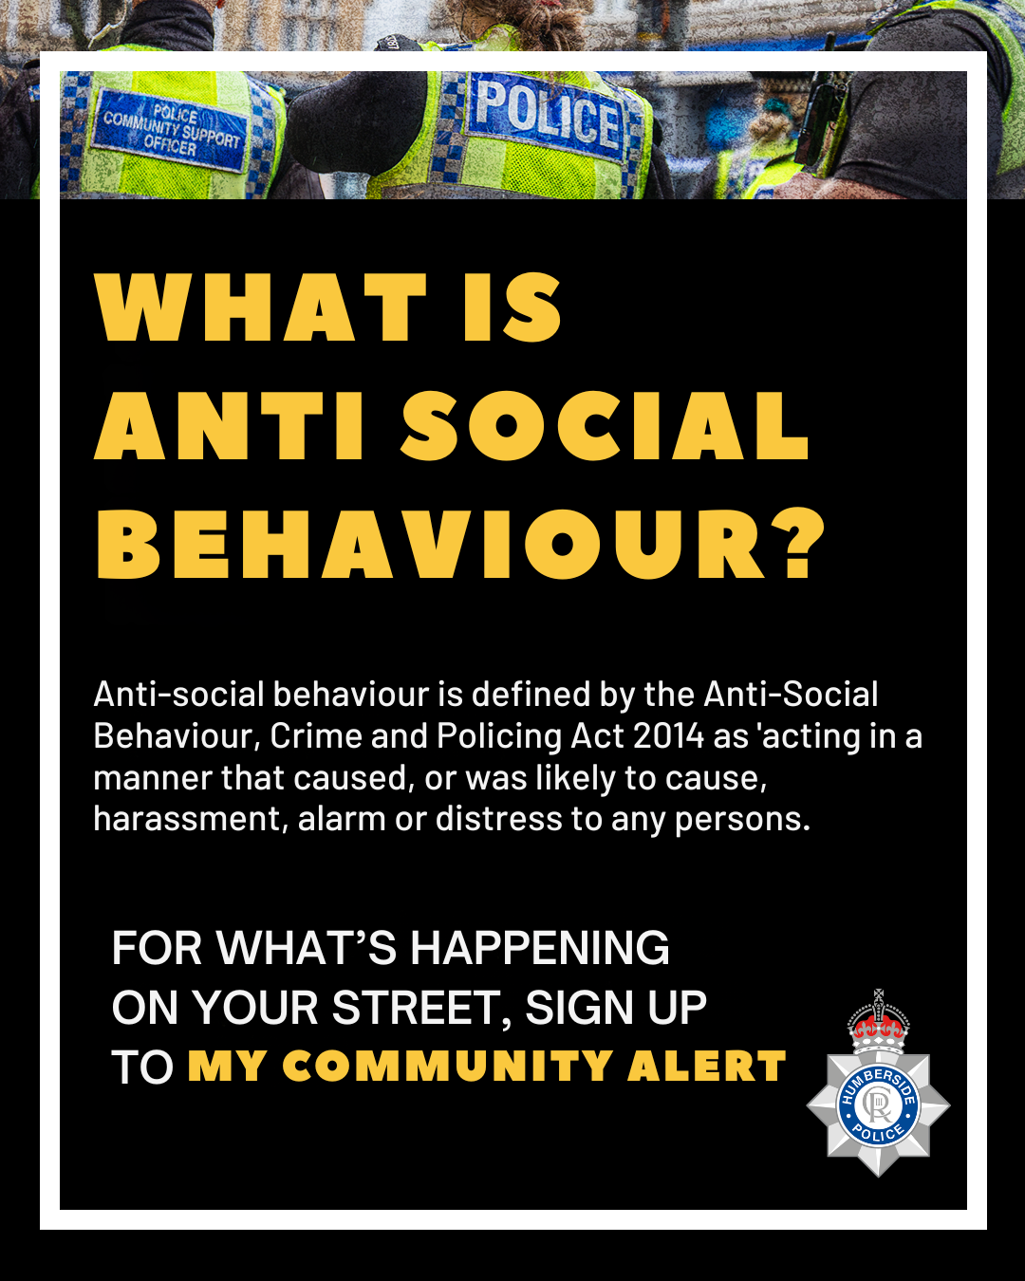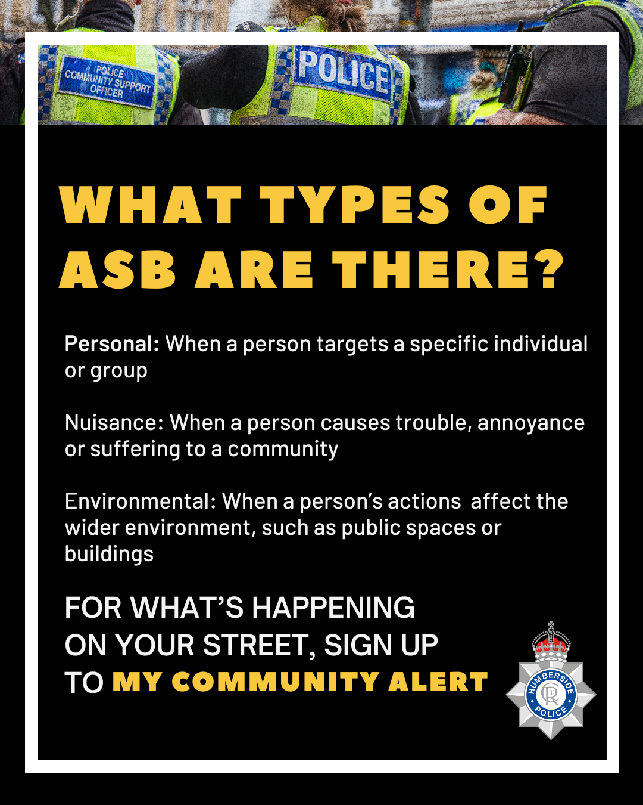
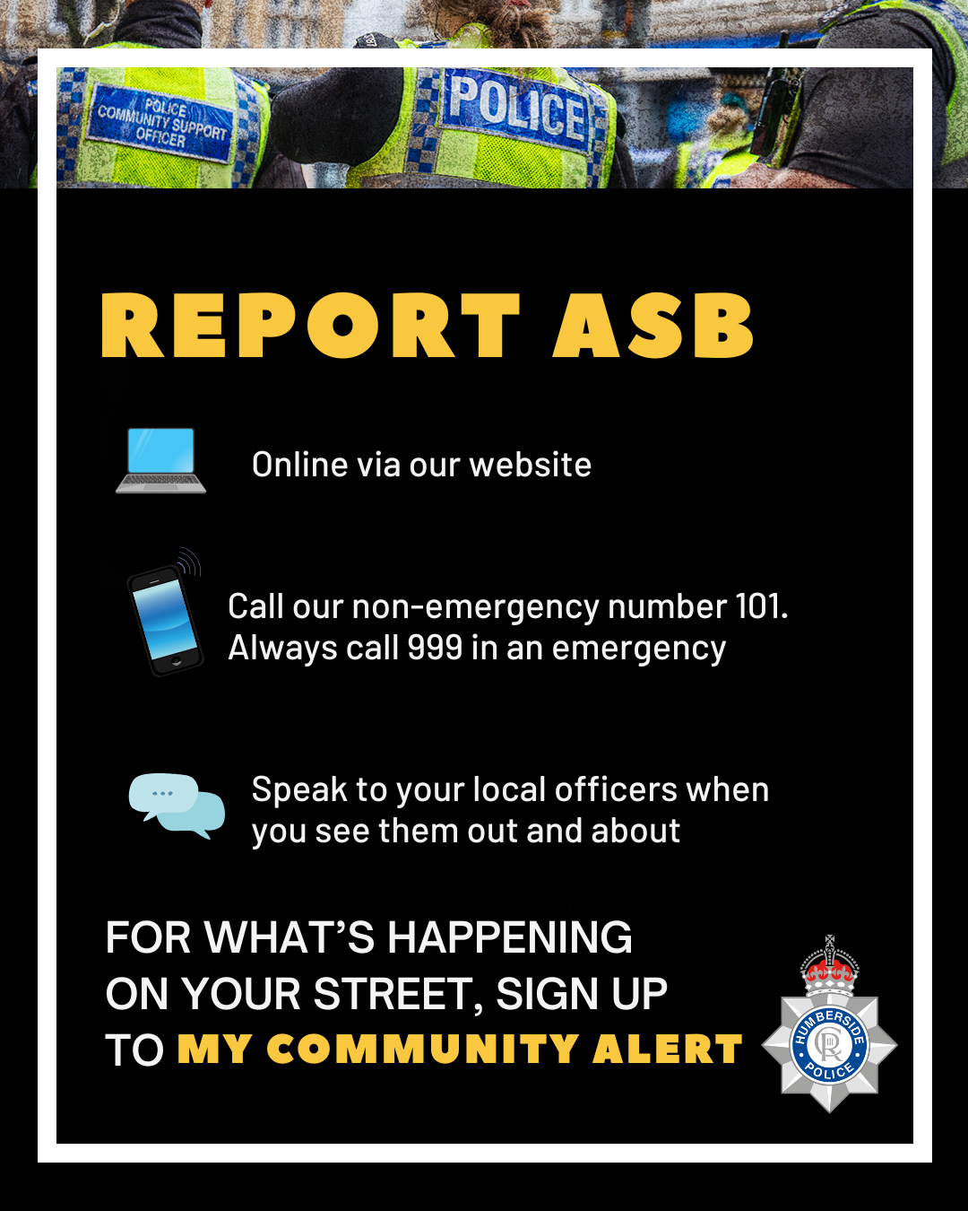
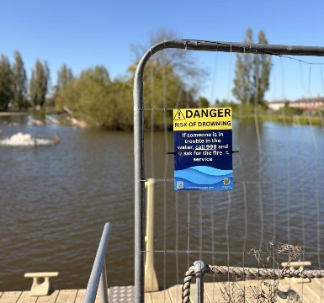
Working with partner agencies to reduce drowning and serious injuries. The Humber region is dominated by a long stretch of coastline and a large tidal river splitting it in two. Follow our advice to stay safe in and around water, whether it be the sea, a lake, a river, or a reservoir:
- Obey any warning and safety signs
- If you are going out on your own, let someone know where you are going and when you are coming back
- Look out for trip or slip hazards around water and stick to proper pathways
- Remember riverbanks and cliff edges may be unstable and give way

What to do if someone falls into deep water

If you see someone struggling in the water, never jump in yourself. Instead, remember these steps to save a life:
- Phone: Dial 999 immediately
- Float: Tell the person in the water to stay calm and float on their back
- Throw: Give them rescue equipment or anything that floats
Use What3Words app to help emergency services find you. The app helps to pinpoint your location within a 3m square using a unique three-word address. This helps 999 call handlers to pass on your location to our firefighters and other emergency responders.

