Welcome to your Rutland North police e-newsletter. Here you will find all of the latest news from a Rutland North policing perspective.
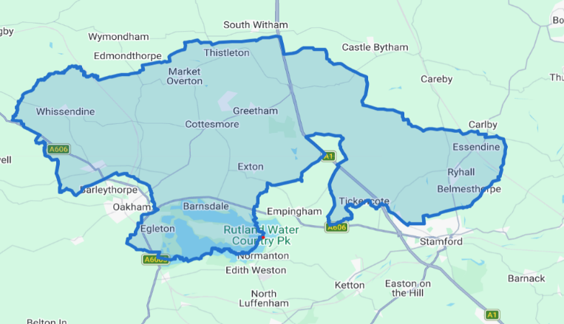
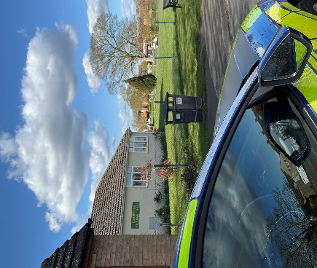

What matters to you

We have listened to you and the concerns you have raised through surveys, community consultations and analysing crime trends.

Rutland North Newsletter
May 2026 | PC Bland and PCSO Lyall
Using this data, we have created the following Oakham & Barleythorpe priorities that the Dedicated Neighbourhood Team will focus their efforts on:

Page 1

Rutland North Beat

Priority 1: Burglary You said: Burglary is a continuous issue on the Rutland North Beat
This past month, myself and PC Bland have been focused on tackling burglary through proactive patrols, targeted reassurance visits, and close engagement with the community. We have patrolled areas identified as higher risk, carried out door-to-door enquiries following incidents, and provided crime prevention advice to residents to help secure their homes and belongings. We have also been gathering intelligence and working with partner agencies to identify and disrupt offenders. Our ongoing efforts aim to reduce burglary, prevent repeat incidents, and ensure residents feel safe and supported in their homes.Priority

Priority 3: Rural crime: You said: Reports of rural crime in and around Rutland North.
What We Have Done: This past month, myself and PC Bland have been addressing rural crime through targeted patrols in key areas and engagement with local farmers and landowners. We have gathered intelligence, acted on reported concerns, and provided crime prevention advice to help protect property, equipment, and livestock. Our continued work aims to deter offending and support the rural community.

2: Road Safety: You said: Speeding vehicles on the Rutland Safety Beat roads is a priority you want us to address, specifically the lack of adherence to 30mph zones.What We Have Done: This past month, myself and PC Bland have been working to improve road safety across the area through a combination of high-visibility patrols and proactive engagement with road users. We have focused on locations where concerns have been raised, addressing issues such as speeding, careless driving, and general road safety behaviour. Alongside enforcement activity where necessary, we have spoken with drivers and members of the public to promote safer habits and awareness. Our efforts aim to reduce risk on the roads, prevent collisions, and help keep the community safe.

Over the past month on the 36 beat, PC Bland and I have focused on strengthening community safety and visibility, with a particular highlight being our involvement in recent local events such as the village coffee morning and the community safety drop-in at the parish hall. These sessions allowed us to share crime-prevention advice, answer questions, and build trust with residents. Alongside this, increased foot patrols and targeted reassurance visits led to several valuable intelligence reports about suspicious activity, helping us identify a known offender travelling through the area, which was swiftly acted upon by colleagues. Feedback from residents has been overwhelmingly positive, with many commenting that our presence at community events has made them feel more connected to and supported by their local policing team.

4 Burglary related offences
1 reports of rural crime 2 report of road safety

May 2026

Rutland North Newsletter

Crime data for the last 30 days

In the last 30 day there have been:

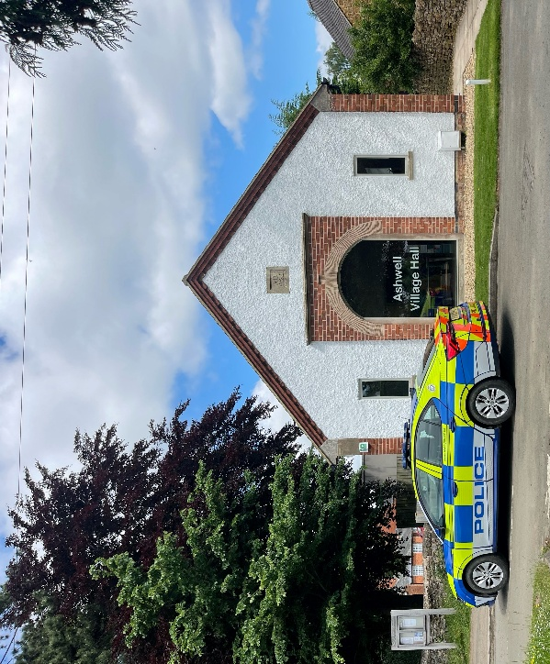
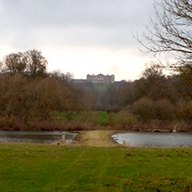

Community engagements—come along and meet the team!

14.06.3036 - 14:30- Ashwell village hall beat surgery

