
E- E-Scooter Enforcement and Nuisance Vehicle Patrols

Get the latest crime statistics
by
v
isiting:

www.kent.police.uk/yourare
a

Beltinge & Reculver

Ward

newsletter

September
202666

.

Here is your monthly update on the work carried out across the wards of Beltinge and Reculver over the past few weeks. Thank you to all residents who continue to report concerns and support our policing efforts. Your information helps us target issues effectively and keep our community safe.

Tackling anti-social use of vehicles remains a priority within the ward, and my colleagues and I have continued to respond to concerns raised by residents regarding e-scooters and nuisance driving.

Over the past month:

- I have been speaking with residents and gathering information and intelligence, which have proved invaluable in identifying those responsible and helping to tackle the ongoing nuisance caused by anti-social e-scooter use.

- Following numerous reports from residents regarding nuisance e-scooters, my colleagues and I carried out targeted patrols within the Hillborough Estate and surrounding areas to address the dangerous and anti-social use of e-scooters.

- During one proactive stop, three youths were found to be riding e-scooters whilst wearing face coverings. As a result, all three e-scooters were removed from use.

Update from E-Scooter Stop

- We are pleased to report that since this enforcement action was taken, no further reports of anti-social e-scooter use have been received within the area.

- Although reports have reduced, nuisance vehicles and e-scooters will remain a neighbourhood policing priority, and I will continue to carry out patrols and act on any information received from the community.

- I would like to thank residents who have reported incidents and shared information with me. Community intelligence plays a vital role in helping us identify issues, target enforcement activity, and take positive action.

Nuisance Vehicles

- My colleagues and I responded to reports of a nuisance vehicle being driven in an anti-social manner within a local supermarket car park. Concerns were raised that an individual was sitting on the bonnet of the vehicle whilst it was being driven around the car park, creating a significant risk.

- Whilst the vehicle had left the location prior to our arrival, we carried out enquiries in the surrounding area and successfully located the vehicle nearby. Further actions were taken with the driver, and enquiries into the incident were progressed.

- We will continue to respond robustly to reports of dangerous driving, nuisance vehicles, and anti-social behaviour to help keep our communities safe.

Drug Use in a Residential Area

- I have also been speaking with residents regarding ongoing concerns about cannabis being smoked within a residential area.

- I have been working to establish the individual responsible. This remains an ongoing piece of work, and I am continuing to liaise with residents and partner agencies where appropriate to address the issue and take positive enforcement action.

Closing Comments

As we move into the autumn and holiday season, I would like to thank everyone who has taken the time to speak with me. Anti-social behaviour will remain a priority over the coming months, particularly during school holidays.

Your continued support and reporting help us keep our neighbourhoods safe, and it is greatly appreciated.

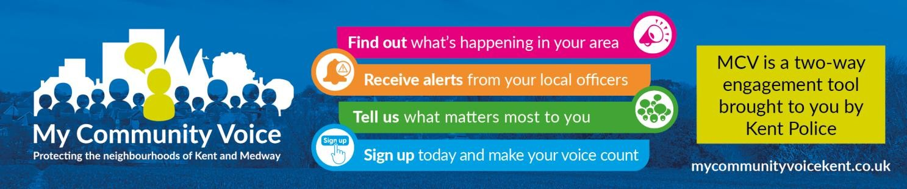
- Supporting our community: By working closely with residents, local partners, and community groups, we aim to build trust, improve safety, and create stronger relationships across the area. Whether it’s providing reassurance, acting on concerns, or helping vulnerable individuals access the support they need, our focus is on being visible, approachable, and proactive. Together, we can continue making our neighbourhood a safer and more positive place to live.

1

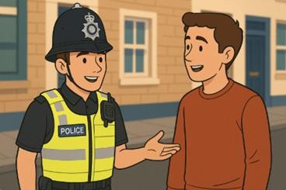
Community Engagement: We are committed to engaging with the Coastal Wards community. This includes holding regular community meetings, which are advertised via My Community Voice. We want to hear your concerns and work together to find solutions.

We are committed to keeping you informed. We publish this monthly newsletter and provide updates on local crime trends and the work we are doing to address these issues on My Community Voice.

2

Next month’s engagements:  - Tuesday 6th October 2026 @ 10:30 -12:00 – HatHats Coffee, Reculver, Ct6 6SS.  - Thursday 15th October 2026 @ 15:30 -17:00 – Costa Coffee, 6 The Boulevard, Herne Bay, CT6 6GZ. | Your local officer:  PC Jack Roy

