Mid Holderness Ward Newsletter – May 2026
Detailed crime and ASB data for your area can be obtained by visiting www.police.uk and following the ‘Find your Neighbourhood’ link.
Meet Your Community Police Team

Inspector Ian Foster Sergeant Mick McLaughlin PC Maria Adlington PCSO Darren Bainton
What’s happening in Your Area & Community Priorities?

43 crimes reported during April.
Humbertalking has set our priorities, this month we are to:
- Tackling Anti-Social Behaviour
- Improve Road Safety around our schools.
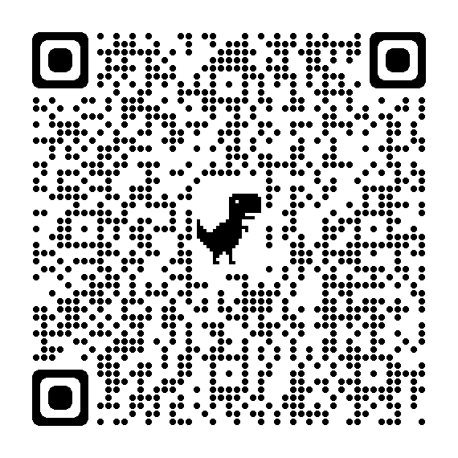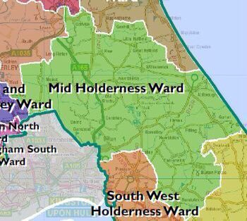
QR – please scan to visit our Community Team page.

Here’s a summary of crimes that have been reported across Mid Holderness last month:
Domestic Related incidents: (eleven investigations)
Domestic incident x3 Harassment x5, Assault x 1, Threats x1, sexually offence x1
Residential Burglary reports: (six investigations)
05/04/2026 entered via insecure kitchen window and remove vehicle keys from table and use to steal a VW Golf Main Street, SWINE
05/04/2026 entered insecure garage and open vehicle, nothing taken, Main Street, SWINE
05/04/2026 entered unoccupied property by smashing rear window, Crab Tree lane, OLD ELLERBY
16/04/2026 attempt burglary seen on CCTV door handle tried, no entry made, Elm Grove, ALDBROUGH
24/04/2026 entered unoccupied property by smashing rear window, Main Road, BILTON
26/04/2026 damage to door, no entry, nothing stolen, Skirlaugh Road, OLD ELLERBY
Business Burglary reports: (No reports)
Thefts: (four investigations)
13/04/2026 Theft Sproatley Rd, SPROATLEY – blue badge taken from vehicle.
18/04/2026 Theft A165, LONG RISTON – Make off without payment for fuel.
24/04/2026 Theft A165, LONG RISTON – Make off without payment for fuel.
26/04/2026 Theft Front Lane, ELSTRONWICK – theft of oil from church tank

Vehicle Crime: (one investigation)
05/04/2026 Theft Main Street, SWINE– theft of cash & tools from vehicle.
Damage: (four investigations)
07/04/2026 damage to bird scarer, Church Lane, BURSTWICK.
07/04/2026 damage to vehicle’s bodywork, Churchill Rise, BURSTWICK
20/04/2026 damage in unoccupied farm outbuildings– Main Road, BILTON
21/04/2026 damage to fence, Main Street, CATWICK
Public order x 2, Assault x 6, Harassment x2, Fraud x1, stalking x1, and 4x anti-social behaviour, attempt accosting x1 reported in April across the Mid Holderness ward area.
Humber-talking has set our priorities, this month we are to:
- Tackling Anti-Social Behaviour
We regularly deploy high visibility patrols to our communities in response to reports of criminal damage, drug dealing and anti-social behaviour.
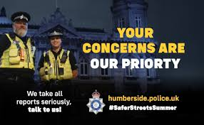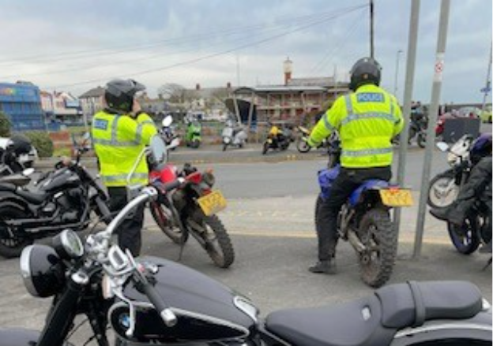
The local policing team have also had productive meetings with partners from East Riding Council, Parish Councils and Neighbourhood Watch groups to listen to community concerns.
Our officers are also committed to eradicating the harm that the illegal and anti-social use of off-road bikes cause to the communities through our Operation Yellowfin.
Action – aims to:
- Protect vulnerable residents
- Restore community confidence and create a safer environment
- Demonstrate the effectiveness of a partnership approach between with local partners.
Intended outcome:
- Reduce the number of ASB reports
- Increase residents’ confidence and feeling of safety
Anyone who wishes to report anti-social or criminal behaviour can contact The Police on 101 or East Riding of Yorkshire Council on 01482 393939
- Improve Road Safety – around our schools.
As with most other areas, road safety is something in which we can improve upon in our rural communities. Action –
- As we enter the spring months, members of the Holderness Policing Team will continue to be out and about policing our roads to promote safe behaviour and enforcement of traffic laws.
- Officers will continue to support Bilton & Aldbrough Primary Schools to reduce traffic in the villages and encourage families to walk or cycle to school.
Intended outcome:
The intended outcomes are to:
- Education & awareness campaigns to reduce the number of casualties on our roads.
- Create a culture of road safety where individuals understand and practices safe behaviours.
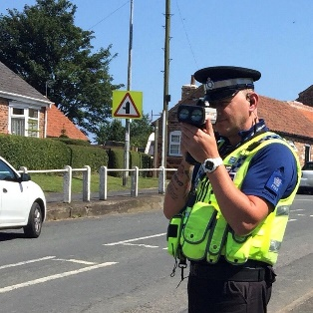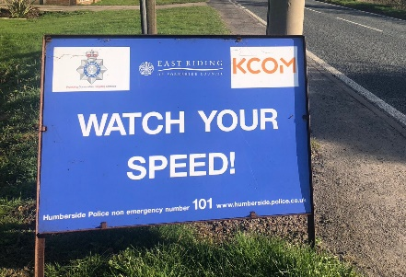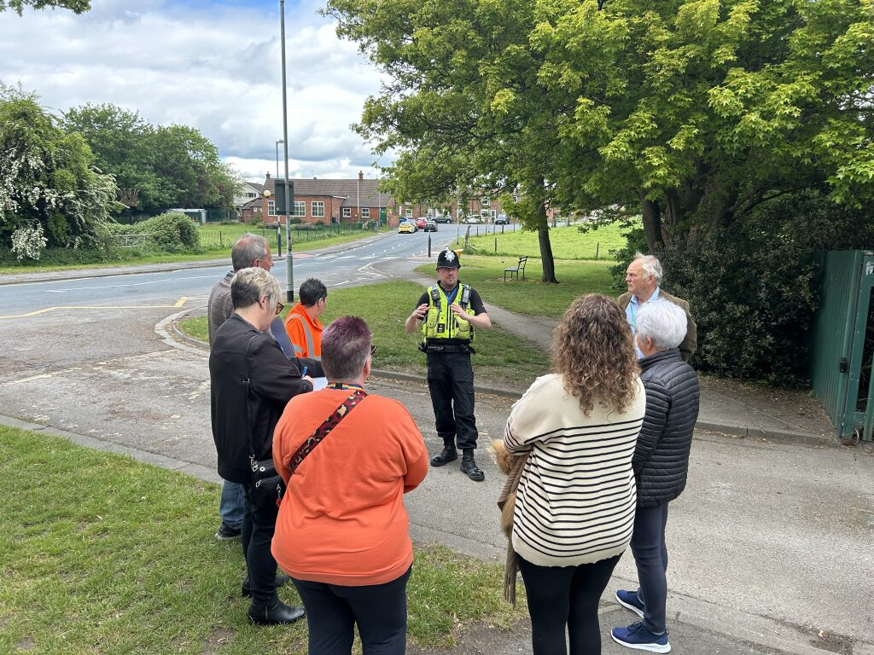
With the return of all children to our primary schools after the Holidays, the Community Team will be conducting patrols around the schools making sure that the roads are safe for everyone especial for our young members outside the schools’ gates.

One of the regular features of covering a seaside area on the East Coast is the arrival of residents to our touring caravan sites.

In the run up to the Bank Holidays of the year, now is a good time for static caravan owners out there to consider your security and personal safety.

Think about the house in which you live when you’re not up at the coast:

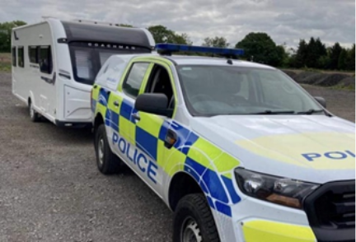
- Do you make sure your doors and windows are secure?
- Do you make sure you have decent locks on them?
- Do you lock your windows and doors when you go out?
- Do you ensure that valuables are not on open view in your home, particularly when you’re away?
If you’ve answered “Yes” to these four questions, now ask yourself:

Do I do the same at my static caravan?

Remember, the same rules apply to caravans as houses and cars: basically, don't leave items on display as they encourage opportunist thieves. Consider nets or blinds, or if you don't like these, simply make sure everything gets put out of view when you leave your caravan. So many people get their caravans entered and items stolen simply because items are left on open display. Never leave credit cards, wallets or money in them. Just like with a car, you're making your property an easy target if you do. Mark up your property with your postcode (Pens are available at Police stations) and never leave doors or windows insecure.

But, think about your personal safety too:

- Have you got a smoke alarm in your caravan?
- Do you ensure that your keys are readily available should you need to get out in a hurry?
- Do you have a fire escape plan?

This could save your life!

Our colleagues in the Fire Service are happy to advise you here. If in doubt, do seek advice from them. Their website is www.humbersidefire.gov.uk .

So have fun as you enjoy our coast this summer but think about your security and make sure you don’t let the thief take advantage. And remember your safety too!
Protect your home during the warm weather:
We are seeing the return of the warmer weather, and with that, there is the opportunity to open your windows to let some fresh air into your home.
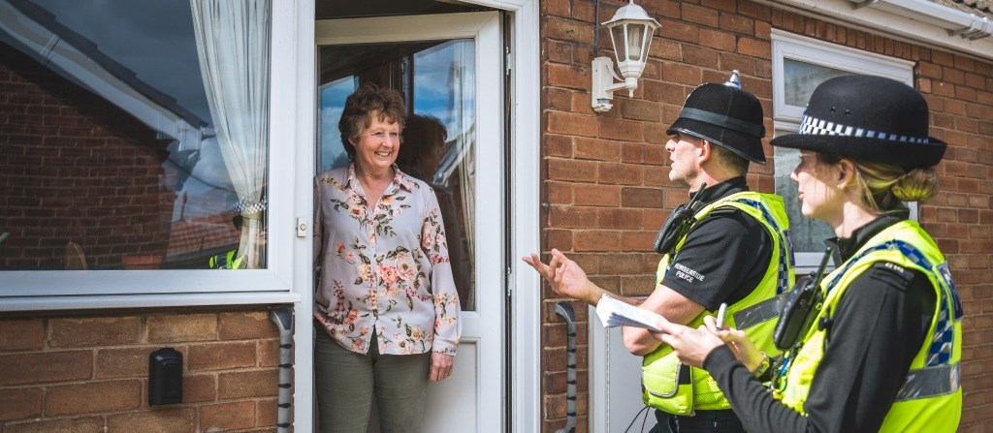
Whilst I don't want to stop you from doing that, this is just a reminder that 1 in 3 burglaries within Humberside are committed where the burglar has gained entry through an open window or an unlocked door.
So, by closing windows that someone could climb through when you aren't in a room, and by locking your doors, you will make your home less of an easy target to an opportunist burglar.

Further crime prevention advice can be found on the Secured by Design website https://www.securedbydesign.com/

Meet 'Bobbi': Helping you access non-emergency advice online
Ever had a non-emergency question and weren’t sure who to ask or how to get in touch with us?
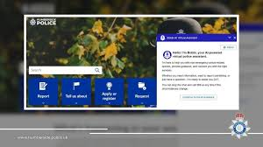
We introduced Bobbi, our AI virtual assistant, designed to answer frequently asked, non-emergency questions that would normally come into our Force Control Room and be handled by a call handler.
Alongside our existing ways of contacting us, including online forms, telephone lines and front counters, Bobbi provides an additional option, giving people 24/7 access to advice and information.
Bobbi interacts in a conversational way but is fully automated, using trusted policing information to offer guidance or direct you to the right place for a wide range of topics. This is the same information used by our call handlers and has been developed with input from partner forces also trialling the system.
If Bobbi can’t answer your question, or you need to speak to someone, you will always be transferred to a member of our team.
You can find Bobbi on our website at the bottom right corner of your screen, just click on the speech bubble and ask your non-emergency question.

How you can help
Your local Neighbourhood Policing Team appreciates the importance of being in the right place, at the right time, for the right reasons to reassure the public, improve public confidence and reduce crime and anti-social behaviour in the area in which we all live and work.
We encourage all residents to call and report any issues where they live so that we can deal with any issues and step up our patrols in that area.
If you feel that there are other issues affecting you or your local community that should be given priority, please inform your local councillors or your Neighbourhood Policing Team.
News and Appeals - Please visit our website www.humberside.police.uk for the latest news & appeals
FACEBOOK users did you know? You can find out more about the work of your local officers and teams by liking their Facebook accounts: Please visit Humberside Police – East Riding of Yorkshire South www.facebook.com/HumberbeatERYS
Twitter (X) users can keep up to date with events, alerts and traffic news within Mid Holderness by following the community team @HumberbeatERYS and @PCSODarrenB
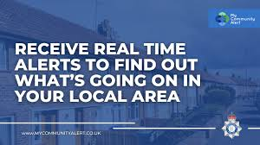 My Community Alert – Sign up for free
Engagements: In May 2026, the dates and locations are as follows:
5th- Tuesday 7pm East Garton Parish Council, Village Hall, ALDBROUGH
9th- Saturday 11:30am Coffee morning @the Village Hall, Swine Lane, CONISTON
9th- Saturday 12:30pm Cuppa with the Parish @the Village Hall, Main Street, Wawne
26th- Tuesday 7:30pm Burstwick Parish Council, Village Hall, BURSTWICK
27th- Wednesday 7pm Riston Parish Council, Village Hall, LONG RISTON
30th- Saturday 11:30am Coffee morning @the Village Hall, Swine Lane, CONISTON
Schools will be visited during the morning and afternoon commute.

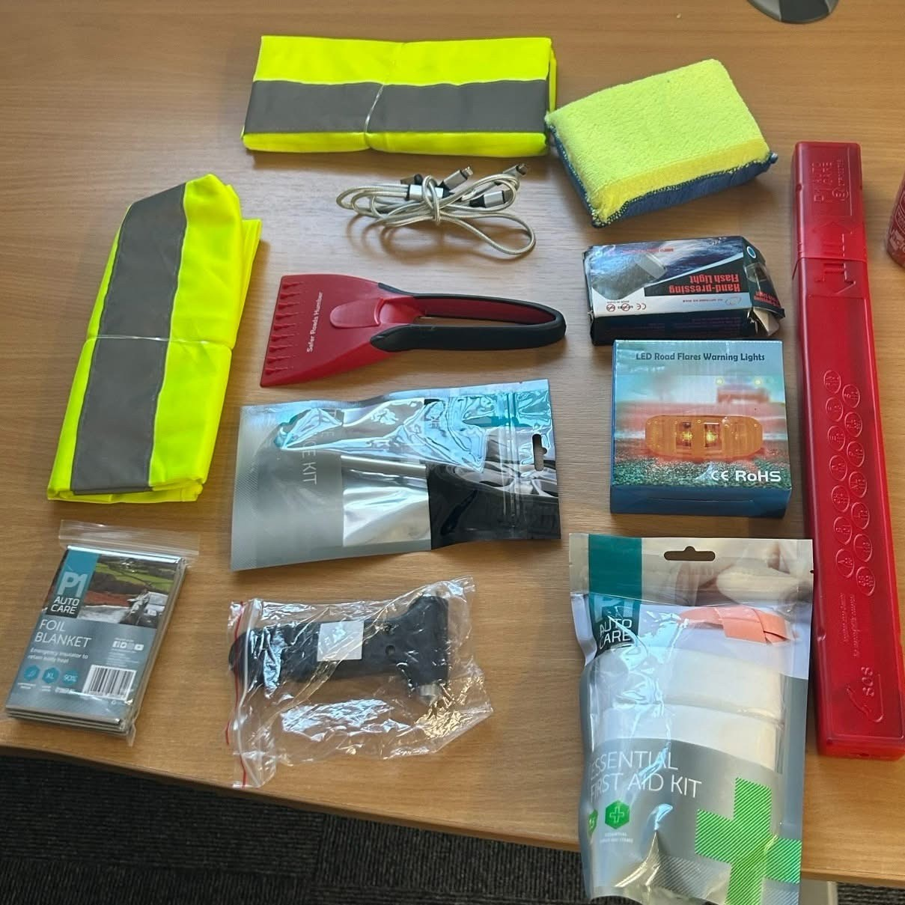
🚗 Heading out this Bank Holiday? How prepared are you if you break down?

Our Road Safety Team has pulled together a vehicle kit to help keep you safe on the roadside - could you tick all of these off?
✅ High-vis vests
✅ First aid kit
✅ Foil blanket or a spare blanket
✅ Windscreen clearing sponge/scraper
✅ Phone chargers
✅ Tyre tread depth gauge
✅ Warning triangle
As well as making sure you have food and drink.

Heading further afield or travelling after dark? Don’t forget:
✅ Spare screenwash
✅ Torch (check it’s working!) – essential at night or in poor visibility

🚨 Why it matters:
Breaking down can be stressful and having the right kit means you can:
✔️ Be seen by other drivers
✔️ Stay warm and protected
✔️ Get help quickly

A little preparation goes a long way in keeping you and your passengers safe.

👉 Before you set off this Bank Holiday, take a few minutes to check what you’ve got in your car.

We hope you all have a safe Bank Holiday long weekends, a lovely opportunity to spend some well-deserved family time; Key Springtime Safety Messages from Police:

- Road Safety & Traffic: As weather warms, police remind drivers to watch for increased pedestrians, cyclists, and motorcyclists. Drivers are urged to slow down, share the road, and avoid distractions.
- Property Security: Spring is a prime time for burglary. Residents are encouraged to secure homes, sheds, and gardens, with tools like "Immobilise" recommended to register property and deter theft.
- Livestock Protection: Rural police advise dog walkers to keep dogs on leads near livestock, as spring brings vulnerable lambs and calves.
- Scam Alerts: Authorities warn of "springtime scams," particularly bogus HMRC tax refund messages (texts/emails) targeting taxpayers.
- Community Engagement: Increase our time to conduct Humbertalking, Community Officers discuss local issues like anti-social behaviour

Darren
PCSO Darren Bainton



