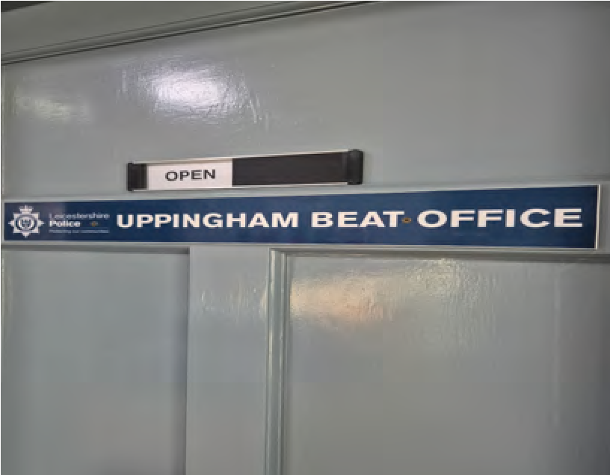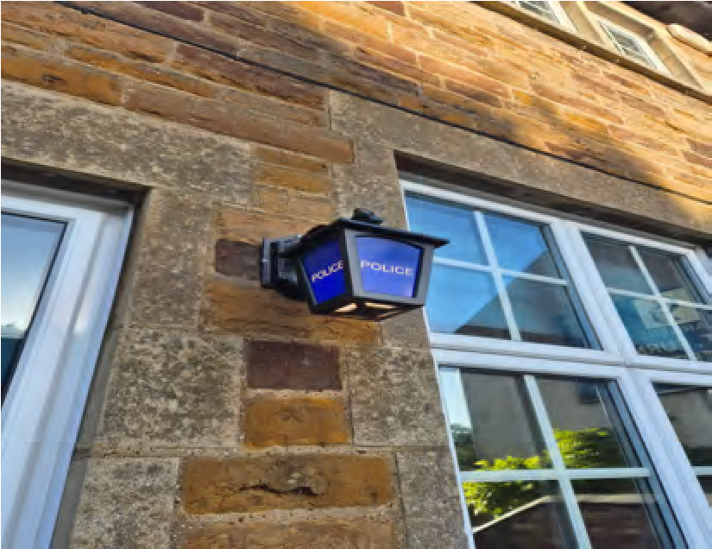
Welcome to your
Uppingham
police e
-
newsletter.
What matters to you

We have listened to you and the concerns you have raised through surveys, community consultations and analysing crime trends. Using this data, we have created the following Uppingham Town priorities that the Dedicated Neighbourhood Team will focus their efforts on:
Road Safety:
You said: Speeding vehicles on Rutland roads is a priority you want us to address, specifically the lack of adherence to 30mph zones.
What we are going to do: We will complete high visibility patrols of hotpot areas with partner agencies and deal proactively with offenders with a view to providing suitable advice or action where required.
Drugs:
You Said: Drug dealing as well as drug use in the area.
What we are going to do: Develop our intelligence picture around those who commit this type of crime so we that we can effectively target our resources in the right areas, at the right time, with the aim of deterring, disrupting and bringing offenders to justice.
Anti-Social Behaviour:
You said: Specific issues of Anti-Social Behaviour (ASB) concerning individuals in the community, ‘nuisance neighbours’ and irresponsible dog ownership / walking is an area you want us to focus on.
What we are going to do: Throughout July, the team carried out regular high-visibility patrols in areas identified as road safety concerns, using marked police vehicles and targeted enforcement activity to deter offending. Officers conducted numerous vehicle stops and document checks, taking robust action where offences were identified. This work resulted in traffic offence reports being issued, vehicles being seized where appropriate, and intelligence being submitted to support wider policing activity.

Neighbourhood Link
We continue to encourage local residents to have their say through Neighbourhood Link surveys, our aim is to keep all residents that have signed up to this aware of issues happening in Rutland.
Our policing priorities are set every quarter following returns of Neighbourhood Link surveys, along with crime pattern analysis data and issues highlighted by of our professional partners.
The more results we have from surveys, the better informed we are as to where to target resources.
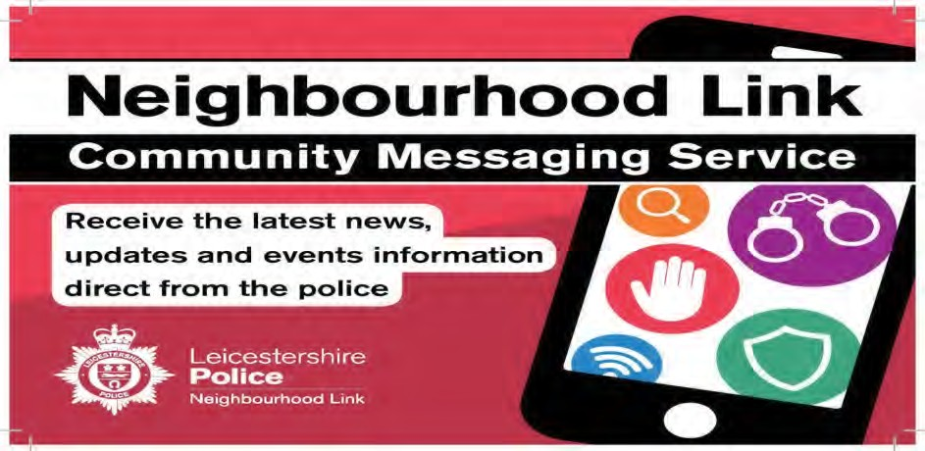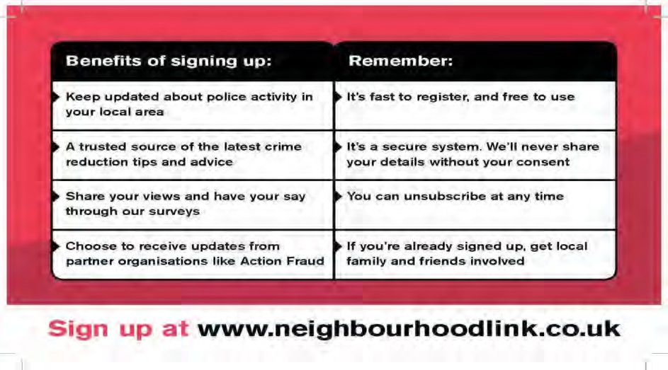
Uppingham Newsletter

Newsletter

Crime trends and Prevention advice
Throughout July, the Uppingham Team has been proactively tackling reports of anti-social behaviour across Uppingham and the surrounding villages. Through targeted patrols in identified hotspot locations, engagement with local residents, and partnership working with local agencies and businesses, officers have taken positive action to address community concerns and prevent issues from escalating.
Intelligence gathered during patrols and community engagement has been submitted to support ongoing investigations and assist in identifying those responsible for anti-social behaviour. The team has also maintained a visible presence in areas of concern, providing reassurance to residents and responding to reported incidents.
We understand the impact that anti-social behaviour can have on local communities and remain committed to addressing issues that affect residents, businesses, and visitors. We encourage anyone who witnesses or experiences anti-social behaviour to report it to the police, as the information provided helps us build our intelligence picture, direct patrols effectively, and take action against those responsible. By working together, we can continue to keep Uppingham and the surrounding villages safe and welcoming places to live, work, and visit.

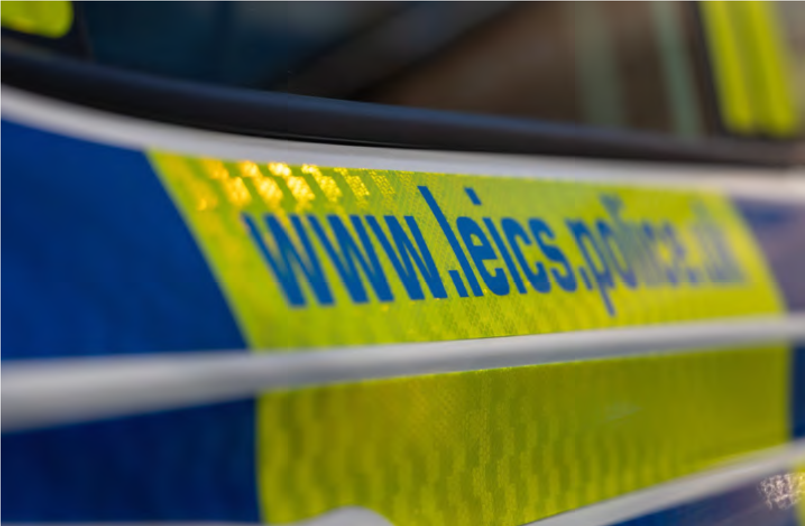

Uppingham Newsletter

