FRIENDS AGAINST SCAMS
Scams affect the lives of millions of people across the UK
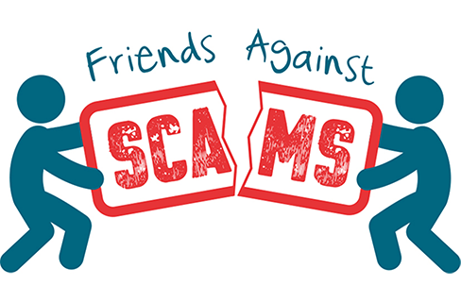
FRIENDS AGAINST SCAMS is a National Trading Standards initiative which aims to Protect & Prevent people becoming scam victims by empowering communities to spread the message & become a ‘Friend Against Scams’
Want to know more?
Drop by Wednesfield Market, High Street, Wednesfield
on Friday 4th September between 10.00am – 12:00
- Public Protection Officer Heather along with Officers from Heath Town & Wednesfield Neighbourhood Police will be available to offer tips & advice on how to stay safe, along with current scams; doorstep callers, postal, telephone & on-line scams; including those too good to be true offers tempting us to part with our cash.

- FREE Information packs on ways to stay scam savvy. FREE Information about Crime Prevention.


