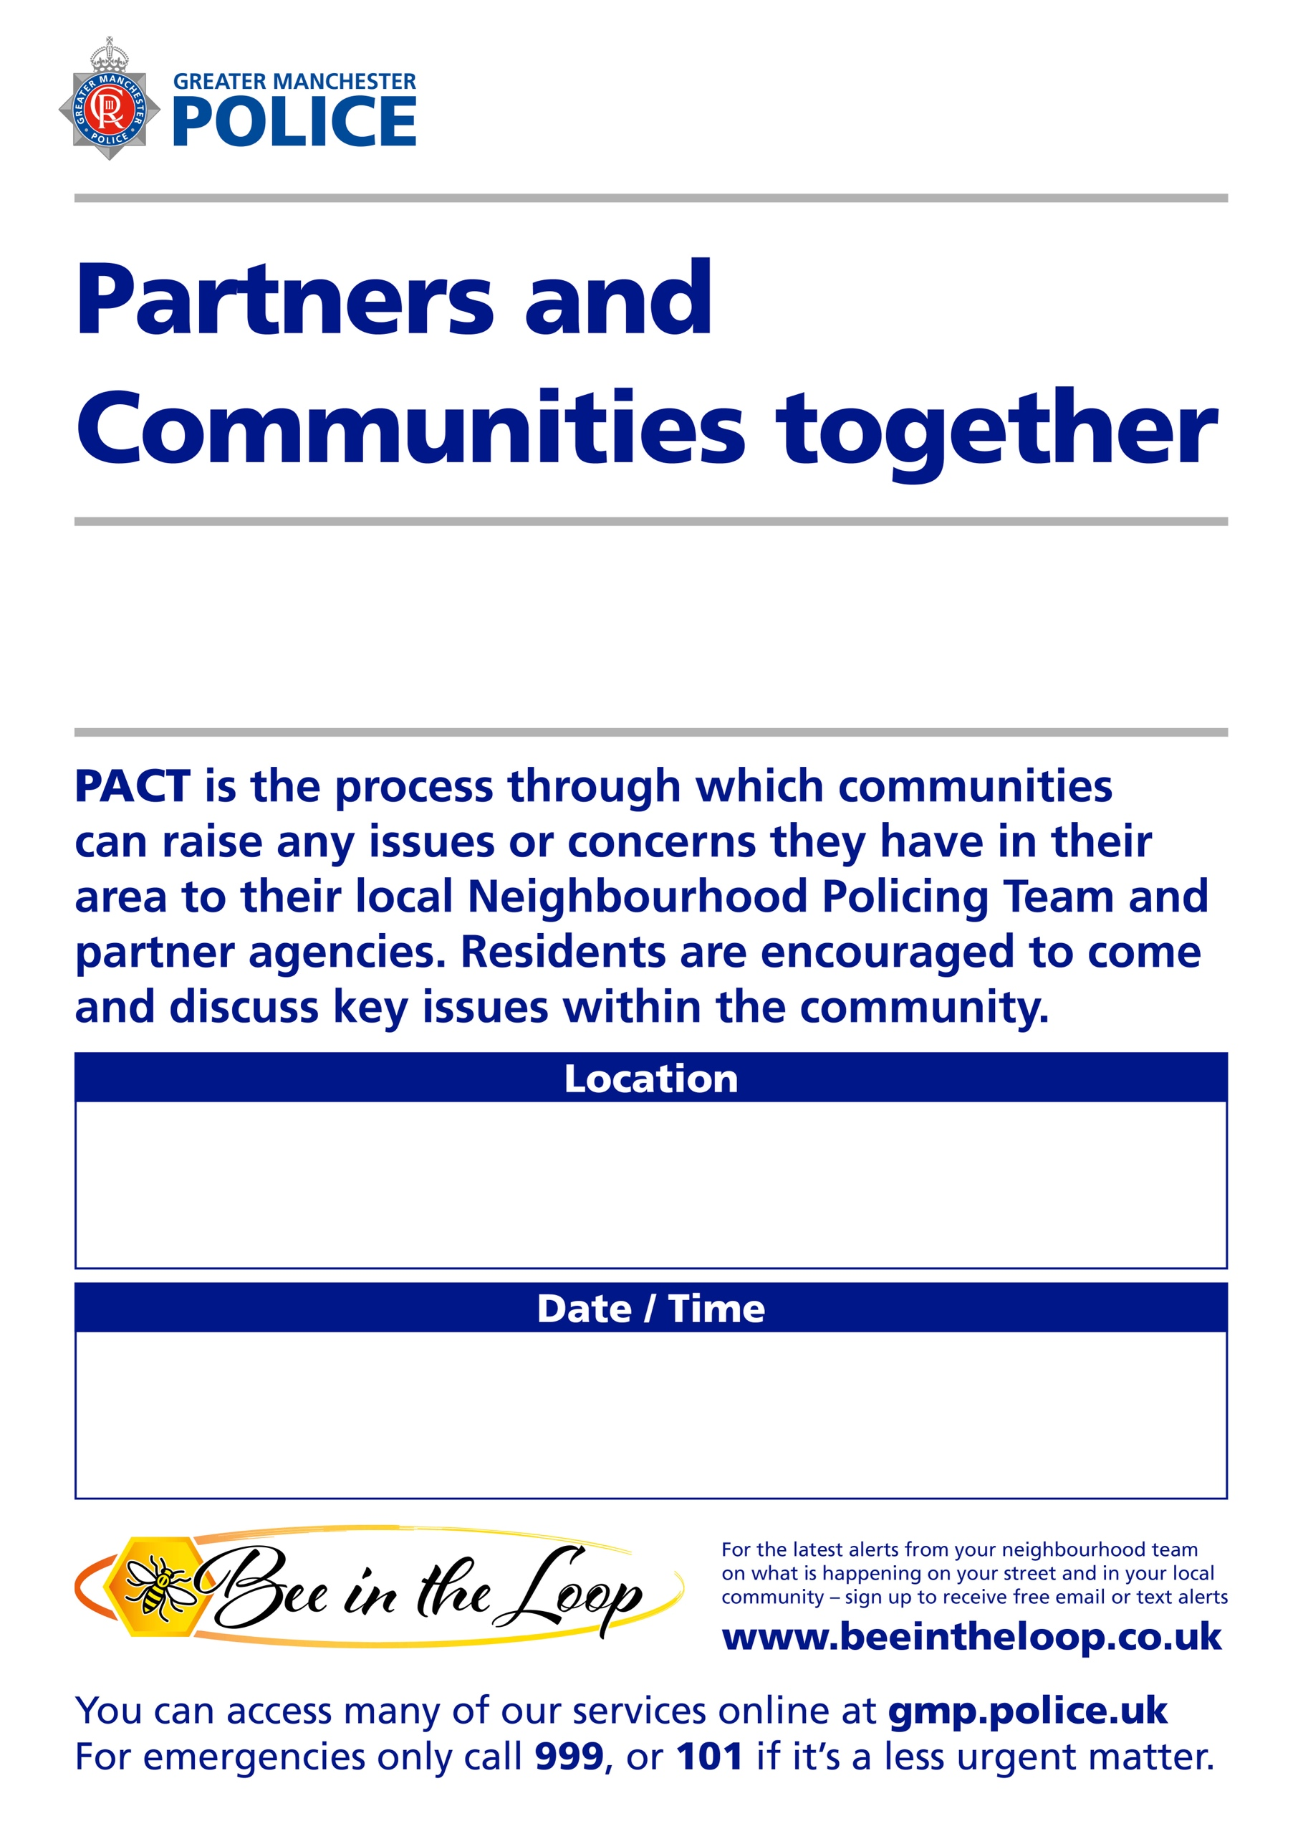
Friday 4th September at 13:00
Reddish
Re:dish, 2 Gorton Road, Reddish, SK5 6AE

