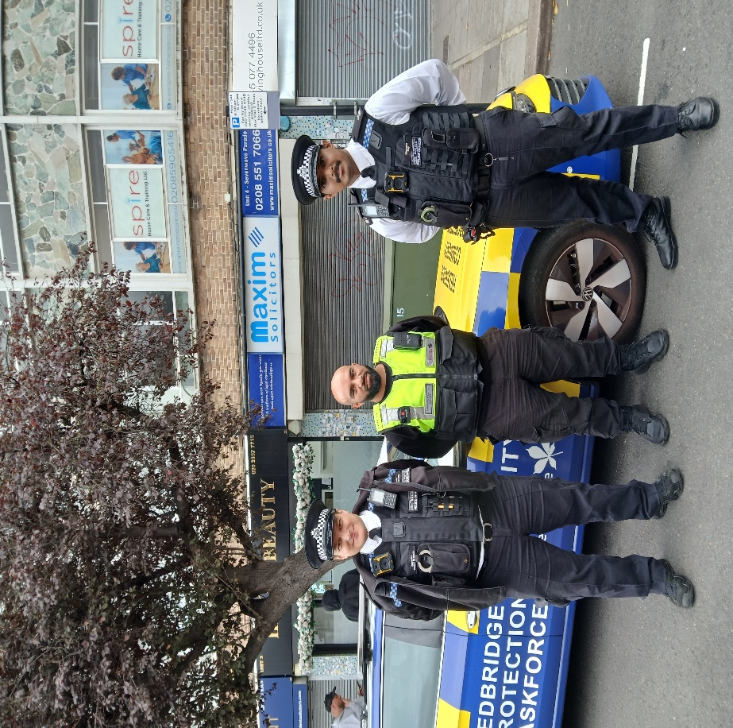
Barkingside SNT would like to invite residents to the following
30th November,VAWG, Violence against women’s and girls’ safety Walk talk and do, meeting point outside Black Moon bar, Seven ways Parade, IG2 6JX,4-5pm
.

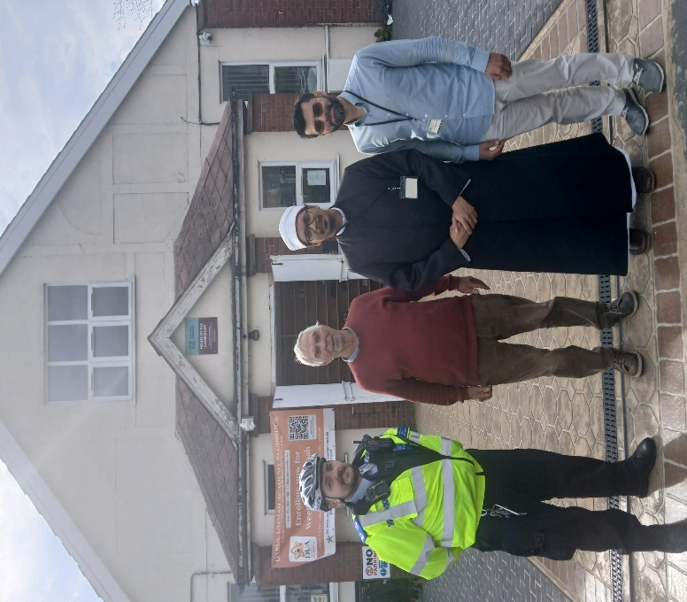
Barkingside SNT
PS383EA Catherine Brindley McEvoy, PC 1940EA Omar PEREIRA, PC1441EA Dean TITCOMBE, PCSO Martin KADLUBIEC 7005EA
Please sign up to new police platform met Engagement www.metengage.co.uk
@MPSbarkingside Twitter(X) account is no longer in use
@MPSRedbridge Twitter (X) account is still in use



Ward events
Some of what we been up to……
www.met.police.uk
Mobile - 07917013339
101 in non-emergency – 999 in emergency
- Reassurance patrols @ Little Gearies ,Inglehurst Garden.
- Gaysham Avenue
- Stop and search
- Arrest enquiries
- Ward priorities patrols
- VAWG walk, talks and due.
- Targeted shoplifting at Gants Hill
- Promoting new met Engagement platform
- Get in touch www.metengage.co.uk
Mobile - 0208 721 2567
Crime stoppers call anonymously – 0800 555 111
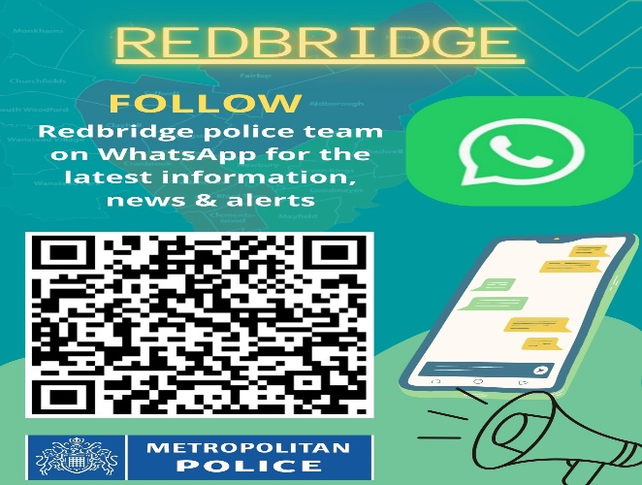

November 2026
Redbridge WhatsApp

We listened and have upped our foot patrols in Barkingside
BARKINGSIDE SNT – NEWSLETTER- November 2026
Barkingside Ward Newsletter
November 2026 Community Update
Dear Residents,
The Barkingside Safer Neighbourhood Team (SNT) continues to work closely with residents, local businesses, faith groups, schools and partner agencies to keep our community safe. We remain committed to visible policing, crime prevention, safeguarding and addressing the issues that matter most to our residents.

Community Protection Warning Issued for Persistent ASB Offender
Working in partnership with Redbridge Council Enforcement Officers, Barkingside SNT has taken action against a prolific offender responsible for repeated anti-social behaviour and begging across the borough, particularly within the Barkingside and Clayhall wards.
As a result of joint partnership working and ongoing evidence gathering, a Community Protection Warning (CPW) was issued. This warning forms part of a wider approach to tackling behaviour that negatively impacts local residents, businesses and visitors.
We will continue to work with our partners to address anti-social behaviour and ensure that Barkingside remains a safe and welcoming place for everyone.

High Visibility and Reassurance Patrols
Officers have continued conducting high-visibility patrols throughout Barkingside Ward at various times of the day and evening. Recent patrol locations have included:
- Gants Hill
- Gaysham Avenue
- Inglehurst Garden
- Crombie Close
- Longwood Gardens
- Eastern Avenue
- Cranbrook Road
- Woodford Avenue
- Little Gearies

These patrols help deter crime and anti-social behaviour, provide reassurance to residents and allow officers to engage directly with members of the community. Patrol locations continue to be informed by intelligence, community feedback and ward priorities.

Engagement with Local Faith Communities
Barkingside SNT recently attended an open day at a local mosque, providing an excellent opportunity to engage with members of the community and local faith leaders.
During the event, officers discussed local ward priorities, listened to community concerns and delivered a personal safety presentation. The event provided valuable opportunities to strengthen relationships, build trust and provide reassurance to attendees.
The engagement was very well received by the Imam and members of the congregation. We would also like to thank Ward Chair Michael for attending and supporting the event.
Maintaining strong partnerships with all faith communities remains an important priority for Barkingside SNT.

Violence Against Women and Girls (VAWG)
As part of our ongoing commitment to tackling Violence Against Women and Girls, Barkingside SNT continues to support and promote Walk, Talk and Do initiatives across the ward.
These events give residents the opportunity to identify locations where they feel unsafe and discuss practical measures that can improve community safety. We encourage residents to participate and share their views to help shape future policing activity.
Further details can be found at:
www.met.police.uk

Community Reassurance and Crime Prevention
Officers continue to provide crime prevention advice across the ward, including guidance on vehicle security, burglary prevention and reporting suspicious activity.
Residents are reminded to:
- Lock vehicles and remove valuables from sight.
- Consider using steering wheel locks and signal-blocking pouches for keyless vehicles.
- Ensure doors and windows are secured when leaving home.
- Report suspicious activity promptly.
Community information and intelligence remain essential in helping us identify issues and target resources effectively.

Coffee with a Copper
Barkingside SNT hosted a Coffee with a Copper engagement event at Barkingside Methodist Church, providing residents with an opportunity to meet their local officers, discuss concerns and receive crime prevention advice in an informal setting.
The event was well attended and allowed officers to hear directly from residents about issues affecting the local community, while also providing updates on current policing priorities and ongoing work across the ward.
We would like to extend our sincere thanks to the Barkingside Ward Councillors for attending and supporting the event, as well as to the staff and volunteers at Barkingside Methodist Church for hosting us.
Community engagement events such as these are invaluable in helping us build stronger relationships with residents and ensuring that local concerns continue to shape neighbourhood policing priorities.

Working Together
Information provided by residents continues to help shape local policing priorities. We remain committed to taking concerns seriously and responding appropriately to issues affecting our community.
Thank you to everyone who continues to engage with us and support local policing initiatives.

Tackling Street Drinking and Anti-Social Behaviour
Barkingside SNT continues to work collaboratively with Redbridge Enforcement Officers (REO) to address street drinking and associated anti-social behaviour within the ward.
Particular attention is being given to the Gants Hill area, where a Public Spaces Protection Order (PSPO) is in place. Officers from both agencies regularly conduct joint patrols and engage with individuals involved in street drinking to improve the safety and environment of public spaces.
Where appropriate, enforcement action will be taken, including the issuing of Fixed Penalty Notices (FPNs) for breaches of the PSPO. Our aim is to reduce anti-social behaviour, improve community confidence and ensure public spaces remain welcoming and accessible for residents, businesses and visitors.
We would like to thank residents for continuing to report incidents and provide information, which helps us identify hotspots and target our patrols effectively.

Community Message
As we approach Bonfire Night, we would like to wish everyone celebrating a safe and enjoyable evening with family and friends.
If attending firework displays, please do so responsibly, follow safety guidance and be considerate of your neighbours, elderly residents, young children and pets who may be affected by loud noises.
By celebrating safely and respectfully, we can ensure that everyone is able to enjoy the occasion while helping to keep our community safe.
Best wishes,
Barkingside Safer Neighbourhood Team
Metropolitan Police Service

