Mid Holderness Ward Newsletter – June 2026
Detailed crime and ASB data for your area can be obtained by visiting www.police.uk and following the ‘Find your Neighbourhood’ link.
Meet Your Community Police Team

Inspector Ian Foster Sergeant Mick McLaughlin PC Maria Adlington PCSO Darren Bainton
What’s happening in Your Area & Community Priorities?

52 crimes reported during May.
Humbertalking has set our priorities, this month we are to:
- Tackling Anti-Social Behaviour
- Improve Road Safety around our schools.

QR – please scan to visit our Community Team page.

Here’s a summary of crimes that have been reported across Mid Holderness last month:
Domestic Related incidents: (seventeen investigations)
Domestic incident x4 Harassment x5, Assault x 5, Burglary x1, sexually offence x1, Damage x1
Residential Burglary reports: (two investigations)
15/05/2026 entered via patio door, remove medication & cash Churchill Avenue, BURSTWICK
19/05/2026 two bikes and tools taken from shed, Highfield Crescent, BILTON
Business Burglary reports: (No reports)
Thefts: (three investigations)
02/05/2026 Theft A165, LONG RISTON – Make off without payment for fuel.
03/05/2026 Theft A165, LONG RISTON – Make off without payment for fuel.
17/05/2026 Theft A165, LONG RISTON – Make off without payment for fuel.
Vehicle Crime: (no reports)
Damage: (six investigations)
02/05/2026 damage to window, Dorset Avenue, SKIRLAUGH.
04/05/2026 damage, Dorset Avenue, SKIRLAUGH
08/05/2026 damage to hedge St.Peter’s Walk, WAWNE
20/05/2026 damage to patio door, Dorset Avenue, SKIRLAUGH
26/05/2026 damage to windows, Lambwath Lane, NEW ELLERBY
28/05/2026 damage to garden ornament, Westlands Road, SPROATLEY
Public order x 2, Assault x 13, Harassment x2, Fraud x1, and 6x anti-social behaviour with motorbikes/e-bikes, reported in May across the Mid Holderness ward area.

Humber-talking has set our priorities; this month we are to:
- Tackling Anti-Social Behaviour
We regularly deploy high visibility patrols to our communities in response to reports of criminal damage, drug dealing and anti-social behaviour.
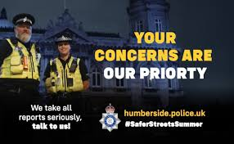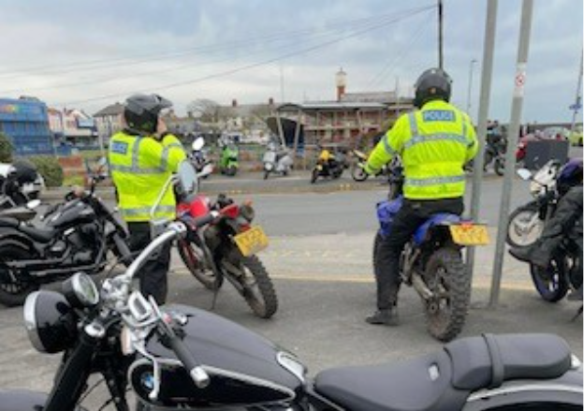
The local policing team have also had productive meetings with partners from East Riding Council, Parish Councils and Neighbourhood Watch groups to listen to community concerns.
Our officers are also committed to eradicating the harm that the illegal and anti-social use of off-road bikes cause to the communities through our Operation Yellowfin.
Action – aims to:
- Protect vulnerable residents
- Restore community confidence and create a safer environment
- Demonstrate the effectiveness of a partnership approach between with local partners.
Intended outcome:
- Reduce the number of ASB reports
- Increase residents’ confidence and feeling of safety
Anyone who wishes to report anti-social or criminal behaviour can contact The Police on 101 or East Riding of Yorkshire Council on 01482 393939

- Improve Road Safety – around our schools.
As with most other areas, road safety is something in which we can improve upon in our rural communities.

Action –
- As we enter the summer months, members of the Holderness Policing Team will continue to be out and about policing our roads to promote safe behaviour and enforcement of traffic laws.
- Officers will continue to support Bilton & Aldbrough Primary Schools to reduce traffic in the villages and encourage families to walk or cycle to school.
Intended outcome:
The intended outcomes are to:
- Education & awareness campaigns to reduce the number of casualties on our roads.
- Create a culture of road safety where individuals understand and practices safe behaviours.
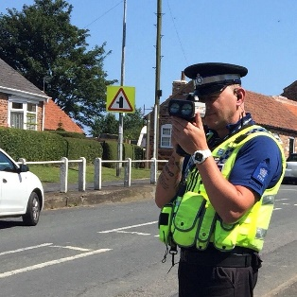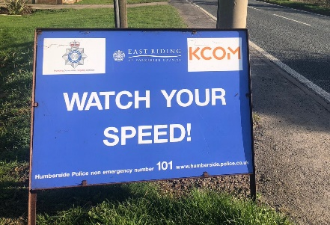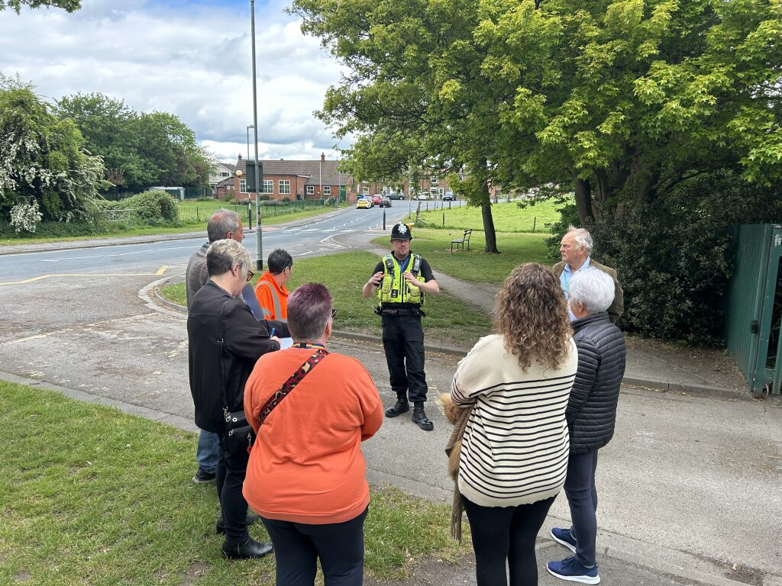
With the return of all children to our primary schools after the Holidays, the Community Team will be conducting patrols around the schools making sure that the roads are safe for everyone especial for our young members outside the schools’ gates.

Improving safety of our roads across Mid Holderness

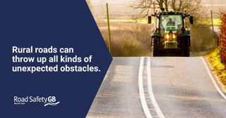 You’ve no idea what’s around the corner so slow down and give yourself time to react.

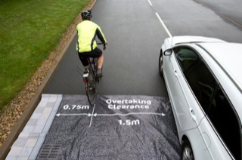
Be ready to meet cyclists and slow-moving vehicles when you least expect them on rural roads.

If you’re out for a country drive, look out for other road users. Don’t forget to “LOOK, LOOK & LOOK AGAIN” for those on two wheels.

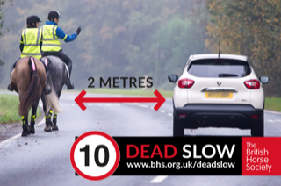 Remember to share the road and we ask drivers to look out for Walkers, Cyclists and Horse Riders – Give them plenty of room

How you can help
Your local Neighbourhood Policing Team appreciates the importance of being in the right place, at the right time, for the right reasons to reassure the public, improve public confidence and reduce crime and anti-social behaviour in the area in which we all live and work.
We encourage all residents to call and report any issues where they live so that we can deal with any issues and step up our patrols in that area.
If you feel that there are other issues affecting you or your local community that should be given priority, please inform your local councillors or your Neighbourhood Policing Team.
News and Appeals - Please visit our website www.humberside.police.uk for the latest news & appeals
FACEBOOK users did you know? You can find out more about the work of your local officers and teams by liking their Facebook accounts: Please visit Humberside Police – East Riding of Yorkshire South www.facebook.com/HumberbeatERYS
Twitter (X) users can keep up to date with events, alerts and traffic news within Mid Holderness by following the community team @HumberbeatERYS and @PCSODarrenB
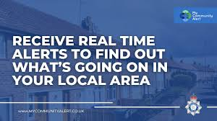 My Community Alert – Sign up for free
Engagements: In June 2026, the dates and locations are as follows:
10th- Wednesday 7pm Withernwick Parish Council, St.Albans Church, WITHERNWICK
20th- Saturday 11:30am Coffee morning @the Village Hall, Swine Lane, CONISTON
Schools will be visited during the morning and afternoon commute.

Humberside Police's longest-running youth event, and it's all about you! Since 1989, we've been supporting young people in making a positive impact in their communities each summer.
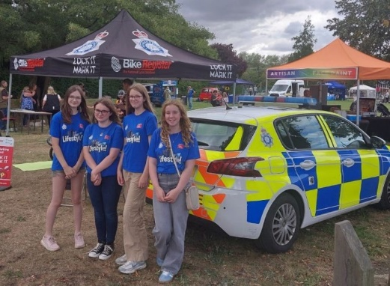 Making a Difference
Every year, young participants take on cool and inspiring projects, from awareness campaigns and public space clean-ups to charity fundraising and community support. Your dedication and teamwork help make your neighbourhoods better places to live.
Lifestyle is ready to be launched in your area.

Action: All Neighbourhood Policing Teams have received their Lifestyle packs with promotional materials and their PowerPoint (and video) to be delivered in schools and youth centres.

Lifestyle is our longest-running youth engagement event, inspiring young people since 1989 to make a positive impact in their communities through innovative, fun-filled, and inspiring projects during their summer holidays. Each year, we witness incredible dedication from young individuals who strive to improve their neighbourhoods, showcasing exceptional organization and teamwork to achieve their Lifestyle goals.

Lifestyle is open to 10-16 year olds, either in small teams of 2-5 members or as larger youth teams representing youth clubs. This programme offers Humberside’s young people the chance to fill their summer with enjoyable activities that benefit their communities. You can find out more about Lifestyle on our new dedicated website: Humberside Police Lifestyle – Making a Difference, where registration will open soon.

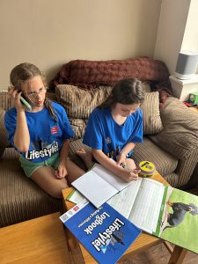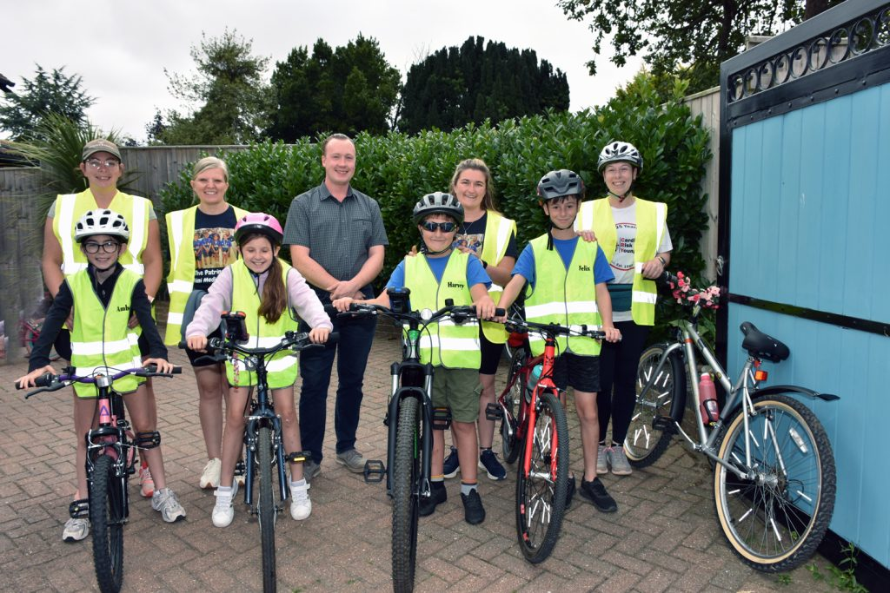
"Lifestyle is great for young people to achieve success in areas they feel are valuable to them. It connects everyone involved with their community and the city they live in. It gives everyone involved a sense of purpose and pride."
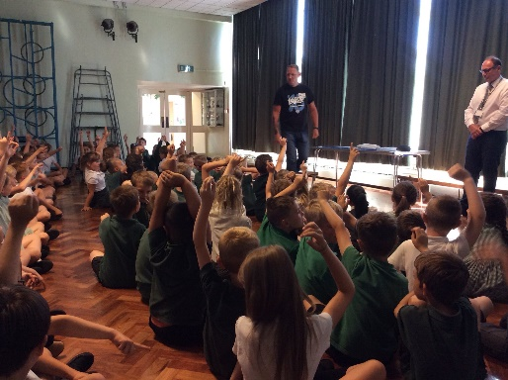
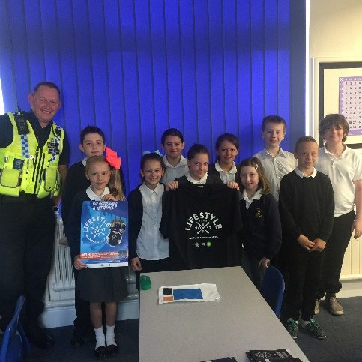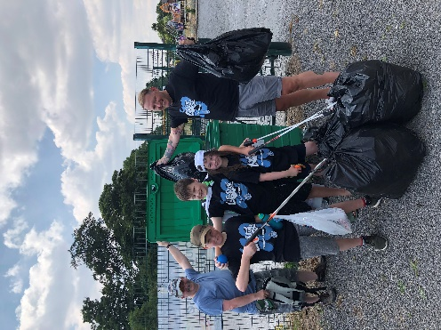



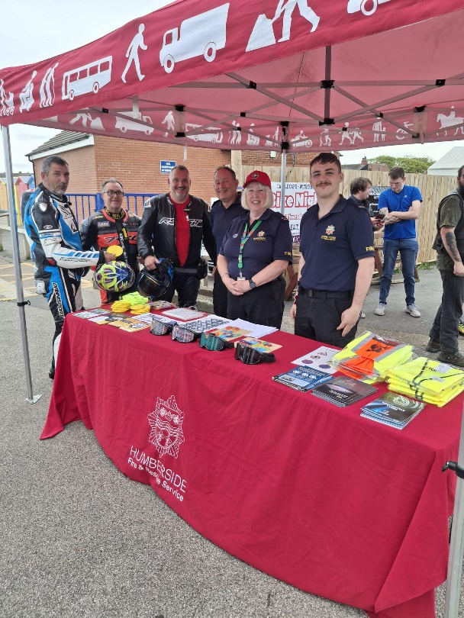
HUMBERSIDE FIRE & RESCUE crew from Withernsea Fire Station attended the Bike Night at Castle Café to meet with local riders and share important road safety advice.
It was great to see so many bikes and have the opportunity to speak with members of the biking community about staying safe on our roads. From protective gear and bike maintenance to rider awareness and making safe choices, every conversation helps promote safer journeys for everyone.
A big thank you to Castle Café for hosting and to all the riders who stopped by for a chat. Stay safe, ride smart, and look out for one another

Key Springtime Safety Messages from Police:

- Road Safety & Traffic: As weather warms, police remind drivers to watch for increased pedestrians, cyclists, and motorcyclists. Drivers are urged to slow down, share the road, and avoid distractions.
- Property Security: Spring is a prime time for burglary. Residents are encouraged to secure homes, sheds, and gardens, with tools like "Immobilise" recommended to register property and deter theft.
- Livestock Protection: Rural police advise dog walkers to keep dogs on leads near livestock, as spring brings vulnerable lambs and calves.
- Scam Alerts: Authorities warn of "springtime scams," particularly bogus HMRC tax refund messages (texts/emails) targeting taxpayers.
- Community Engagement: Increase our time to conduct Humbertalking, Community Officers discuss local issues like anti-social behaviour

Darren
PCSO Darren Bainton



