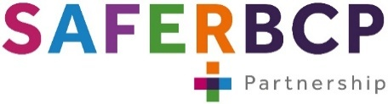


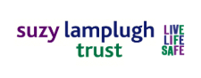

Active Bystander
30-minute FREE training webinar
16th July 6.30pm – 7pm
16th
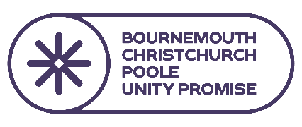
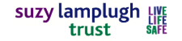
Violence Against Women and Girls (VAWG) remains a significant issue across the UK. As part of our commitment to the Unity Promise and making BCP a safer place for women and girls, we are offering this training to support our Night-Time Economy (NTE) colleagues and businesses.
Research by L’Oréal Paris and the Suzy Lamplugh Trust shows that:
- 80% of women in the UK have experienced harassment in public spaces
- The most common unwanted behaviours being staring, intimidatingly sitting or standing right by someone, and verbal abuse.
- Encouragingly, 84% of people said a situation improved when someone intervened
Join us for just 30 minutes to build your confidence and learn:
- The “5 D’s” of bystander intervention
- Safe ways to step in safely
- How to support others
Book your free space here: https://www.ticketsource.com/bcp-cst/t-rzqzvqk

