
Issue: July Edition 2026
Melton Mowbray Town Centre Newsletter

The NR31 Beat Team
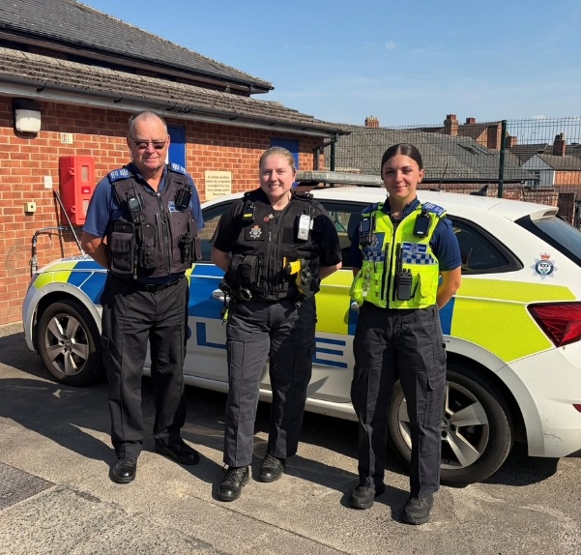

- PC 1836 Lucy Baxter

- PCSO 6131 Malcom Durrant
- PCSO 6017 Etienne Kennington-Dawe

What matters to you
We have listened to you and the concerns you raised and prioritized the following:

Priority 1: Antisocial Behavior
The community has raised the issue of Anti-Social Behavior on the Melton Town Beat as a top priority.
What we have done: Hot spot patrols are continuing!
With schools now closed for the Summer Holidays, we anticipate an increase in anti-social behaviour (ASB) within the town centre. We will continue to work closely with local businesses through the SMART radio network to monitor activity, share information, and identify any emerging issues at the earliest opportunity.
High-visibility patrols will be conducted where appropriate, and we will engage with young people positively to help prevent incidents and maintain a safe and welcoming environment for members of the public, residents, and visitors.
It is important to recognise that the vast majority of young people behave responsibly and do not come to police attention. Our increased presence during the holiday period is intended to provide reassurance to the public, support local businesses, and ensure that any issues involving a small minority are identified and dealt with appropriately. This proactive approach helps maintain a positive atmosphere within the town centre for everyone to enjoy throughout the summer.

Priority 2: Drug Dealing

The community has raised the issue of drug dealing on the Melton Town Beat.

What we have done: During patrols, a number of stop searches have been conducted on both individuals and vehicles, resulting in the seizure of controlled drugs and the identification of persons involved in criminality. Officers have also seized drug paraphernalia from public spaces, helping to disrupt drug use and deter further offending.

In addition, we have continued to gather and develop intelligence relating to individuals and locations suspected of being involved in drug-related activity. This information is used to inform future patrols, targeted operations, and enforcement opportunities, enabling us to take a proactive approach to addressing concerns within the community and providing reassurance to residents, businesses, and visitors.

Priority 3: Theft and Burglary
What we have done: Preventing and reducing theft within the town centre continues to be a key priority. We conduct regular patrols of local shops and retail areas and liaise with shop owners and staff to understand the issues they are facing and identify ways in which we can support them.
We encourage retailers to continue reporting theft offences and sharing information through the DISC system, as this helps build intelligence, identify repeat offenders, and support enforcement action. By working closely with businesses and maintaining a visible presence within the retail environment, we aim to deter offenders, increase opportunities to identify those responsible for theft offences, and provide reassurance to businesses, employees, and members of the public.

What We have been up to..
Meet the Melton Inspector!

On Tuesday the 21st of July, Inspector Paterson-Bell attended the local market in the Town Center, alongside PC Lucy Baxter, to meet residents and speak about the local policing priorities.
The town centre was particularly busy, providing an excellent opportunity to speak with everyone.
A range of community concerns, questions, and positive feedback were discussed. The event was well attended! And thankyou to everyone who stopped to talk.
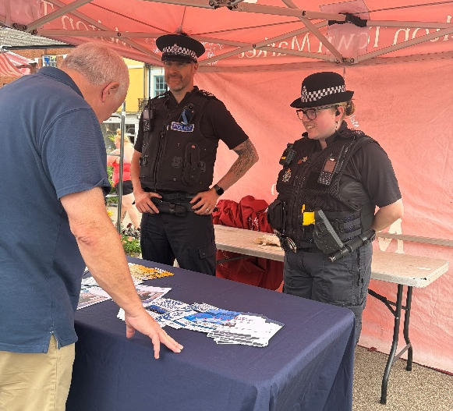

Throughout the month…

  - PCSO 6131 Durrant has recently moved from the Town North Beat (NR32) back to the Town Center Beat (NR31). We are happy to have him back!
  - PCSO 6017 attended an incident in the town centre involving a member of the public who had collapsed during the recent period of hot weather. Fortunately, appropriate assistance was provided and the individual received the support they needed.
This incident serves as an important reminder for everyone to take care during periods of high temperatures. We encourage residents and visitors to stay well hydrated, seek shade where possible, and avoid spending prolonged periods in direct sunlight, particularly during the hottest parts of the day. Taking these simple precautions can help reduce the risk of heat-related illnesses.
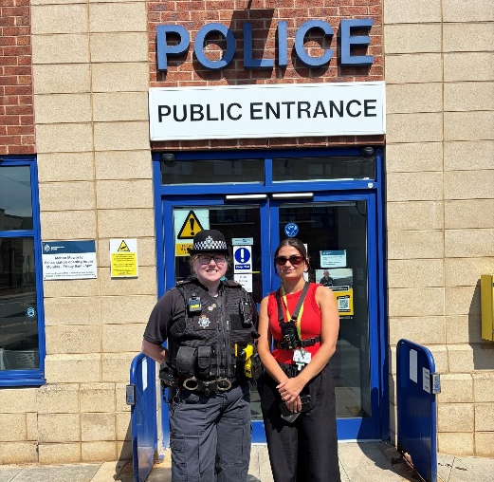
  - PC Lucy Baxter recently completed a patch walk with Katie from the Council’s Safer Communities Team. During the walk, several rooftops and derelict locations were visited where people have been gaining access. We have identified this as a recurring issue and are aware of a number of locations that are being targeted. Climbing onto roofs and entering abandoned buildings presents a significant risk, with a fall potentially resulting in serious injury and having life-changing consequences.
We are working closely with partner agencies and property owners to address these concerns by identifying ways to restrict access, including boarding up vulnerable locations, improving security measures, and reducing opportunities for people to gain entry. We will continue to monitor these areas, gather intelligence, and take proactive steps to prevent access.

3/8/26- Beat surgery @ Esquires
Community engagements

22/9/26- Beat surgery @ Cattle market
23/9/26- Beat surgery @ Library
6/10/26- Beat surgery @ the park



For the future

Please continue to report any suspicious activity to the police on either 101 or on the website.
Thanks for reading the newsletter!

Contact us on:
Melton Police - FACEBOOK
101 – NON EMEGENCIES
999- EMERGENCIES
Melton Station Front Desk.

