Introduction
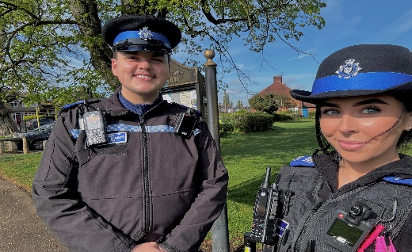

PS 2179 Mark Body
Wigston Newsletter
Issue: July 2026
PCSO 6158 Cara Hayter PCSO 6115 Adam Ghrairi

#YouSaid - What matters to you

Keeping Wigston Safe
Local officers and PCSOs have continued proactive work across Wigston, with high-visibility reassurance patrols taking place in key areas, including Wigston center (Bell Street and surrounding), Aylestone Lane, Little Hill and The Meadows.
These patrols aim to deter crime, engage with residents, and respond to concerns around anti-social behavior (ASB).

Officers are encouraging residents to continue reporting issues, as community intelligence plays a vital role in shaping local policing priorities and ensuring timely action is taken.

Tackling Anti-Social Behavior (ASB)
ASB remains a focus for neighborhood teams. Patrols have been specifically targeted at areas where residents have raised concerns about:
- Youth disruption
- Rowdy or nuisance behavior using vehicles in hotspot areas.
- Drug use in public spaces. This includes vehicles.

The beat team has reported positive results from increased patrols, including engagement with young people, seizure of nuisance vehicles, and collaboration with partner agencies to resolve recurring issues.
This month our team has seized numerous E-Scooters and E-Bikes.

• Road Safety & Traffic Enforcement
Road safety continues to be a priority across Wigston. Residents have reported issues such as speeding, dangerous driving, and obstructive parking.
In response, officers have:

Conducted regular traffic patrols in hotspot areas. We have now places signs’ up in areas that have been reported to us as hot spot areas.
- Carried out vehicle stop checks based on intelligence. This has also included stopping people that we can see on their mobile phones. This has resulted in multiple people being issued tickets.
- Conducted speed checks to ensure road users adhere to speed limits in areas that you have raised to us as having high rates of speeding in the area.

These operations are part of an ongoing effort to reduce dangerous driving and improve safety for all road users.

Tackling Drug-Related Activity
Local police teams continue to address concerns around drug use and dealing in Wigston. Work has included:

  - Intelligence-led operations and warrants
  - Increased patrols in known hotspot areas
  - Partnerships with other agencies to prevent ongoing issues and develop intelligence in areas known to us.
Recent activity has resulted in disruption of local drug activity, showing the importance of public information and reporting.

Burglary & Vehicle Crime Prevention
Neighborhood officers continue working to reduce burglary and vehicle crime by:
  - Conducting targeted patrols in hotspot areas
  - Providing crime prevention advice to residents. Particularly as we approach the warmer weather, we have been ensuring that people have closed windows and doors before leaving their homes unoccupied.
  - Developing intelligence in relation to subject vehicles and individuals

There have been reductions in certain vehicle-related offences, thanks in part to targeted operations and intelligence-led policing.
Residents are reminded to:
  - Lock doors and windows, even if you are just going out for a short period of time.
  - Avoid leaving valuables in vehicles
  - Report suspicious behavior promptly. This allows us more time to get to them, and increases are likeliness to catch those and challenge their behavior early doors.

Working with the Community
Wigston’s neighbourhood team works closely with:

  - Inspector Day had a ‘Meet the Inspector’ event in Wigston this month, whereby residents, workers in the local community had the opportunity to talk with him, ask questions and receive information and advice.
  - Community groups. This month, we attended the Wigston Residents Forum. We have learnt from attending this that there are ongoing concerns around E-scooters and E-bikes. We carry out operations each month to tackle those using these vehicles and seize them. We have also stated that they are illegal, however, we must risk assess when we challenge those on them, as the risk of their injury is far greater at times with us pursuing them than it would be for them to ride it away. That does not mean that we will not get it, we often know individuals and can therefore attend their home address to remove them off of them when safe to do so.

This partnership approach helps deliver long-term solutions to local issues and improves safety across the borough. Recent engagement activities have included community patrols, youth engagement, and ongoing communication via social media and local messaging systems.

How You Can Help
You can support your local police team by:
    - Reporting crimes or suspicious activity via 101 or online
    - Call 999 in an emergency
    - Sharing information that could assist investigations
    - Joining local alerts such as Neighbourhood Link for updates

Final Message
Your neighbourhood team remains committed to visible policing, tackling priorities, and keeping Wigston safe. Continued community support is essential in helping police respond effectively and build a safer environment for everyone.
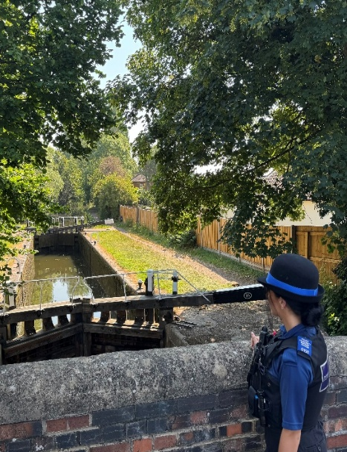
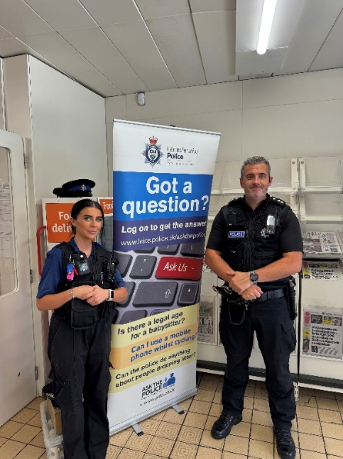
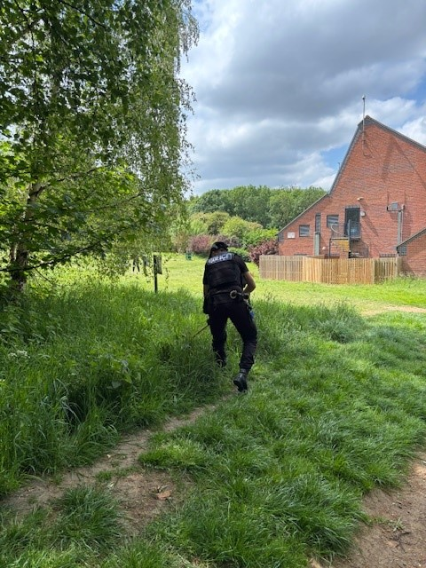

UPCOMING BEAT SURGERIES:
      - 6th August- 6pm-7pm Tythorn Community Centre 6115 and 6158
      - 21st August- Willow Park- 11:00-12:00

Other ways to keep up with our beat surgeries and what we get up to is to go to our Facebook page: “Oadby and Wigston Police”

Our website has information on several different types of crime, resources and local services. Calling 999 in non-emergency situations can delay access for those in urgent need.
#HelpUsHelpYou by visiting our website to get more information or access the service you need https://orlo.uk/RKenf

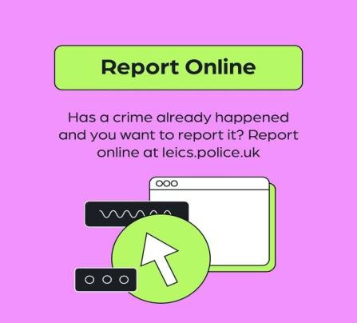
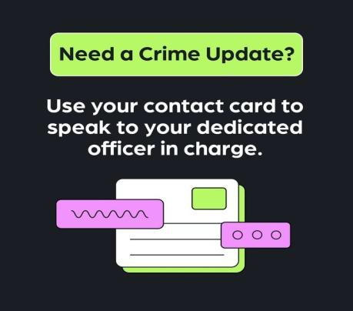




Follow our channels for the latest updates
WhatsApp Channel
Your local NPA Facebook page
Receive more updates
Instagram

Confidence Survey Your Views Survey




