
Loughborough Central Newsletter
Issue: July 2026


Your Local Team

- Sgt 2075 Katie Hazard
- PC 4236 Alex Beirne
- PC 1636 Ian Thompson
- PC 1188 Catherine Gayler
- PC 1041 Sophie Hayward
- PCSO 6938 Kelly Foulds
- PCSO 6151 Euan Smedley
- PCSO 6032 Amy Birch

What matters to you
We have listened to your concerns and will prioritise the following:
Priority 1: To reduce the number of thefts in and around Loughborough Town Centre.
What we have done: Cycle register schemes continue, and it is pleasing to note that there has been a significant decrease in the number of cycle theft reports.
Working closely with the town centre security wardens, we have seen a decrease in the number of thefts.
We have linked in with several stores who have been repeatedly targeted to help reduce the number of thefts they are having. With that several arrests and remands have been made as a result.

Priority 2: Reduce Anti-social behavior reported by residents across the local area in varying formats including car cruise meetings, noisy parties, youths causing issues in the town Centre.
What we have done: Additional officers are currently being deployed as part of Operation Lexical, whereby officers patrol in and around Loughborough town centre to combat reports of anti-social behaviour
Page 1
Loughborough Central Newsletter
The safer streets team are deployed into the town centre to tackle ASB in the vicinity, they work closely alongside council and retail establishments to tackle this behaviour.

Priority 3: There are an increasing number of e-bikes and e-scooters being used in the town Centre which is causing potential danger to pedestrians.
What we have done: Operation Pedal fast is currently ongoing to tackle this issue; officers will be taking robust action against those riding illegal e-scooters.
Our dedicated beat team work closely with the safer streets team to offer information to the public around e-scooters at beat engagements and information stalls.

News
Beat Engagements
10:00 – 11:00 Monday 10th August 2026 – Costa, 1 Market Place, Loughborough, LE11 3EA
10:00 – 11:00 Thursday 27th August 2026 – 12 Fredrick Street, Loughborough, LE11 3BJ

Get involved!
Please take this opportunity to raise any concerns you may have and to find out what we are doing to tackle the issues that matter to you.
We urge you to call 999 in an emergency - if you or someone else are in immediate danger, or if a crime is in progress.
Please take the time to visit the site in order that you can come and share your views and help to develop the priorities that concern you. This can be done using the QR code below.
On 30th June 2026 officers from Loughborough were tackling the illegal use of e-bikes and e-scooters, while also carrying out checks on those being used legally.

Numerous bikes and scooters were stopped and continue to be stopped with multiple vehicles being seized for offences.

If your bike accelerates like a motorbike and the pedals are just there for moral support, there is a good chance we’ll be interested in taking it from you.
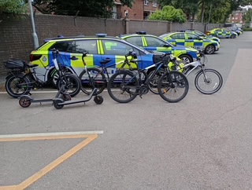

Don’t miss out on our events

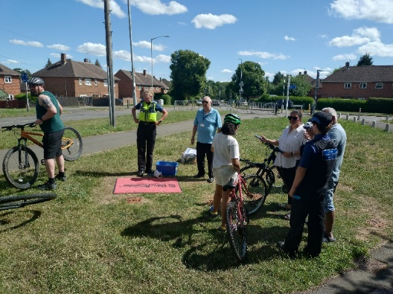
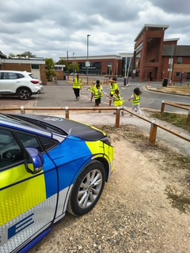

Please see our social media page for upcoming events on Loughborough Central
Facebook : Charnwood Police

Loughborough Central Newsletter
Page 2

