

PCSO Gareth

PCSO Alisha

PCSO Molly
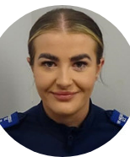
PCSO Enamul

PCSO Emma

PCSO
Gareth.Prentice@south-wales.police.uk 07929720168

Alisha.Gronland1@south-wales.police.uk 07557212907
Molly.Howell@south-wales.police.uk
07974084401
Enamul.Hoque@south-wales.police.uk 07825503414
Emma.Worrall@south-wales.police.uk
07890064282
GRANGETOWN
SWP

