

We have listened to you.

Issue:
July 26

Western Ward

Newsletter

Introduction

#YouSaid
-

What matters to you

PS Simon WALTERS

PC Dave MARTIN

PC Callum JOHNSTON

PC Georgia POWELL

PC Lee FLAVILL

PC Alex ALDRICH

PCSO Pete SMITH

PCSO Sally
-
Ann MORGAN

PCSO Sabra BABAI

PCSO Andy BROWN
PCSO Grant JARVIS
Priority 1
Dangerous and illegal use of vehicles around the Western Ward continue to be reported and raised as concerns by local residents. Speeding, E-bikes and E-Scooters and dangerous parking outside Primary Schools have all been highlighted.
Action Whilst the schools are on Holiday, we have focused our attention to Nuisance Vehicle/E-vehicles.
On 7th July a stolen vehicle was recovered from Chainama Close. On 11th July a 14-year-old male riding an E-bike failed to stop off from officers after they saw him riding carelessly along Tournament Road. Officers’ safety stopped the male and seized the machine. On 17th July we raided an address o the Braunstone Frith and located 4 Sur-Ron/E-bikes. Three were stolen, all were causing crime and nuisance on Western Ward.
Priority 2
Retail crime continues to be a problem for our shops across the Western ward which is causing staff to feel unsafe whilst at work.
Actions There was an increase in Thefts from shops reported during July. One known male offender has been responsible for numerous of those offences and is currently being sought.
Local shops share information about offenders who target our shops regularly.
Priority 3
The community in the area of Styon Road, Keightley Road and Lamen Road tell us that youths are regularly causing Anti-Social Behaviour in and around the grassed Play area. Motorcycle gatherings causing excessive noise, Vandalism/damage to Property are regularly being reported.
Actions Patrols continue in this area as problems still occur.
One family living nearby on Keightley Road have been identified as repeat offenders. One of their machines has been seized and they have been issued a warning letter.


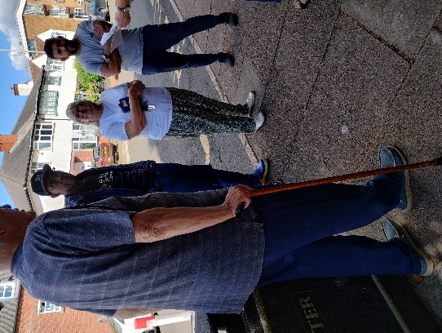
News and Community Events July 2026

.

Patch Walk with Local residents and councillors
PCSO 6094 Sally on a patch walk with Councillors Dempster and Cole.
This is in relation to signage, line marking, vehicle obstructions outside Dovelands School, Hinckley Road and Kingswood Avenue, update on the plans moving forward before the next newsletter

Summer HAF 2026
PCSO 6094 Sally has been attending the Summer HAF 2026 at the team Hub on St Oswalds Road. As well as attending in her working hour, Sally has been attending as a volunteer on her days off, to help and support young people in the area. This shows real commitment to a valued member of the team who puts 100% into her work with young people and the great staff at the Hub.
Summer HAF 2026 for children with benefit-related free school meals. Sports -Crafts – Dance – music -food, and much more. This is on Monday to Friday (4weeks) from 20th July till 13th Aug
Please see poster for details and QR code

Drugs Warrants
Team have been executing Drugs Warrants on the area this month with the Help of neighbourhood action team One on liberty Road and the other at Deansburn house. In both cases arrests were made and positive action was taken.
Missing piece of the jigsaw
Most intel comes from members of the public who are blighted by drugs and crime, that effecting their lives and communities. Please report all incidents and concerns, via single on-line home, 101, or crimestoppers.
Your information could be the missing piece to the crime jigsaw.

-..

Anti-social behaviour survey |  | Your Views Survey

Upcoming beat event Activities eat

Summer event
9:00AM - 2:00PM, Tue 11 August 2026
Team HUB St Oswalds Road
Summer HAF
9:00AM - 2:00PM, Wed 12 August 2026
Team HUB St Oswalds Road
Summer HAF
9:00AM - 2:00PM, Thu 13 August 2026
Team HUB St Oswalds Road
Beat Surgery, Co-Op, Aikman Avenue
12:00PM - 1:00PM, Sat 15 August 2026
Beat Surgery with PCSO 6083 Andy Brown
Beat Surgery at New Parks Salvation Army Center.
11:00AM - 12:00PM, Mon 17 August 2026
New Parks Salvation Army Centre, 330 Aikman Ave, New Parks, Leicester LE3 9PW
Beat Surgery, New Parks Library
6:00PM - 7:00PM, Wed 19 August 2026
New Parks Library, Aikman Avenue
Beat surgery
10:00AM - 1:00PM, Thu 20 August 2026
Team HUB St Oswalds Road
Beat surgery
10:00AM - 12:00PM, Fri 21 August 2026
St Annes community hall Letchworth Road
MH Cafe
3:00PM - 5:00PM, Sat 22 August 2026
Team HUB St Oswalds Road
Beat Surgery at One Stop Shop on Stephenson Drive
11:00AM - 12:00PM, Wed 26 August 2026
One Stop Shop, 155 Stephenson Drive, Leicester

Community Events & Things to do in your Area Area

Mon – Fri Open Daily New Parks Hub St Oswalds Road Loads to get involved with
Mon – Fri 10:00-13:00 Salvation Army Aikman Ave Coffee Chat & Charity Shop
Mon – Fri Open Daily New Parks Library Aikman Ave
Mon – Fri Open Daily New Parks Leisure Centre
Mon -Fri Open Daily St Annes Church & community (updates on Facebook)
Tue 10:00-12:00 New Parks New Friends Aikman Ave Library
Wed 10:00-12:00 Stokeswood allotments Stokes Drive Coffee Morning
Wed 12:00- 13:00 New Parks Pantry Lunch Club, Eat & Meet
Thu 12:00- 15:00 New Parks Food Bank Methodist Batterbee Road
Loads of amazing things going on in the area please support these groups
Follow us @LPWestLeicester

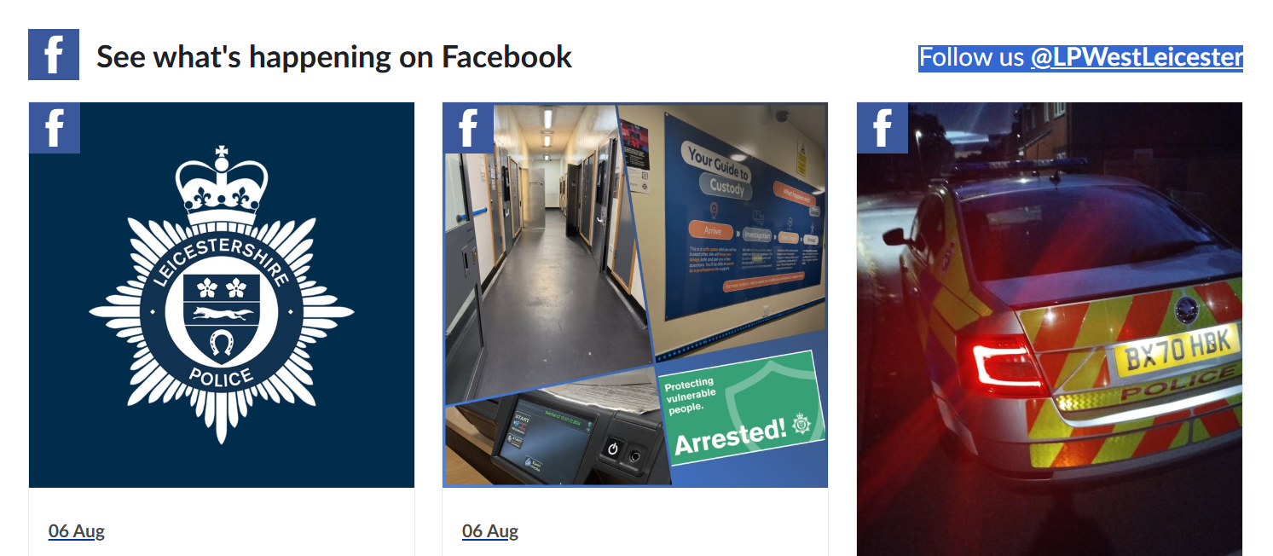
nts November 25

And now for the main event! …

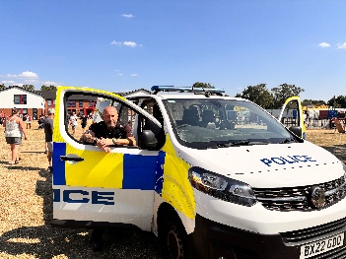
PC Dave, PC Georgia, and PCSO Grant were delighted to attend Forest Lodge Academy’s Summer Fair. It was a fantastic event with a great turnout from the local community. The team enjoyed meeting families, chatting with residents, and supporting a day filled with fun activities. Thank you to everyone who came along and helped make it such a success.
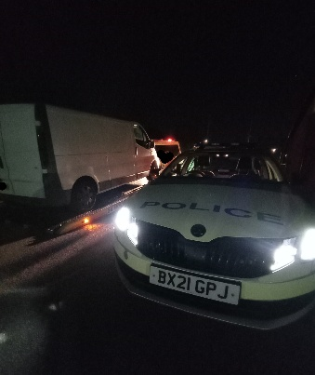
PC Callum attended a head on collision on Dillon Road, involving an elderly gentleman on a bike. The male suffered some serious injuries that were very gruesome but thankfully PC Callum’s swift actions and the help of Paramedics meant he blue lighted the male to hospital and was treated for his injuries. Were please to say he will make a good recovery!

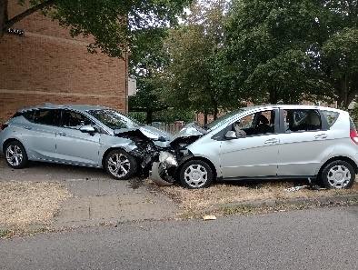

PC’s Georgia and Dave attended a report of a head on Collison on Aikman Avenue. Where a stolen vehicle had crashed into a parked car. Thankfully no one was injured. We cant comment too much on this as it is still being investigated.

