
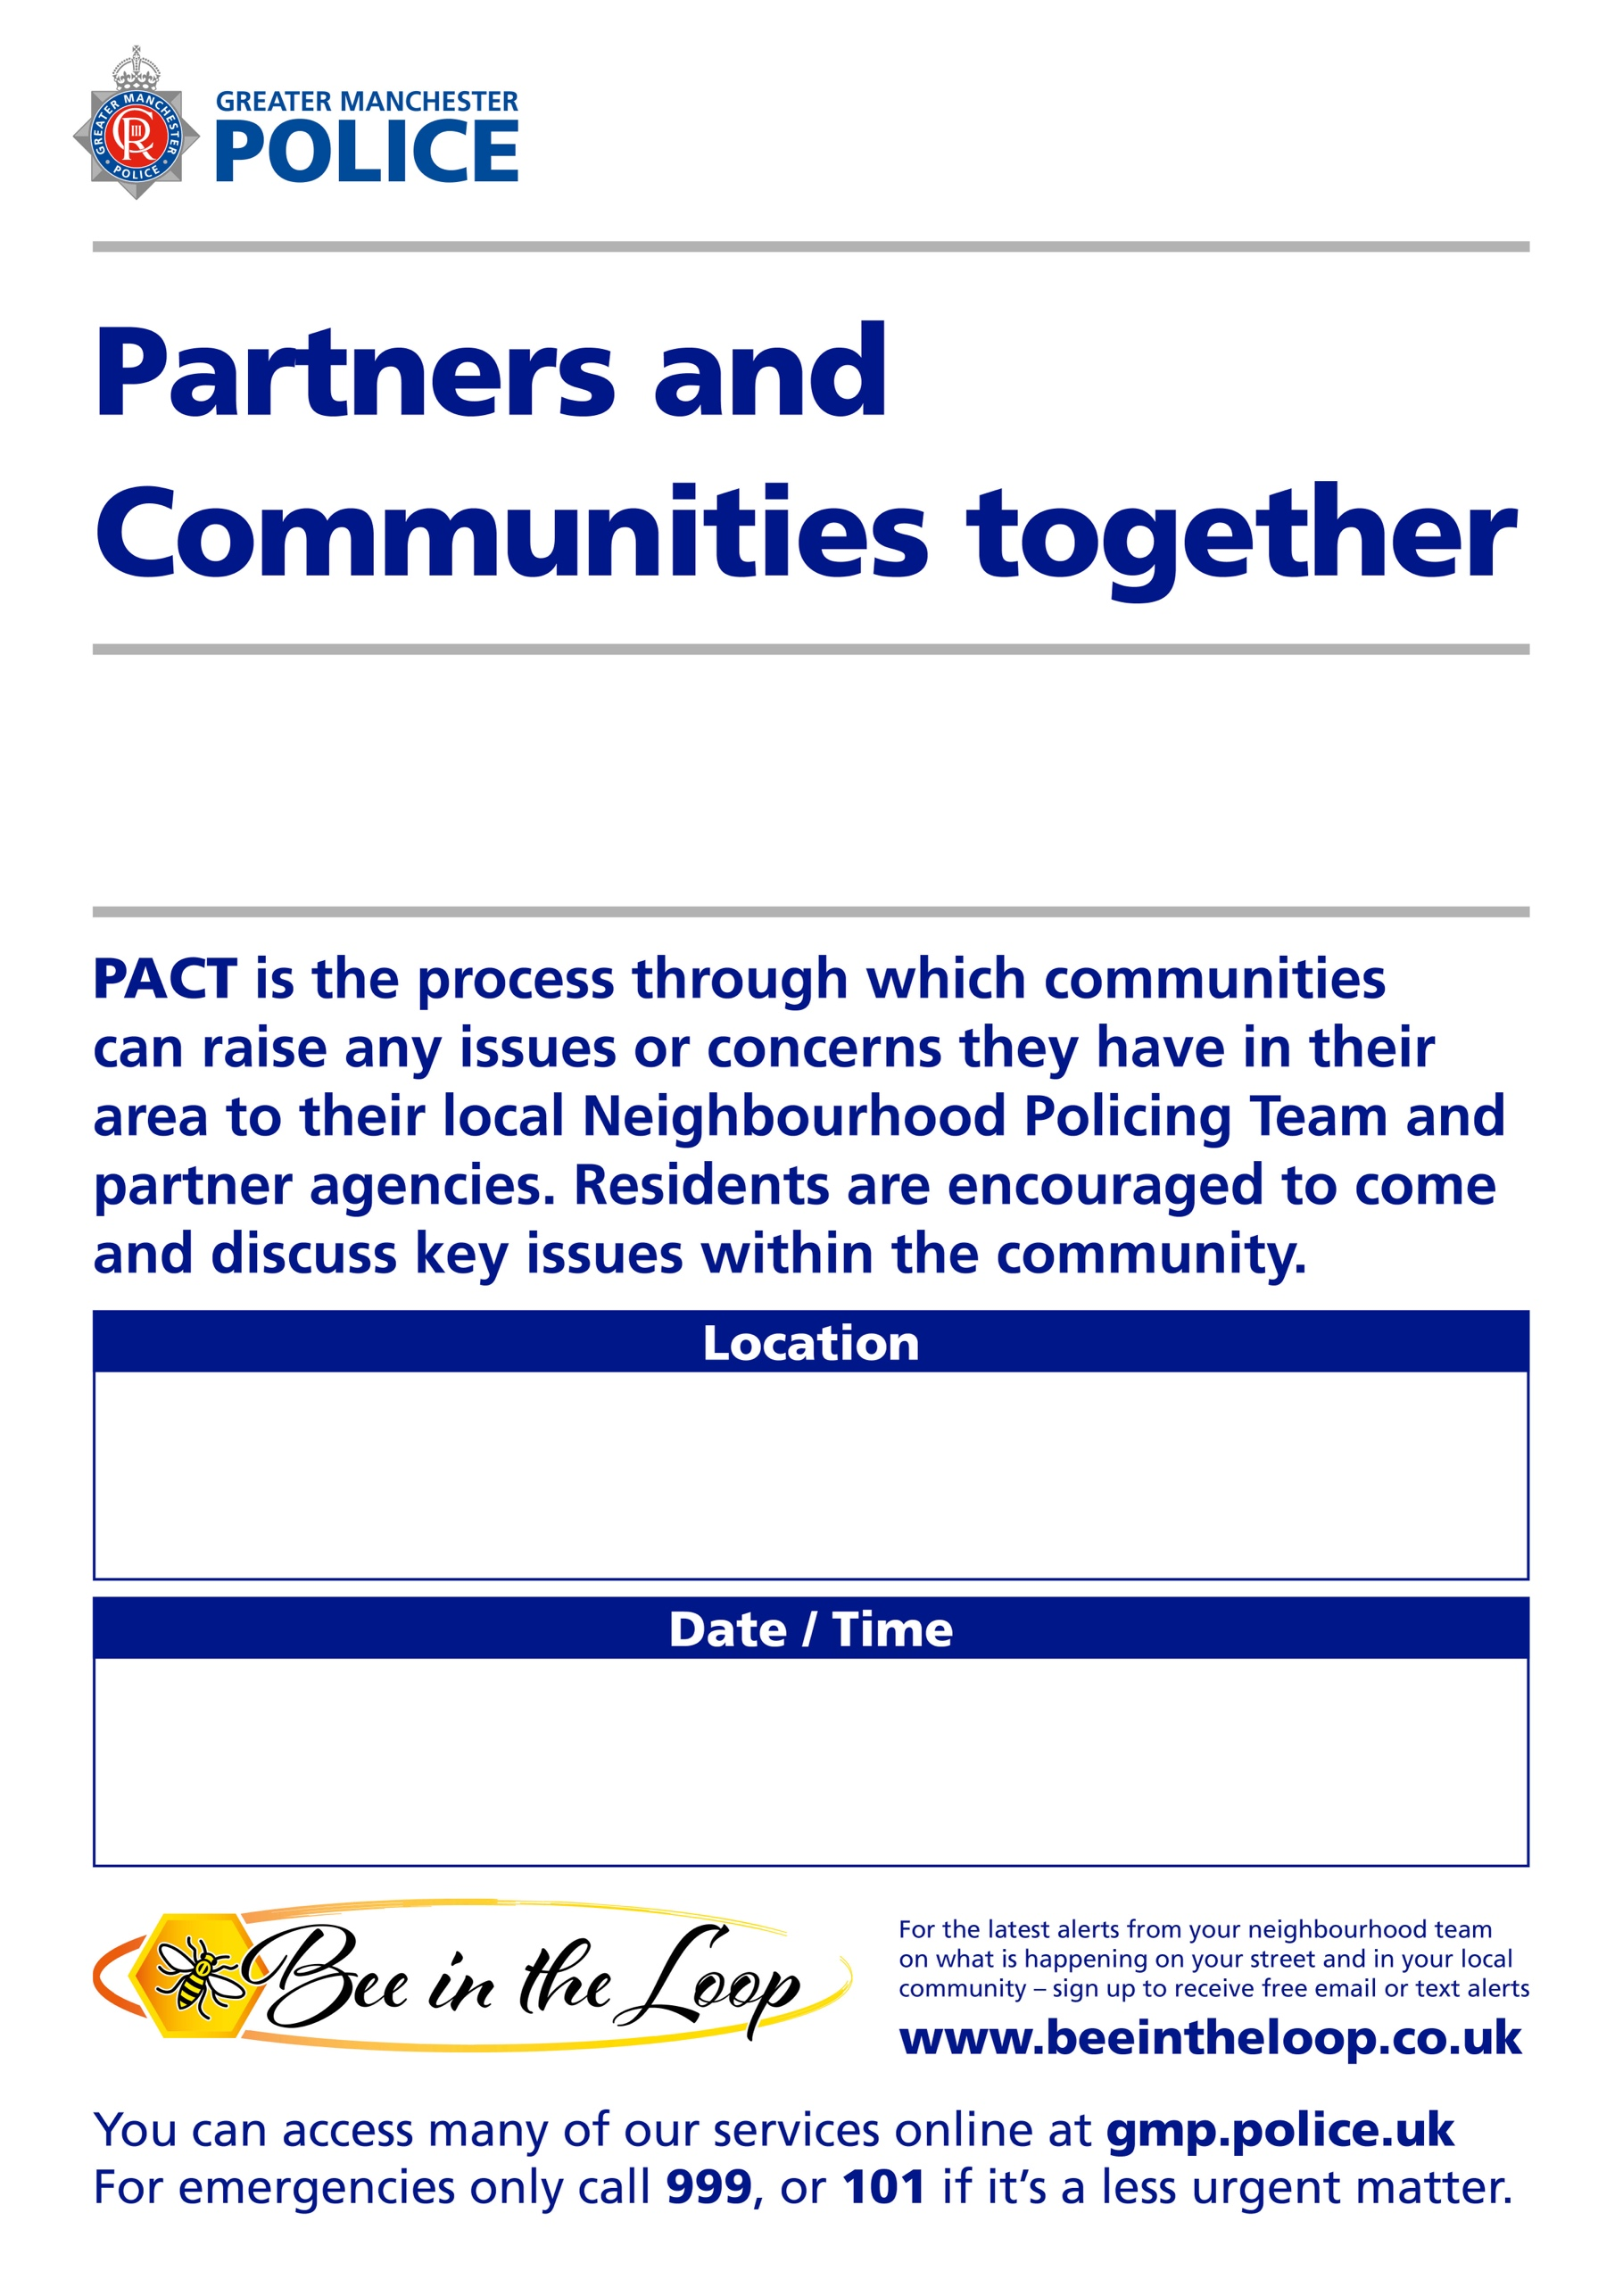
A drop in session giving you a chance to speak to your neighbourhood policing team.
No need to book.
Coffee with a Cop
10:00 on 25/10/2026
Leoni’s, 110 Heaton Moor Road, Stockport, SK4 4NZ

