
Your Bideford Coastal and Rural local newsletter
Spring edition 2026

Meet your local policing team

Sergeant Clark PC Ciantar PCSO Haywood

Inspector Seear
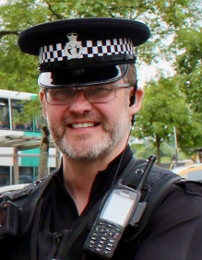

Welcome!

My name is Inspector 16270 Seear and I am the local sector inspector for Torridge.

We will be bringing you a regular newsletter full of safety tips and crime prevention advice, as well as giving you updates on issues and priorities that are of concern to local communities.

In this Spring edition, we have included useful information about how to stay safe while enjoying our beautiful region over the coming months.

Myself and my colleagues work hard to keep you safe 24 hours a day, 365 days a year.

Remember, if you need us but you’re not in immediate danger or a crime isn’t taking place, please call 101 or get in touch via our website www.dc.police.uk

If you see us out and about – please come and say hello. We would love to meet you.
What has been happening in your area?

During the month of March 2026, officers covering the Bideford area, responded to 272 logs.

This number is down 23.4% from the same period in 2025 including, but not limited to:

36 Public safety and Welfare
16 Domestic related incident
16 Missing Persons
30 Reports of Violence
3 Criminal Damage
27 Reports of ASB
42 Highway disruptions/Road Offences (Not including speeding or RTC)
11 RTC
7 Sudden Deaths

A large proportion of police incidents are not crime related. Of those which were, some investigations can be progressed through out of court disposals such as Community Resolution, Individuals being reported, or by voluntary interview.

As well as responding to the 272 logs, officers also worked on file building for court, taking witness and victim statements, foot and vehicle patrols, booking in evidence, surveillance, executing warrants, attending court, attending training courses and inputting intelligence onto the system.
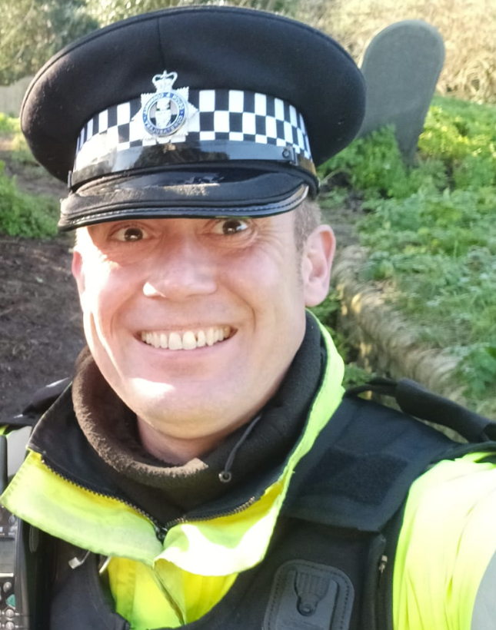

Dog walkers urged to take care

Lambing season is underway and in March and April, we support Op Recall - a national operation to raise awareness of the impact of livestock worrying and prevent livestock attacks.

A report from the National Farmers’ Union in 2024 confirmed that dog attacks on livestock in the UK were estimated to cost £2.4 million.

Local police teams will be working in communities this Spring to provide advice on how to reduce livestock attacks.

Remember: If you’re walking your dog in an open space, make sure it is under control at all times. If around livestock, make sure it is on a lead.

Livestock worrying is a crime and you can be prosecuted, receiving up to six months in prison and/or a £1,000 fine. If you witness an attack on livestock, please do not intervene; keep yourself safe and call 999.



Keeping your garden crime free

Now Spring is here many of us are looking forward to spending more time in our gardens. Now is a good time to think about shed security and how you can keep your belongings safe.

Protecting your garden and outbuildings keeps your valuables hidden. Here are some tips to consider:
- Keep hedges and walls at the front of your house low so burglars have nowhere to hide.
- Lock side gates at all times
- Consider spiky, defensive planting and keep hedges, walls and fences around your back garden high
- Gravel driveways and paths make it harder for burglars to go undetected, due to the noise caused when someone walks on them.
- Install an outside security light so intruders cannot approach without being seen and consider fitting a burglar alarm system.
For more information on how you can keep your home safe, please visit the Devon & Cornwall Police website



Rogue Traders: what you need to know

Now the warmer weather is approaching, you may consider making improvements to your home and garden.

Be cautious of rogue traders who may knock on your door and offer to do work for you. Things to look out for include being offered a very cheap price that is too good to be true and being rushed into making a decision.

Remember to ask for identification and understand the terms and conditions of the work. If you notice anything suspicious report your concerns to police by calling 101 or call 999 if you feel you are in danger.

Spring into action – stop crime before it starts
1. Keep windows secure
It’s tempting to leave windows open as the days get brighter and warmer, but open windows can be an easy way in for burglars. Close windows when you’re out of the room - especially if they are on the ground floor.
2. Vehicle safety
Don’t give thieves a chance this spring. Always remove valuables from your car, and check it’s locked, before walking away. Ensure your car windows are closed when you are away from your vehicle.
3. Online scams
Spring is a busy time for online shopping and holiday deals. Be cautious of fake websites and messages asking for personal details. Check web addresses carefully and never click links in unexpected emails or texts.
4. Neighbourhood Watch
Longer days are a great time to reconnect with your community. If you notice something unusual in your area, share it with your neighbours or report it.
5. Bicycle safety
Cycling season is back! Mark your bike with a police-approved security tag and register it on the BikeRegister. Always lock it, even when you’re at home.
6. Holiday reminder
Heading away for a break? Ask a neighbour to keep an eye on your home, use timer switches for lights, and avoid posting travel plans on social media.

Sign up to Devon & Cornwall Police Community Messaging service.

This is our free two-way messaging service that keeps you informed about what’s going on in your local area.

You can choose exactly which updates you want to receive, including information about crime, anti-social behaviour, safety advice and positive local news.

Alerts are sent straight to your email, and you can reply directly to our teams if you have something you’d like to share with us. You can opt out any time.

Join over 40,000 people who are already part of the community – sign up here: https://community-messaging.dc.police.uk/



Keep up to date with what’s happening in your area:

Facebook: Bideford Police

Website: www.dc.police.uk and enter your postcode

