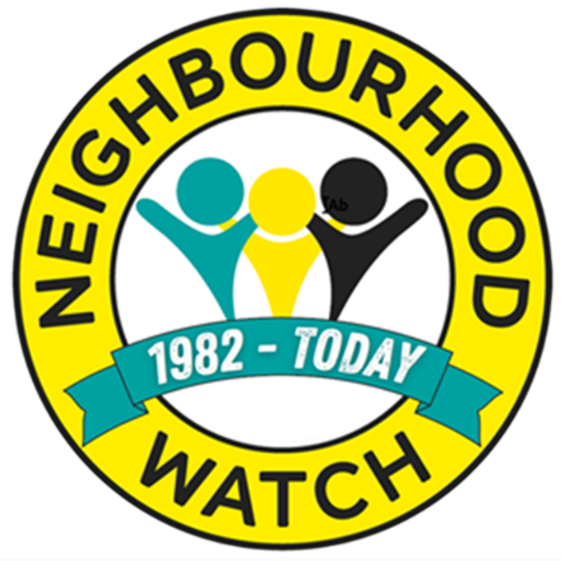

Alert Administration for Neighbourhood Watch Coordinators

Contents
Introduction 1
Your Information and Preferences 2
Your Information 3
Edit Your Details 3
Login Information 4
Changing Your Password 4
Interests & About You 5
Demographic Information 5
Community Interests 6
Information Providers 7
Message Settings 7
Unsubscribe Options 8
Member Area – Message Settings 10
Neighbourhood Watch 11
Apply to Create a New Scheme 14
Messages 14
Message Inbox 15
How to Receive Messages 18
Message Types 19
Message Forwarding Address Book 21
Neighbourhood Watch Tools 22
Manage Schemes 22
Edit an Existing Scheme 23
View and Edit Membership 26
Suggested Members 27
Invited Members 27
Add someone to your scheme. 30
Send a message to scheme members. 31
Applying to Join or Start a New Scheme 31
Suggested Schemes 31
Applying to Start a New Scheme 32
Scheme Messages 38
Writing Your Message 39
Insert an Image 40
Select Attachments 41
Linking Selected Message Text to a URL 41
Inserting Mail Merge Fields 42
Sending the Completed Message 42
Use of Your Data 43
FAQs 44
Log Out 44

Introduction
As a coordinator you can perform administrative tasks for your scheme and your details by using the Log In link on the menu bar of the Our Watch website. As well as being able to update your personal details and preferences you can also keep your scheme, or schemes if you are an area coordinator, up to date by allowing you to change the details of the scheme or schemes you coordinate. You can keep your scheme membership current by admitting new members, removing those who have left and editing their roles. The system also allows you to send messages securely to your scheme members and to receive replies from them. It is also possible to send email invites and messages to potential new members of schemes and will provide a list of any members of Neighbourhood Watch that live in or near a scheme area but have not yet joined a scheme. You are also able to add people as new members to Neighbourhood Watch and then enrol them onto your scheme.
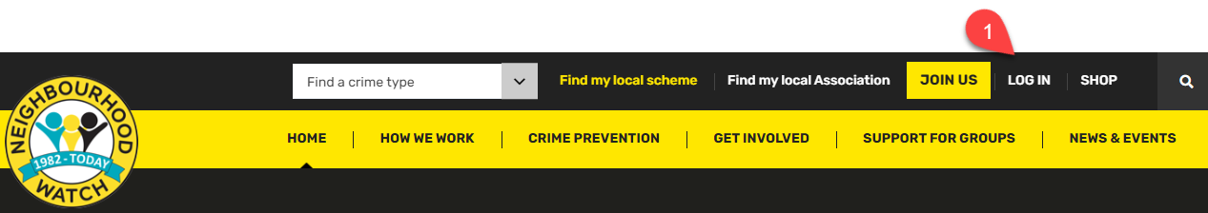
Tasks are completed using the Alert website. To access this secure area, you need to login to gain access to the scheme and membership administration areas.
- Go to https://ourwatch.org.uk, you will need your username and password and click on LOG IN.
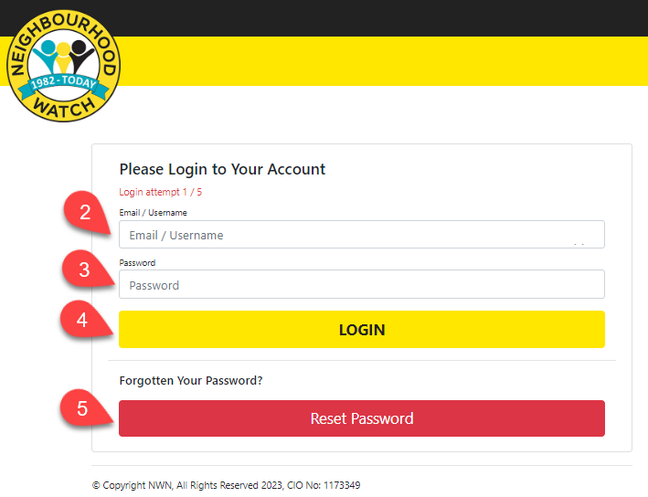
This will open the Log In page.

- Enter your email address or username.
- Then your password.
- Click LOGIN.
- If you have forgotten your password, you can create a new password by clicking the Reset Password button.

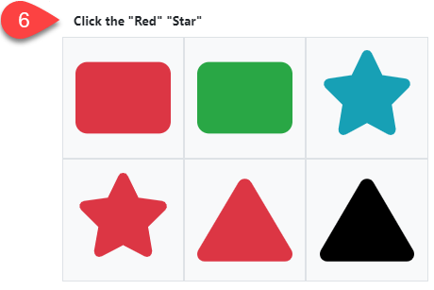
- When LOGIN is clicked a verification box will open. This will ask for one of the shapes to be clicked.

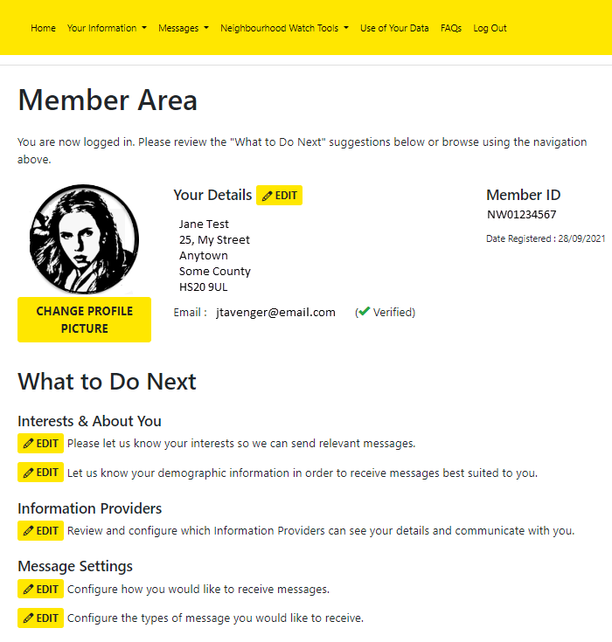
Your Information and Preferences
Once you are logged in your details will be displayed in the Member Area page. If any of your details need changing, click on the “What to do next” icon by the area you wish to change. You can return to the Member Area page at any time by clicking on Home in the top menu. This is described in more detail in the following sections.
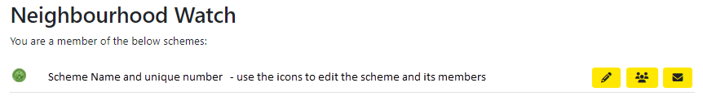
The bottom of the page shows either the scheme or schemes you are already a member of
or provides an opportunity to join or create a new scheme.
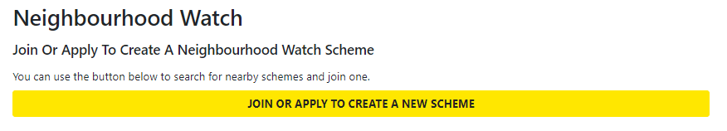

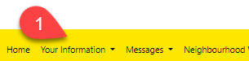
Your Information

- Selecting Your Information via the top menu opens links to each section of your personal details and preferences, or the “What to do next” icon next to the relevant section on the Member Area page displayed when you logged in or click on Home in the top menu.

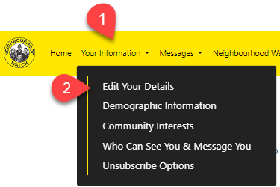
Edit Your Details
- Select Your Information from the top menu.
- Select Edit Your Details. The Edit Your Details page is displayed where your details can be updated.
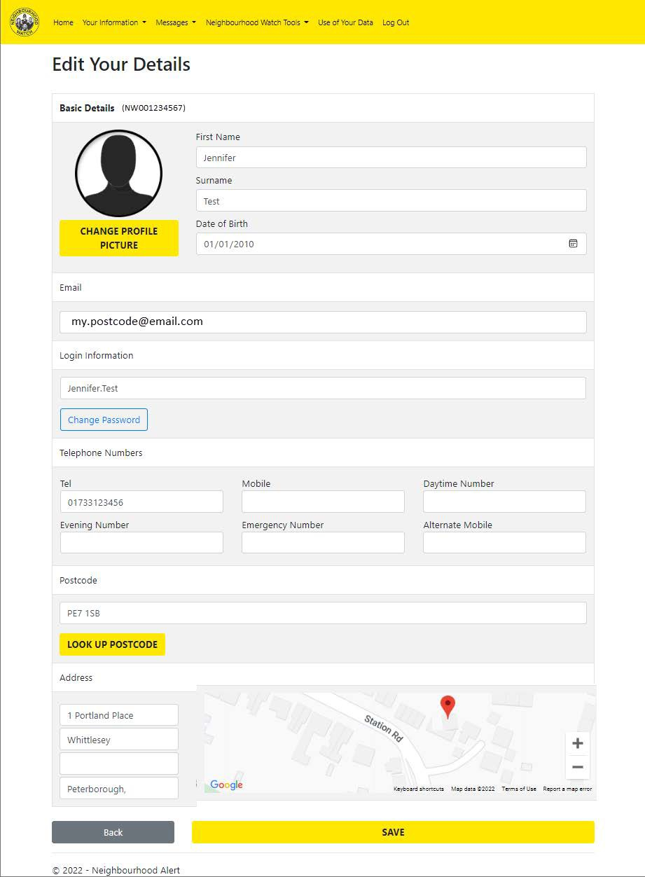
To make any changes to the information displayed, click in the box to change, and add, delete, or update the entry. If the address details need to be updated, you can enter the postcode of the address and click Look Up Postcode or enter the address details in the boxes. If the red address icon needs to be moved, you can click and drag it to the desired location.
If you would like to change your profile picture from the default silhouette, click the Change Profile Picture button. This will open a file browser where the required picture can be selected and opened. It is possible to scale the picture using a slider and move the picture by clicking and dragging (a circle shows the area that will be displayed). The picture can be rotated by clicking the appropriate arrows. Click on Set as Profile Picture to store the changed picture.
Remember to click on SAVE to save any other changes made to the details.

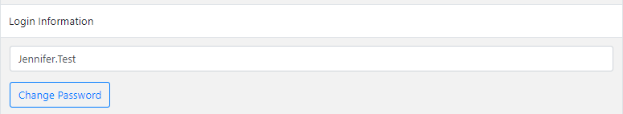
Login Information
It is possible to alter your username in the username text box under Login information. This may be helpful if you share your email address with someone else or you do not have an email address. By default, this is usually set to the email address entered when you initially registered. The system will check to ensure that the new username is not already in use before accepting the change. This will take effect next time you login. Be careful to make a note of what you choose to enter, or you will not be able to login next time.

Changing Your Password
Changing your password regularly is a sensible security precaution. Click Change Password and the ‘Please Create a New Password’ page will appear.
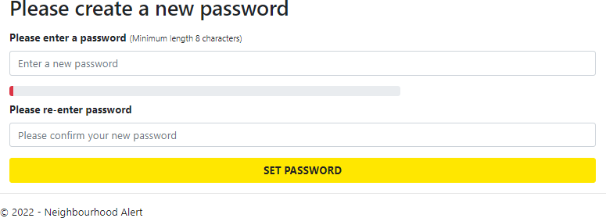

Enter the new password remembering that it is case sensitive. Repeat the same password in the second box.
Save the new password by clicking on SET PASSWORD. The new password will be required next time you log in. If you do forget the password, unlike the username, there is a forgotten password link on the login page which will help you to change your password for a new one. To recover your username, contact your local MSA.

Interests & About You

Demographic Information
Under the Equality Act 2010 we have a responsibility to eliminate discrimination and harassment, advance equality of opportunity and promote understanding between different groups. This area helps us to collect the information we need to meet this responsibility.
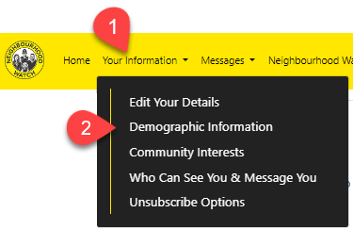
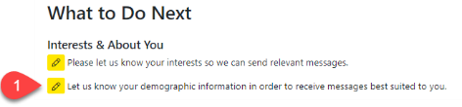
To enter or change your demographic information use either the top menu and select ‘Your Information’ then chose Demographic Information or click the pencil icon next to 'Let us know your demographic information in order to receive messages best suited to you’ in the What to Do Next section of the Home page.

This will open the Demographic Information page.
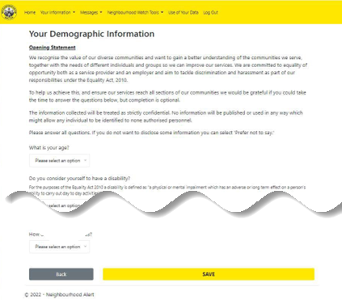
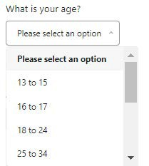
When all the options are completed remember to press SAVE to store the information. The information can be changed by revisiting this page at any time and re-selecting the original choice. The Back button will return to the Member Details page without saving changes.
Click next to the entry you wish to change or enter information for.
Use the scroll bar to see the options available.
Click to select a choice. 'Prefer not to say' is at the end of the list

Community Interests
Community Interests permits additional Alert messages from the community groups shown to be sent to the logged in user. The Community Interest Groups you opt into can be changed provided they are public groups. Some Community Groups are private and only the administrators of the group can invite members to join.
To join a new group, or leave one you already belong to, select Community Interests in the Your Information sub group from the top menu or click the “What to do next” icon next to ‘Please let us know your interests so we can send relevant messages’ .

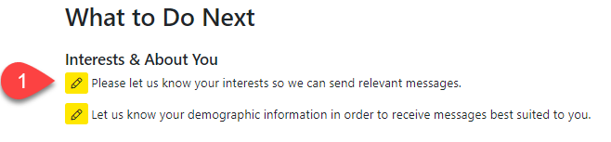
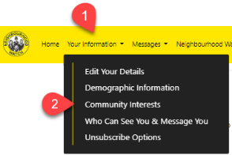

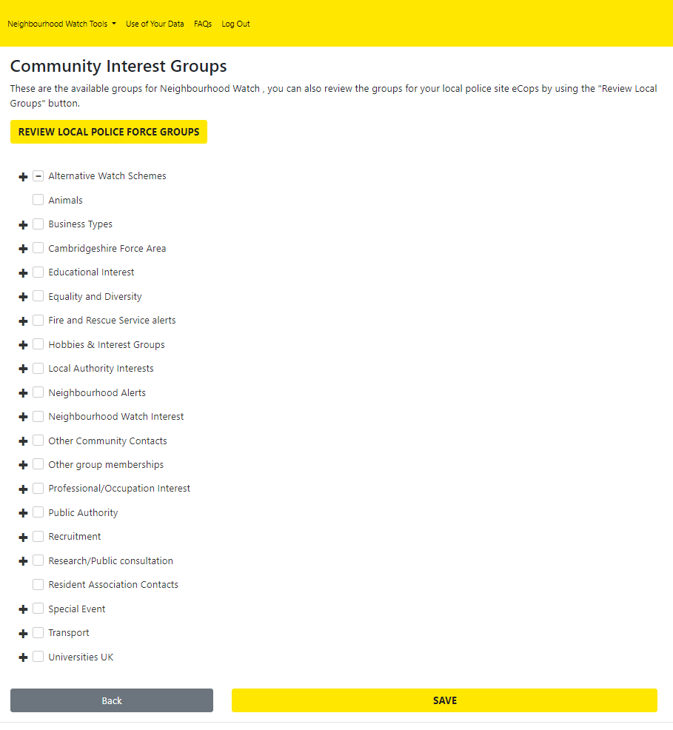
The initial view shows groups specific to Neighbourhood Watch. Clicking on REVIEW LOCAL POLICE FORCE GROUPS changes the view to show groups which are linked to another organisation in this case the local police version of Alert for your area.

Click on the View/Hide row icon to see the groups under each section.

Click on the box next to any groups you would like to receive Alerts from. If you decide to cancel this later, you can return to this area and untick the box.

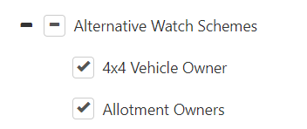
The 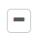 icon will untick any previously selected choice in the current section. Here the Alternative Watch Schemes section has been opened. An empty box next to the section name can be ticked clicked to show a tick . This will select all the groups in that section.
Remember to save any changes by clicking on the Save button at the bottom of the page. Clicking on Back will return to the Member Area page.

Information Providers
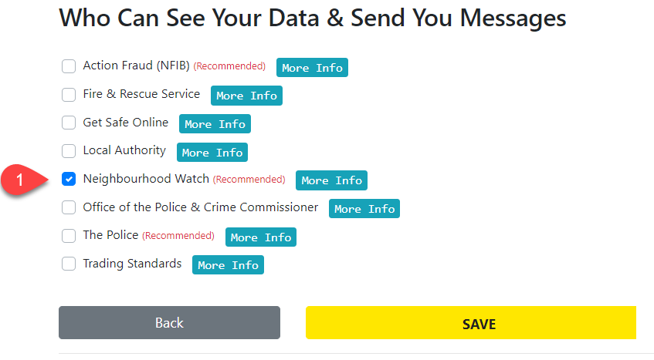
The organisations that you can agree to share your details and communicate with are listed here. Where organisations are not ticked their administrators cannot see your details or communicate with you. The recommended organisations are indicated and further information about them is made available by clicking on the button.
Remember to save any changes by clicking on the Save button at the bottom of the page. Clicking on Back will return to the Member Area page.

Message Settings
So far, the menu options have given different paths to arrive at the same options. This is not the case with message settings, so each route will be described separately beginning with the top menu route first.

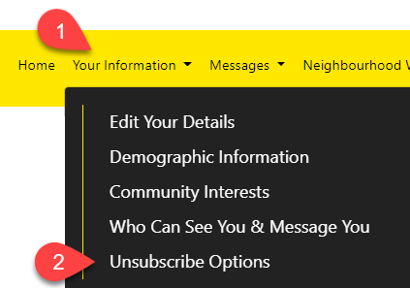
Unsubscribe Options
Select ‘Your Information’ and then ‘Unsubscribe Options’ from the sub menu. The Unsubscribe Options page is displayed.
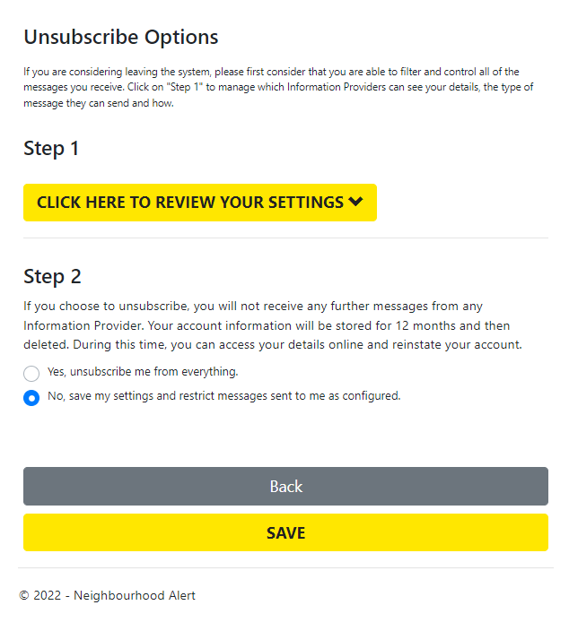
This page displays 2 steps. To open step 1 click on CLICK HERE TO REVIEW YOUR SETTINGS.
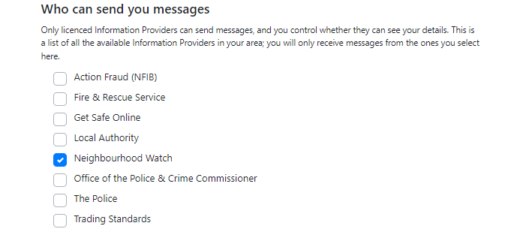
The next screen appears with Step 1 as the first section.
This allows you to select who can send you messages and whether they can see your details. Unticking or ticking the boxes either grants or removes the Information Providers ability to send you messages and to see your details. If you untick all boxes this is the same as using Step 2 to unsubscribe from the system except that you will not be allowed to save this set of choices as the system will warn you that you have to have at least one box ticked.

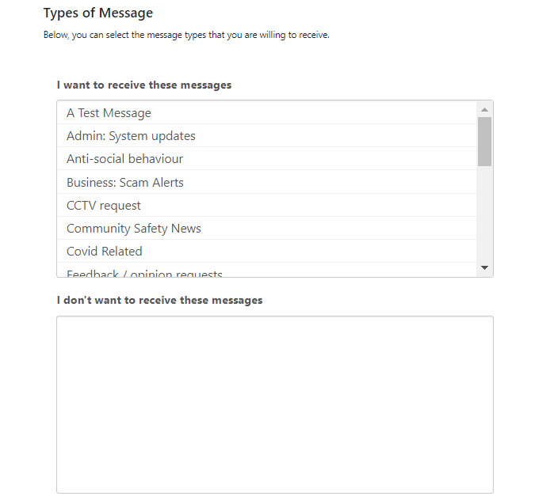
The second part of the page allows filtering of message types. Each message sent through the system has a specific message type which reflects the content of the message. If the type is listed in the ‘I want to receive these messages box’ then any message which has this type will be delivered to you. If you do not want to receive messages of a particular type of content, then click on it and it will transfer to the ‘I don’t want to receive these messages’ in the box below. You can reverse this process by clicking on any that are shown in the lower box, and they transfer back and will then be received.
Note that many messages are mixed content so moving Covid to the lower box will stop all messages with Covid set as their type, but this will block the entire message which may include other content of a different type which you may have wanted to see.

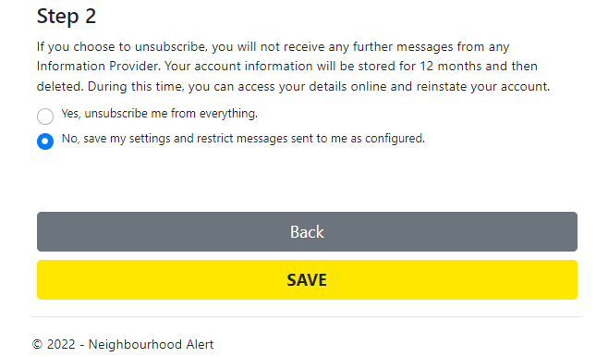
Step 2 is a way of unticking all provider boxes so that your account cannot be accessed or receive messages from any of the Information Providers. You will be asked to give a reason for unsubscribing.

Remember to save any changes by clicking on the Save button at the bottom of the page. Clicking on Back will return to the Member Area page.

Member Area – Message Settings
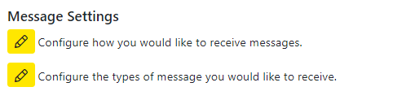
On the member area page, the message settings are shown under the ‘What to Do Next’ heading.

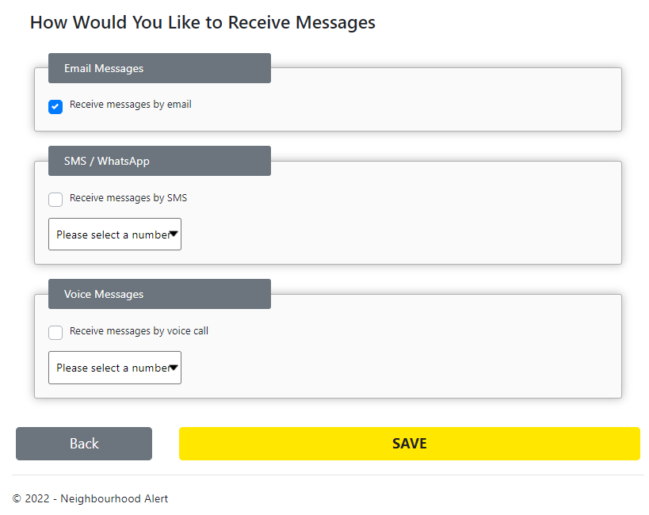
The first option allows you to choose the method used to send the messages to you. The choices allow email, SMS/WhatApp and Voicemail. For SMS/WhatsApp and Voice Messages you can select a call number from the appropriate drop-down boxes. If the number required is not available in your details, you will be prompted to enter this before the options can be saved.
Normally Neighbourhood Watch uses email so this should be selected.
Click on Save to save any changes made.

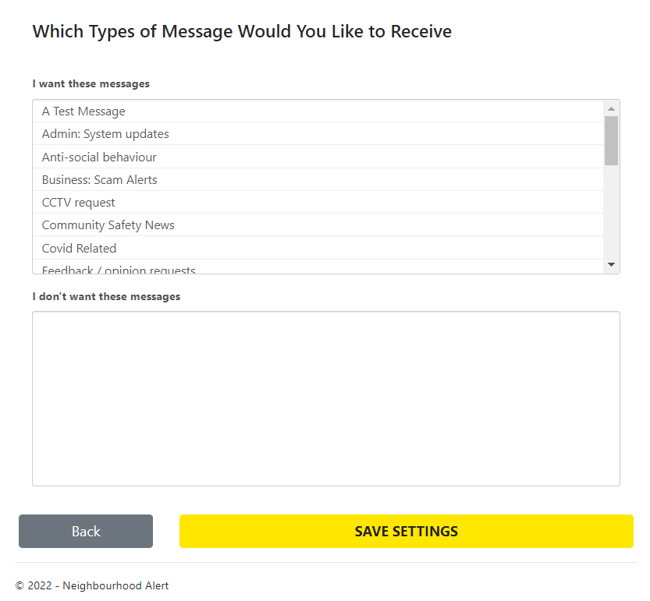
The second option configures the types of messages you receive so that only content from the selected types of messages can be received. This is the same as the second part of Step 1 above. Click on any message types that are in the top box to move them into the lower box. Any messages of the content type in the lower box are not sent to you. Clicking a message in the lower box move the type back to the like to receive box.
Remember that most messages contain mixed content so although the type of the message may be unwanted the message may contain other content which is from other types. As only one message type can be set the whole of the message will be blocked.

Save any changes by clicking on the Save button at the bottom of the page. Clicking on Back will return to the Member Area page.

Neighbourhood Watch
The last section of the member area page lists all schemes that you are a member of. If you are a coordinator, you can also find this information using the top menu bar under Neighbourhood Watch Tools and selecting Manage Schemes from the submenu. This is covered in more detail later in this guide.
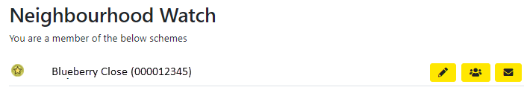

Your status in each scheme is shown by the icon to the left of the row. The status of a scheme member can be changed by using the pencil icon which opens the scheme editor.
 | Member of a scheme
 | Deputy Coordinator in a scheme
 | Main Coordinator of a scheme
 | Area Coordinator of multiple schemes

The icons at the end of the row allow you to administer the scheme and message it’s members. These tools can also be accessed using Neighbourhood Watch Tools -> Manage Schemes Neighbourhood Watch Tools described later in this guide. An area coordinator is assigned by an administrator and cannot be altered or deleted.
See Neighbourhood Watch Tools section for further details.
 | Edit the scheme
 | View and edit membership of the scheme
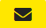 | Send a message to scheme members

Where the member is not already a member of a scheme the bottom section of the screen will provide an opportunity to join an existing scheme or apply to create a new scheme.
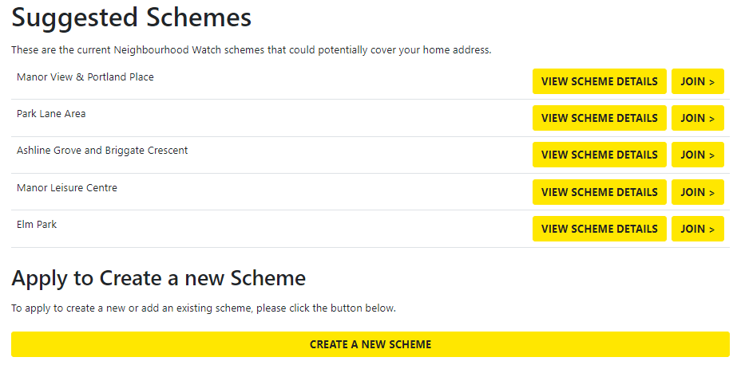
Clicking the JOIN OR APPLY TO CREATE A NEW SCHEME button will display a selection of local schemes that can be joined.

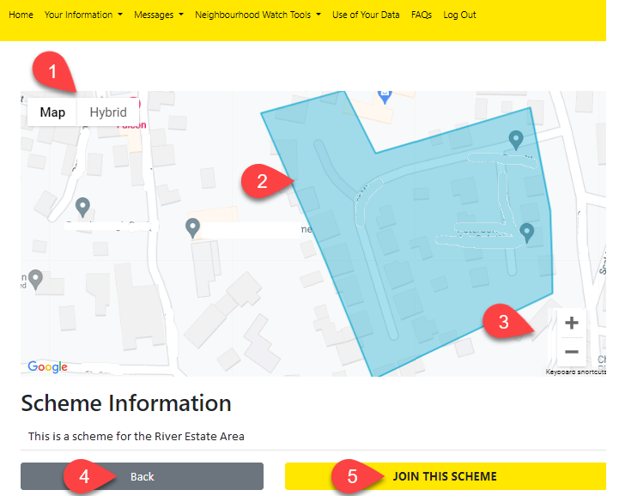
Clicking on VIEW SCHEME DETAILS will show the location and description of the scheme to help with making a suitable choice.

- Use the options to change from the default map view to the hybrid view which shows an arial view.
- The scheme coverage area is shown in a semi-transparent blue.
- Click on + or – to enlarge or reduce the map’s zoom level.
- Click on Back to return to the scheme choices screen.
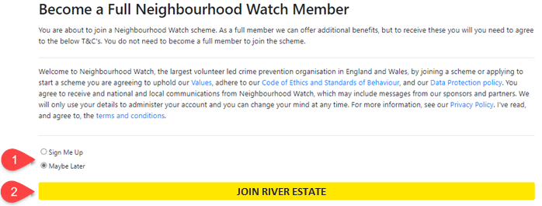
- Clicking on JOIN THIS SCHEME opens the screen below.

When you join a scheme, it will allow you to become a fully registered Neighbourhood Watch Member.
- You can choose to join the scheme now or later. Selecting Maybe Later will allow the user to look at the other suggestions and make a more informed choice. To join the scheme, ensure that the “Sign Me Up” option is selected. As the action of joining a scheme also includes becoming a full member the Terms and Conditions are displayed.
- The JOIN button includes the name of the scheme the member will be joining. When this button is clicked the member joins the selected scheme.
An email will be sent automatically to the scheme coordinator to inform them that a new member has indicated they have joined the scheme. There is a link in the email for the coordinator to reject the application.
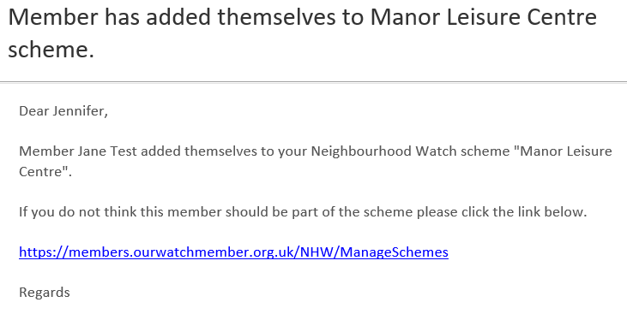

Apply to Create a New Scheme
If none of the existing schemes are suitable then there is an option to apply to create a new scheme. This is described in detail in the Applying to Create a New Scheme section of this guide.

Messages
The Messages option on the menu provides a set of controls for reading and controlling what messages will contain and how they will be delivered. Many of these functions are available via other menu routes but this menu brings them together for convenience.
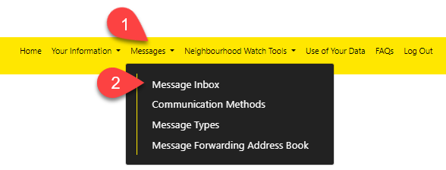

Message Inbox
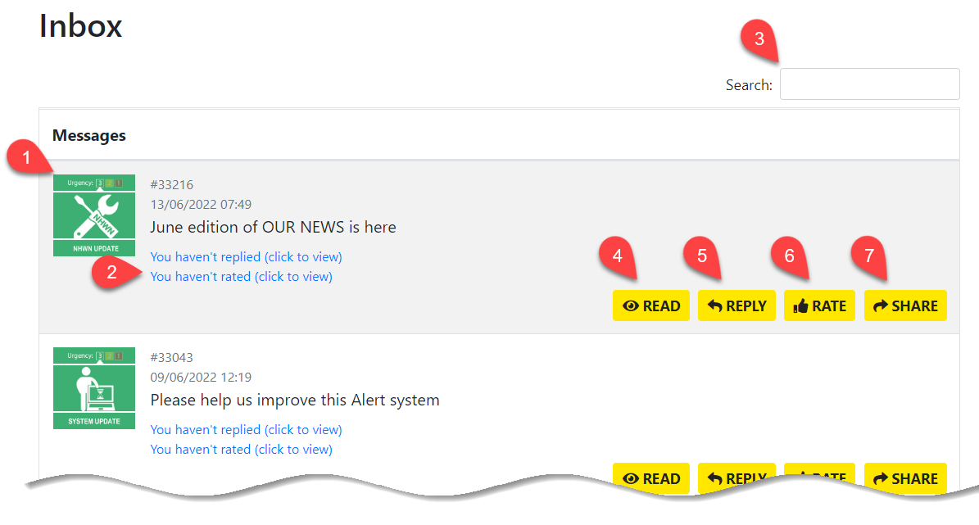
The Message Inbox displays all the messages you have received in date order starting from the most recent. It is where you can read, reply, rate and share your received messages. These are described in more detail in the following sections. As the list of messages may become quite long over time there is a navigation menu at the bottom of the page.

- The icon shows the urgency of the message on a scale of 1 -3 using traffic light colouring. The least urgent is coloured green through to most urgent in red. It also the displays the message type, remember that the message may be mixed content so the type may not reflect accurately the full content of the message.
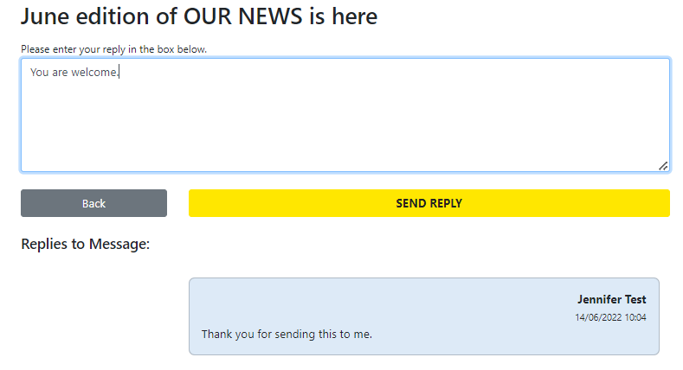
- Reminders are shown here which will display the message replies and link to the ratings page when clicked (detailed explanation of ratings follows after the explanation of replies).
The replies page shows a trail of all the replies for the selected message in date order most recent first. You can add further responses in the box at the top which will be added to the trail underneath. This is like a webchat system allowing rapid and secure communications between recipients.
- Search allows you to enter a key word or phrase that appears in a message title. Entering text and pressing return will filter the received messages list to show only messages meeting the criteria.

- Clicking on  opens the message so that it can be read. Messages are kept in an archive that can be searched and reviewed. There is also a complete audit mechanism built into Alert allowing messages and replies to be viewed.
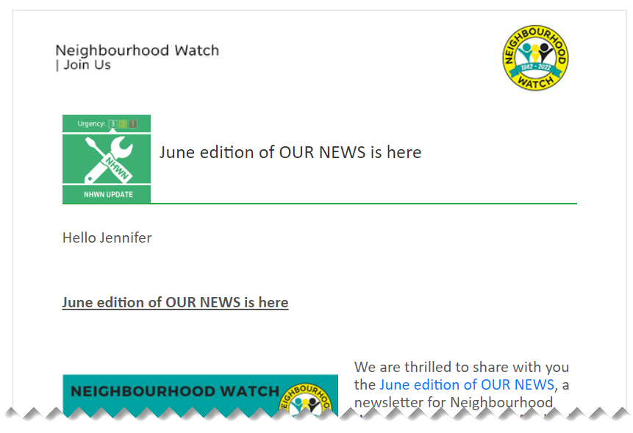
- The  button will open a view of the selected message and check that this is the message that the reply is related too. Click No to cancel replying and stay on this view. Use the back button on the browser to return to the list of messages. Click YES to confirm this is the message you want to reply too and continue to the reply view.

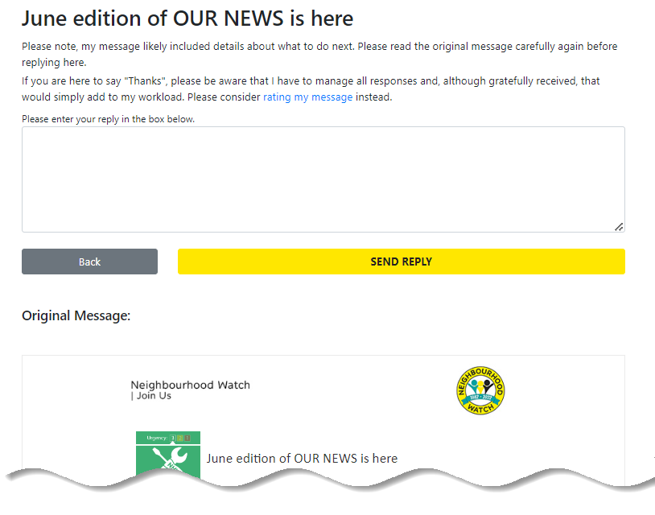
Type your reply in the text box, the original message is displayed below for reference and click the SEND REPLY button to send the message. Click Back to cancel replying and return to the messages list.
When the reply has been sent a confirmation message appears. Click BACK TO RECEIVED MESSAGES to exit this screen and return to the received messages list. The reminder will now show that you have replied and when.

- Clicking the  button allows messages to be rated according to their relevance, content, and quality on a three-point scale. By default, these are set to which can be changed by clicking on the thumbs-up icons. A short feedback survey is included along with an original of the message being evaluated. Clicking SUBMIT RATING acknowledges your rating has been sent and clicking BACK TO RECIVED MESSAGES return to the received messages list.
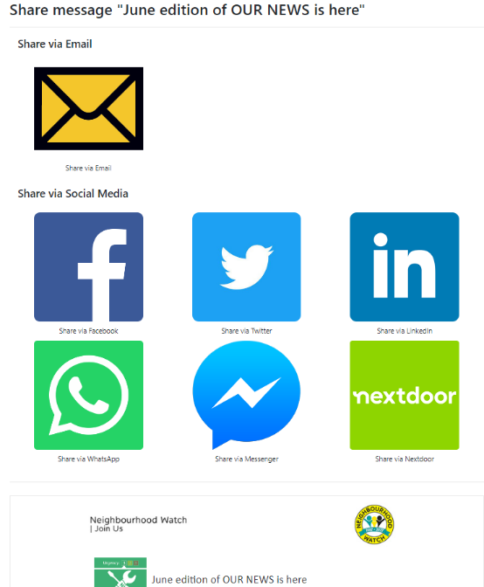

- The 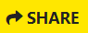 option will allow the original message to be shared with more recipients than originally intended. For the purpose of this guide, we will use email in this guide although other options may be available in your area. The first view shows the alternative methods for sharing a message. Clicking on the Share Email icon will open a new view where the people that you are sharing the message with can be selected.

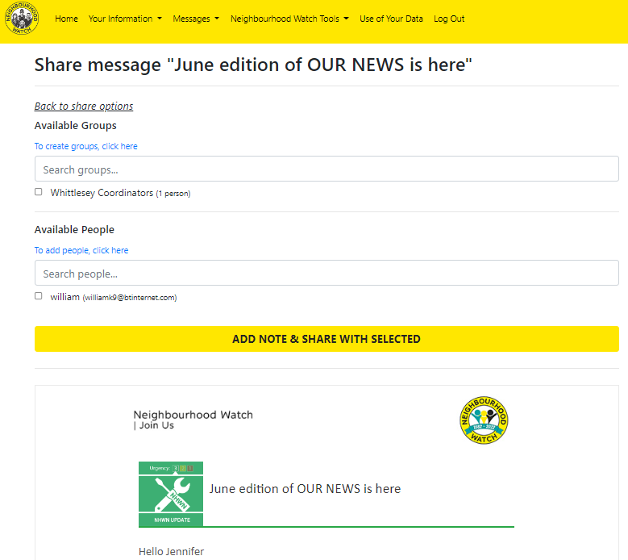

The original message is shown underneath to check that the intended message is being shared. The people you can share with will be shown in the Available Groups and Available People. It is possible to add extra groups and names by clicking on the links under each heading which both open the Message Sharing Address Book.
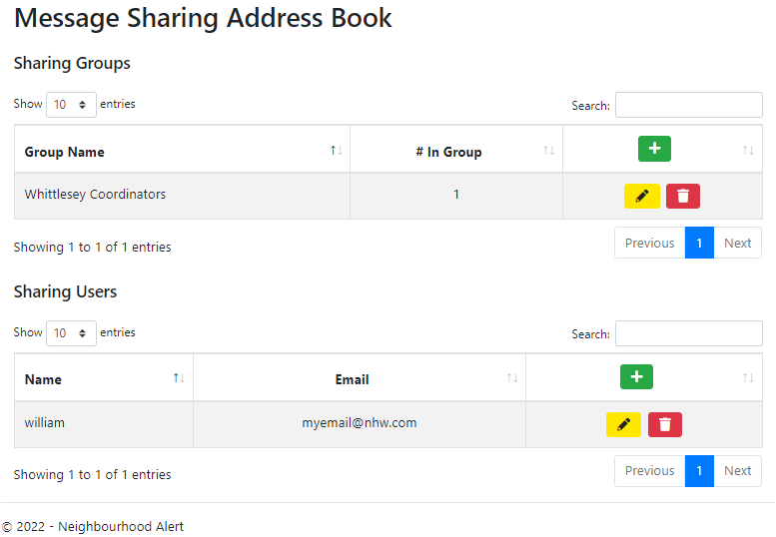
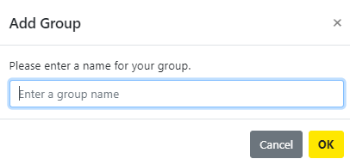
Clicking on the in the Group Name row with Sharing Groups will allow a new group to be created enter a name for the group. Click OK and the group will be added to the group list. Create groups before adding the people so that new people can be added to the correct group as they are created.
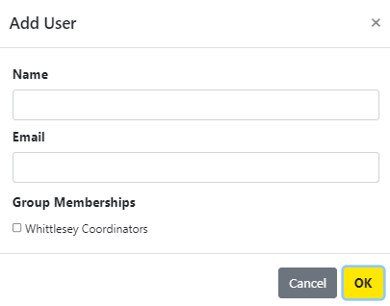
To add new users, click on the in the Name row within Sharing Users. Enter the name and email address of the user. The user can be any member of the public that is known to you. Finally, you can add the new user to a group by ticking the appropriate group box. Click on OK to save.

If you need to make changes to existing groups or members click on the pencil icon in the group or user sharing areas. The appropriate box with be shown and information can be re-typed until correct. Unticking any group setting for a user will remove them from the group.
To remove a sharing group or user click on the bin and the item will be removed.

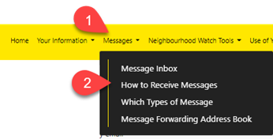
How to Receive Messages
This option allows you to choose the method used to send the messages to you. The choices allow email, SMS/WhatsApp, and Voicemail. For SMS/WhatsApp and Voice Messages you can select a call number from the appropriate drop-down boxes. If the number required is not available in your details, you will be prompted to enter this before the options can be saved.
Normally Neighbourhood Watch uses email so this should be selected.
Click on Save to save any changes made.

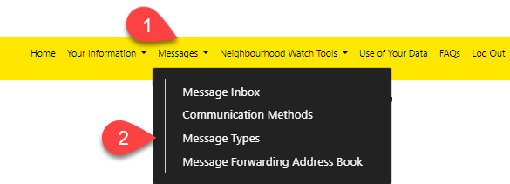
Message Types

This option allows you to decide which type of messages you will be sent by filtering out unwanted message types.
Each message sent through the system has a specific message type which reflects the content of the message.
If the type is listed in the ‘I want to receive these messages box’ then any message which has this type will be delivered to you. If you do not want to receive messages of a particular type of content, then click on it and it will transfer to the ‘I don’t want to receive these messages’ box.
You can reverse this process by clicking on any that are shown in this box, and they transfer back and will then be received.
 Note that many messages are mixed content so moving Covid to the lower box will stop all messages with Covid set as their type, but this will block the entire message which may include other content of a different type which you may have wanted to see.
Click SAVE SETTINGS to save any changes or click Back to return to the Member Area.
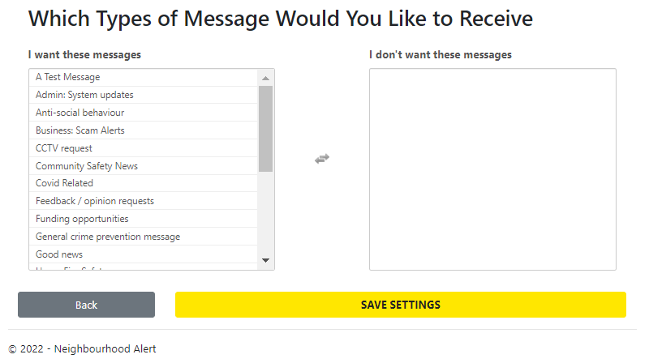

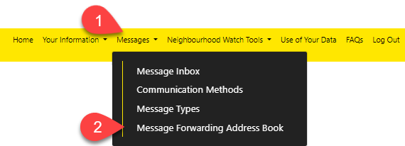
Message Forwarding Address Book

The Message Sharing Address Book allows members of the public to receive messages through the Alert system when the messages can be shared. This makes it possible for messages to include non-members of Neighbourhood Watch such as Police Officers from the local Neighbourhood Policing team and Local Councillors to receive communications from Coordinators. Clicking on the Message Forwarding Address Book option in the Messages submenu opens the address book page.
Clicking on the in the Group Name row with Sharing Groups will allow a new group to be created enter a name for the group. Click OK and the group will be added to the group list. Create groups before adding the people so that new people can be added to the correct group as they are created.To add new users, click on the in the Name row within Sharing Users. Enter the name and email address of the user. The user can be any member of the public that is known to you. Finally, you can add the new user to a group by ticking the appropriate group box. Click on OK to save.
If you need to make changes to existing groups or members click on the pencil icon in the group or user sharing areas. The appropriate box with be shown and information can be re-typed until correct. Unticking any group setting for a user will remove them from the group.
To remove a sharing group or user click on the bin and the item will be removed.

Neighbourhood Watch Tools

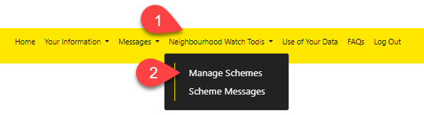
Manage Schemes
- Managing scheme administration and sending messages to scheme members are two key tasks for a coordinator.
- Clicking on Manage Schemes will open the Your Schemes view which can also be opened from the Member Details page as described previously. If no schemes are listed, you will need to click the JOIN OR CREATE A NEW SCHEME go to the Join or Create a New Scheme section of this guide.
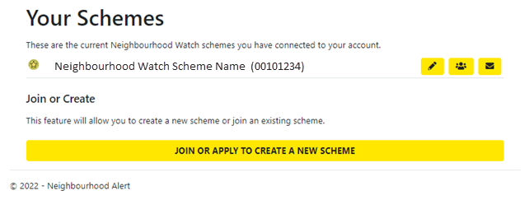
The first part of the screen will list all the schemes you are a member of. It is possible to be a member in more than one scheme. An Area Coordinator may be allocated a number of schemes which they can oversee for instance to act as a mentor to a new coordinator or where a coordinator cannot be replaced.
Your status in a scheme is shown by the icon to the left of the row. The status of a scheme member can be changed by clicking the pencil icon which opens the scheme editor described in the next section.
The status icon meanings are listed in the table below.
Member of a scheme
Deputy Coordinator in a scheme
Main Coordinator of a scheme
Area Coordinator of multiple schemes

The icons at the end of the row allow you to administer the scheme and message it’s members.
Edit the scheme
View and edit membership of the scheme
Send a message to scheme members

The purpose of a scheme is to show an area that coordinators administer. Most scheme boundaries are defined by using local cultural or geographical aspects which strengthens its cohesion and purpose to the community it supports. This prevents, to some extent, overlapping of coordinators responsibilities and is unique to Neighbourhood Watch. However, this does not preclude any member from outside the scheme area from applying to join any scheme or deciding not to join a scheme when joining Neighbourhood Watch. This might be important where a friend or relative wants to be informed of what is happening in the area where a vulnerable relative or person lives but they live outside the scheme. This principle of external membership of the scheme is also essential for an Area Coordinator who may be a member of multiple schemes.
As a coordinator your role includes designing the area that you feel comfortable in coordinating. This can be of any size, possibly starting with a small number of houses and expanding if you want as more people ask to join. There will be other administrators, coordinators and the Ourwatch website that can provide guidance on deciding what would be a good starting point for you.

Edit an Existing Scheme
The following text assumes you want to make changes to your existing scheme description. You will not be able to re-map the scheme boundaries. To do this you must ask your local MSA. If you are only intending to change the membership, use the View and Edit Membership of the Scheme icon as this focuses on just that task. When you click on Edit the scheme editor will be displayed.
This is divided into two parts. The first half deals with the written details of the scheme and the second half will allow you to map the boundaries of your scheme. As mentioned above you are only able to view this and plan any changes which will be made for you by an MSA.

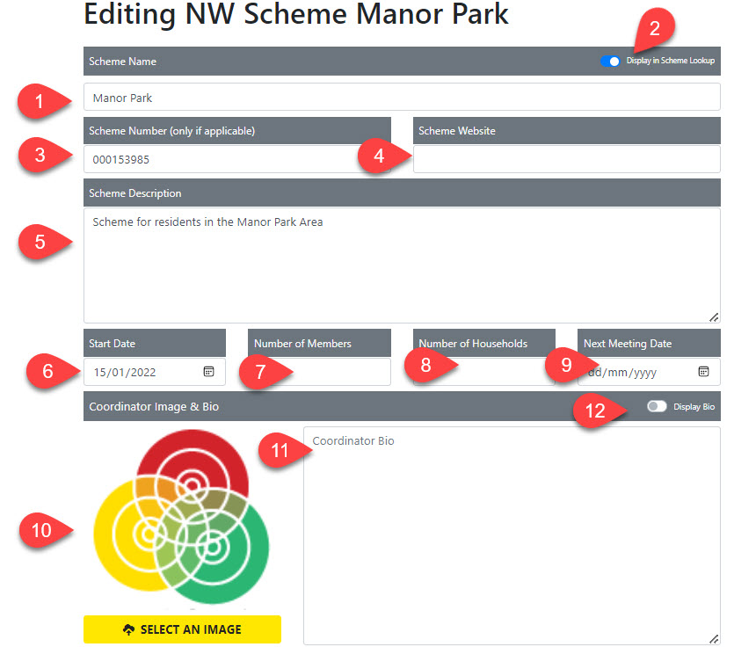
- The Scheme Name is how your scheme will be recognised in maps and searches, so it is important to make it as unique as possible and short as possible. You may wish to include your postcode or some other detail in the Name if your street uses a commonly used name or a range of house numbers if you cover part of a long road for example, High Street (Odd Nos. 1- 21).
- The Display in Scheme Lookup slider can be turned off if you are planning your scheme but don’t want it to show on the Ourwatch Scheme Finder just yet. You can come back and change this when you are ready.
- You will not know the scheme number as it has not been created yet. Leave this blank and the system will fill the number in when you click Save Data. The scheme number is unique to your scheme and could be added to the scheme name if required. It could be a useful aid in identifying and verifying a Facebook site as genuine if incorporated into the Facebook banner.
- If you have a website, you may wish to highlight it from the scheme. If so you can fill the URL in here if not leave blank.
- The details are shown to prospective members when they are thinking of applying. You can type a fuller description of the scheme and include something that helps people understand its purpose.
- The start date of your scheme (use the date picker or type the date)
- You can enter several members here – it can be a target number rather than actual or left blank
- The number of households is helpful it can be any number from 0 onwards – if you want to be accurate you can count the houses on the map using the hybrid view described below.
- Next meeting date – leave blank if no meetings are planned.
- You can add your photo if you wish by clicking SELECT AN IMAGE and uploading the picture you want to use. This will help your members to recognise you.
- The coordinator bio can provide members with an online introduction to you.
- If you do not want the coordinator photo or bio to display online then move the bio slider to off.

Remember to click on SAVE DATA at the bottom of the page to save any changes you have made.

The lower half of the page provides the tools to alter the coverage area of the scheme which you can set when creating a new scheme. This will allow you to define the area of the scheme when you create it. After that if changes are needed, for instance if the scheme needs to expand its coverage to cater for changes in the local requirements, you will need to ask the local MSA to do this for you.
Scrolling down the page will display the coverage area map.
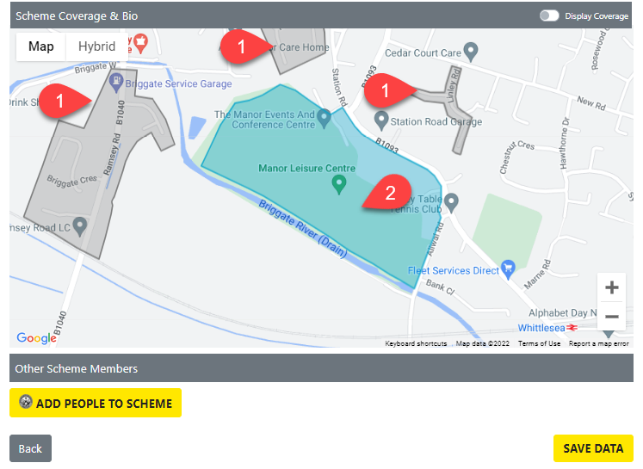
This shows all other schemes in the area in dark grey on the map. Your own scheme is shown in blue colour
Click the ADD PEOPLE TO SCHEME button this will open a view of the current membership which can also be opened directly by clicking on the View and Edit Membership icon at the end of the row.

View and Edit Membership
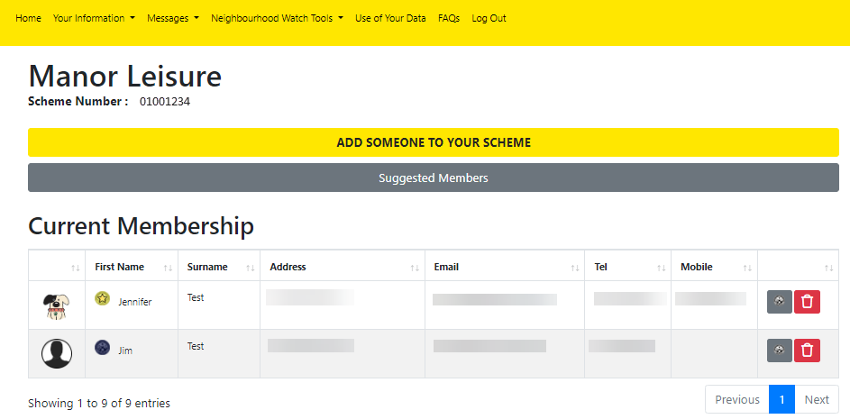
The current membership of the selected scheme is shown first.
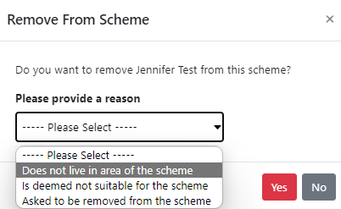

It is possible to delete a member by clicking on the bin icon at the end of the row. A warning dialogue is shown. Chose a reason for the deletion which is a best fit for your reason then confirm by clicking Yes. To cancel the deletion, click on No

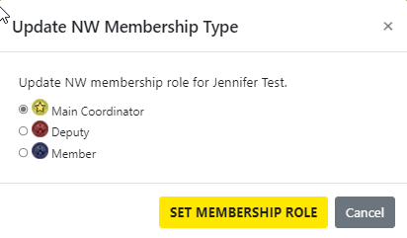
You can click on the status button to change the status of the member in this scheme. Their status will remain unchanged in any other scheme. The Update Membership Type window is shown from which a new status can be selected by clicking on the radio button of choice and then click SET MEMBERSHIP ROLE
You will not see Area Coordinator on the list as this role is set by an administrator.

To add more members who have previously registered on Alert to the scheme, click on Suggested Members to open the next view.
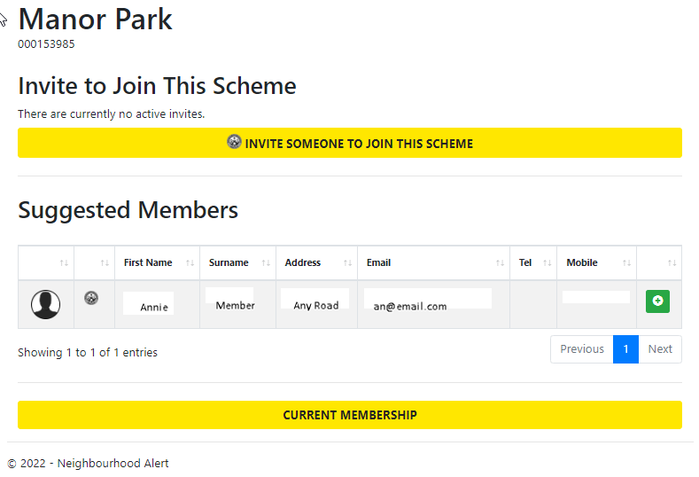
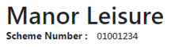
This screen provides two methods for adding new members, from the suggested members and by invitation.

Suggested Members
The suggested members are those members already recorded on the system who live within the boundaries of the scheme but are yet to join a scheme. To add any of the members listed onto the scheme named at the top of the view, click on the add member icon.
The Update NW Membership Type view will be shown so that the status of the new member can be set by clicking the radio button next to the appropriate type.
Click on the SET MEMBERSHIP ROLE button and the member will be added to the current scheme member list.

Invited Members
Invited members can be any member of the public registered on the system whose name and email address you know. They will receive an email from Alert explaining that have been invited to join the scheme which will provide them with links to web addresses needed to join Neighbourhood Watch and complete their registration.
To start the invitation process, click on the INVITE SOMEONE TO JOIN THIS SCHEME button.

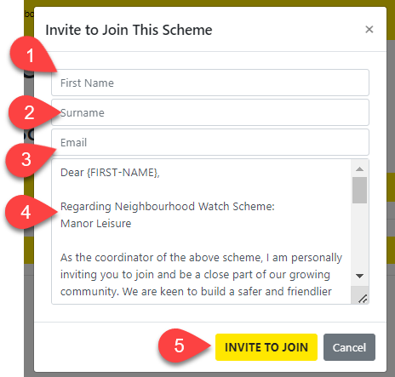
The Invite to Join this Scheme view will appear.
1. Enter the First Name
2. Enter the Surname
3. Enter the email address of the person you are inviting.
4. The email they will receive is shown below the details entered. It will have some merge fields e.g. {FIRST-NAME} which will be replaced by personalised text in the email that will be sent to the recipient. The text of the email can be amended to take account of local preferences.
5. Click on INVITE TO JOIN and the invitation will be sent by email.
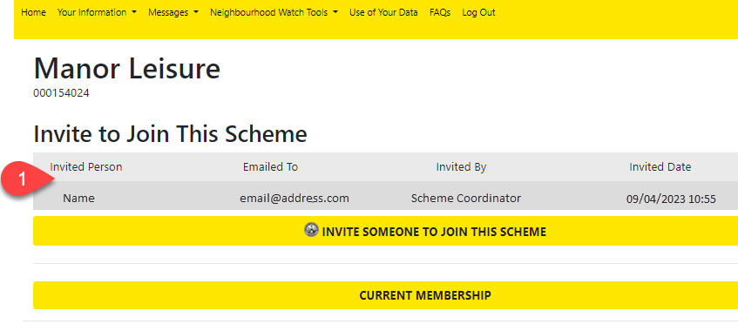
The screen will add the invite to the initial screen as reminder of who and when invites have been sent.

When the recipient opens the email invite link they will open this view and be able to click on the acceptance which will ask them to agree our terms and provide further details to complete their registration.
Once completed clicking NEXT will open further details for the user to complete.

The invited member of public will be able complete their registration to Neighbourhood Watch and once they click COMPLETE REGISTRATION will become a member of both Neighbourhood Watch and the scheme.
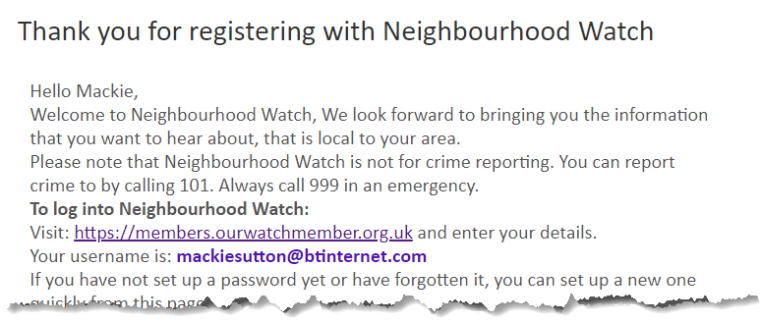
The recipient will receive a welcome email telling them what to do next.

Add someone to your scheme.
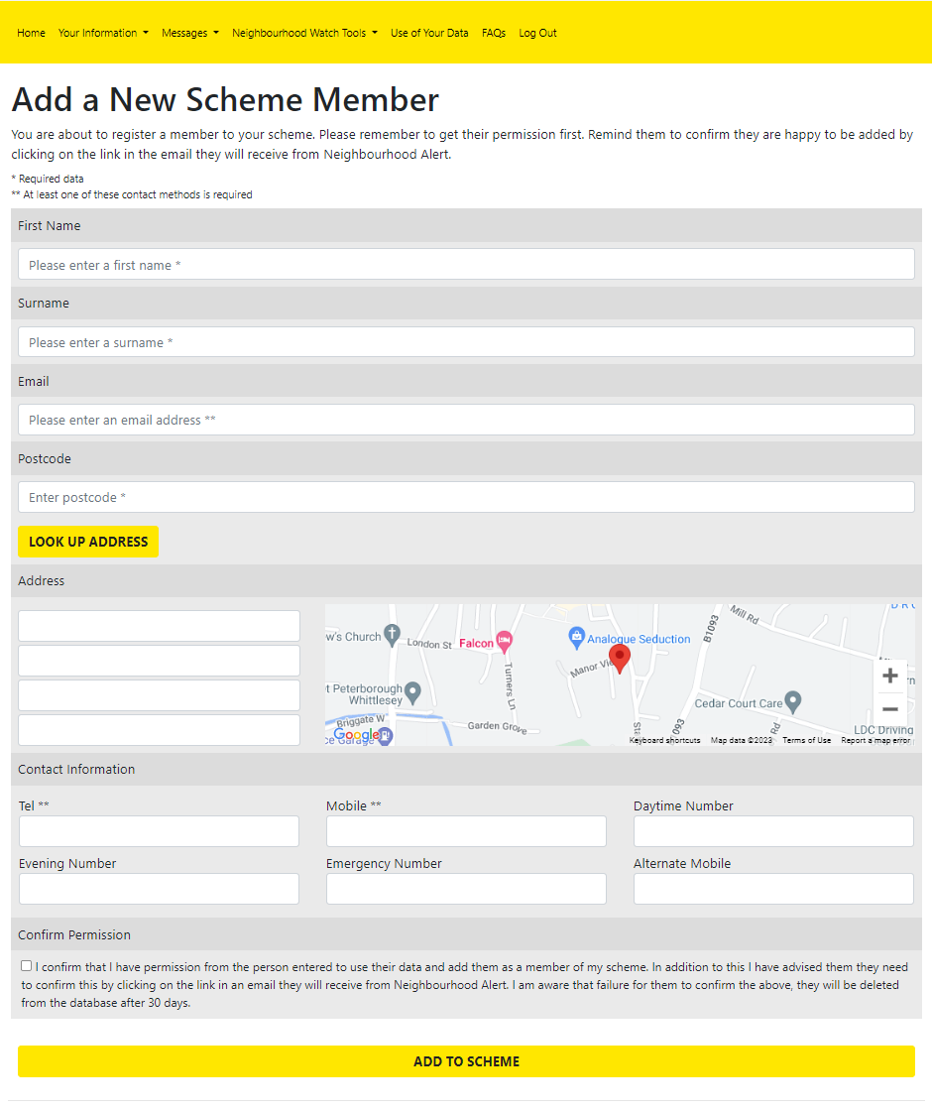
Add someone to your scheme will allow you to add a person to your scheme who is not on the Alert database. This both creates a new record on Alert for the person and adds them to the membership list of the scheme selected. Click on ADD SOMEONE TO YOUR SCHEME. The details screen is displayed. Note especially the text which explains the permissions that are required which must be obtained from the individual. Click ADD TO SCHEME when the details are complete and person will become a registered member of the selected scheme.

Send a message to scheme members.
The third icon, send a message to scheme members is a link to the Scheme Messages option from the top menu Neighbourhood Watch Tools -> Scheme Messages detailed in the next section.

Applying to Join or Start a New Scheme
This part of the guide applies if you clicked on JOIN OR APPLY TO START A SCHEME. If you did not click on this option, skip this section.
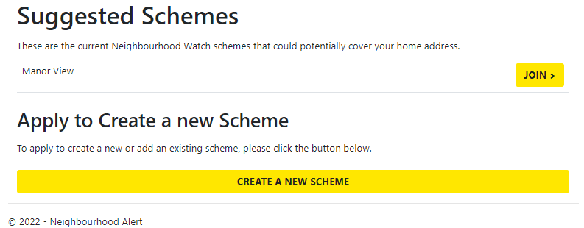
When you click on JOIN OR APPLY TO START A SCHEME, a list of suggested existing schemes will be displayed along with the option to CREATE A NEW SCHEME.

Suggested Schemes
Suggested schemes are selected from the existing schemes which may be close to where you live. This is the most appropriate choice for a member who wants to join a local scheme or if a coordinator wants to join another local scheme to help their coordinator, for instance as a deputy, or to cover the absence of the original coordinator.
Click JOIN to begin joining the scheme.
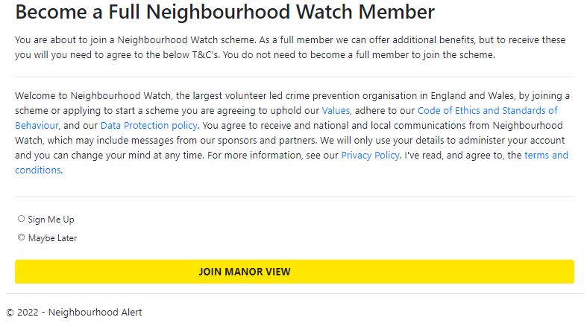
The next view allows user to click a radio button to become Full Member. Click JOIN [Scheme Name]
The scheme will be added to the user’s scheme list. As the new member of the scheme is given Member status, they will only see the message and bin icons. The coordinator or an MSA will be able to change the status if necessary.

Applying to Start a New Scheme
A new scheme can be set up ready for use by any member, but it will need approval from an administrator of the system before use.
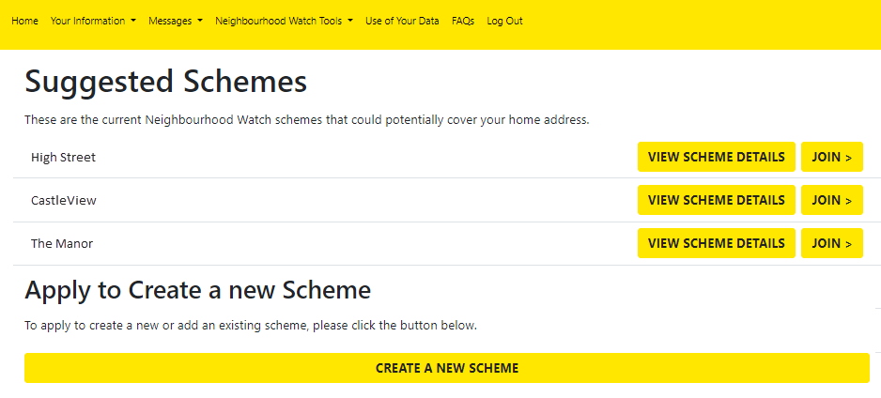
When you click on JOIN OR APPLY TO START A SCHEME, a list of suggested existing schemes will be displayed along with the option to CREATE A NEW SCHEME.

Click on CREATE A NEW SCHEME.

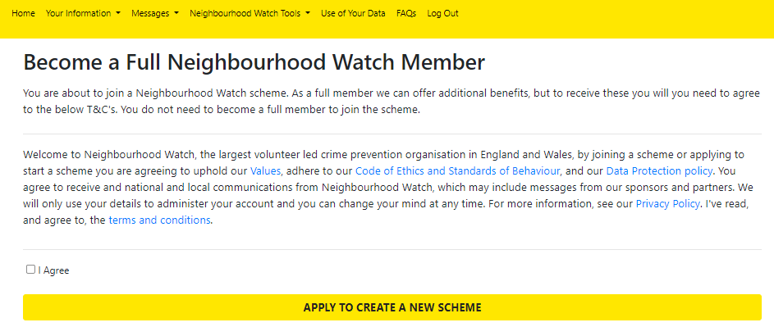
The Become a Full Member Screen is shown whether you are already a full member or not. Tick the I Agree box and then APPLY TO CREATE A NEW SCHEME.
The scheme creation screen is then displayed.
This is divided into two parts. The first half deals with the written details of the scheme and the second half will allow you to map the boundaries of your scheme.
- The Scheme Name is how your scheme will be recognised in maps and searches, so it is important to make it as unique as possible and short as possible. You may wish to include your postcode or some other detail in the Name if your street uses a commonly used name or a range of house numbers if you cover part of a long road for example, High Street (Odd Nos. 1- 21).
- The Display in Scheme Lookup slider can be turned off if you are planning your scheme but don’t want it to show on the Ourwatch Scheme Finder just yet. You can come back and change this when you are ready.
- You will not know the scheme number as it has not been created yet. Leave this blank and the system will fill the number in when you click Save Data. The scheme number is unique to your scheme and could be added to the scheme name if required. This could be a useful aid in identifying and verifying a Facebook site as genuine if incorporated into the Facebook banner.
- If you have a website, you may wish to highlight it from the scheme. If so, you can fill the URL in here if not leave blank.
- The details are shown to prospective members when they are thinking of applying. You can type a fuller description of the scheme and include something that helps people understand its purpose.
- The start date of your scheme (use the date picker or type the date)
- You can enter several members here – it can be a target number rather than actual or left blank
- The number of households is helpful it can be any number from 0 onwards – if you want to be accurate you can count the houses on the map using the hybrid view described below.
- Next meeting date – leave blank if no meetings are planned.
- You can add your photo if you wish by clicking SELECT AN IMAGE and uploading the picture you want to use. This will help your members to recognise you.
- The coordinator bio can provide members with an online introduction to you.
- If you do not want the coordinator photo or bio to display online, then move the bio slider to off.
The lower half of the page provides the tools to alter the coverage area of the scheme which you can set when creating a new scheme. This will allow you to define the area of the scheme when you create it. After you click SAVE DATA if any further boundary changes are needed, for instance if the scheme needs to expand its coverage to cater for changes in the local requirements, you will need to ask the local administrator to do this for you.
Scrolling down the page will display the coverage area map.
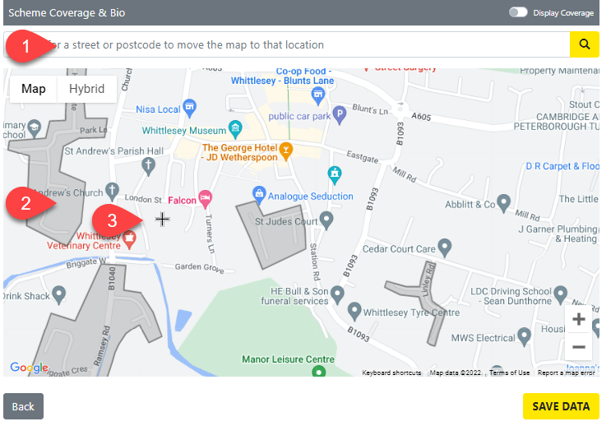
- Entering a post code or address allows the map to be moved to an appropriate area. The map can also be moved by clicking and dragging.
- This map shows existing schemes in the area in dark grey on the map. You can switch to a hybrid view if it is helpful to see the arial view of an area by clicking on hybrid in the top left box. Note that as schemes are shown in a semi-transparent colour the dark grey may change in appearance if the scheme area includes parks or lakes etc.
- A small cross shows where the drawing point for the boundary of your scheme is currently located. This can be moved using the pointing device on your computer. Move the mouse to the start of your boundary and click to show the first location dot.

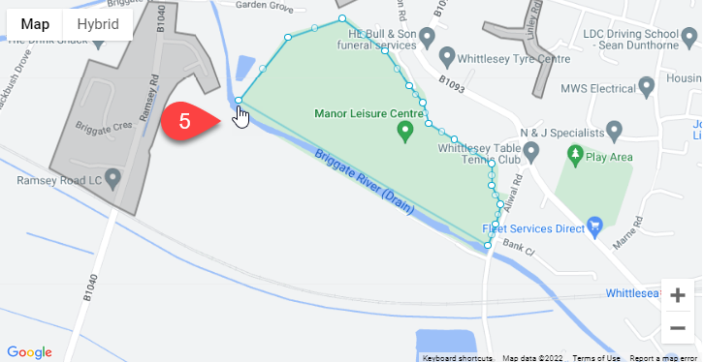
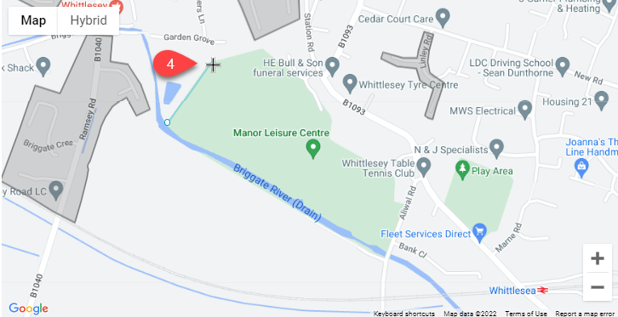
- The map will now show a straight blue line from that dot to the current location of the cross. Click again and this will set a second fixed point. The scheme must have at least three points to be saved.

- Keep moving and clicking until the boundary encloses the area required. To finish hover over the starting point and the cross will change to a hand. Clicking now will close the boundary.

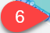
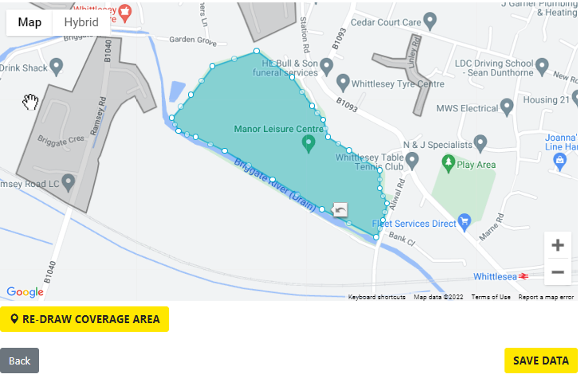
- The shape you have drawn now shows a solid colour. If you want to change the shape, click and drag the dot nearest to the change. If you wish to remove a dot, click the arrow icon and it will be removed. The line will be a straight line between the dots either side.
When the shape is completed a RE-DRAW COVERAGEA AREA button appears. This deletes the shape so that it can be redrawn.
SAVE DATA saves all the data entered on the page. The scheme shape is now fixed and cannot be changed although it is still possible to change all the other data. The unique scheme number is is filled in by the system once the data has been stored.
Once saved the creating user is automatically added to the scheme and the coverage area of the scheme cannot be changed by a coordinator. If you need to change the area boundaries, you will need to contact an MSA to make the change.
After SAVE DATA is clicked the add people area is shown at the bottom of the page. If you wish to add more people to the scheme, click the ADD PEOPLE TO SCHEME button this will open a view of the current membership which can also be opened directly by clicking on the View and Edit Membership icon at the end of the row. This function has been explained in detail in the View and Edit Membership section of the guide.

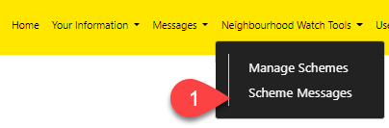
Scheme Messages
- Scheme Messages is designed for sending messages to your scheme members. This is a secure and easily identifiable method for sending messages than using an email client on your machine. The messages are recorded by the system for easy recall. There is no need to know the emails for your members or to store them on your local machine as the system will look after all aspects of creating and sending the email using the information stored in the Neighbourhood Watch Database.

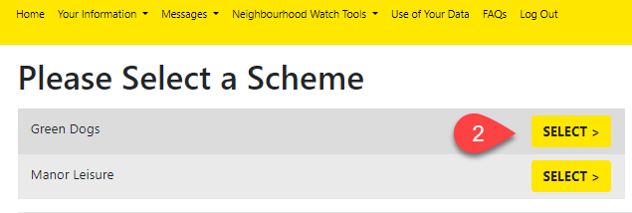
- The next view shows the schemes that you are a coordinator for. Click on SELECT> to send messages to the selected scheme members.
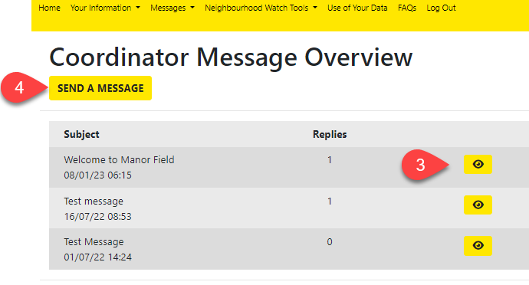
- The Coordinator Message Overview shows a list of previous messages sent each of which can be viewed by clicking on the view message icon. It also shows how many replies have been received.

- Click on the SEND A MESSAGE button to start composing a message.

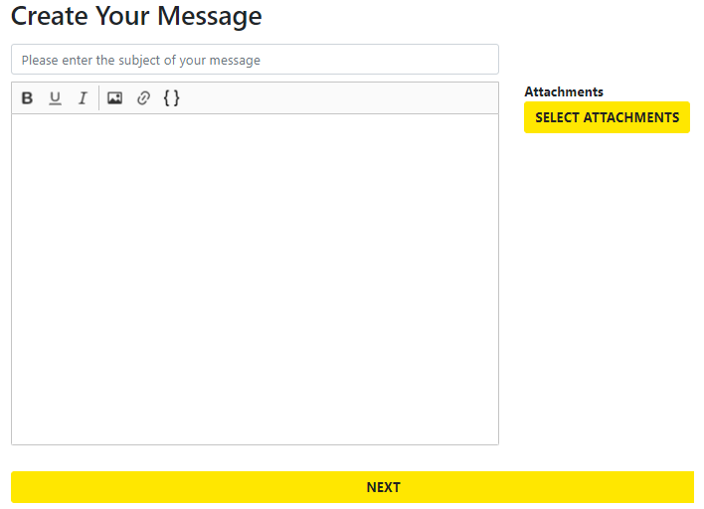
Writing Your Message
The window expands to include the editor. This is a simple editor designed to avoid problems caused by the wide range of recipient email clients. Start by adding a title suitable for the subject of the message content.
The main text box has a selection of icons for modifying the appearance of the text and also icons for inserting a picture, creating a link, and adding a selection of mail merge fields for personalising the message.
Bold Type
Underline
Italic
Insert a picture
Insert a link
Insert a mail merge field.
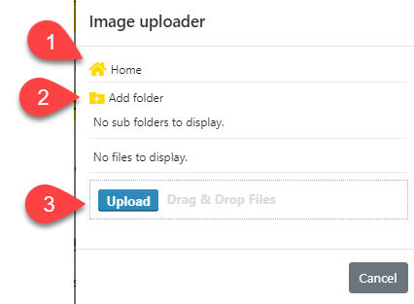
The actions for changing text are straightforward and can either be applied by clicking the icon and then typing or typing the text first and applying the effect by highlighting the text and clicking the icon. If there are many folders to choose from it is easy to get lost when picking the correct folder. Click Home (1) to return to the Home folder.

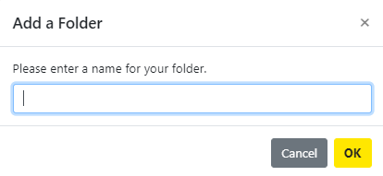
Insert an Image
Clicking on insert a picture opens the image uploader. To manage the image store, it is possible to create a folder tree by clicking add folder (2) and entering a name in the add a folder box. Here Nature has been added.

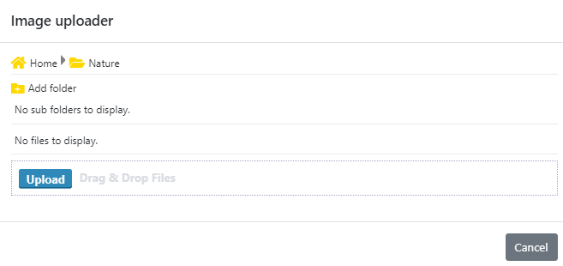
Picture files are uploaded by selecting the destination folder by clicking on the symbol and then clicking the upload button to open the file explorer and selecting the image or clicking and dragging the image into the Drag and Drop Files box. The picture will then be stored in the image store.

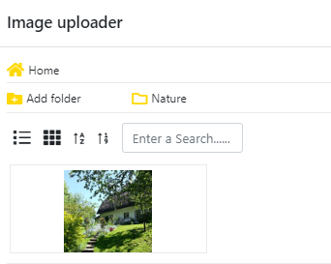
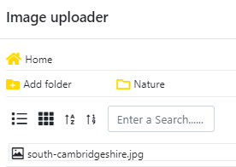
To insert the picture into the message, select the picture by either clicking on the name or the thumbnail depending on the folder view you select from the image uploader viewer icons.

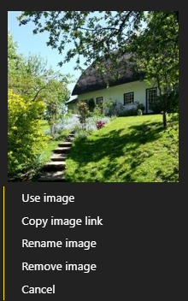
Right click over the name or thumbnail to open a hidden menu which provides some image management tools.
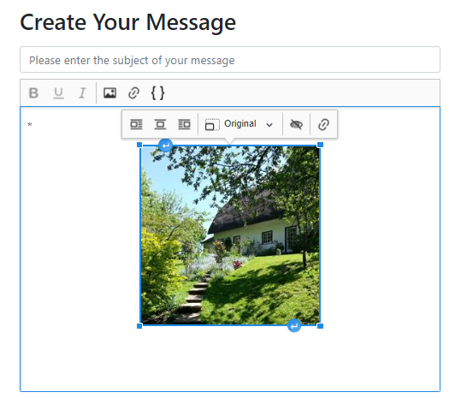
When the image has been inserted into the message it can be placed, resized, have different alternative text added and be linked to another address. These options become available when the inserted image is right clicked, and a menu will appear above the picture.
Further image and text variations are to use the small rectangles in the picture corners to click and drag to adjust the size and the lower right bent arrow and upper left bent arrow to allow insertion of text below and above the picture.

Select Attachments
Clicking on the SELECT ATTACHMENTS button opens the file uploader which works exactly like the image uploader, but the file is attached to the message rather than inserted. This allows documents and pictures to be attached.

Linking Selected Message Text to a URL
The use of hyperlinks allows text typed into the message to link to any web address such as a document in cloud storage or a web page. To use this, enter suitable text into the message such as the document title then highlight it. Click on the link icon and enter the web address into the box and click the tick. The words will then call the web address.

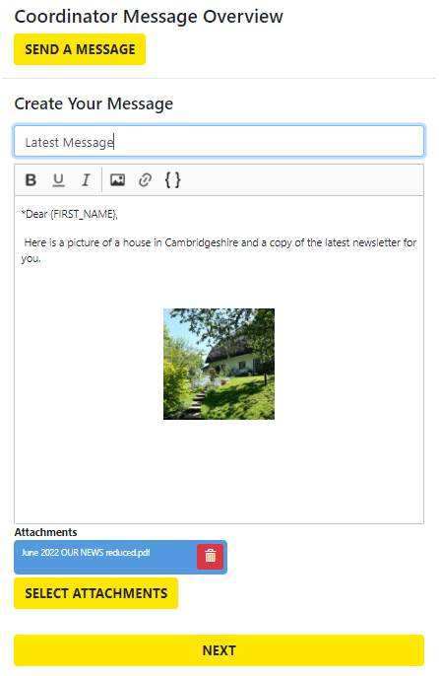
Inserting Mail Merge Fields
Mail merge fields allow the message to be personalised for all the intended recipients. To use mail merge fields, click on the icon at the position in the text you want to add the field. At present there are two {FIRST-NAME} and {SURNAME}.
A typical use would be to add the recipient’s name to the message. As an example:
Dear {FIRST-NAME}, would insert the first name correctly for each message recipient.

Sending the Completed Message

Once the message is written click on NEXT at the bottom of the page.

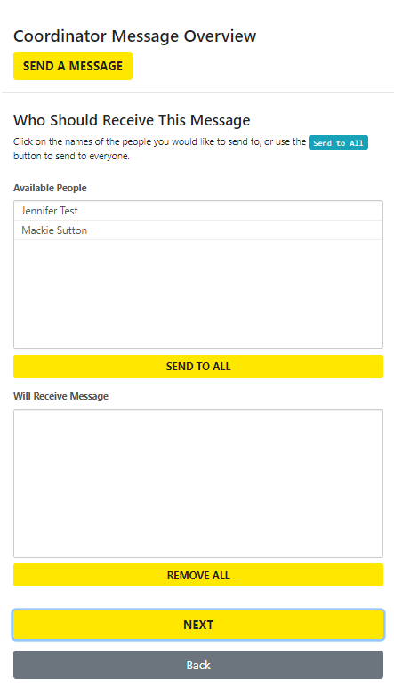
Select the recipients who will receive the message. The names offered will start with all the members in the scheme available.
You can then either click on the SEND TO ALL button and all the names will move into the ‘Will Receive Message’ box.
If you only want some people to receive the message then you can select individuals by clicking on their name they will be moved into the lower box.
The REMOVE ALL button will move recipient all back to the top box or you can click individuals to move them.
When all the required recipients are in the bottom box click NEXT
NOTE: When you click NEXT the message is sent to the recipients immediately so check that the correct names are in the ‘Will Receive Message’ before clicking NEXT
The message will be shown in the Coordinator Message Overview and both the message and replies can be reviewed from there or you can go to your Inbox described earlier.

Use of Your Data
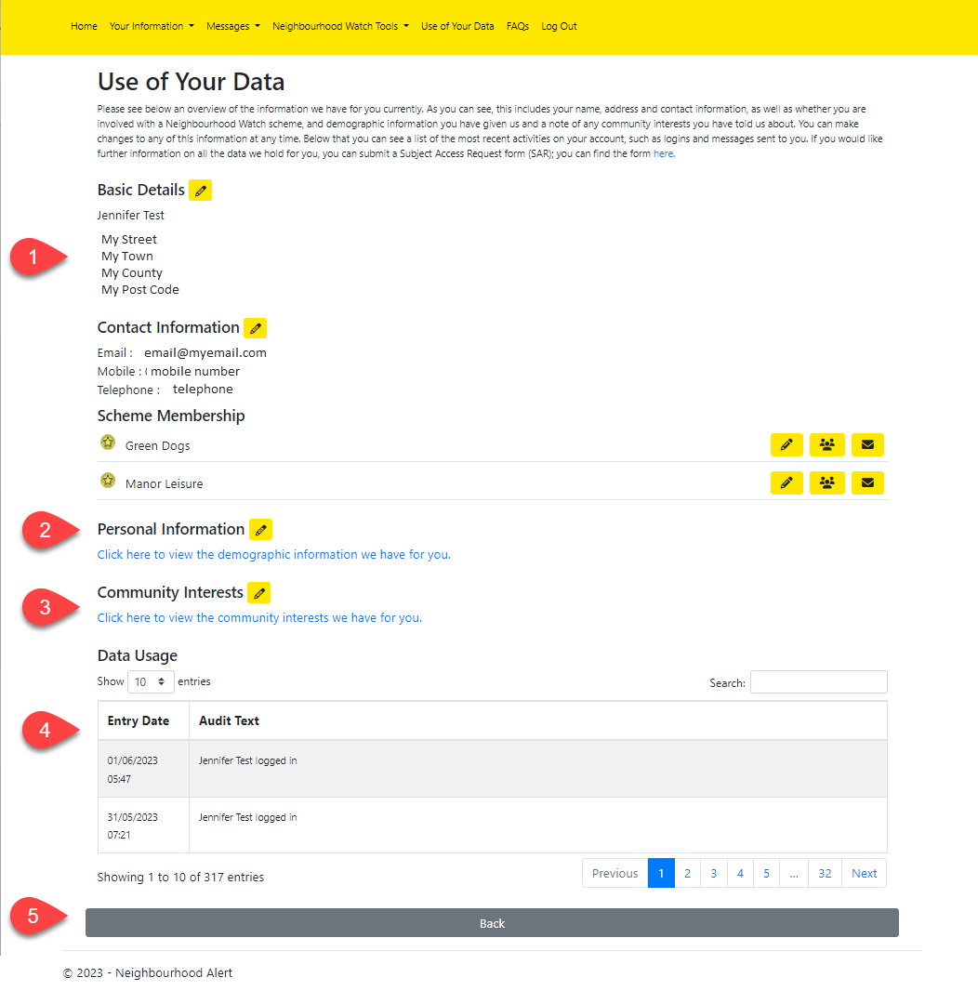
This page provides a summary of all the information the system holds in your record. It includes your basic details, contact information, scheme membership, personal information such as demographics, and your community interests. You can also view your use of data such as when you logged in and view an audit trail of messages sent and received by you.
- Shows the basic details which can be edited by clicking on the pencil.
- The demographic information can be edited by clicking on the pencil or viewed by clicking the link.
- Community Interests can be edited and viewed by clicking on the pencil or simply viewed by clicking the link.
- Shows an audit trail of the actions taken by the logged in user which can be viewed a page at a time by clicking on the page navigation menu.
- Clicking on the Back button will show the Member Area view from the Home page.

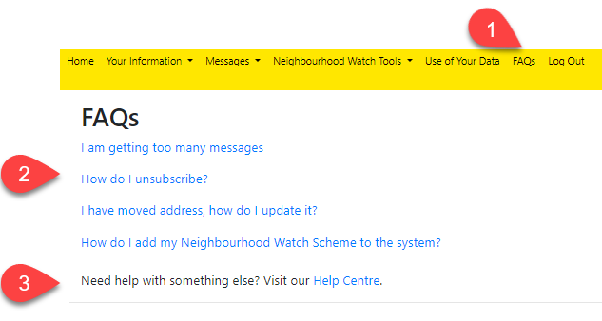
FAQs

- Selecting FAQs from the top menu displays some Frequently Asked Questions as a set of links.
- A selection of the most common questions are linked directly click the required item to display.
- The bottom line shows a link to the Help Centre which is a comprehensive set of topics to provide further help with using the Alert system.

Log Out
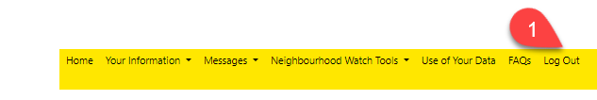
It is important to always Log Out when finished with using Alert otherwise the system can remain open for some time and anyone who might use the computer will be able to access the data.
- When the Log Out option is selected the user is immediately logged out from the system. This is confirmed by the following screen.

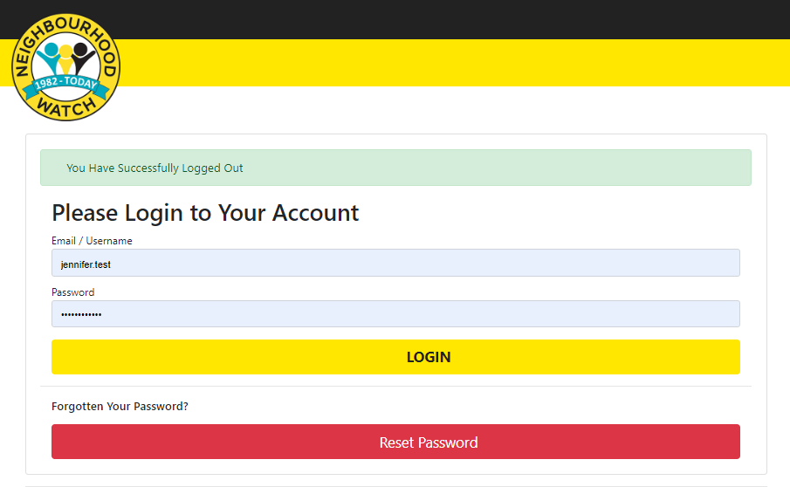

After selecting Log Out the screen shows the Log In screen which may be closed or used to log in againor to allow another user to login.

