Mid Holderness Ward Newsletter – September 2026
Detailed crime and ASB data for your area can be obtained by visiting www.police.uk and following the ‘Find your Neighbourhood’ link.
Meet Your Community Police Team
 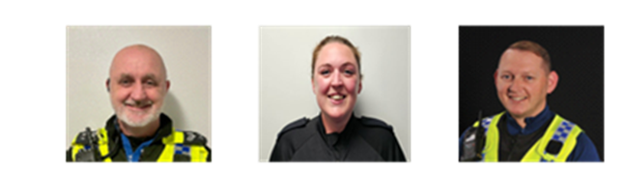 Inspector Ian Foster Sergeant Mick McLaughlin PC Maria Adlington PCSO Darren Bainton

What’s happening in Your Area & Community Priorities?
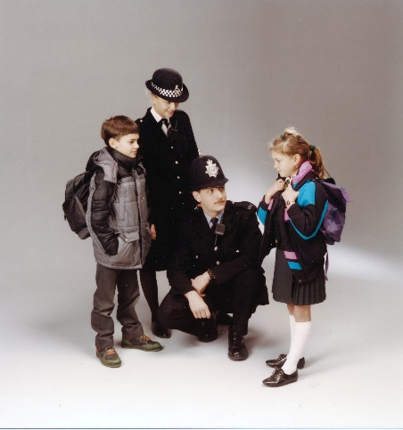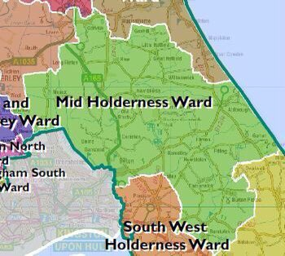
New: Flashback to the 90s campaign, linked to the Back-to-School initiative to keep our communities safe and connected

41 crimes reported across August, ( up from 36 recorded in July 2026)
Humbertalking has set our priorities, this month we are to:
- Reduce ASB, Criminal damage and Arson
- Improve Road Safety
Here’s a summary of crimes that have been reported across Mid Holderness last month:
Domestic Related incidents: (twelve investigations) Domestic assault x2, Domestic x6, Breach of non molestation order, threat to harm, damage, controlling & coercive behaviour.
Residential Burglary reports: (no reports)

Business Burglary reports: (one investigation)
14/08/2026 customer helped self to drinks from behind bar SPROATLEY
Thefts: (five investigations)
08/08/2026 Theft A165, LONG RISTON – make off without payment.
08/08/2026 Theft A165, LONG RISTON – make off without payment.
11/08/2026 theft of car parts, Hull Road GREAT HATFIELD
16/08/2026 Theft, A165 LONG RISTON make off without payment for fuel.
23/08/2026 Theft A165, LONG RISTON make off without payment of fuel
Vehicle Crime: (three investigations)
16/08/2026 damage to vehicle, Churchill Rise, BURSTWICK
21/08/2026 damage to rear windscreen, Ingram Avenue, BILTON
24/08/2026 Theft Rise Road, SKIRLAUGH theft of rear number plate.

Damage: (two investigations)
13/08/2026 Damage to play equipment matting Riston Playing Fields, LONG RISTON
26/08/2026 Damage Dorset Avenue, SKIRLAUGH glass pane of front door smashed.

Other: (eighteen investigations)

02/08/2026 possession of drugs ALDBROUGH
11/08/2026 possession of drugs Hull Road GREAT HATFIELD

Public order, Assault on care staff x4, Assault x2, harassment x2, harassment by neighbour x2, online harassment, threats on FB, threats to care staff, Assault Police, Damage to police vehicle on arrest.

Humber-talking has set our priorities, this month we are to:
- Tackling Anti-Social Behaviour, reducing damage and Arson

We regularly deploy high visibility patrols to our communities in response to reports of criminal damage, drug dealing and anti-social behaviour.
The local policing team have also had productive meetings with partners from East Riding Council, Parish Councils and Neighbourhood Watch groups to listen to community concerns.
Our officers are also committed to eradicating the harm that the illegal and anti-social use of off-road bikes cause to the communities through our Operation Yellowfin.
Action – aims to:
- Protect vulnerable residents
- Restore community confidence and create a safer environment
- Demonstrate the effectiveness of a partnership approach between with local partners.
Intended outcome:
- Reduce the number of ASB reports
- Increase residents’ confidence and feeling of safety
Anyone who wishes to report anti-social or criminal behaviour can contact The Police on 101 or East Riding of Yorkshire Council on 01482 393939
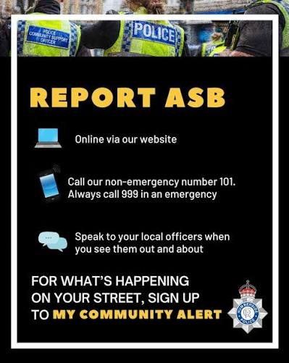

- Improve Road Safety.
As with most other areas, road safety is something in which we can improve upon in our rural communities.

Action –
- As we enter the late summer, members of the Holderness Policing Team will continue to be out and about policing our roads to promote safe behaviour and enforcement of traffic laws.
Intended outcome:
The intended outcomes are to:
- Education & awareness campaigns to reduce the number of casualties on our roads.
- Create a culture of road safety where individuals understand and practices safe behaviours.

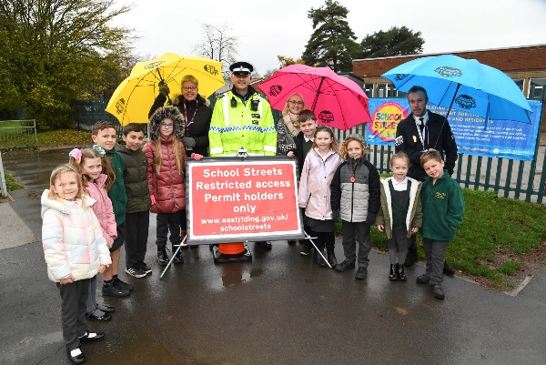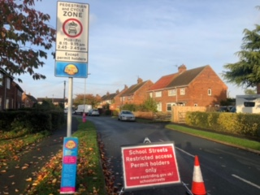

As children return to school in September, the Neighbourhood Police Teams top tips for ensuring children and parents are ready for the journey ahead and can stay as safe as possible.

Families are being advised to take to two wheels or travel on foot if they can and plan out journeys to allow extra time as an increase in traffic is expected.
Community Officers have invited families to “rethink how they travel” encouraging all to walk and cycle where possible, especially for families that live within a mile of their school.

Make sure you’ve checked out our top tips before setting off on the journey to school. These include:

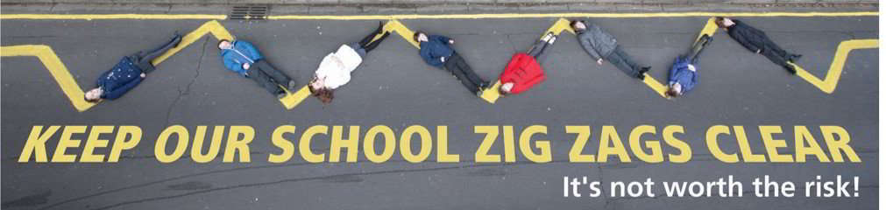

Map it out
If you’re travelling to a new school, trying a different route or getting to school on foot or bike, there’s help available to plan and prepare for your journey.

Allow extra time
There will be more traffic on the road so when you plan your route, allow extra time to get there (including for any arrangements that specific schools might have in place).
You could test out your route to make sure you’re prepared.

Plan for the end of the journey too
If necessary to drive, park safely and where possible consider parking further away and walking the last five minutes of the journey. This will help reduce congestion and pollution around the school gates and allow families to maintain social distancing.

Gear up and be prepared
For those taking the journey on two wheels, bikes need to have had all of the relevant safety checks either at home or can be taken to a cycle hub. Children need to remember a helmet!
For families where this might be the first time that children are getting back in the car, children need to have the correct car seat.

Stay alert on the road
Help children to stay alert and remind them of the road safety messages when using the road. Using a mobile phone or other distractions such as listening to music should be avoided to ensure that they can look, listen and be as safe as possible on the journey to school.

How you can help
Your local Neighbourhood Policing Team appreciates the importance of being in the right place, at the right time, for the right reasons to reassure the public, improve public confidence and reduce crime and anti-social behaviour in the area in which we all live and work.
We encourage all residents to call and report any issues where they live so that we can deal with any issues and step up our patrols in that area.
If you feel that there are other issues affecting you or your local community that should be given priority, please inform your local councillors or your Neighbourhood Policing Team.
News and Appeals
Please visit our website www.humberside.police.uk for the latest news & appeals
FACEBOOK users did you know? You can find out more about the work of your local officers and teams by liking their Facebook accounts: Please visit Humberside Police – East Riding of Yorkshire South www.facebook.com/HumberbeatERYS
Twitter (X) users can keep up to date with events, alerts and traffic news within Mid Holderness by following the community team @HumberbeatERYS and @PCSODarrenB
My Community Alert - free sign up
“My Community Alert” is a free messaging system operated by Humberside Police and Humberside Fire & Rescue Service, giving you information about incidents happening in your area. Choose how you often you want to hear from us and about the issues that matter to you.

Engagements: In September 2026, the dates and locations are as follows:
3rd Thursday 7pm – Parish Council Meeting, the Village Hall, WAWNE
4th Friday from 10am – Tour of Britain Stage 3 Lloyds Cycle Race
24th Thursday 7:30pm – HATFIELD Parish Council Meeting, WITHERNWICK
29th Thursday 7:30pm – Parish Council Meeting, the Village Hall, BURSTWICK
October 3rd Saturday 11:30am -Village Hall, Swine Lane, CONISTON
More dates TBC – please sign up to My Community Alerts for further events.
Schools will be visited during the morning and afternoon commute.

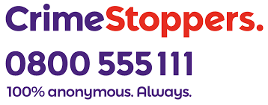
The Crimestoppers Charity believe that everyone has the right to feel safe from crime. Whoever you are, wherever you live, from communities to companies.



Message from our Fire & Rescue partners: Dangers of Flying Lanterns.

Flying lanterns are also known as Chinese Lanterns, Wish Lanterns or Sky Lanterns. Traditional flying lanterns go back thousands of years in both Chinese and Thai celebrations, but are becoming more popular worldwide for celebrating weddings, birthdays, anniversaries or any other special event.

Flying lanterns are airborne paper lanterns, generally constructed from paper around a wire frame. They contain a small candle or other solid fuel cell and when lit the flame heats the air inside the lantern causing it to rise.

The Chief Fire Officers’ Association and Humberside Fire and Rescue Service do not support the use of these lanterns and ask members of the public and event organisers to refrain from using them.

These floating lanterns not only constitute a fire hazard but also pose a risk to livestock, agriculture, camping activities, thatched properties and hazardous material sites.

Whilst these lanterns are undoubtedly a popular and beautiful sight, the potential damage they can cause is significant. Once released, the lantern can be carried many miles before descending back to ground level. The unpredictability of the landing area whilst possibly still having a naked flame makes flying lanterns a considerable fire risk.

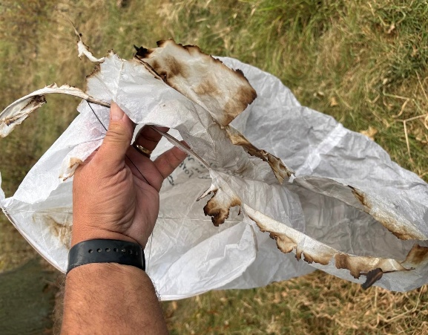


Meet Clampy, the star of the DVLA’s new campaign –

here to show you exactly what can happen when you take a risk by not taxing your vehicle: frustration, inconvenience, and a car going nowhere.

It takes minutes to tax your vehicle online, and Direct Debit can help you stay up to date automatically.

Avoid the hassle. Tax your vehicle today: www.gov.uk/dvla/taxit

Need to know if a vehicle's tax is up to date?

All you need is the vehicle's number plate. You'll also be able to see if the vehicle has been registered as off the road with a Statutory Off Road Notification (SORN).

Check at www.gov.uk/check-vehicle-tax


Lloyds Tour of Britain Family Cycling Festival 2026

The Lloyds Tour of Britain Family Cycling Festival is coming to Hull (Friday 4 September). The event is an exciting opportunity for you and your family to enjoy riding on a traffic-free course on the same day as the professionals. Whether you're a seasoned cyclist, a young rider finding your confidence, or simply looking for a fun day out, everyone is welcome. It’s the ideal family activity for everyone to spend time together and experience the joy of cycling.

The festival runs from 11am–2pm, so you can ride as many laps as you want and still have time to soak up the atmosphere and watch the world's best riders race through your town.

It's a unique opportunity to experience the buzz of the Tour from the saddle and to cheer on the pros from the roadside. Best of all, it's completely free to take part.

Just bring your bikes, your family and your sense of adventure and we'll provide the traffic-free roads.

Event Details
- Date: Friday, 4 September 2026
- Time: 11:00 am – 2:00 pm
- Location: East Park, Holderness Road, Hull, HU8 8JU
- Cost: Free admission

