Community Policing Update  Your local officers remain committed to keeping our community safe and reassured. We continue to carry out high-visibility patrols across the area, focusing on building positive relationships and deterring criminal activity.  Off Road Bikes  We’ve had reports of off-road bikes being used illegally in our area. These bikes must not be ridden on roads, pavements, or public spaces and can pose a risk to others.  Under Section 59 powers, riders causing nuisance or alarm can receive a warning, with bikes liable for seizure if offences continue. We are also seizing bikes being used unlawfully.  We’re carrying out patrols and will take action where offences are identified, including seizing bikes. Please continue to report incidents with as much detail as possible.  Catapults  We have received reports of catapults being used in the area, which can be dangerous and cause damage or injury. Catapults used to harm wildlife or property may result in police action.  We ask parents and guardians to be aware of how these items are being used and to speak with young people about the risks and consequences.  Please continue to report any incidents so we can take appropriate action and keep our wards safe.  - Community Engagement: We are committed to engaging with the North Rural Wards community. This includes holding regular community meetings, which are advertised via My Community Voice. We want to hear your concerns and work together to find solutions.  We are committed to keeping you informed. We publish this monthly newsletter and provide updates on local crime trends and the work we are doing to address these issues on My Community Voice. |   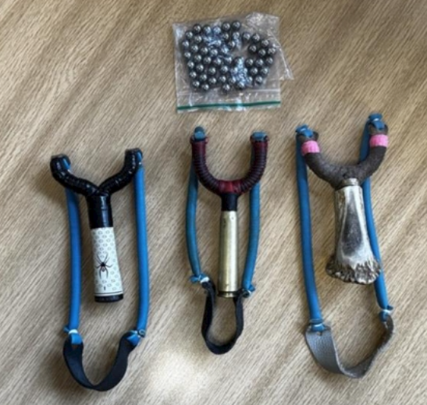
Next month’s engagements:  - Blean Village, School Lane 8th July 2026 11:00-12:00hours  - Hersden Community Centre 10th July 2026 10:00-11:00hours  - Coffee Corner, Herne Bay Road 17th July 2026 15:00 – 16:00hours  - Canterbury Garden Centre, Canterbury Road 29th July 2026 09:00-10:00hours | Your local officers are;  PC 30838 PARKINSON WELLARD  PCSO 62956 SINCLAIR

Upcoming events to look out for!

Your local officers will be holding an upcoming bike marking event in the area to help prevent theft. Bring your bike along to have it security-marked and registered.
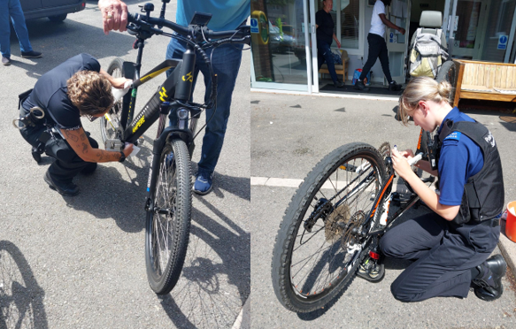
Keep an eye on our channels for dates and locations—we look forward to seeing you there!
.

