Welcome to your Oakham & Barleythorpe police e-newsletter. Here you will find all of the latest news from an Oakham & Barleythorpe policing perspective.
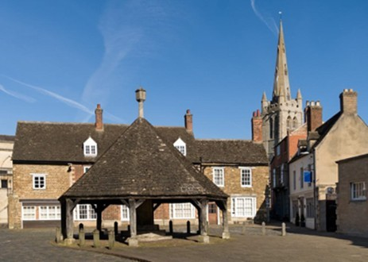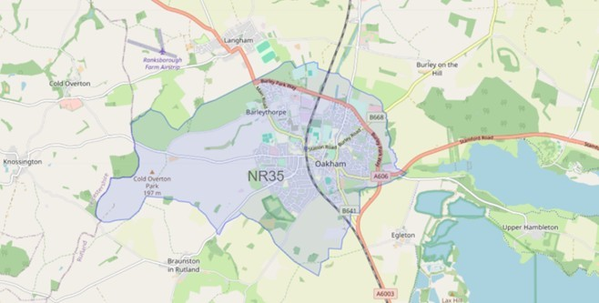

What matters to you

We have listened to you and the concerns you have raised through surveys, community consultations and analysing crime trends.

Oakham & Barleythorpe Newsletter
September 2026
Using this data, we have created the following Oakham & Barleythorpe priorities that the Dedicated Neighbourhood Team will focus their efforts on:

Page 1

Oakham & Barleythorpe Newsletter

Priority 1: Anti-social behaviour (ASB): You said: Anti-social behaviour in and around Oakham & Barleythorpe is becoming more frequent in certain areas.
What we have done: During August, the Oakham Beat Team has been working alongside the Safer Streets Team, Community Safety Team, and response officers from Melton Mowbray to tackle anti-social behaviour (ASB) across identified hotspot areas. Through joint patrols, engagement with residents and local businesses, and targeted interventions, several perpetrators have been identified and dealt with appropriately.

Priority 2: Road Safety: You said: Speeding vehicles on Oakham & Barleythorpe roads is a priority you want us to address, specifically the lack of adherence to 30mph zones.
What We Have Done: During August, the Oakham Beat Team, working alongside response officers, has taken proactive action to address criminality and improve community safety. As a result of targeted patrols, vehicle stops, and intelligence-led activity, several vehicles have been seized for offences including drug-related activity, having no insurance, and vehicle excise duty (tax) offences. A number of investigations remain ongoing

Priority 3: Drug dealing/taking: You said: Reports of drug dealing/ taking in and around Oakham & Barleythorpe.
What We Have Done: Throughout July, the Oakham Team has continued to tackle drug-related offending through targeted patrols, intelligence-led activity, and proactive policing. As a result of this focused work, several suspects have been identified and arrested for drug offences, helping to disrupt criminal activity within the area. Officers have also carried out a number of stop checks at locations of concern, gathering valuable intelligence and supporting ongoing investigations.

This past month we have seen-

5 drug related offences
0 reports of Road Safety 2 report of Anti-Social Behaviour
Anti-social behaviour
Throughout August, the Oakham Neighbourhood Team has been working closely with local residents, partner agencies, and response officers to tackle reports of anti-social behaviour across the area.

Through increased high-visibility patrols, community engagement, and targeted problem-solving, the team has identified individuals responsible for causing concern and taken appropriate positive action. Officers have continued to gather intelligence, address community concerns, and work collaboratively with partners to prevent further incidents.

The Oakham Neighbourhood Team will continue to monitor identified hotspot locations and encourages residents to report any ongoing issues so that we can maintain safe, welcoming, and enjoyable communities for everyone.

If you’ve witnessed antisocial behaviour, please report it to us. Report antisocial behaviour | Leicestershire Police (leics.police.uk)
Community engagements—come along and meet the team!
11.10.2026, 10:00– Beat surgery at Oakham Castle, a chance to meet your neighbourhood team and report any concerns to the Police.

