
”As your Local Policing Inspector, here is a quick update on our Safer Neighbourhood Team’s focus for July. While our 24/7 emergency teams handle 999 calls, our dedicated neighbourhood officers are focusing on visibility and prevention across Chesterfield this summer.
​Our Summer Priorities:
​Safe Open Spaces: Increasing foot patrols in parks and town centres while schools are off.
​Tackling Seasonal ASB: Working with partners to quickly resolve, nuisance behaviour, and neighbour disputes.
​Crime Prevention: Delivering home and vehicle security advice to stop opportunistic summer thefts.
​Community policing relies on you. If you see us out on patrol or at a summer event, please come chat and share what's happening in your area so we can direct our resources effectively.
​Have a safe and happy summer.
Inspector Carter”
​Inspector Carter

Inspector 15568 Carter
Chesterfield Local Policing unit
July 26
Inspector’s Update
Safer Neighbourhoods

Tackling Nuisance Motorbikes Together
I want to address the top issue reported to our Safer Neighbourhood Teams: nuisance and anti-social motorbikes. Following the tragic death of a local child involving one of these bikes, I know concern is high across Chesterfield. We are treating this with the utmost seriousness.
​This summer, our dedicated team is executing a robust three-pronged action plan:
- ​Enforcement: Utilizing Section 59 powers, reviewing CCTV, deploying specialist Off-Road Bike Units, and utilizing advanced drone support to track and catch offenders safely.
- ​Education: Engaging with parents, schools, and youth groups to highlight the severe risks of illegal riding.
- ​Intelligence: Pinpointing specific riders, routes, and storage locations.
​Why Intelligence is Key
Pursuing moving bikes is often too dangerous for the public. The safest tactic is combining our drone technology and community intelligence to seize vehicles directly from the addresses where they are stored.
​To help us build cases and permanently confiscate these bikes, please report:
- ​Who is riding them (names or descriptions).
- ​Where they are being stored.
- ​What the bikes look like (colours, makes, markings).
​Every report helps. Thank you for helping us keep Chesterfield safe.

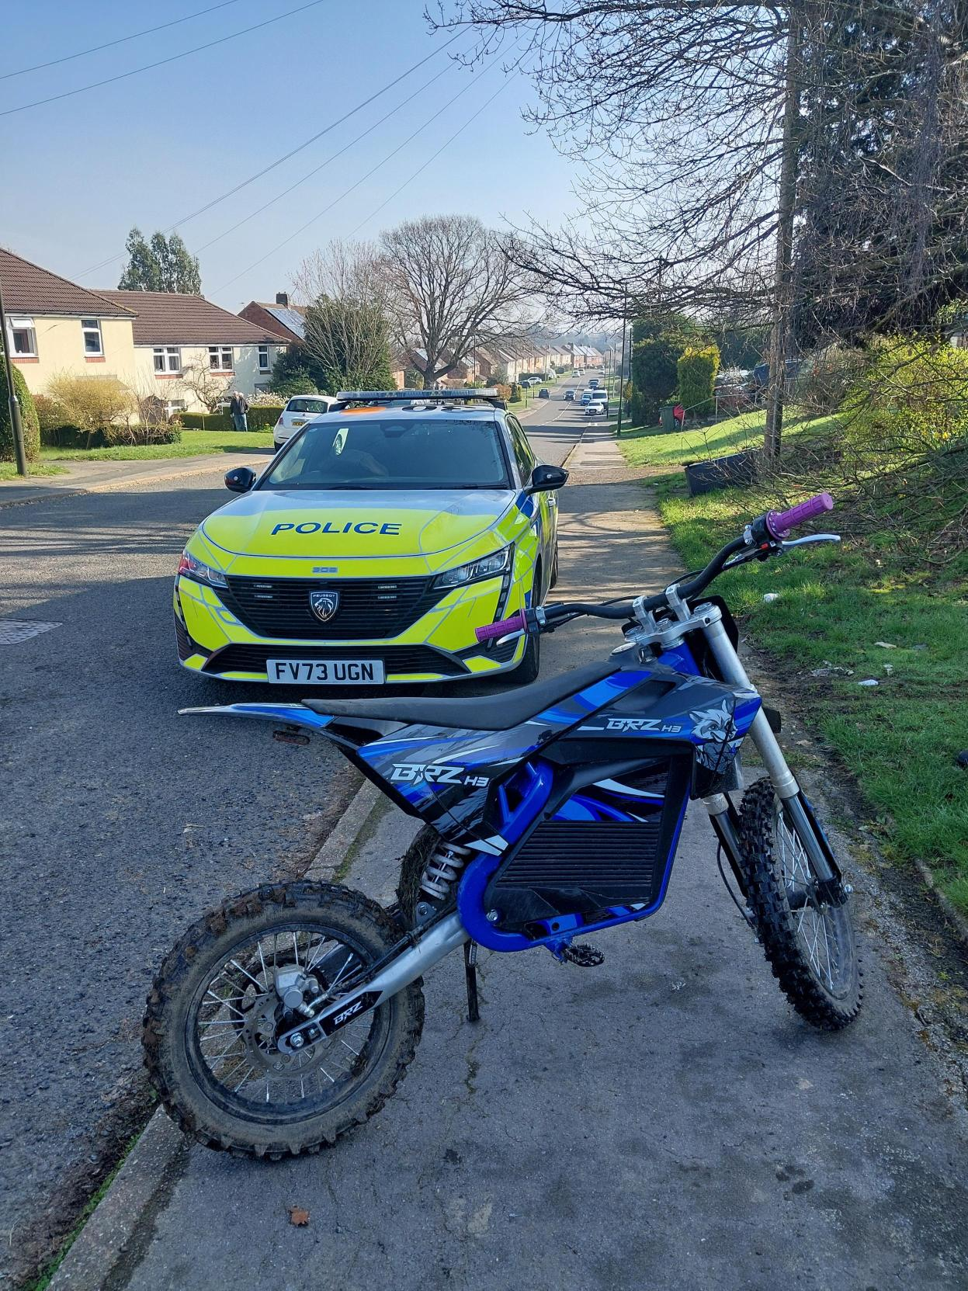

Nuisance Motorbike Success

#ASB | Two men have been arrested as part of a Chesterfield policing initiative to crack down on the anti-social use of e-bikes and motorcycles in the town.

On Tuesday 21 July officers patrolling in Newbold Road noticed a suspicious e-motorbike, and despite indicating for the bike to stop the rider sped off.

With support of National Police Air Service (NPAS) two bikes were spotted riding dangerously around Holmebrook Valley Park.

Officers attended but the riders continued to make off from police.

They then began riding over Loundsley Green Park and were pursued by officers onto Penine Way.

A 24-year-old man riding a black e-bike was stopped and detained. He was arrested for dangerous driving, failing to stop, driving without insurance, and possession of cannabis.

With further assistance from NPAS a second man, age 20, was located in a flat in Cuttholme Road. He was found in possession of a red and white e-bike.

The man was arrested on suspicion of driving without a licence, driving without insurance, and possession of cannabis.

Both men have since been bailed pending further enquiries.

We recently launched the Town Centre Partnership in Chesterfield, with a dedicated local police team working closely with partners to keep the town safe. E-motorbikes are often raised as a key concern from local people, which is why this is a focus for the local team.

Watch here if you missed it - Derbyshire Constabulary | Facebook



