MELTON RURAL SOUTH MONTHLY NEWSLETTER
July 2026

BEAT PRIORITIES:
- Rural Theft
- Road Safety
- Drugs

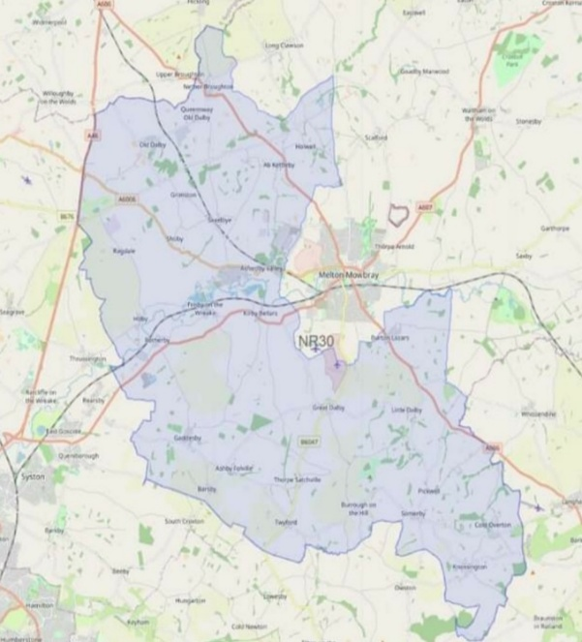
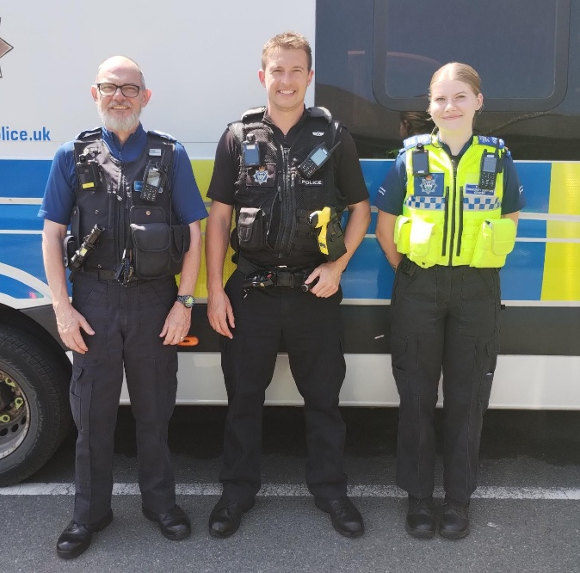
PC 3009 Tranter, PCSO 6575 French, PCSO 6589 Wittering

JULY CRIME and INCIDENT STATS
Thefts – 6
Burglaries – 7
Criminal damage – 8
Assault (including domestic related assault) – 10
Road Traffic Collisions / Road Traffic related incidents, including dangerous driving – 38
Drug dealing/possession – 5

As you can see acquisitive crime is relatively low but there has been a higher demand on your local police in relation to Assault and Domestic Related Assault incidents.
ROAD SAFETY / POLICING THE ROADS
Unfortunately we have to report considerably more road related incidents in May than the previous month. There have been a significant number of Road Traffic Collisions (RTCs), sadly one of which resulted in a fatality. There has also been an increased number of road users driving dangerously, once again we see excessive speed and not driving to the road and weather conditions being responsible.
As mentioned in the previous newsletter we have put together a number of small operations targeting the areas that see the most issues. PC Tranter has continued to dedicate more time to road traffic policing; vehicle defect tickets issued in addition to cars stopped for excessive speed. PCSO French has once again been conducting high visibility patrols on the beat’s roads to deter anti social use of the roads and poor driving. In addition PCSO French has continued to conduct speed monitoring operations across the beat.
Just one instance of this was when PC Tranter was driving towards Asfordby when a van appeared in front of him overtaking a vehicle he’d been tailgating for some time. Narrowly avoiding a collision, the driver got himself a ticket for driving without due care and attention.

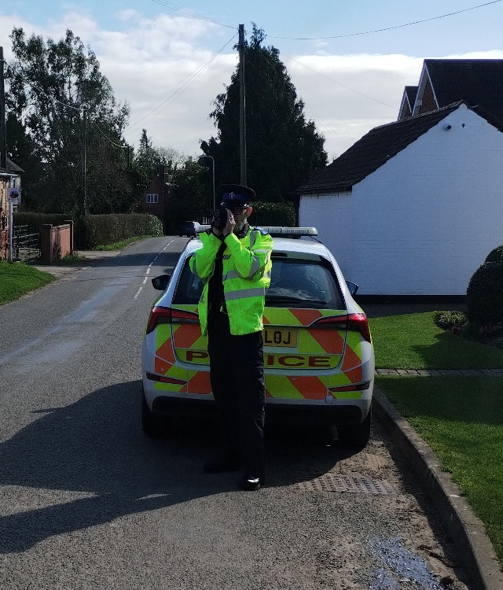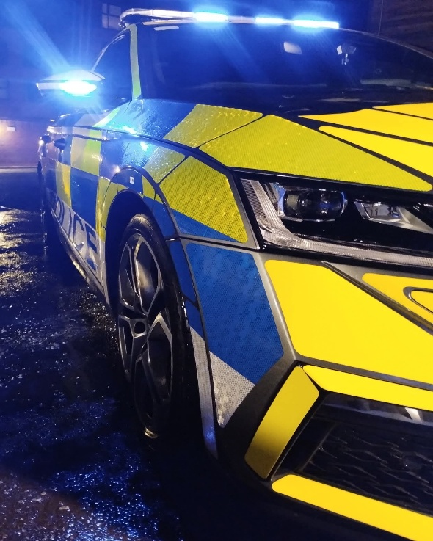

RURAL THEFTS
May has seen a reduced number of reported thefts from rural premises. Rural thefts remain one of the three main beat priorities, so the beat team are putting a lot of attention into continuing to reducing this threat. In addition to this we have continued to keep farm and agricultural thefts relatively low and making efforts to stop / check any agricultural equipment moving around. Both PC Tranter and PCSO French have dedicated hundreds of miles of overt patrols across the beat to deter criminals including driving in and out of farmyards and businesses to protect the rural community.
DRUGS
The beat team continue to work proactively with the Drugs beat priority, gathering intelligence and regularly stopping suspicious vehicles.
PC Tranter and PCSO French have held numerous beat events and surgeries allowing the residents of the area to meet us face to face. This gives us the chance to engage with you and answer and questions you may have. If available, we have a marked car with us to allow children to see what equipment we use and have a go.

OTHER BEAT ACTIVITIES
PCSO French has continued with a series of Student Engagement Events at Brooksby College. The aim of these events is to build a rapport with the students so they feel comfortable talking to police about issues concerning them.
Pro-active patrols have continued in Asfordby by the beat team to address the anti-social behaviour being carried out by a group of youths. As part of this PC Tranter responded to reports of a youth tearing around the area on a quad bike. The youth was spoken to and the quad bike seized.
PC Tranter attended a serious collision occurring on the beat and in conjunction with Leicestershire Fire and Rescue, A doctor from the East Midlands Immediate Care Scheme (EMICS), East Midlands Ambulance Service and the Air Ambulance, all working together to give the casualty the best possible chance possible.
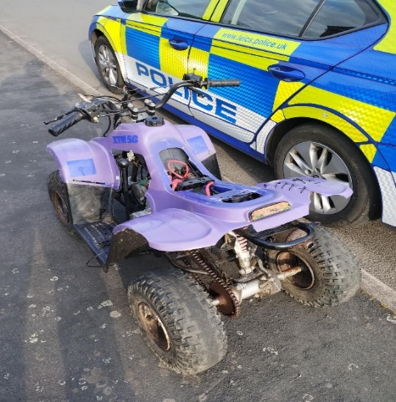
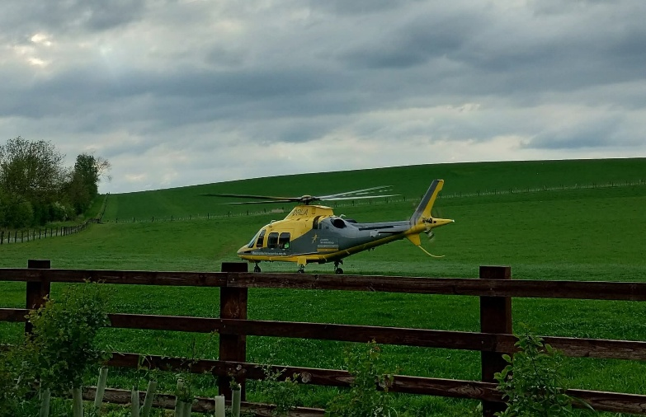

UPCOMING BEAT EVENTS
14/06 Gates Garden Centre Charity Event
22/06 Brooksby Student Engagement Event
27/06 Ab Kettleby School Village Event

Thank you,
PC Tranter
PCSO French
Melton Rural South Beat Team

