
Issue: September Edition 2026
Melton Mowbray Town Centre Newsletter

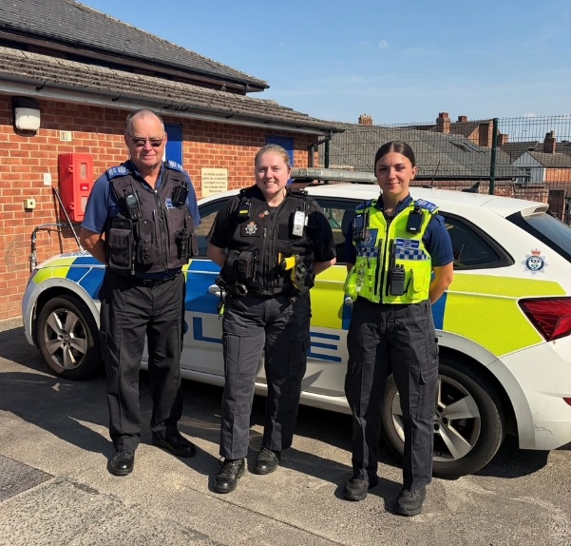
The NR31 Beat Team

- PC 1836 Lucy Baxter

- PCSO 6131 Malcolm Durrant
- PCSO 6017 Etienne Kennington-Dawe
What matters to you

We have listened to you and the concerns you raised and prioritized the following:

Priority 1: Antisocial Behavior
The community has raised the issue of Anti-Social Behavior on the Melton Town Beat as a top priority.
What we have done: Hot spot patrols are continuing with informed and targeted areas at the top of the list.
ASB is and will always remain a priority for the town beat as, and we appreciate ASB is not purely youth orientated, the town centre does and always will draw youth into it and remains high on our patrol patterns. With winter approaching bringing with it a downturn in weather conditions the dangers of rooftop antics are continuing to cause issues and as always, we would urge parents to explain this to their children if deemed appropriate. We are also entering the Halloween and Bonfire night season and officers will be speaking to retailers regarding the location within stores and who they sell to items such as both Fireworks obviously but also the ASB weapon of choice ie eggs and flour and other associated items.

Priority 2: Drug Dealing

The community has raised the issue of drug dealing on the Melton Town Beat.

What we have done: Address’s, based on intelligence and observations, were attended and after letting ourselves in numerous individuals were detained, searched and appropriately dealt with including arrests and work continues to put them up in front of the courts. Furthermore, an address was identified as being ‘cuckooed’ where the resident is coerced to enable dealers to set up shop in the home. This and other locations are then subject to regular checks from officers, and these are unannounced and at varying times.

Priority 3: Theft and Burglary
What we have done: Numerous individuals were detained, arrested and are now at the B & B known as HMP. In a one single week 5 arrests were made for suspects involved not only in thefts and burglaries but associated offences - some even nicked twice in the same week. That week also highlighted the importance of joint agency and retailer collaboration in providing CCTV, suspects names and statements to that effect and local retailers informing police within minutes when a wanted individual was spotted. Within minutes of being seen the subject/suspect were wearing Police bracelets and on their way to our custody suite.

What We have been up to..
Throughout the month…

Patrols have continued come rain or shine, day and night with a few community engagements and drop-in meetings where local residents can meet the beat team for updates, advice and more.
Officers have also been investigating cases that have been assigned to them including burglaries, criminal damage, Fraud cases involving counterfeit bank notes and a variety of other crimes.

On the 25th PC Lucy and PCSO Etienne attended the “Action in Melton” group in the library. They spoke to the group about local concerns, personal safety, home safety, and any questions they had about day-to-day work. Our most asked questions were about the differences between PCSOS and PC’s! A very common question we get asked, and our answer to you is:

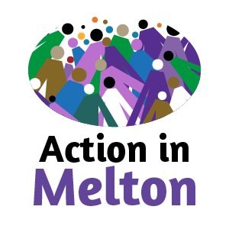
A Police Constable (PC) is a sworn police officer with full police powers, including the ability to arrest offenders, investigate crimes, interview suspects, and respond to emergency incidents. PCs are responsible for enforcing the law and carrying out criminal investigations to protect the public.

A Police Community Support Officer (PCSO) is a uniformed member of police staff who focuses on community engagement, crime prevention, and providing reassurance to the public. PCSOs patrol neighbourhoods, tackle anti-social behaviour, offer safety advice, and build relationships with residents, helping to solve local issues while supporting police officers in keeping communities safe.

On the 26th PCSO Etienne visited the Melton Building Society to talk to customers about scam awareness, it was lovely to speak to people about their opinions and experiences and to pass on useful information too. If you think you may have been targeted by a scam, then contact your bank immediately! You can also report fraud to Action Fraud on 0300 123 2040 or visit www.actionfraud.police.uk.
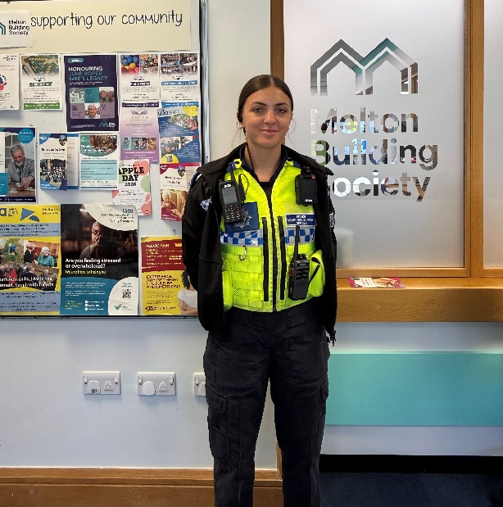
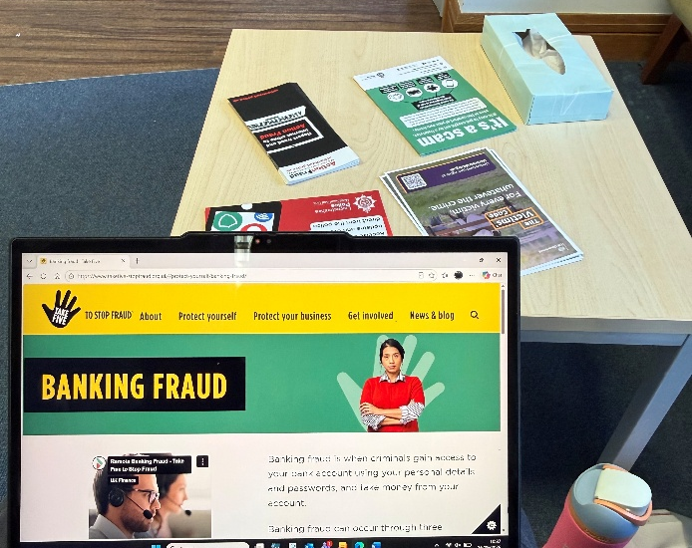

Community engagements


9/10/26- Beat surgery @ McDonalds
6/10/26- Beat surgery @ The park
17/11/2026- Beat Surgery @ The Steam and Bean
24/11/2026- Beat Surgery @ The Cattle Market

For the future

Please continue to report any suspicious activity to the police on either 101 or on the website.
Thanks for reading the newsletter!

Contact us on:
Melton Police - FACEBOOK
101 – NON EMEGENCIES
999- EMERGENCIES
Melton Station Front Desk.

