Mid Holderness Ward Newsletter – October 2026
Detailed crime and ASB data for your area can be obtained by visiting www.police.uk and following the ‘Find your Neighbourhood’ link.
Humberside Police are saddened by the death of our colleague Michael ‘Mick’ McLaughlin, who has died after a short battle with cancer.
Mick joined Humberside Police in 2001 and carried out various roles throughout the force; and most recently was the community sergeant in Hedon and Withernsea as the South & Mid Holderness neighbourhood team. Mick had made a significant impact across local communities during his 25-year career through his “professionalism and unwavering dedication”, adding that he was a well-respected officer who was always there for anyone who needed his help.
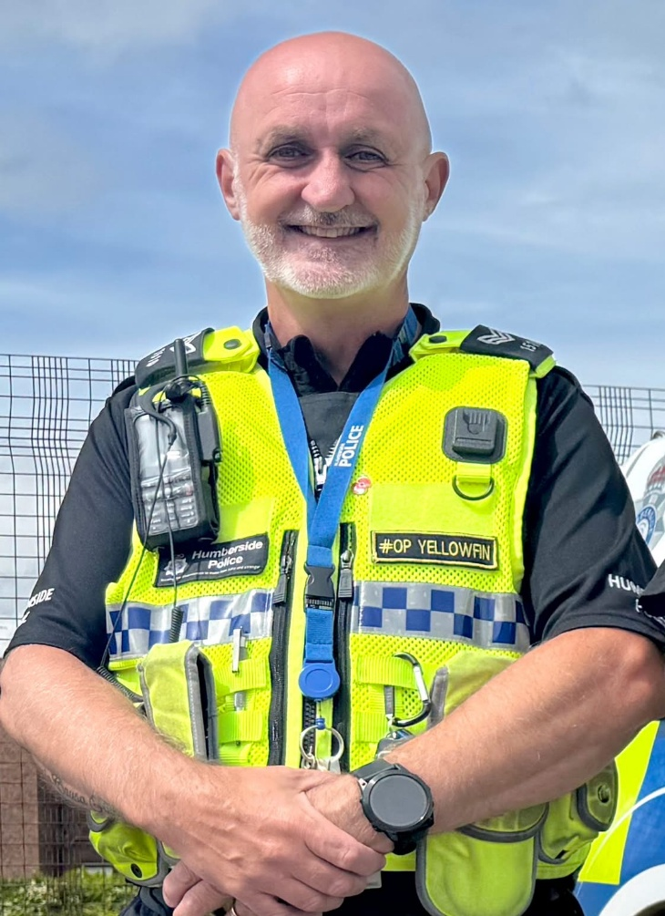
He is survived by his wife Sharon and his son Ewan, and stepchildren Charlie and Daisy. His close friends say he also treated his beloved dog Ted as a fourth child.
Lee Sims, Chair of Humberside Police Federation: “We are devastated to hear of the loss of Mick after his short battle with cancer. Mick was very well liked throughout the force, and whenever you saw him, he would always make the time to stop and have a chat.
“Mick was a genuinely lovely man who was respected by all his colleagues.”

What’s happening in Your Area & Community Priorities?
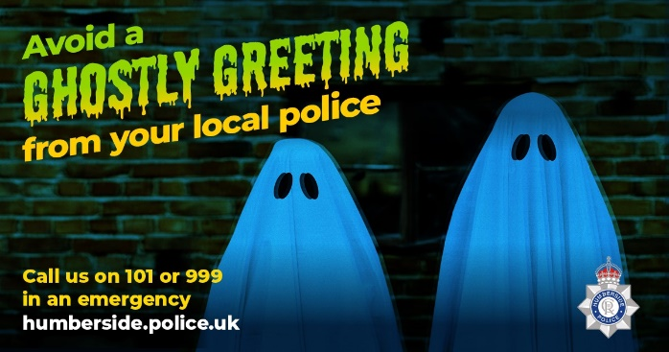
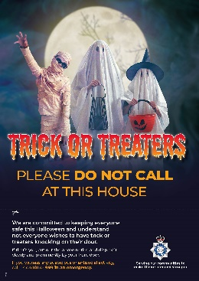

New: HALLOWEEN CELEBRATIONS -visit our website for advice and downloadable posters on how to stay safe this season or sign up to MY COMMUNITY ALERT

37 crimes reported during September, (41 recorded in August 2026)
Humbertalking has set our priorities, this month we are to:
- Reduce ASB, Criminal damage and Arson this Halloween
- Improve Road Safety
Here’s a summary of crimes that have been reported across Mid Holderness last month:
Domestic related incidents: (16 investigations)
Residential Burglary reports: (three investigations)
11/09/2026 attempt burglary Back Lane, Elstronwick man seen trying door handles to an unoccupied property under renovation.
16/09/2026 attempt burglary St.Augustine’s Drive, SKIRLAUGH shining torch, trying door handles, no entry gained.
16/09/2026 burglary in a garage St.Augustine’s Drive, SKIRLAUGH electric bike taken from the garage, later found discarded nearby.
Business Burglary reports: (no reports)
Thefts: (two investigations)
08/09/2026 Theft Abbey Road, BILTON – theft of parcel.
12/09/2026 Theft Main Street, BURSTWICK – cycle taken.
Vehicle Crime: (four investigations)
11/09/2026 Arson Hull Road, GREAT HATFIELD – abandoned vehicle set alit.
12/09/2026 Damage to Vehicle Black Tup Lane, ARNOLD
14/09/2026 Damage to vehicle, Churchill Rise, BURSTWICK
19/09/2026 Harassment further damage to vehicle Churchill Rise, BURSTWICK

Damage: (three investigations)
16/09/2026 Damage to fencing Church Lane , SKIRLAUGH
16/09/2026 Damage to crop fields, East Newton, ALDBROUGH
17/09/2026 Damage to tennis court fence, Main Street, LONG RISTON.
9 other reports including Public order, sexual offence, ASB by neighbour, fraud, public order by neighbour, ASB use of motorbike reported in September across the Mid Holderness ward area.
Humber-talking has set our priorities, this month we are to:
- Tackling ASB, reducing damage and Arson
We regularly deploy high visibility patrols to our communities in response to reports of criminal damage, drug dealing and anti-social behaviour.
The local policing team have also had productive meetings with partners from East Riding Council, Parish Councils and Neighbourhood Watch groups to listen to community concerns.
Our officers are also committed to eradicating the harm that the illegal and anti-social use of off-road bikes cause to the communities through our Operation Yellowfin.
Action – aims to:
- Protect vulnerable residents
- Restore community confidence and create a safer environment
- Demonstrate the effectiveness of a partnership approach between with local partners.

Intended outcome:
- Reduce the number of ASB reports
- Increase residents’ confidence and feeling of safety
Anyone who wishes to report anti-social or criminal behaviour can contact The Police on 101 or East Riding of Yorkshire Council on 01482 393939

Action - Humberside Police’s Halloween campaign aimed at helping to combat burglary offences, help reduce incidents of Anti-Social Behaviour and to provide advice and support to the local communities.

Officers from neighbourhood policing teams will be going out and speaking to schools across the force about anti-social behaviour and encouraging youngsters to enjoy the festivities without becoming a nuisance in their neighbourhood.

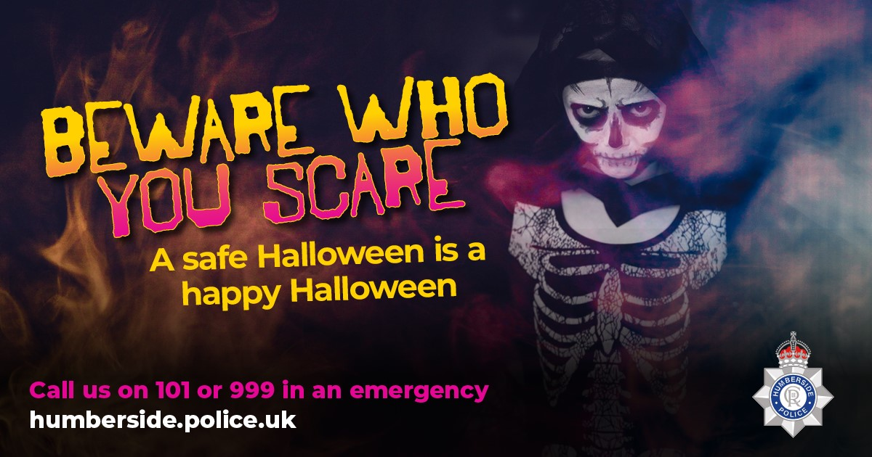

Retailers are reminded of their responsibility not to sell flour and eggs to youngsters on the run up to Halloween and Mischief Night. Posters available from My Community Alert

Our officers are also committed to eradicating the harm that the illegal and anti-social use of off-road bikes cause to the communities through our Operation Yellowfin.

Anyone who wishes to report anti-social or criminal behaviour can contact The Police on 101 or East Riding of Yorkshire Council on 01482 393939

- Improve Road Safety.
As with most other areas, road safety is something in which we can improve upon in our rural communities.

Action –

As we enter autumn and the clocks fall back at the end of the month, members of the Holderness Policing Team will continue to be out and about policing our roads to promote safe behaviour and enforcement of traffic laws.

Intended outcome:
The intended outcomes are to:
- Education & awareness campaigns to reduce the number of casualties on our roads.
- Create a culture of road safety where individuals understand and practices safe behaviours.
- Continue to support Bilton Community Primary School with the ERYC School Streets scheme.

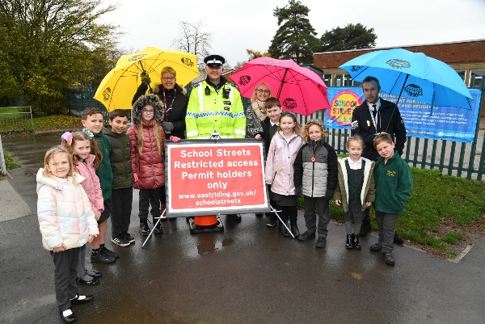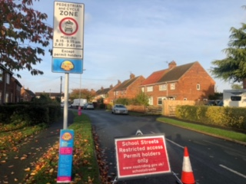

Preventing Residential dwelling Burglaries
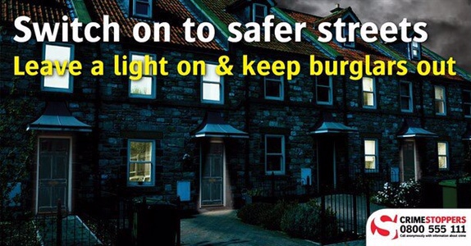

Is anybody home?
Lock your doors at all times; even when you leave briefly, are outside on your property, or inside your home. Also, keep your valuables in a safe or lockbox when you go out.
- Lights - You can get plug-in timers for your lamps - and timers for your ceiling lights. Don't just light up the hall. Fool a burglar by lighting up the landing, bathroom, bedroom and living room too. Really fox him by varying the times each light comes on.

- Sound advice - Use a plug-in timer for a radio - make it a talk station rather than music.

- Windows - Remember to shut all windows, even small and upstairs ones, when you leave the house, in your garden or in the rear of your property. If you're upstairs, close your downstairs windows and if you're planning some time away, get a trusted neighbour to shut the curtains at night. You could return the favour some time!

Tackling Rural Crime:

Rural crime is not limited to the farm yard. Serious and organised crime groups are often linked to rural and wildlife crime particularly in relation to theft of agricultural machinery and poaching like hare coursing.
Holderness patrols are reminding farmers to review their security and to keep their properties/equipment safe.
In relation to the security of Tractor GPS Receiver and Screens, please visit the Police website for crime prevention advice around MARK IT, REMOVE IT and LOCK IT.

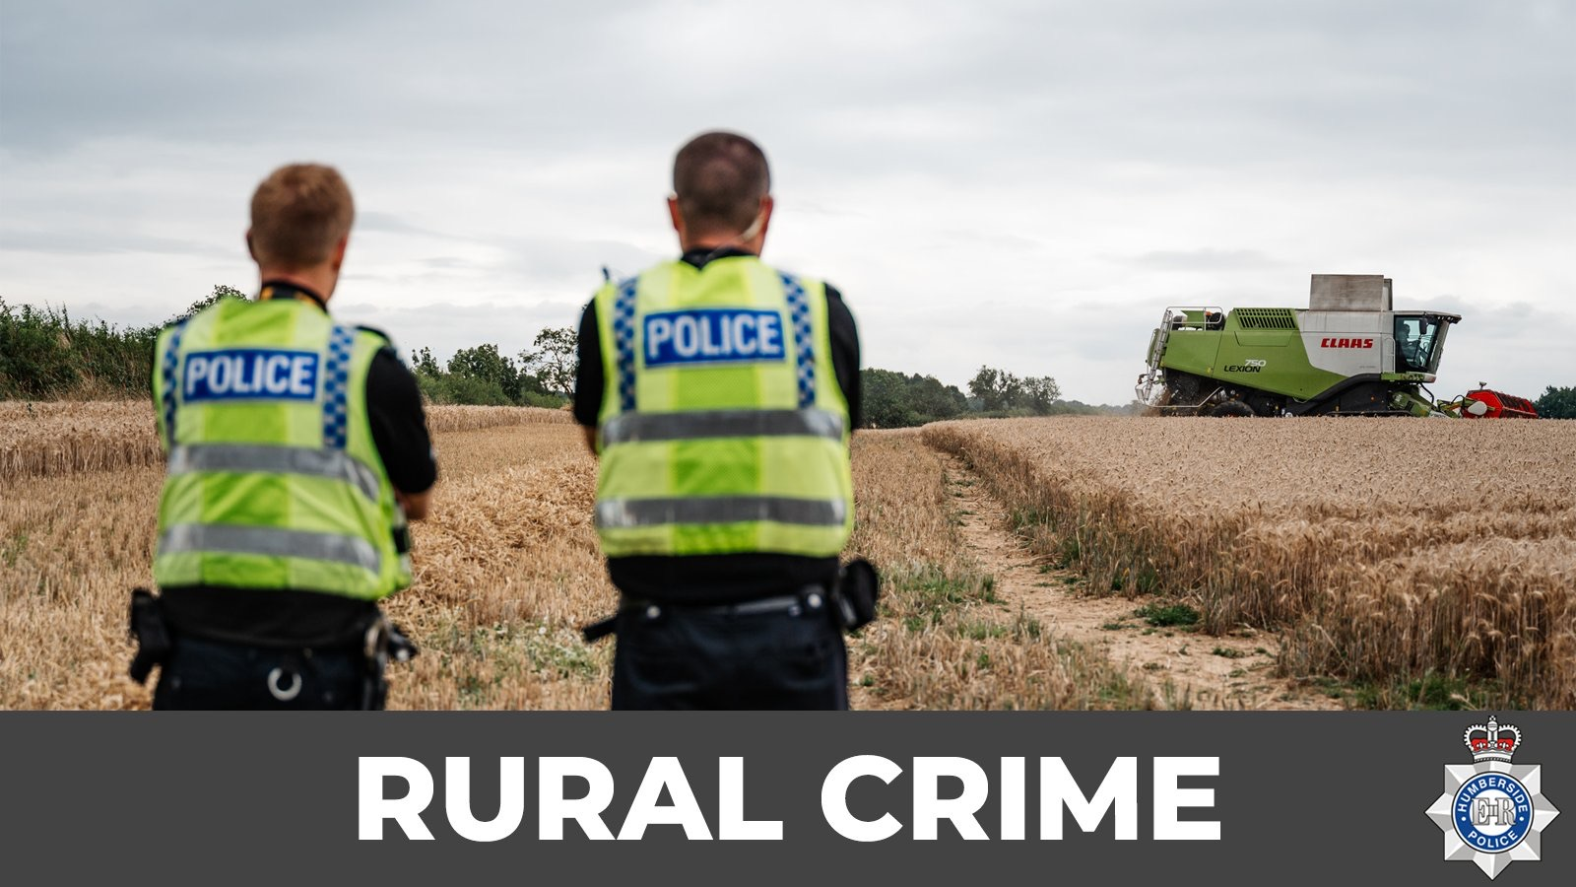
ACTION: work with partner agencies to protect the community and detect crime, including the Rural Crime Task Force, Farm Watch, NFU and Young Farmer Clubs.

How you can help
Your local Neighbourhood Policing Team appreciates the importance of being in the right place, at the right time, for the right reasons to reassure the public, improve public confidence and reduce crime and anti-social behaviour in the area in which we all live and work.
We encourage all residents to call and report any issues where they live so that we can deal with any issues and step up our patrols in that area.
If you feel that there are other issues affecting you or your local community that should be given priority, please inform your local councillors or your Neighbourhood Policing Team.

News and Appeals
Please visit our website www.humberside.police.uk for the latest news & appeals
FACEBOOK users did you know? You can find out more about the work of your local officers and teams by liking their Facebook accounts: Please visit Humberside Police – East Riding of Yorkshire South www.facebook.com/HumberbeatERYS
Twitter (X) users can keep up to date with events, alerts and traffic news within Mid Holderness by following the community team @HumberbeatERYS and @PCSODarrenB
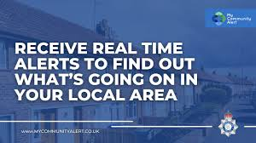 My Community Alert - free sign up

Engagements: In October 2026, the dates and locations are as follows:
24th- Saturday 11:30am -Pop in @ the Village Hall, Swine Lane, CONISTON
9th- Monday 7pm - Aldbrough Parish Council, Village Hall, Garton Road
14th- Saturday 11:30am -Pop in @ the Village Hall, Swine Lane, CONISTON
Schools will be visited during the morning and afternoon commute.

HULL FAIR – Enjoy ALL the fun of the Fair

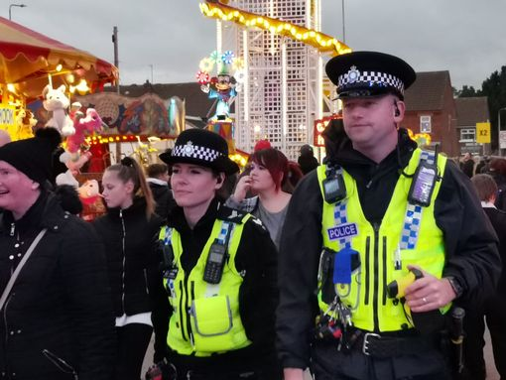
Before setting off
Leave any valuables such as electronic devices, jewellery and credit cards at home; only take what you absolutely need and remember to lock all windows and doors before you set off.

Getting to Hull Fair
Drinking alcohol on buses is prohibited. Anyone caught trying to carry alcohol on to the buses will be refused entry and anyone caught drinking alcohol on a bus will be asked to get off. While on the buses respect the rights of other passengers by keeping noise down to a minimum.
If you drive to the fair park in a well-lit busy area and make a note of where you are parked.
When you leave your car ensure nothing is on view, remove all valuables.

While at Hull Fair
Keep your money and mobile phones in a safe and secure place. Consider wearing clothes that have pockets with zips or using a money belt to keep your property safe.
If you see anything suspicious report it immediately to a Police Officer.

If attending the fair with small children consider using a wrist link or harness to prevent them wandering off. Also give children guardian contact details to carry, so any children who become lost can be reunited with their guardians quickly.

Make sure you are familiar with the location of the Police, First Aid and Lost/Found Children Offices.

Getting home from Hull Fair
Have a pre-arranged meeting place to go to in the event of you become separated from friends/relatives. If travelling by bus, ensure you keep enough money aside for your bus fare home. Be sure where, and which bus, you need to get on in advance
 Message from our Fire & Rescue partners:

Along with our partners at Humberside Fire and Rescue Service we are urging residents to be extra vigilant around Halloween and Bonfire Night to ensure the season goes off with a bang for all the right reasons.
Patrols will be working alongside Humberside Fire to identify illegal bonfires being built in the run up to Bonfire Night itself.
As always, there will be a crackdown on the illegal sale of fireworks. If the public are concerned by rogue suppliers, please contact Trading Standards on 0808 223 1133 or for a fly-tipping concern, then they should ring East Riding of Yorkshire Council – 01482 393939


