An Update from July…
Safer Neighbourhoods

August 2026
Matlock & Tansley

What has the team been up to?

New Priories update
One of our new priorities for the next 3 months is Youth related Anti-social behaviour in Hall Leys Park. In relation to tackle this we been patrolling the park regularly, doing high-visibility patrols in the hotspot areas. To help with the ASB we have been giving out ASB warning letters out and speaking to the parents /carers. To help with youths drinking alcohol in the park we have been doing stops searches for alcohol when necessary.
Warrant executed
Four charged with drug offences following series of warrants in Matlock Four suspects have been charged with drug offences following a series of warrants executed in Matlock. Officers forced entry into four separate properties in the town on Wednesday 8 July and arrested four men and two women on suspicion of drug offences. All six suspects were taken to a police station to be interviewed. The four suspects below have been charged with being concerned in the supply of Class A drugs (cocaine and ecstasy), supplying Class B drugs (cannabis) and money laundering. *Shaun Buxton (34) of Lynholmes Road, Matlock *Ashley Dunne (29) of Hurst Rise, Matlock *Ricky Dunne (30) of Overdale, Matlock *Kevin Else (48) of Overdale, Matlock Ricky Dunne was also charged with possession of an offensive weapon in a private place. All four appeared at Southern Derbyshire Magistrates’ Court on Thursday 9 July and were remanded into custody. They are next due to appear before Derby Crown Court on Thursday 6 August. As part of the day of action, a 32-year-old woman was also arrested on suspicion of drugs and money laundering offences. In addition, a 25-year-old woman was arrested on suspicion of drug offences and possession of an offensive weapon in a private place. Both have been bailed whilst enquiries continue. The operation is being led by our Criminal Exploitation Team.

Street meet dates

TUESDAY 4TH AUGUST 1700-1730- Farmers Larder
Matlock

FRIDAY 14TH AUGUST 1000-1100- Imperial Rooms, Matlock

SATURDAY 15TH AUGUST 1100-1200- Market Day,
Hall Leys Park

WEDNESDAY 19TH AUGUST 1000-1100- Market Day, Hall Leys Park

THURSDAY 20TH AUGUST 1000-11000- Soul Food Café, Matlock

FRIDAY 21st AUGUST 1000-1100 – Imperial Rooms, Matlock

TUESDAY 25TH AUGUST 1700-1730- Farmers Larder Matlock

THURSDAY 27TH AUGUST 1430-1500- Tansley Village
Hall

Safer Neighbourhoods
Matlock & Tansley.

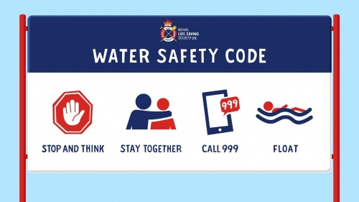

Summer Safety
Sumer holidays have finally started!! During the school holidays, and particular in hot weather numbers increase in younger people going into open water.
The dangers of open water

-Very cold temperate

-Hidden currents

-Deep water

-May be hidden rubbish or debris under the surface that can injury you or maybe trap you

FLOAT to live
Even in warm weather, open water in the UK remains cold enough to cause Cold Water Shock. This will affect even a strong swimmer's ability to control their breathing and swim effectively.

To help minimise the effects of cold water shock:

Fight your instinct to panic or swim hard.

Lean back in the water to keep your airway clear.

Open your body up, extending your arms and legs, pushing your stomach up.

Actions- gently move your hands and feet to help you float.
Time- in 60 – 90 seconds you’ll be able to control your breathing.

