Mid Holderness Ward Newsletter – August 2026
Detailed crime and ASB data for your area can be obtained by visiting www.police.uk and following the ‘Find your Neighbourhood’ link.
Meet Your Community Police Team
  Inspector Ian Foster Sergeant Mick McLaughlin PC Maria Adlington PCSO Darren Bainton

What’s happening in Your Area & Community Priorities?
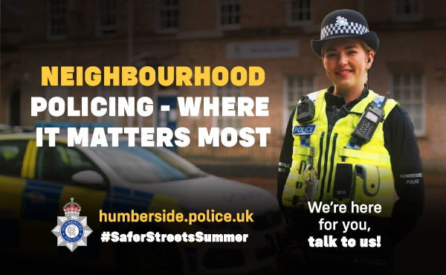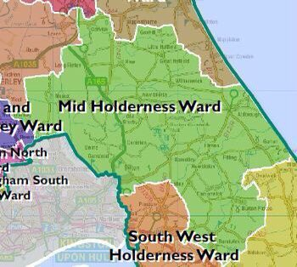
New: Our Neighbourhood Policing Team (NPT) campaign, linked to the NPCC’s Safer Streets Summer initiative to keep our communities safe and connected.

36 crimes reported across July, ( down from 40 recorded in June 2026)
Humbertalking has set our priorities, this month we are to:
- Reduce ASB, Criminal damage and Arson
- Improve Road Safety
Here’s a summary of crimes that have been reported across Mid Holderness last month:
Domestic Related incidents: (ten investigations) Domestic assault x4, Domestic theft, Domestic related sexual offence of indecent images, Domestic neglect of children, stalking, threats to ex partner, domestic theft of mobile phone & belongings.
Residential Burglary reports: (no reports)
Business Burglary reports: (no reports)
Thefts: (ten investigations)
01/07/2026 Theft, HUMBLETON – theft of bird scarers
01/07/2026 Theft Main Road, BILTON – theft of external key safe of business premise
02/07/2026 Theft Back Lane, ELSTRONWICK – theft of hot tub water pump.
08/07/2026 Theft A165, LONG RISTON – make off without payment.
13/07/2026 Theft Longdales Lane, CONISTON – theft of scrap metals of skip.
12/07/2026 Theft from garden Main Road, SKIRLAUGH theft of two water pumps
14/07/2026 Theft Leven Road, CATWICK – make off without payment.
26/07/2026 Theft A165, LONG RISTON – make off without payment.
26/07/2026 Theft A165, LONG RISTON – make off without payment.
28/07/2026 Theft of solar lights from garden Aldbrough Road, WITHERNWICK
Vehicle Crime: (one investigation)
13/07/2026 Theft from motor vehicle, Cross Street, ALDBROUGH
Damage: (five investigations)
13/07/2026 Damage to front window Dorset Avenue SKIRLAUGH
15/07/2026 Damage curtain side trailer, Greens lane, BURTON PIDSEA
15/07/2026 Damage to play equipment, Main Street LONG RISTON
15/07/2026 Damage to play park safety matting, Main Street LONG RISTON
23/07/2026 Damage to hay bales Seaside Road, ALDBROUGH
Other: (ten investigations)
Animal welfare, Public order x 3, Assault x 3, Assault road rage motorcyclist vs Horse Rider, harassment by neighbour x2.
Humber-talking has set our priorities, this month we are to:
- Tackling Anti-Social Behaviour, reducing damage and Arson

We regularly deploy high visibility patrols to our communities in response to reports of criminal damage, drug dealing and anti-social behaviour.
The local policing team have also had productive meetings with partners from East Riding Council, Parish Councils and Neighbourhood Watch groups to listen to community concerns.
Our officers are also committed to eradicating the harm that the illegal and anti-social use of off-road bikes cause to the communities through our Operation Yellowfin.
Action – aims to:
- Protect vulnerable residents
- Restore community confidence and create a safer environment
- Demonstrate the effectiveness of a partnership approach between with local partners.
Intended outcome:
- Reduce the number of ASB reports
- Increase residents’ confidence and feeling of safety
Anyone who wishes to report anti-social or criminal behaviour can contact The Police on 101 or East Riding of Yorkshire Council on 01482 393939
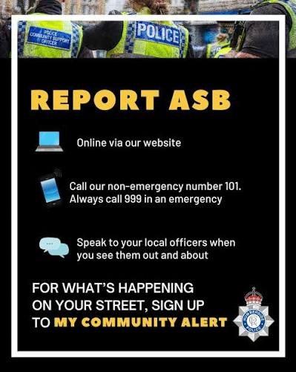
- Improve Road Safety.
As with most other areas, road safety is something in which we can improve upon in our rural communities.

Action –
- As we enter the summer holidays, members of the Holderness Policing Team will continue to be out and about policing our roads to promote safe behaviour and enforcement of traffic laws.
Intended outcome:
The intended outcomes are to:
- Education & awareness campaigns to reduce the number of casualties on our roads.
- Create a culture of road safety where individuals understand and practices safe behaviours.
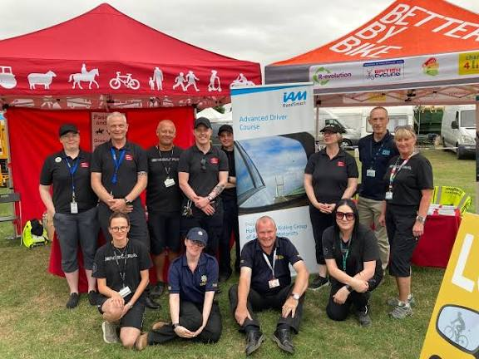

How you can help
Your local Neighbourhood Policing Team appreciates the importance of being in the right place, at the right time, for the right reasons to reassure the public, improve public confidence and reduce crime and anti-social behaviour in the area in which we all live and work.
We encourage all residents to call and report any issues where they live so that we can deal with any issues and step up our patrols in that area.
If you feel that there are other issues affecting you or your local community that should be given priority, please inform your local councillors or your Neighbourhood Policing Team.
News and Appeals
Please visit our website www.humberside.police.uk for the latest news & appeals
FACEBOOK users did you know? You can find out more about the work of your local officers and teams by liking their Facebook accounts: Please visit Humberside Police – East Riding of Yorkshire South www.facebook.com/HumberbeatERYS
Twitter (X) users can keep up to date with events, alerts and traffic news within Mid Holderness by following the community team @HumberbeatERYS and @PCSODarrenB
My Community Alert - free sign up
“My Community Alert” is a free messaging system operated by Humberside Police and Humberside Fire & Rescue Service, giving you information about incidents happening in your area. Choose how you often you want to hear from us and about the issues that matter to you.

Engagements: In August 2026, the dates and locations are as follows:
Saturday 8th & Sunday 9th from 10am Blue Light Weekend, WITHERNSEA
19th Wednesday 7:15pm – Parish Council Meeting, the Village Hall, CATWICK
22nd Saturday 11:30am -Village Hall, Swine Lane, CONISTON
More dates TBC – please sign up to My Community Alerts for further events.
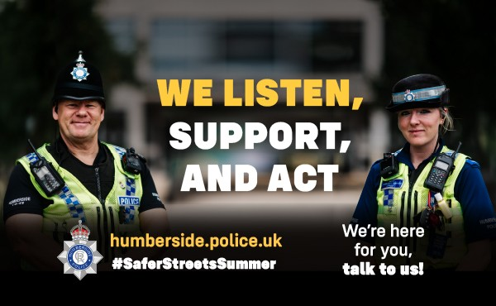
Neighbourhood Policing is so much more than community engagement to all our officers, it’s an opportunity to make a difference in tackling crime, anti-social behaviour, working with partners to solve community-based problems as well as gathering information to help inform the bigger policing picture.
“I hope that you enjoy finding out a bit more about them and the brilliant work they do to remain community focused, workforce focused, and victim focused day in day out.
“Together, we can make our streets safer this summer, and beyond.”
Keep an eye on our website, and social media accounts for more on what we’re getting up to, and of course sign up to My Community Alert to find out what’s happening on your street

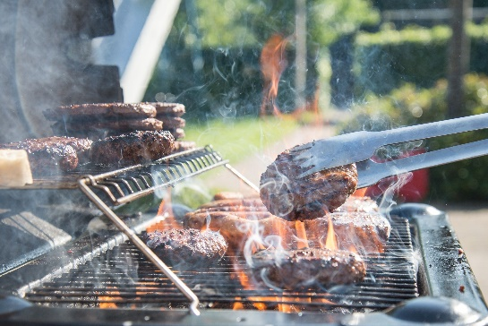

Warm weather and lighter evenings are a perfect time to light a barbecue and enjoy time outside with family and friends. We have a few tips which will reduce the risk of fire during or after cooking.
BBQ safety tips
To avoid injuries or damage to property follow these simple precautions:
- Never leave the BBQ unattended
- Ensure the BBQ is on a flat site, well away from a shed, trees or shrubs
- Keep children, garden games and pets well away from the cooking area
- Keep a bucket of water or sand nearby for emergencies
- Ensure the BBQ is cool before attempting to move it
Disposable BBQs bring several risks, from grass fires to harming wildlife.
- Disposable BBQs are often not put out properly, which can cause grass fires, especially in hot weather when the ground is dry
- The ground beneath a BBQ can remain searingly hot for hours after it has been removed, posing a risk to anyone who might walk over it
- They pose a threat to wildlife and their disposable design makes them wasteful and harmful to the environment

FOUR TIPS FOR SHARING THE ROAD WITH FARMERS

It is getting to be that time of year again! Many farmers are out in their fields with harvesting their crops. Which means tractors and other large farm equipment will be out on the roads.

Every year we hear of accidents occurring between motorist and farm equipment. These accidents can be prevented, here are four tips to help prevent an accident.

1. Slow Down!
The tractors are moving much slower than regular motorist. This means you will approach them much quicker than other traffic. As soon as you see them, you need to start slowing down.

2. Know your Surroundings.
This means, be mindful of your location. Know what kind of traffic is up ahead of you and the equipment, also be aware of the traffic that is behind you. You must also watch for drivers that are not being as patient. They may try to pass you and the equipment, or others may pull out in front of you and the equipment.

Be sure to also watch for turn signals or even hand signals from the driver in the tractor. He may be turning into a field entrance that you may not see or notice.

3. Leave plenty of space between you and the equipment.
This includes when you are behind them waiting to pass and while passing them. If you can’t see the driver and his mirrors, he can’t see you. Also keep in mind they will need more space to turn.

4. Be Patient!
They are working hard and appreciate your patience. They are out doing their job of feeding the world.
And remember to always give a wave!
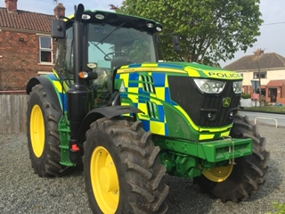

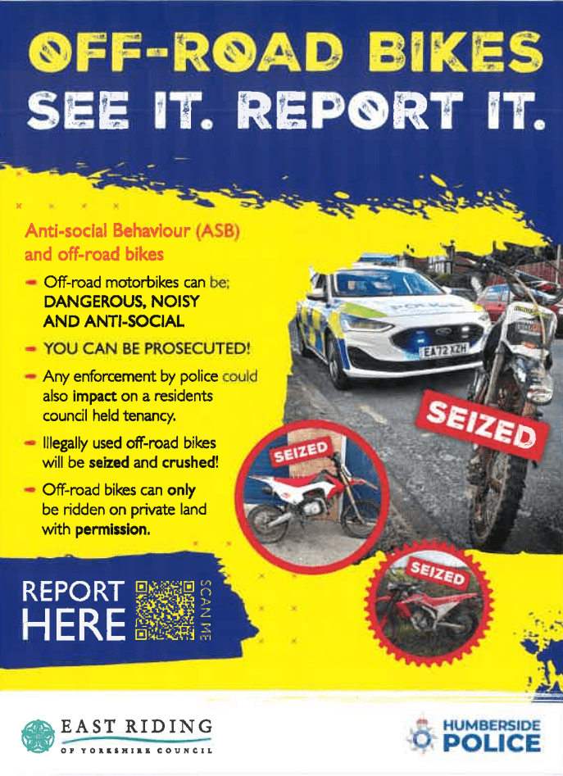

RAISING AWARENESS OF OUR EMERGENCY & LIFESAVING SERVICES
Withernsea Seafront Blue Light Weekend was the idea of Steve Medcalf in 2022.
​
​He wanted to raise awareness and money for local emergency, lifesaving and military veterans' services while the same time putting Withernsea on the map.
​
​A small group of family and friends were determined to realise his dream.

