Safer Neighbourhood News
Welcome to the May edition of our local newsletter!

We would like to thank our community for its continued support and partnership. As the warmer weather approaches, we encourage residents to help prevent crime by locking vehicles and homes, removing valuables from plain sight, and reporting suspicious activity promptly.

Thank you for helping us keep the community safe!

MV = Motor Vehicle Crime
VWI = Victim With Injury (Assault)



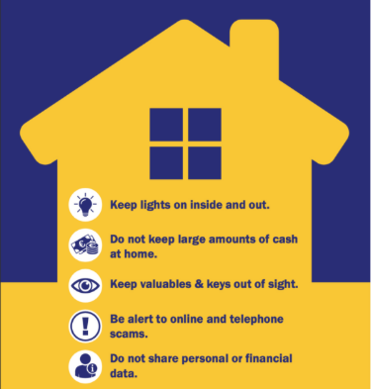

Burglary
There were 5 residential burglaries, 1 attempted residential burglaries, 0 non – residential burglary,
0 attempted non - residential burglaries, and 1 artifice burglaries reported in April.
Sunday 5th of APRIL 2026
Padstow Road, Enfield, Enfield, EN2 8BU
Suspect(s) approached from a side alleyway and forced entry to the rear of the premises whilst the occupants were away on holiday. An untidy search was carried out for the property, and the suspect(s) made off with unknown items

Wednesday 15th of APRIL at approx. 15:30hours
WAVERLEY ROAD, ENFIELD, ENFIELD, EN2 7BT
Entry was gained by suspect(s) approaching the premises from the rear via the garden. Access was forced through a ground floor window, where the glass was cut, broken, or otherwise interfered with. The same window is believed to have been used as the exit point. Once inside, suspect(s) conducted a search of the occupied premises, which was selective in nature and left the property in an untidy condition.

ERMONT CLOSE, ENFIELD, ENFIELD, EN2 7BF
Unknown person(s) gained entry to the property via a rear window, conducted a messy search inside, and exited through the same point. Multiple items stolen from the property.

Tuesday 21st of APRIL 2026
ROUNDHEDGE WAY, ENFIELD, ENFIELD, EN2 8LD
Burglary – Business & Community: Unknown suspect(s) attempted to gain entry to the garage; however, no access was gained and nothing was stolen. Minor damage was caused to the garage door.

Friday 24th of APRIL 2026 at 17:17 hours
HOLTWHITES HILL, ENFIELD, ENFIELD, EN2 8BT
Two males, posing as water board employees, gained entry to the property and stole £100 in cash from the victim’s purse.

Saturday 25th of APRIL 2026 between 1400 and 20:45
CHASE GREEN AVENUE, ENFIELD, ENFIELD, EN2 8EB
Unknown suspect(s) gained access to the premises via a side gate and rear window, causing damage to both the window and patio doors.

Tuesday 27th of APRIL 2026
HADLEY ROAD, ENFIELD, ENFIELD, EN2 8LA
Burglary – Business. Suspect(s) were observed walking through fields on the farm before accessing the site. They then opened and interfered with a static generator located on the premises. They have then sprayed graffiti onto some of the buildings and thrown some metal grinders that were lying about at some sheets breaking them

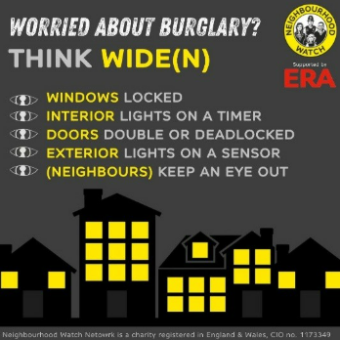

Motor Vehicle Crime
There were 6 thefts of motor vehicles, and 1 theft from motor vehicle was reported in April.

Saturday 11th of April 2026 between 20:00pm and 02:35am
BERKELEY LODGE, 2 CHASE RIDINGS, ENFIELD, ENFIELD, EN2 7DQ
Theft Of Motor Vehicle - Vehicle stolen from outside victims address overnight as well as neighbours' bike.

Saturday 11th of April 2026
BERKELEY LODGE, 2 CHASE RIDINGS, ENFIELD, EN2 7DQ
Theft Of Motor Vehicle-motorbike

Sunday 19th of April 2026
The Ridgeway, CHASE FARM HOSPITAL
Theft From Motor Vehicle catalytic convertor stolen.
Between Saturday 19th at 14:00 and Monday 20th of April 2026 at 07:15
CHASE GREEN AVENUE, ENFIELD, ENFIELD, EN2 8EA
Theft of a motor vehicle-vehicle has been stolen overnight from outside her home address

Tuesday 21st of April 2026
The Ridgeway, CHASE FARM HOSPITAL
Theft of a motor vehicle- motorbike stolen from outside of Hospital by suspect unknown

Friday 24th of April around 2pm
HADLEY ROAD, ENFIELD, ENFIELD, EN2 8JS
Theft Of Motor Vehicle - victim vehicles have been left unattended and on their return the victim discovered their vehicle has been stolen by unknown suspect

Friday 24th of April between 22:30 and 08:00
PERRY MEAD, ENFIELD, ENFIELD, EN2 8BP
Theft of motor vehicle – unknown suspect(s) stole the victim’s locked and secured vehicle from the location.

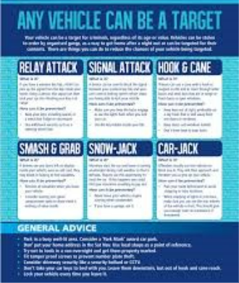
Theft person
There were 0 theft of person reported in April.



Criminal Damage

There were 2 criminal damages to motor vehicles, and 4 other criminal damage reported in February 2026.

Wednesday 1st of April 2026 .

PERRY MEAD, ENFIELD, ENFIELD, EN2 8BP

Criminal damage to a vehicle where value of that damage is £500 or over and under £5000

Friday 3th of April 2026

BYCULLAH ROAD, ENFIELD, ENFIELD, EN2 8ES

Criminal damage to a dwelling where value of that damage is under £500.

Friday 10th of April 2026

ELMER CLOSE, ENFIELD, ENFIELD, EN2 7EZ

Criminal damage to a dwelling where value of that damage is under £500.

Sunday 19th of April 2026

PETWORTH COURT, ANTLER WAY, ENFIELD, ENFIELD, EN2 8GN

Criminal damage to other property where the value of that damage is under £500

Friday 24th of April 2026

Enfield Road, Enfield, Enfield, EN2 7QS

Criminal damage MV– tyres slashed, and scratches caused to the side of the victim’s vehicle.

Thursday 30th of April 2026

PETWORTH COURT, 10 ANTLER WAY, ENFIELD, ENFIELD, EN2 8GN

Criminal damage to other property where the value of that damage is under £500.

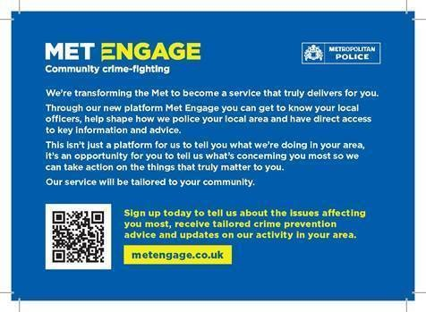
https://www.metengage.co.uk/

Through our new platform Met Engage you can get to know your local officers, help shape how we police your local area and have direct access to key information and advice.

This is not just a platform for us to tell you what we are doing in your area, it's an opportunity for you to tell us what's concerning you most so we can act on the things that truly matter to you.

YOU CAN STILL CONTACT US AS BELOW

Team Members

Based at Enfield Patrol Base your

Dedicated Ward Officers (DWOs) on

Ridgeway Ward are:

Supervisor

PS Alex Kane

Dedicated Ward Officers:

PC Jane Rudolph

PCSO Deb Anjan

PCSO Agachi Simona

Email: ridgeway@met.police.uk

If you wish to report a crime you must always use
101 for non-emergency matters.
Always dial 999 in an emergency.

Useful Contacts
24/7 Police Station
Edmonton Police station
462 Fore Street, Edmonton N9 0PW

