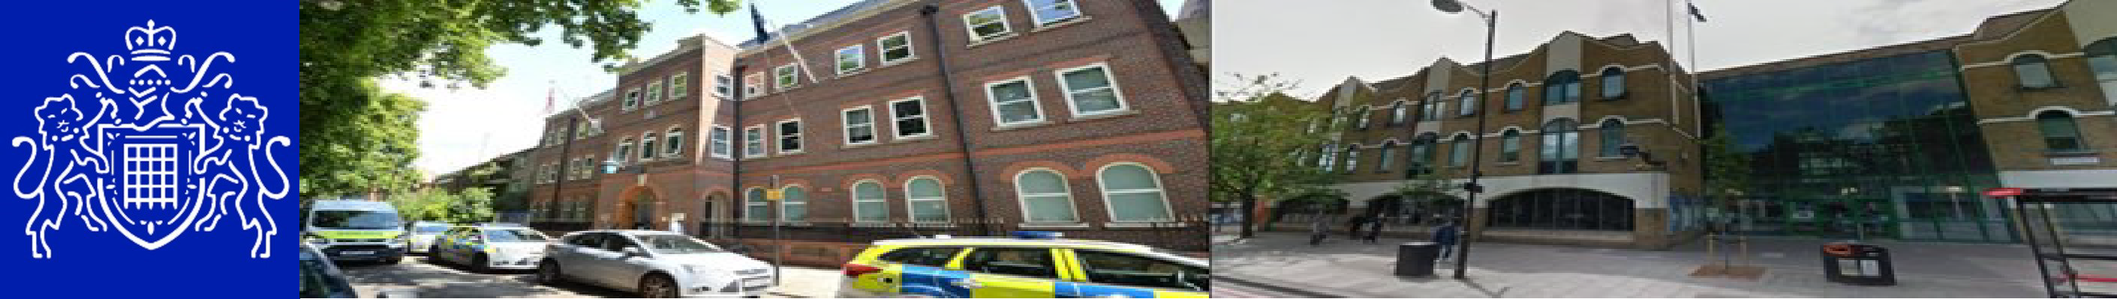
Central East BCU — Mile End SNT
Safer Neighborhood Newsletter September 2026

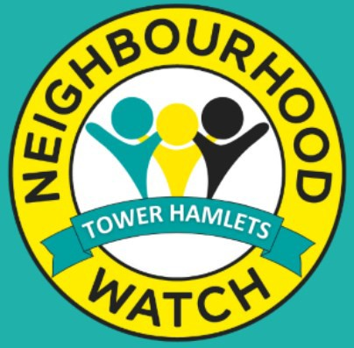


Your Safer Neighbourhood Team

Your Local Mile End SNT is overseen by PS Bourne and our team members are
PC Furlonger, PC Lacey, PC Grewcock,
PC Iryna, PCSO Yates, PCSO Romanik, PCSO Hoq,
PCSO Tanas.

Safer Neighborhood Officers conduct regular highly visible patrols across the ward to deter and disrupt criminal activity and anti-social behavior. They also hold regular crime prevention events, public contact sessions and community meetings to hear about the issues that matter most to you

Contact us
Your Safer Neighborhood Ward phone, email and Social media accounts are NOT monitored 24/7 and are NOT intended for the public to re- port crimes on, instead please use the non-
emergency number 101 or complete and online report .

IN AN EMERGENCY DIAL 999

Mile End SNT contact us: CEMailbox.MileEnd@Met.Police.uk

Social Media

MET ENGAGE :
Get the most out of your neighborhood with MET ENGAGE. It's where communities come together, exchange recommendations. Read the latest local
news and be made aware of upcoming events from public services.
Register with MET ENGAGE :

www.metengage.co.uk
Sign Up for Met Engage & complete the Local Area survey at: https://survey.metengage.co.uk

Neighborhood Watch
Neighborhood Watch is about people getting to-
gather with their neighbors to take action to reduce crime. They work by developing a close relationship between community members and the local Police. To find out what groups are active in your area and to register to join London Borough of Tower Hamlets | Neighborhood Watch Network (ourwatch.org.uk)



Central East BCU — Mile End SNT
Safer Neighborhood Team Newsletter September 2026 2026

Community Engagement / Action :

Mile End SNT Officers carry out our monthly activities
such as Bike Marking Events, Walk, Talk and Do,
advertising.
MET ENGAGE and getting in touch with our community
members directly to provide support and reassurance whenever it’s needed and necessary. www.metengage.co.uk

During September, officers also made a number of
Arrests including arrests in connection with class A drugs, burglary, common assault and breaching of the court
orders. Officers continue to conduct high-visibility and
Reassurance patrols across identified hotspots area to
deter offending and address concerns raised by local
Residents. Our local SNT issued numerous ASB warnings
In response to incidents of anti-social behavior, where
appropriate.

You said: Providing regular foot patrols around Canton Street, Hind Grove, Gough walk, Pigot Street.
We did: Mile End SNT officers increased their visible presence
and patrols around Canton Street, Hind grove, Gough walk and Pigot Street. Officers also issued number of ASB warnings where appropriate to individuals whose behavior causing concerns within the community.

On Saturday 26/09/2026 officers stopped the suspected Individual, who was known as outstanding wanted/missing
Suspect. Officer’s actions resulted in the arrest of the male
Suspect.

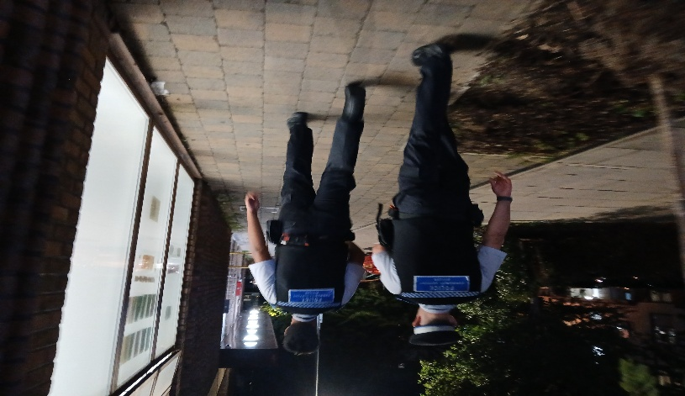
On Wednesday on 23/09/2026 Mile End SNT conducted our Ward Panel Meeting at St. PAULS WAY COMMUNITY CENTRE, E3 where we met our local community members and our partnership agencies.
During the meeting we discussed new priorities for our ward and listened to the safety concerns raised by our residents. We would
Like to thank all participants attending the meeting and sharing
Their views and concerns with us!


Central East BCU — Mile End
Safer Neighborhood Newsletter September 2026

Crime in Your Area
If you have a problem in your area but don’t want to talk to Police, Contact Crime Stoppers or Fearless.
These organizations are confidential, and you will not be asked for your details.

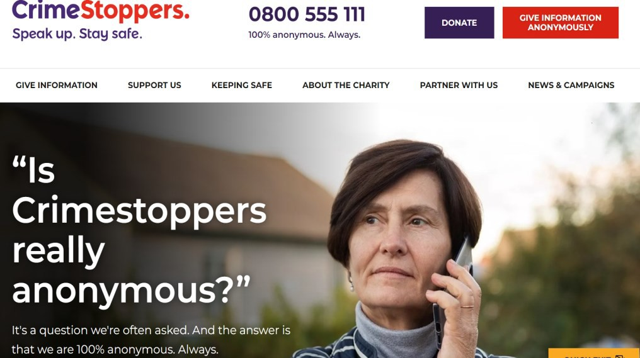

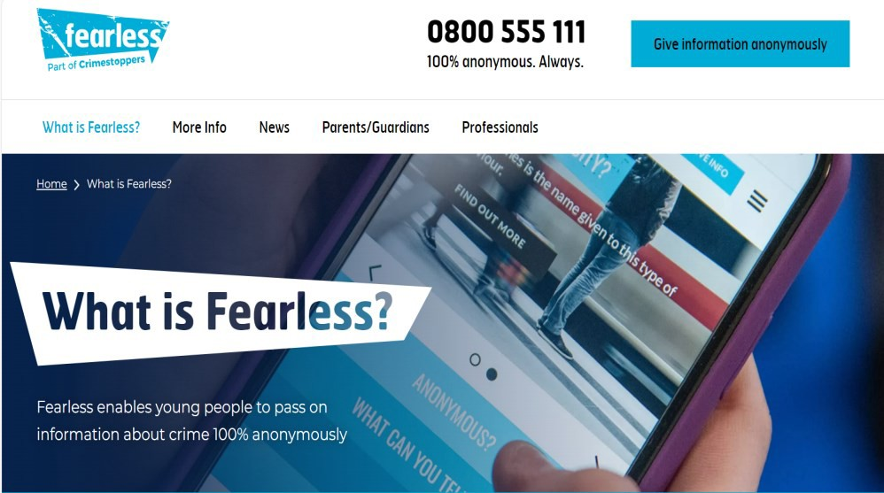

Number of Crimes in your Area—December 2025 For a more in depth statistics and data for London please visit
https://www.met.police.uk/sd/stats-and-data

Crime type | Tower Hamlets | Mile End
Theft and  Handling | 940 | 29
Violence | 857 | 55
Burglary | 213 | 9
Drugs | 243 | 23
Vehicle offences | 197 | 14
Robbery | 103 | 4
Sexual offences | 108 | 10
Weapons | 26 | 1

Upcoming Events



