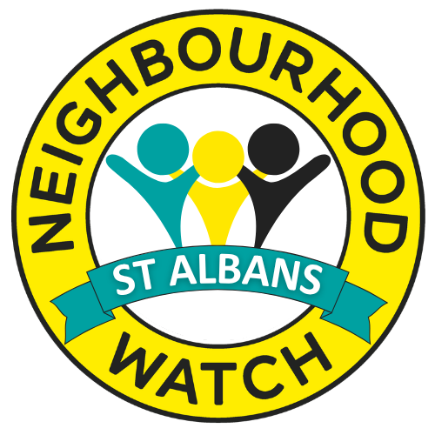 | NEIGHBOURHOOD WATCH / ST ALBANS  Strengthening Our Communities  OCTOBER 2026 • COMMUNITY NEWSLETTER
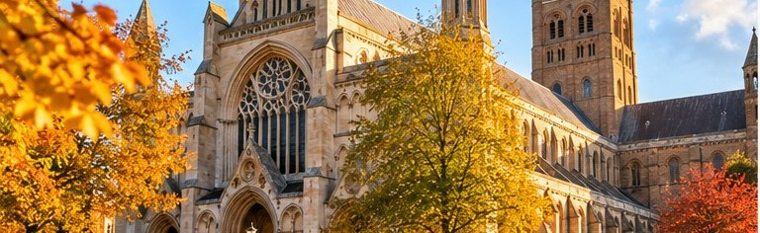
TOGETHER WE CONNECT, CARE AND GROW
Dear Friends and Neighbours,
Welcome to our October newsletter. This month is about simple ways to make St Albans a safer, friendlier place: meeting neighbours, enjoying local events and supporting each other. We hope you will find something to take part in — and share with a friend.
FEATURED INVITATION • FREE COMMUNITY OUTING

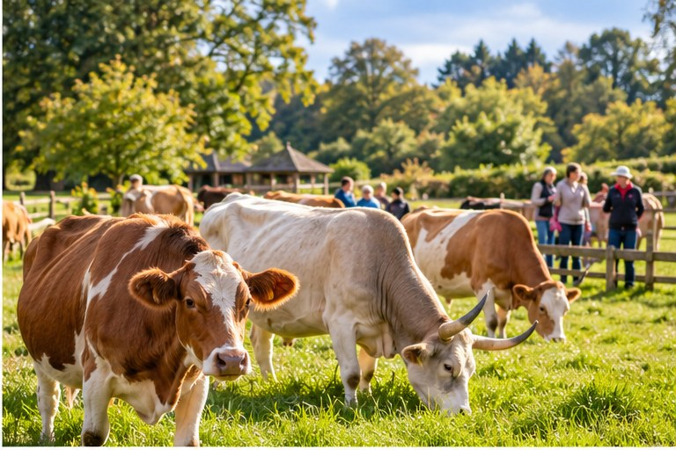 | A peaceful day at New Gokul Cow Sanctuary  THURSDAY 19 NOVEMBER • 10:30AM–2PM  Bhaktivedanta Manor, Hilfield Lane, WD25 8EZ  Enjoy a relaxing visit, meet the cows and oxen, and learn about their care. A warm vegetarian lunch follows — all free of charge.  TO JOIN: Simply reply to this newsletter email.

COMING TO ST ALBANS • COMMUNITY CONVERSATION

The People’s Emergency Briefing
We hope to host a local screening of this film about the climate and nature crisis, and how neighbours can prepare and support one another. Date and venue to be arranged. Interested? Reply to this newsletter email. Film information: nebriefing.org/the-film.
WHAT’S ON • NOVEMBER & DECEMBER


EVENTS AT A GLANCE
SUN 1 NOV | St Albans Vegan Market  From 10:30am · St Peter’s Street · Food, crafts and ethical gifts.
7–9 NOV | Cathedral Christmas Artisan & Art Fair  St Albans Cathedral · Artisan stalls and art.
SUN 8 NOV | Diwali Celebration & Sunday Market  St Albans city centre · Festival of light and community stalls.
WED 18 NOV | Outsmart the Scammers — online  Safer St Albans Academy · 7pm · Reply for the Eventbrite booking link.
SUN 22 NOV | St Albans Christmas Cracker  Noon–6pm · City centre · Stalls, gifts, food and festive entertainment.
THU 26 NOV | Older People’s Day — Redbourn  10–11:30am · Redbourn Village Hall · Local activities and support.
SUN 6 DEC | Rudolph Run — St Albans  Registration from 10am · Waterend Barn · Hospice charity event.

LOCAL RESIDENTS • YOUR VOICE MATTERS

London Colney Neighbourhood Watch meeting
We are planning a local residents’ meeting to share ideas and discuss community safety. No date has been set. If you would like to attend, simply reply to this newsletter email.
Coordinators’ Zoom Meeting — Monday 30 November
6pm via Zoom. Reply to this newsletter to request joining details.
KEEPING OUR NEIGHBOURHOODS SAFE

Home security for darker evenings
Burglars may target homes that look empty during the darker afternoons. These simple steps can help:
- Set lights on timers or smart plugs to make your home look occupied.
- Lock doors, windows, side gates, sheds and garages; put away tools and ladders.
- Consider motion-activated lighting, a doorbell camera or an alarm.
- Lock vehicles and remove valuables from sight.
- Look out for neighbours — never confront a suspicious person.
Report non-emergencies: 101 or herts.police.uk | Emergency or crime in progress: 999
YOUR COMMUNITY NEEDS YOU

Become a Neighbourhood Watch volunteer
We need street coordinators and deputies in Park Street, Cunningham, Ashley, St Peter’s, Verulam, Marshalswick, Wheathampstead and Sandridge. You can also help with events, workshops and outreach projects — even a little time makes a difference.
Interested? Reply to this newsletter email.
Community Speed Watch
We’re gathering residents interested in working with police on local speeding concerns. To be part of the group, reply to this email.
WELLBEING & KINDNESS

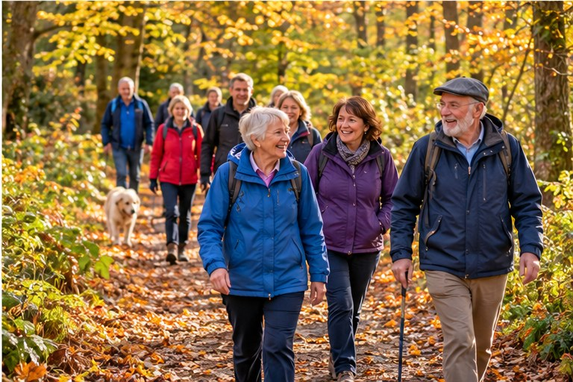 | Free Hertfordshire Health Walks  Enjoy friendly, guided walks throughout autumn, suitable for different abilities. Call 01992 555888 or email healthwalks.cms@hertfordshire.gov.uk.

Fireworks: please consider your neighbours
Fireworks can be distressing for pets, older residents and people with health conditions or sensory sensitivities. Please avoid setting them off at home and consider an organised display instead.
Small acts matter: check in on a neighbour, invite someone along to an activity or share helpful local information.
STAY CONNECTED • REPLY TO THIS NEWSLETTER
To join an outing, attend a meeting, or offer to help, simply reply to the email that brought you this newsletter. With warm wishes, NHA St Albans City & District.

