An Update from June…
Safer Neighbourhoods

July 2026
Darley Dales and Winster.

Street meet dates
7th July 12:00 – 13:00 - The Terrace Café Crime Prevention Event, The Whitworth, Station Road, Darley Dale

10th July 14:30 – 15:00 - The Terrace Café Community Catch Up, The Whitworth, Station Road, Darley Dale

11th July 15:00 – 16:00 - Prevention Event, Tippin Park, Darley Dale

17th July 12:30 – 13:00 - Face-to-Face meet on Whitworth Park, Darley Dale

22nd July 14:30 – 15:00 - Street meet on Tippin Park, Darley Dale

24th July 11:00 – 11:30 - Street meet on Whitworth Park, Darley Dale

27th July 14:30 – 15:00 - Street meet on Tippin Park, Darley Dale

29th July 18:30 – 1900 - Outside the Terrace Café, The Whitworth, Station Road, Darley Dale

What has the team been up to?

Introduction:

Anti-Social Awareness week
Anti-social Behaviour week has began. From the 29th of June until the 5th of July, it is Anti-social Behaviour week, to raise awareness for issues caused by Anti-social Behaviour. To do this, we have been conducting Anti-social Behaviour engagements and School talks highlighting the issues and consequences. Anti-social Behaviour has been reported as one of Darley Dale and Winster’s biggest issue according to our Derbyshire Alert Surveys. The aim of this week is to discuss the issues created by it, how it affects you and what we can do to resolve the issues caused by it. If you are affected by Anti-social Behaviour, feel free to approach any officers you see in and around your area to discuss your experience. If you see Anti-social Behaviour taking place, please call 999 to report the issue so it can be delt with immediately.
What has the team been doing?
In June, the Safer Neighbourhood team Conducted Plain Clothes Operations around Darley Dale to target certain issues in the area. In additions to this, the team has undertaken more high visibility foot patrols in hotspot areas to assist in deterring crime.

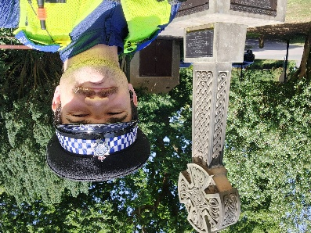
New PCSO on the beat!
Good afternoon. I am PCSO Seb Hart and I am the new PCSO for the Darley Dale and Winster area. I look forward to getting to know these areas and their communities. If you ever see me on patrol, please feel free to come and talk to me about any issues and concerns you may have, or if you just wanted a friendly natter.

Safer Neighbourhoods
Darley Dale and Winster.


Quarterly Priorities
July marks the end of another quarter of the year, which means it is time to review the quarterly priorities. After speaking to the locals, the key priorities have been identified as:
- Anti-social Behaviour
- Road safety issues and Speeding traffic/Hazardous driving
- Drug dealing
We have already begun to address these issues; however, we cannot solve these issues without your help. If you see something happening, please report it so we can develop a better understand of what is happening and can address the issue quickly. If it is easier, please feel free to approach one of our team members whilst they are on patrol to discuss your concerns.
School talks
More School talks have been planned, mainly focusing on Anti-social Behaviour and Summer Safety. As the summer holidays approach us, we hope to show the schools how they can stay safe during the summer holidays and what Anti-social Behaviour is so they understands what it means and how to avoid accidently doing it.




