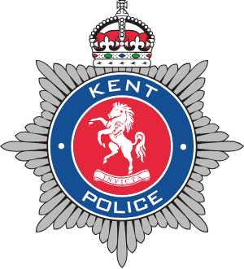
COFFEE
WITH A COP
Monday 18th May 2026
10:00-12:00pm
West Kingsdown Parish Council Office
The Pavillion, London Road
West Kingsdown
Kent
TN15 6HS
MEET PC WILSON
Your local beat officer
This is an opportunity to meet your local beat officer, raise any concerns you may have and to tackle the issues that matter to you.
NO BOOKING REQUIRED- Just drop in!
We look forward to seeing you there

