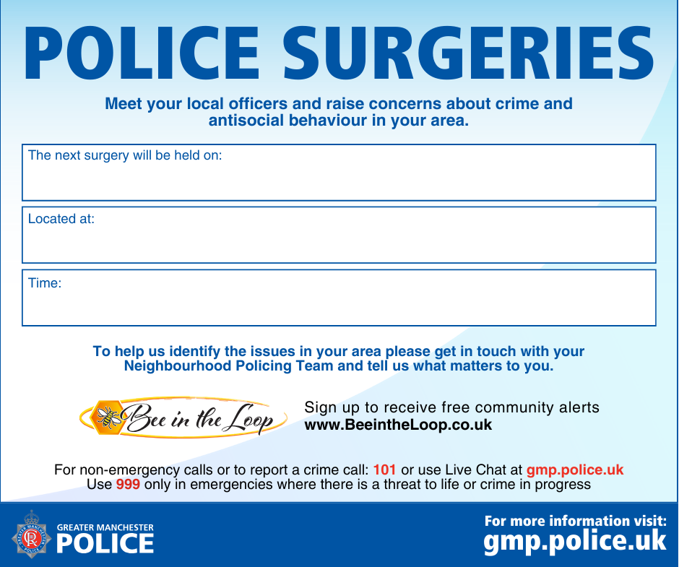
Honeywell centre Hadfield street
1630-1830
27th of August 2026

