Welcome to your Oakham & Barleythorpe police e-newsletter. Here you will find all of the latest news from an Oakham & Barleythorpe policing perspective.
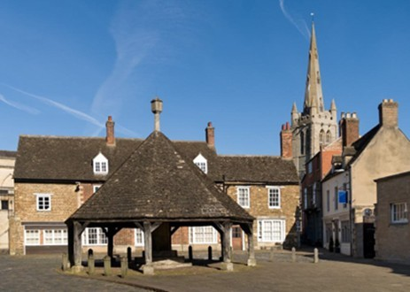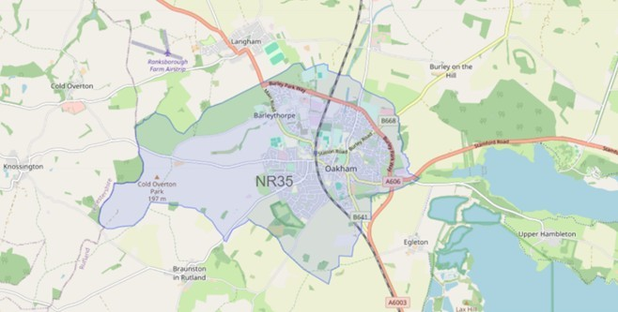

What matters to you

We have listened to you and the concerns you have raised through surveys, community consultations and analysing crime trends.

Oakham & Barleythorpe Newsletter
April 2026
Using this data, we have created the following Oakham & Barleythorpe priorities that the Dedicated Neighbourhood Team will focus their efforts on:

Page 1

Oakham & Barleythorpe Newsletter

Priority 1: Anti-social behaviour (ASB): You said: Anti-social behaviour in and around Oakham & Barleythorpe is becoming more frequent in certain areas.
What we have done: During April, myself and PC Hughes have carried out high-visibility patrols in identified ASB hotspot areas, engaging with residents and local businesses to address ongoing concerns. We have conducted joint patrols and targeted interventions, speaking with individuals involved, issuing appropriate advice and warnings, and offering reassurance to the community.

Priority 2: Road Safety: You said: Speeding vehicles on Oakham & Barleythorpe roads is a priority you want us to address, specifically the lack of adherence to 30mph zones.
What We Have Done: During April, myself and PC Hughes have actively tackled road safety concerns through targeted high-visibility patrols and speed monitoring in key areas. We have engaged with motorists to provide road safety advice, addressed reports of speeding and poor driving standards, and worked proactively to deter unsafe behaviour.
Priority 3: Drug dealing/taking: You said: Reports of drug dealing/ taking in and around Oakham & Barleythorpe.
What We Have Done: PC Hughes and PCSO Lauren have been out patrolling at different times throughout the town making full use of stop search powers and dealing with offenders.

2 drug related offences
1 reports of Road Safety 0 report of Anti-Social Behaviour
Anti-social behaviour
As we move into warmer weather, we anticipate a potential increase in reports of anti-social behaviour, particularly involving young people spending more time outdoors. We urge parents and guardians to speak with their children about the impact of ASB and the importance of respectful behaviour within the community, helping to prevent incidents before they occur.

If you’ve witnessed antisocial behaviour, please report it to us. Report antisocial behaviour | Leicestershire Police (leics.police.uk)
Community engagements—come along and meet the team!
28.05.2026– Beat surgery at Oakham Library, a chance to meet your neighbourhood team and report any concerns to the Police.

