Safer Neighbourhoods
Matlock Bath, Cromford, Wirksworth,
Middleton by Wirksworth & Bonsall October 26
New Priroties for July – September 2026…

July saw a refresh for the next quarter of the year proirites… and an update on what we have done in that last quarter…

This update outlines the progress made on the community priorities set for your area by the Local Policing Inspector John TROUP in collaboration with the Safer Neighbourhood Supervisors, Sgt Chris GRANT and PCSO Supervisor Karl MILLWARD.

Community priorities are reviewed and set on a quarterly basis, guiding the focus of the Safer Neighbourhood Team’s activity, in this update, you’ll find:
- A summary of the previous priorities
- The actions taken and outcomes achieved
- The new priorities for the upcoming quarter
New priorities are determined by analysing local crime trends and incorporating feedback from you, the community, through engagement events, surveys and direct contact.

SNT AREA: Wirksworth, Matlock Bath, Cromford, Middleton by Wirksworth and Bonsall.
The previous priorities were: - Speeding
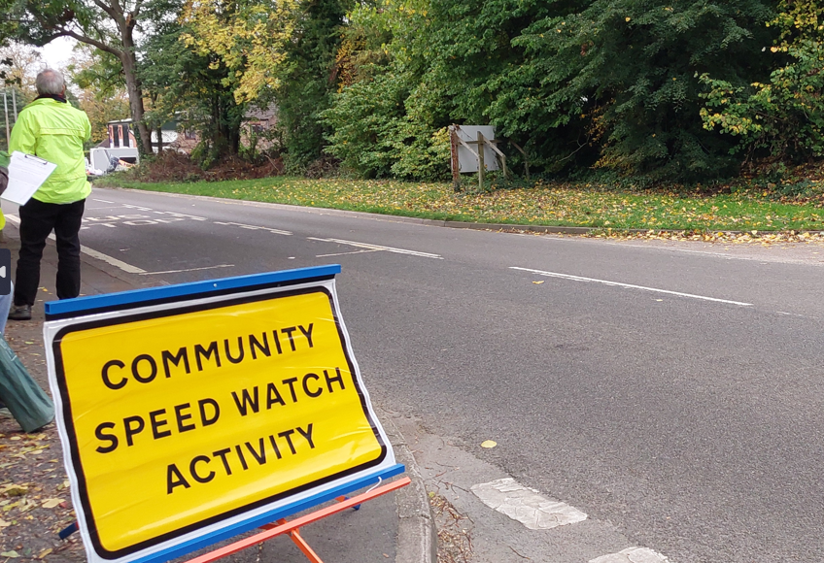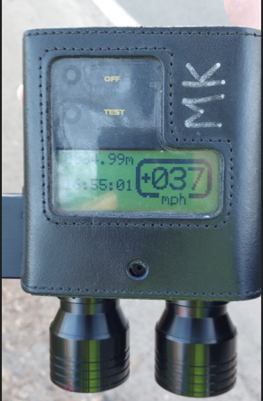

Community Catch-Ups...

Please see further into the newsletter a list of September-December,
Community Catch Ups.

PCSO Hunt will also be popping in as many Community groups as she can throughout the month too! So, you
might see her there!

Can’t make one of our Community
Catch Ups and would like to speak to
us, or arrange a
tool marking visit, please email us via MNT@derbyshire.police.uk and one of the team will be in contact with
you asap.

Safer Neighbourhoods
Matlock Bath, Cromford, Wirksworth,
Middleton by Wirksworth & Bonsall October 26
Action Taken:
In relation to Speeding, we have implemented a Partnership Problem Solving Plan in collaboration with key members of the Community Speed Watches and CREST (Police Speed Enforcement). This plan takes a holistic approach to addressing issues and around Speeding with all partners working towards a shared objective while taking responsibility for their respective areas of focus.

From a policing perspective, we have led on enforcement activity by conducting both high-visibility speed checks in all areas, leading to positive action being taken against those that have chosen to exceed the speed limit.
These outcomes reflect our continued commitment to tackling drug-related crime and maintain community safety through proactive policing.

Outcomes:
• We have seen a decrease in speeding in areas where this has been reported to be an issue.
• Three active Community Speed Watches – Cromford, Middleton by Wirksworth & Wirksworth.

New priorities:
Following this review, the SNT has identified the following priorities for the upcoming quarter:
- Nuisance Parking/Vehicles in Matlock Bath
- Shoplifting in Wirksworth

In relation to the new Priorities, we will:
Suggestions
- Conduct regular high visibility and plains clothes patrols in known hotspot areas for shoplifting.
- Attend local meetings (e.g. Parish council, community forums) to gather feedback and share updates.
- Promote road safety awareness through school visits and youth engagement sessions.
- Take proactive enforcement action against offences such as obstruction and anti-social driving
- Work with Roads Policing Unit for joint operations where necessary
- Collaborate with local councils to identify infrastructure improvements (signage, traffic calming).
- Liaise with Highways and CCTV teams to support evidence gathering and deterrence.
- Share updates and crime prevention advice via Derbyshire Alert and social media
- Publicise successful interventions to reassure the community and encourage reporting.

Safer Neighbourhoods
Matlock Bath, Cromford, Wirksworth,
Middleton by Wirksworth & Bonsall
Safer Neighbourhoods
What we have done in July and August, working in partnership on Nuisance Parking/Vehicles in Matlock Bath…

A working partnership has come together including Police, Derbyshire Dales District Council, Matlock Bath Parish Council, Elected Member of Parliament and their team to discuss issues around the following…

- Parking on the pavements by all vehicles.
- Parking signage throughout the village – includes both yellow/white lines and street signage.
- Parking and/or Police enforcement.
- Road Safety – such as speeding, layout of North & South Parade and volume of traffic that the A6 gets.
We agreed to look at the following potential solutions…
- Use excess pavement on the riverside - create new, additional bike 'cut out' bays to add capacity and loading bay for deliveries.
- Installation of benches planters on the riverside to stop pavement parking, if cut out bays for parking cannot be established.
- Road humps / raised crossings to slow traffic / prevent ASB driving on main A6.
- Extend yellow/white line on pavement to highlight that the double yellow lines extend to the pavement also – to advise that there is no parking on the pavement.
- Electronic car park capacity signs to show capacity at DDDC car parks along the A6.
- Parking Enforcement officers – to look at a different patrol strategy to suit Matlock Bath.

We have patrolled the area and spoke to/advised/used enforcement around the issues mentioned above – it is great to say that 99% of people spoken to has been positive and issues rectified straight away – the other 1% have received fines for parking.

Overall, the main aim of this partnership working is to make Matlock Bath a safer place to visit for all, not to deter anyone visiting. Updates to follow.

Matlock Bath, Cromford, Wirksworth,
Middleton by Wirksworth & Bonsall October 26

Derbyshire Alert & Community Voice…

Have you signed up to our two-way messaging service Derbyshire Alert? This is where you receive messages from your Safer Neighbourhood Team, around prevention advice, appeals, meeting your SNT, and local crime information. This is also where you can request a copy of our Burglary newsletter and Land Rover theft prevention newsletter, for example.

Visit www.derbyshirealert.co.uk to sign up or visit one of our many Community Catch Ups (see first page for info), we hold to sign you up.

There is also the Community Voice, a survey about the area where you live, that gives you the opportunity to tell us about what we should be prioritising. We will be reviewing these next few months, so don’t miss your opportunity to speak up.




Safer Neighbourhoods
Matlock Bath, Cromford, Wirksworth,
Middleton by Wirksworth & Bonsall August 26
As the officer in charge of policing for Derbyshire Dales, I want to provide you with some brief updates on just a few of the things that officers from your Safer Neighbourhoods Teams have been doing over the summer months.
Muti agency meetings have been held with parters to discuss how we can work together to manage and reduce the impact on residents and businesses caused by an increase in visitors to Stanton Moor which is a scheduled ancient monument. Leading up to and throughout the Autmn Equinox Police Officers and PCSOs patrolled these areas to remind people that fires are prohibited under a Public Spaces Protection order and that Camping is not allowed under The Countrysides and Rights of Way Act 2000. They were supported by colleagues from Derbyshire Dales District Council, Fire Service, Peak District National Park, and the Landowner. Whilst one small fire was dealt with by fire service, the occasion passed without significant disruption. You can find out about PSPO’s here Public Space Protection Orders - Derbyshire Dales District Council

Matlock SNT attended a meeting regarding the problems caused by high visitor numbers and the increased reporting of anti-social driving and parking at Matlock Bath. Suggestions for traffic calming measures and protecting pedestrian areas were discussed and have been sent to the relevant agencies for their consideration. We have continued to work with Civil Parking Enforcement to support their work and our colleagues from the Road Policing Unit (RPU), Casualty Reduction and Enforcement Team (Crest) have been out across Derbyshire Dales to help tackle the ‘Fatal Five’, which are Speeding, Drink/Drug driving, mobile phones, seatbelts and careless driving. You can see Sgt Scott Riley discussing these in the constabulary’s podcast Off Duty: The Fatal Five - Roads Policing Unit | Derbyshire Constabulary

SNT officers worked alongside officers from our Criminal exploitation team to successfully execute several warrants across Matlock resulting in four men and 2 women being arrested. You can read more about this here Four charged with drug offences following series of warrants in Matlock | Derbyshire Constabulary. The work done to disrupt crime and drugs in our communities continues, if you have any information regarding drugs or other criminality then you can report this through the Derbyshire Constabulary website, by calling 101 or anonymously via Crimestoppers on 0800555111.

Over the Autumn months officers will be concentrating on the priorities that have been set by you for your areas, you can contribute to these by contacting your local officers Your area | Derbyshire Constabulary, through social media or by signing up to Derbyshire Alert.

The SNT officers will be patrolling in your area and publish their engagements on the meetings and events page of our website. As the nights now begin to draw in then we would encourage residents across the Derbyshire Dales to think about securing their properties and outbuildings and making sure valuable items are safe. Lawnmowers and bikes put in sheds can be a target for thieves so consider locking things together to make them difficult to move and try not to leave things on show. If you are out of the house when it is becoming dark, then consider putting a light or television on or setting a timer switch so that potential thieves cannot see that there is nobody at home. Please come along to one of our engagement events if you would like to ask about the security of your home or discuss anything else with us. To see more about what is happening in your local area then please visit our website or follow us on social media.

Safer Neighbourhoods
Matlock Bath, Cromford, Wirksworth,
Middleton by Wirksworth & Bonsall August 26
Community Catch Ups – October - December 2026October –
02/10/26 – United Reform Church, Wirksworth, Tea & Toast – 9:30-11AM
03/10/26 – Wirksworth Famers Market, The Memorial Hall, Wirksworth – 9AM-12PM
03/10/26 – St James Church, Bonsall – 1PM-2PM
04/10/26 – Wizarding Day, Wirksworth Fire Station, 11AM-3PM
12/10/26 - Knit & Natter, The Nelson Pub, Middleton by Wirksworth – 1-3PM
20/10/26 – Wirksworth Market, The Memorial Hall, Wirksworth – 8:30AM-12PM
31/10/26 – St James Church, Bonsall – 12PM-1PM

School Talks & Community Groups

The new school year started at the beginning of September, means a visits at the beginning and end of the school day across the areas – it was great to see so many new faces at all the schools and there excitement and nerves when starting their new adventures!

PCSO Hunt has also visited vairous community groups, such as knit & natter, tea & toast, easy meals and catching up with residents at Waltham House. These groups give us the opportunity to discuss issues, concerns and crime prevention. As sometimes residents are hard to reach, or sometimes unsure who to speak too. It is always a great pleasure to help people with such issues etc…

Would you like PCSO Hunt to visit your group? Drop us an email – MNT@derbyshire.police.uk or call 101 and ask to speak to PCSO Hunt, 12900.

