
Speed Enforcement Activity

Get the latest crime statistics
by
v
isiting:

www.kent.police.uk/yourare
a

Beltinge & Reculver

Ward

newsletter

October
202666

.

Here is your monthly update on the work carried out across the wards of Beltinge and Reculver over the past few weeks. Thank you to all residents who continue to report concerns and support our policing efforts. Your information helps us target issues effectively and keep our community safe.

Speeding continues to be a key concern raised by residents and remains one of the priorities for the Reculver and Beltinge ward.

Throughout October, my colleagues and I carried out speed enforcement checks on several roads across the Herne Bay area, including targeted activity on Reculver Road following concerns from local residents.

- During these checks, multiple vehicles were detected exceeding the speed limit. One of the most significant offences involved a high-powered motorcycle travelling at 57mph in a 30mph limit.

- Other motorists were recorded travelling at 40mph and 41mph in the same 30mph zone.

- Drivers who were stopped were issued with Traffic Offence Reports, and enquiries are ongoing to identify and take enforcement action against those who failed to stop.

Speed limits are in place to keep all road users safe, and excessive speed significantly increases the risk of serious collisions. As we move into the holiday season, I will continue to carry out enforcement activity and targeted speed checks on roads that residents have highlighted as areas of concern.

If there are locations within the ward where speeding remains an issue, please continue to let me know so that patrols and enforcement activity can be directed where they are needed most.
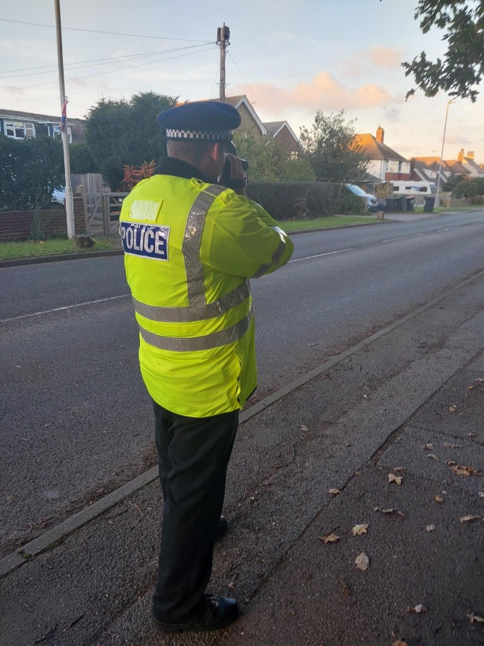

Photo of PC Roy with the speed gun on Reculver Road

Tackling Anti-Social Behaviour

My colleagues and I have continued to respond to concerns raised by residents regarding youths kicking front doors and throwing eggs at properties.

As part of my enquiries, I have been speaking with residents and reviewing CCTV footage to identify those responsible. This work has resulted in some of the details of the individuals being ascertained, and I am now progressing these enquiries to establish the full details for follow-action on these individuals.

Drug Enforcement Activity

Earlier in the month I posted a message regarding reports from residents about suspected drug dealing within a residential area.

- Colleagues and I carried out targeted patrols in the area, including both high-visibility and plain-clothed operations.

- During this activity, five individuals were stopped and searched, resulting in the recovery of cannabis and drug-related paraphernalia. Three of those involved were juveniles, and have been referred to the Youth Justice Team for further intervention.

Since the operation took place, no further reports of drug dealing have been received at that location.

Patrols will continue to provide reassurance and deter further offending. I would like to thank residents who provided information and raised concerns. Community intelligence is invaluable in helping us identify issues and take positive action.

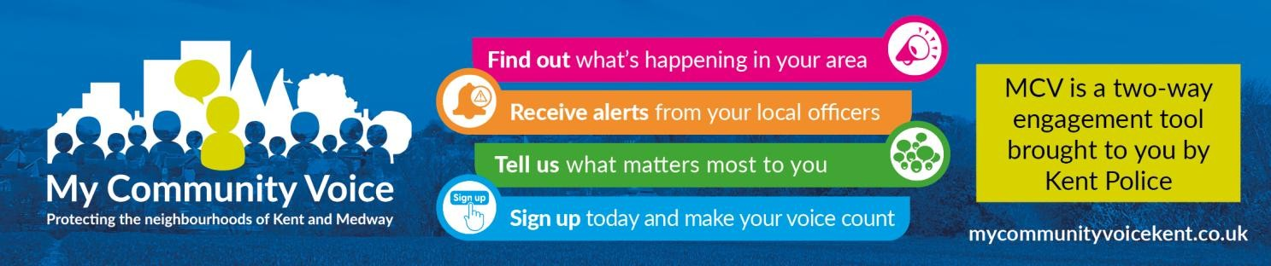
- Supporting our community: By working closely with residents, local partners, and community groups, we aim to build trust, improve safety, and create stronger relationships across the area. Whether it’s providing reassurance, acting on concerns, or helping vulnerable individuals access the support they need, our focus is on being visible, approachable, and proactive. Together, we can continue making our neighbourhood a safer and more positive place to live.

1


Community Engagement: We are committed to engaging with the Coastal Wards community. This includes holding regular community meetings, which are advertised via My Community Voice. We want to hear your concerns and work together to find solutions.

We are committed to keeping you informed. We publish this monthly newsletter and provide updates on local crime trends and the work we are doing to address these issues on My Community Voice.

2

Next month’s engagements:  - Wednesday 11th November 2026 @ 14:00 – 15:00 – Age UK (Herne Bay), 16 Reculver Road, Herne Bay, Kent, CT6 6LE  - Tuesday 17th November 2026 @ 14:30 -16:00 – Costa Coffee, 6 The Boulevard, Herne Bay, CT6 6GZ.  - Thursday 26th November 2026 @ 10:30 -12:00 – HatHats Coffee, Reculver, Ct6 6SS. | Your local officer:  PC Jack Roy

