Community Policing Update  Your local officers remain committed to keeping our community safe and reassured. We continue to carry out high-visibility patrols across the area, focusing on building positive relationships and deterring criminal activity.  Nuisance vehicles  Many residents have raised concerns about vehicles with loud exhausts, unnecessary revving, speeding, and other antisocial driving behaviours. While these actions may seem minor to some, they can cause considerable disruption, particularly during evenings and weekends.  We are working to address these issues through targeted patrols and engagement with drivers. If you witness nuisance vehicle activity, please report it to us with as much detail as possible  Engagements  In July, Herne Bay CSU attended both Windchimes and Baytastic in Herne Bay, where we provided crime prevention advice, spoke with those interested in joining Kent Police about our recruitment process, and gave visitors the opportunity to try on police equipment, test our Public Order kit, and even experience sitting in the cell at the back of a police van.  We hope you enjoyed the events as much as we did. Keep an eye out for future community engagements and come along to say hello!  - Community Engagement: We are committed to engaging with the Greenhill and Westbay community. This includes holding regular community meetings, which are advertised via My Community Voice. We want to hear your concerns and work together to find solutions.  We are committed to keeping you informed. We publish this monthly newsletter and provide updates on local crime trends and the work we are doing to address these issues on My Community Voice. |   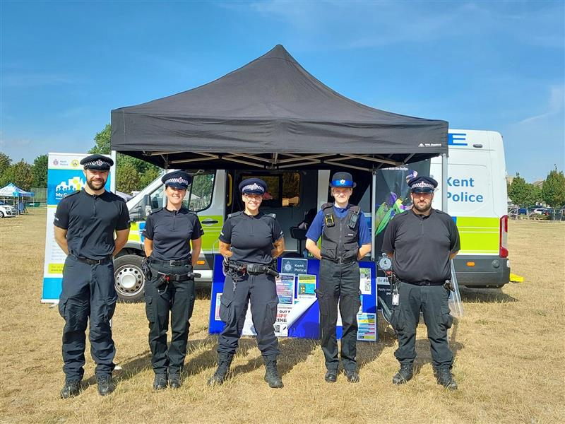  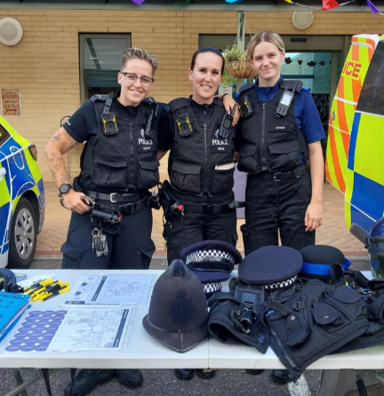
Next month’s engagements:  - Engagement Car – Hampton Car Park 6TH August 2026 10:00-11:00hours  - St Peters Church, Herne Drive, Greenhill 11th August 2026 10:00-11:00hours. | Your local officer is;  PC 15918 TOTTEN

Upcoming events to look out for!

Your local officers will be holding an upcoming bike marking event in the area to help prevent theft. Bring your bike along to have it security-marked and registered.
Keep an eye on our channels for dates and locations—we look forward to seeing you there!



