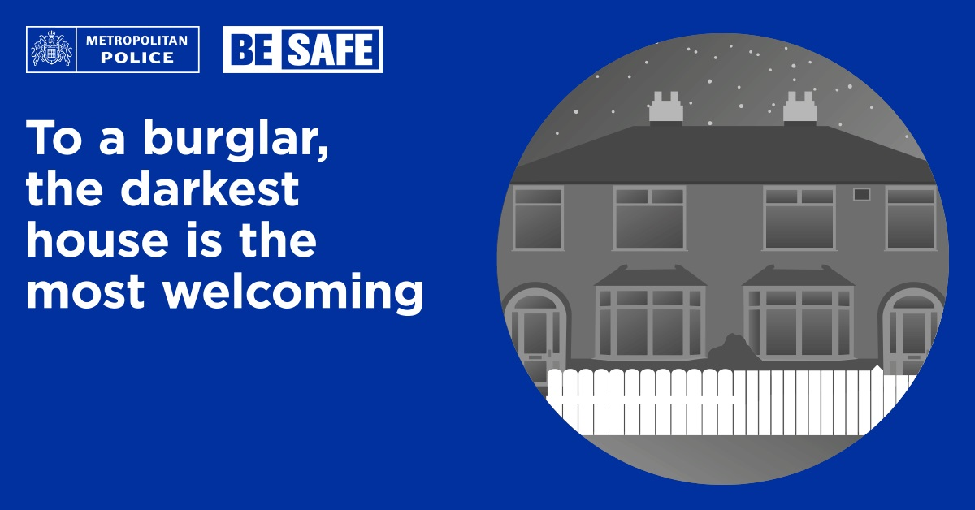
Oakwood Safer Neighbourhood
The clocks don’t go back until the end of October, but we want residents to be prepared to help reduce the chances of becoming victims of crime during the dark autumn and winter months.
Officers are determined to keep up the pressure on criminals and are encouraging the public to help.
Officers will be patrolling burglary hotspot areas identifying houses that could be at risk of burglary,
but after hours of darkness, if no light is on in your home, curtains are not drawn, and no car is on the drive, it's an obvious sign to an opportunist burglar that no-one is in. At this time of the year more than any other it pays to secure your home.
Now is a good time to check around the house and garden to make sure everything is in order.

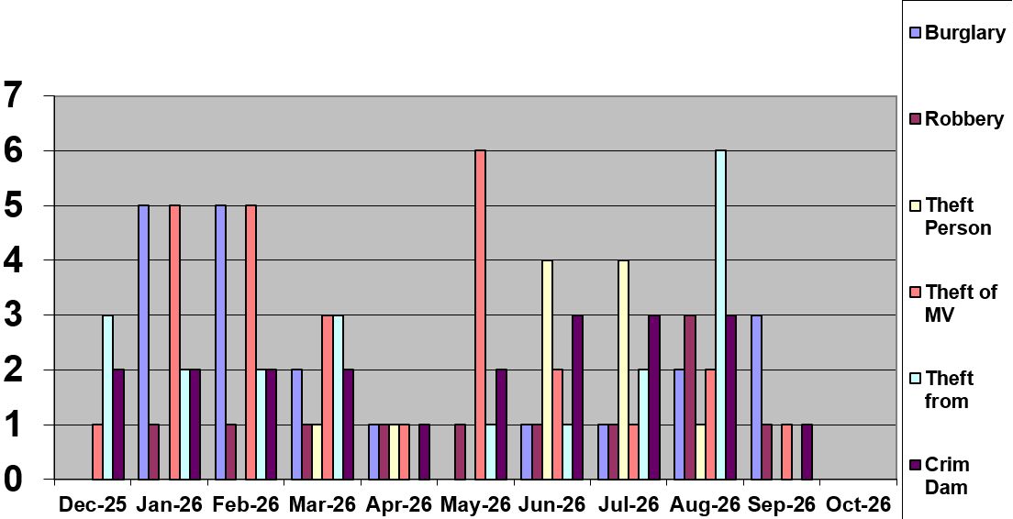

MV = Motor Vehicle Crime
VWI = Victim With Injury (Assault)

Crimes Recorded in September
Burglary
There were 1 residential burglaries, 1 attempted residential burglaries, 2 non – residential burglaries, 0 attempted non - residential burglaries, and 0 aggravated burglaries reported in September.

Friday 4th September 2026 at 9.30pm

LOWTHER DRIVE, EN2 Rear patio smashed in attempt to gain entry believe suspect(s) gained entry via jumping overside gate. Disturbed by occupants, suspects made off in a hatchback car.

Saturday 5th - 6th September 2026

CARLTON AVENUE, N14 Suspect(s) entered garage at rear of property and stole motorcycle.

Tuesday 15th September 2026 between 1pm – 3pm

ASHMEAD, N14 Doorstep Parcel theft from a communal area.

Tuesday 15th September 2026

LOWER KENWOOD AVENUE, EN2 Suspect(s) smashed Bifold doors at the rear of the property, car keys used to steal Volvo XC90. Vehicle recovered after a police pursuit.

Motor Vehicle Crime
There were 0 thefts from motor vehicle and 1 theft of motor vehicles reported in September.

1st September 2026

AVENUE CLOSE, N14

Toyota stolen from street, two people were seen towing the vehicle away.

Robbery

There were 0 personal robberies, 0 commercial robberies and 0 theft from person reported in September.

22nd September 2026

FOTHERGILL DRIVE, N21 Vauxhall Astra stolen via means of robbery -Victim had planned with Suspect/s as potential buyer of a vehicle. Suspect/s have brandished a machete

Other crimes for September

1x Criminal damage

0 x Criminal damage to motor vehicle

0 x GBH / ABH


Good News

- Officers received reports of drug use in a greenspace at BLACKWELL CLOSE, PENNINGTON DRIVE, N21. The team worked closely with Enfield Council to get the area cleared of abandoned rubbish which consisted of chairs and a plastic canopy. Whilst officers conducted daily patrols a community protection notice was issued to a male found loitering at the location smoking cannabis.

- An ASB warning was given to a group of youths in a vehicle playing excessively loud music in the SAINSBURYS CAR PARK in Highlands village during business hours and causing a nuisance to members of the public.

- Officers conducted three stop and searches in FOTHERGILL DRIVE, PENNINGTON DRIVE, N21. One male was given a community resolution for being in possession of cannabis.

To contact police
- In an emergency - Telephone 999
- To report crime telephone 101
- Or online at www.Met.police.uk

- In person at Edmonton Police Station, 462 Fore Street, N9 0PW.
Opening hours: Weekday 10am – 10pm.Weekend 9am – 7pm
- Crime stoppers -Telephone 0800 555 111 or at online www.crimestoppers-uk.org

Safer Neighbourhood Team

Based at Lincoln Road patrol Base

Great Cambridge Road industrial Estate

EN1

Team Members

Dedicated Ward Officers (DWOs) on

Oakwood Ward are:

Dedicated Ward Officers:

Supervisor: PS Ken Carroll

PC King Eze

PCSO Kauana Oliveria

PCSO Lisa Simpson

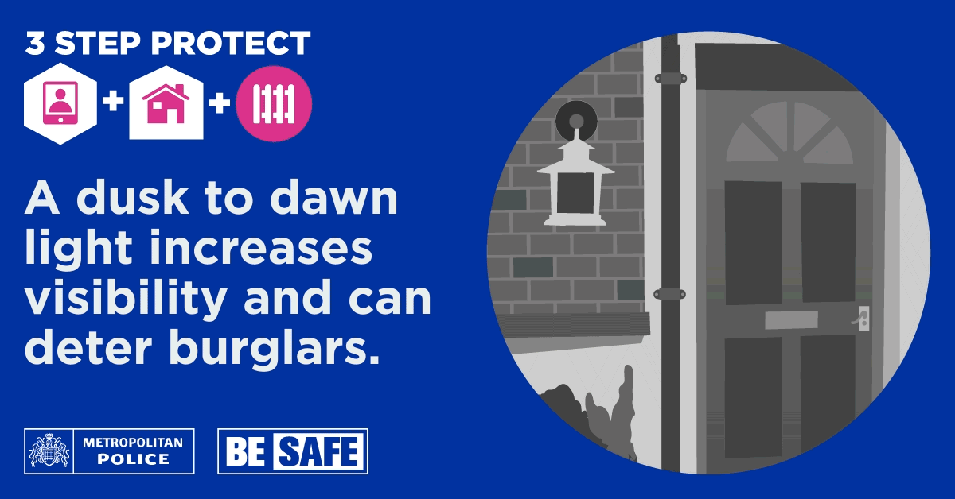

Ward Priorities
- Burglaries
Burglary has now become the ward's primary concern, particularly with the onset of longer dark nights, which have correlated with a slight rise in burglary incidents. The ward panel recognises the need for a proactive approach to address this issue promptly.

- Motor Vehicle crime
The prevention of motor vehicle crime remains a

- significant focus due to ongoing reports of high-value keyless entry vehicles. The ward panel has
agreed that this issue warrants continued attention and resources.

- ASB Anti-Social Behaviour (ASB) remains a ward priority as the summer evenings end, a period during which we often experience an increase in ASB-related incidents. The ward team will increase patrols in known hotspot areas to provide reassurance to residents and deter offending behaviour. The team will also work proactively to identify any emerging ASB hotspots and collaborate with partner agencies and residents to tackle issues effectively and reduce anti-social behaviour across the ward.
**************************************
Every ward in London has a ward panel of local community members that meets with the ward Neighbourhood Policing Team four times a year. Meetings are held in person in the evenings at a local venue. At the ward panel meetings, members explain any community concerns, and the police provide information on crime, antisocial behaviour and their recent activity. The panel then sets the police team a minimum of two very specific priorities and actions to focus on in the ward and report back on at the next meeting. Meetings are also attended by the ward councillors, so that joint problem solving can be identified. The ward panel should be broadly representative of the ward. Members should live, work or study in the ward. They should be able to communicate community concerns to the police and share information widely in the community.
Anyone is welcome, but we are specifically looking to recruit members that are active in any Neighbourhood Watch or WhatsApp groups that are willing to be spokespeople for their respective areas so that we can hear the issues that are affecting you! If you would like to join, the meetings are held quarterly at St Thomas Church, Prince George Avenue, N14 in the evening at 7pm.

