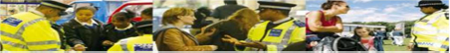

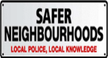

MAY2026
To contact police
*If a crime is happening now or someone is in immediate danger, call 999*Find out other ways to contact us on this link:
https://www.met.police.uk/contact-us/
*Front Counter - Edmonton Police Station
462 Fore Street, Edmonton N9 0PW
Help to make your neighbourhood safer
Attend meetings organised by us, give us a call or drop us an email. Have your say and work with us to find lasting solutions
Become a volunteer, Special Constable or Police Community Support Officer (PCSO) – For details visit:
www.metpolicecareers.co.uk



The use of twitter (x) to share ward new is being phased out and replaced with Met Engage.
ASB & SHOPLIFTING
MV crime – prevention
BURGLARIES – Prevention
WARD PRIORITIES
Panel chair: Glenn Breslin
Councillor’s: Cllr James Hockney
Cllr Peter Fallart
Cllr Pat Gregory

Bush Hill ward panel:
Get crime prevention advice at:
www.met.police.uk/crimeprevention

You can report a crime in your area anonymously via CRIMESTOPPERS. They never ask for your personal information and do not track your device. They are an independent charity that gives the people the power to speak up to stop crime 100% anonymously. Call them or fill in their anonymous online form
The ward panel or Community Action Plan Enfield (CAPE) needs volunteers who represent various groups on the ward such as; residents associations, neighbourhood watches and youth groups. You will take part in the consultation process in deciding the ward priorities and then monitoring the progress of these community chosen priorities. If you are interested, contact the ward email at:
BushHillPark.SNT@met.police.uk
WARD NEWS
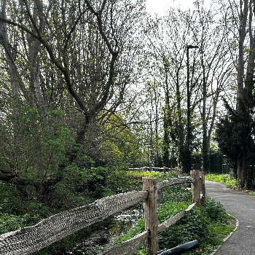


We have recently been focusing on tackling vehicle-related crime within the area, with particular attention on offences such as driving without insurance. This work has involved proactive patrols, vehicle checks, and engagement with motorists to ensure compliance with the law. Our aim is to improve road safety, reduce uninsured driving, and deter those who may be using vehicles for criminal activity.
As well as regularly conducting cycle patrols in ASB hotspots.

ASB – when to contact the police on anti-social behaviour…
Examples of ASB include:
- Excessive loud noise/music at unsocial hours
- Graffiti
- Fly-tipping
- Drinking alcohol in designated alcohol free zones
- Dog fouling
- Damaging property
- Foul language
- Extreme neighbour disputes (when mutual solutions have failed)
- ABH – 0 GBH – 1
- Burglary business / com – 0
- Residential burglary home – 5
- Attempted burglary residential – 0
- Theft of motor vehicle – 6
- Theft from motor vehicle – 3
- Criminal damage – 3

There have been a multitude of section 59s issued for the parking on the pavement at Bush Hill Parade. This has resulted in a significant decline in the parking issue, specifically targeting repeat offenders.
When NOT to contact the police:
- Groups of children playing
- Neighbour doing DIY (within normal hours)
- Music (reasonably loud)
- One off parties/celebrations (prior warning should be given to neighbours)
- Vehicles parking
Who do you report ASB to –
Residents can contact Enfield council noise team to report issues of excessive noise, they will send a council officer to assess and if necessary, speak/fine the offender, should the offence continue.
Enfield Council T. 0208 379 1000 https://www.enfield.gov.uk
The next scheduled event will be mentioned on met engage and the neighbourhood power app, please check for updates.
Community contact points
BHP WARD FIGURES
Crime figures for APRIL 2026

Go online: www.bikeregister.com
- Always use a D-lock
- Lock your wheel and frame together (see card for example).
- Use a bike rack (sign posts are not as secure)
- When possible, do not park your bicycle on the sidewalk or street overnight.
The ONLY police approved cycle database

database
Reminder…

