 | On the beat in  Meole, Copthorne & Sutton  Safer Neighbourhood Team Newsletter | May  2026

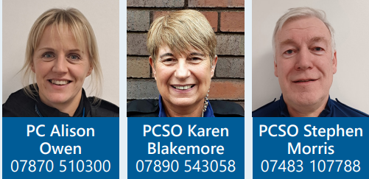
Where we work
Meole, Copthorne, Sutton, Radbrook & Belle Vue
Team email: mcs.snt@westmercia.pnn.police.uk
Team Sergeant: PS 1134 Ward
Safer Neighbourhood Officer: PC 123 Owen
Police Community Support Officer: PCSO 6301 Blakemore
Police Community Support Officer: PCSO 40676 Morris

Current statistics on calls to police and crime recording for your neighbourhood can be found at police.uk. If you wish to discuss further, contact a member of your safer neighbourhood team.

Police Surgery Dates
We continue to conduct police surgeries to answer any questions you may have regarding any issues and concerns in your local area.

Greyfriars Bridge, Coleham
Thursday 28th May 2026 12:00 – 13:00



